**CHAPTER II**

**THE SYSTEM OF PETITIONS AND CASES, FRIENDLY SETTLEMENTS, AND PRECAUTIONARY MEASURES[1]**

# Introduction

1. The IACHR has mechanisms specifically devised to the protection of human rights in the region, these are: system of cases, friendly settlements, and precautionary measures. By submitting a petition to the Inter-American Commission persons who have suffered violations of their human rights may obtain measures of justice and integral reparation. To the extent that this mechanism is operating adequately, persons whose rights have been violated may have a tool at their disposition for resolving their demands that is not only capable of benefiting them in the context of their cases, but that also offers an important tool to the states for addressing structural situations of human rights violations by effectively implementing the recommendations of the IACHR, or friendly settlement agreements approved by it, and for attending to and implementing precautionary measures. This system is a fundamental tool for attaining justice and reparation in individual cases, protecting persons, fighting impunity, and bringing about structural reforms in laws, policies, and practices.
2. The IACHR recalls the central role, in its mandate, of the system of petitions, cases, and precautionary measures, and its importance for promoting and protecting human rights in the hemisphere, both individually and in collective and structural terms. The reports of the Commission on cases, and the judgments of the Inter-American Court, in addition to the specific reparation they provide for victims, have promoted constitutional reforms and jurisprudential changes, and have represented, for the victims of human rights violations, a hope for justice and reparation. From its beginnings the states have promoted this central role and have supported the Commission in this mandate, which began with requests for information to states and then became part of the processing of individual cases. The working tools developed by the IACHR were then recognized by the Commission’s Statute adopted in 1965, and later by its Regulations of May 2, 1967, and in 1969 with the adoption of the American Convention on Human Rights.
3. The pillar of protection and defense, which includes the system of petitions, cases, friendly settlements, and precautionary measures, is a fundamental tool for the IACHR and for all inhabitants of the hemisphere. It is a matter of pride for the Americas, internationally recognized for its objectivity, seriousness, consistency, and legal quality. Mindful of this central role and of the major procedural backlog that has accumulated since the 1990s, the Commission has prioritized reducing the procedural backlog. After a process of consultations that involved more than 500 persons and 300 entities the IACHR approved its 2017-2021 Strategic Plan with five strategic objectives. Reinforcing the system of petitions, cases, friendly settlements, and precautionary measures was identified as the first such objective, and the first program in the plan is the Special Procedural Delay Reduction Program.

# Petitions and Cases

1. Next is a description of the results attained in 2020 in implementing the above-mentioned program. They represent historic gains in the Commission’s work in the system of petitions and cases.
2. In the course of 2020 the IACHR continued achieving results in its program to reduce the procedural backlog after four years of measures adopted in keeping with its 2017-2021 Strategic Plan.
3. In the first stage of implementing the Strategic Plan the following measures were adopted to address the procedural backlog: (1) full-time dedication of an Assistant Executive Secretary for petitions, cases, and friendly settlements; (2) significant reinforcement of personnel; (3) strengthening the employment stability of existing personnel; (4) creating the Section on Precautionary Measures; (5) creating the Processing Unit; and, (6) creating a working group to support the process of overcoming the procedural backlog, made up of three Commissioners and the Executive Secretary of the IACHR.
4. In a second stage, and mainly during 2019, the following additional measures were consolidated: (1) reassigning the professionals with more experience to the system of petitions and cases, and in particular to its admissibility and merits sections; (2) creating a special group to act as a task force for overcoming the procedural backlog in the stage of initial review; (3) implementing a policy for archiving cases that changes the time of inactivity on the part of the parties required for sending the warning regarding archiving from four to three years, and archiving cases in the merits stage when petitioners fail to submit observations in application of Articles 42(1)(a) and (b) of the Rules of Procedure of the IACHR; (4) reducing the number of requests for observations in the stages of admissibility and merits; (5) implementing a pilot plan for serial decisions with respect to the same issue in the stage of admissibility, based on model reports on similar issues; (6) maintaining the measure of joining cases when there is identity of parties, or similar facts or patterns, always respecting the right to defense and equality as between the parties; and (7) continuing to apply the policy of deactivating or clearing up cases.
5. These measures have made it possible for the Commission to achieve unprecedented results and institutional strengthening of its system of petitions and cases, as detailed next:
6. The Initial Review Section as a paradigm shift. The Initial Review Section was established in September 2018 with the task of conducting the initial review or assessment of petitions submitted to the IACHR. In addition, the Initial Review Section was given the fundamental task of bringing up to date the immense mass of petitions from different years that were pending a final decision in this first stage of the procedure.
7. The Initial Review Section was a real change from the previous Registry Group, for two fundamental reasons: (a) the evaluation of the petitions is entrusted exclusively to attorneys with extensive experience in international human rights law, and (b) a much more expeditious working dynamic is assured, with the supervisor working directly with the attorneys.
8. Current methodology: The petitions that come into the Executive Secretariat are recorded in the system and classified based on their subject matter in one of three thematic portfolios: P-A: rights to life, property, freedom of expression, civil due process, the family, and freedom of movement (displaced persons, etc.). P-B: criminal due process and the right to humane treatment broadly speaking. And P-C: administrative and labor due process, political rights, discrimination in general, judicial protection, and social security. Each of these portfolios is under the responsibility of one attorney.
9. The legal analysis is conducted in keeping with Articles 26 to 34 of the IACHR’s Rules of Procedure. The first aspect that is analyzed is compliance with Article 28 of the Rules of Procedure, which establishes the minimum contents required of a petition for it to be considered (Art. 26(1)); in addition, according to Article 27 (and also Article 26(1)) the “condition for considering the petition” is met “only when the petitions fulfill the requirements set forth in those instruments [those of the inter-American system that are applicable], in the Statute, and in these Rules of Procedure.”
10. In other words, in the initial review stage one verifies compliance with the minimum requirements that would be examined in an admissibility report – with the difference that this initial review is preliminary, because it is done before there is a final admissibility or inadmissibility report. Indeed, the request for a new review is now regulated (Resolution 1/19). And it is more flexible than a report on admissibility/inadmissibility because only the position of the petitioner is before the Commission, without the defense of the State; plus because if it is deemed necessary we can request additional information from the petitioner (Art. 26(2)).
11. Figures on decisions: Received in 2020: of 1,990 petitions evaluated, it was decided to go ahead with the processing of 331 (17%); 1,561 (78%) were rejected; and information was requested in 98 petitions (5%). Dismissed petitions: failure to comply with Article 28 (463), failure to state a colorable claim (516), failure to exhaust domestic remedies (271), lack of competence (144), failure to file the petition in a timely manner (77), improper exhaustion (71), and duplication of procedure (19).
12. Number of notifications that a matter has been approved for processing: With the aim of reducing the wait time between the decision to go forward with processing and actual notice thereof to the parties, the Processing and Support Section of the Office of the Assistant Executive Secretary for Petitions and Cases focused on overcoming the chronic procedural backlog, prior to 2014, and adopted a series of measures to resolve the situation of the petitions submitted prior to 2014.
13. Application of Resolution 1/16: [Resolution 1/16](https://www.oas.org/es/cidh/decisiones/pdf/Resolucion-1-16-es.pdf) was rigorously studied by the Commission and came to constitute precisely the “reasoned resolution” required by the Rules of Procedure for deferring the decision on admissibility to the debate and decision on the merits. It applies only to those cases that are in a specific procedural posture that is consistent with the conditions established in the Rules of Procedure allowing for such treatment on an exceptional basis. The Resolution indicates that these conditions are based on the need to adopt decisive measures to reduce the procedural backlog and thereby ensure that the passage of time not keep the Commission’s decisions from having a useful effect, or to act more speedily in matters associated with a precautionary measure where there is a risk of imminent harm. That resolution was an effort aimed at attacking the procedural backlog with transparency. This measure has made it possible for a significant number of cases to be reviewed, thus avoiding the need to prepare, translate, consult, and deliberate on two separate reports in cases that require a timely decision because they meet the conditions set out in the resolution.
14. The Commission continues applying [Resolution 1/16](http://www.oas.org/es/cidh/decisiones/pdf/Resolucion-1-16-es.pdf), adopted on October 18, 2016, insofar as some of the criteria set forth therein appear in matters submitted to it, whereupon both parties are notified.
15. Archives: the IACHR has been reducing the time of inactivity allowed for petitioners from five years in 2015 to three years in 2018. The IACHR also considered that the failure of the petitioner to submit additional observations, a requirement established in Article 37(1) of the IACHR’s Rules of Procedure, should be construed as a serious indication of lack of interest in the processing of a case in the terms provided for in Article 42(1)(b) of the same instrument. And so, having verified the procedural inactivity, and having given notice of the possibility of a decision to archive, as provided for in Article 42(2) of the Rules of Procedure, the IACHR made the decision to archive 77 matters in 2016, compared to 109 in 2017, 152 in 2018, and 148 in 2020.
16. Simplification of procedures: In keeping with its Rules of Procedure, the Commission implemented the practice of forwarding the position of each party to the other party, for observations, only once in the admissibility stage. This measure is in the process of being implemented in the IT systems.

# Decisions on Admissibility and Inadmissibility

1. In 2020 the historic increase in the drafting and approval of reports on admissibility and inadmissibility continued. That year the IACHR approved a total of 290 reports on admissibility, in 246 of which the decision was admissibility; the other 44 petitions were found inadmissible.
2. In order to gauge the impact of the results achieved this year, we should compare them with previous years. In 2016 – the year before implementing the 2017-2021 Strategic Plan – the IACHR approved a total of 45 reports on admissibility (43 admissible and two inadmissible); that figure climbed in 2017 to 120 reports (114 admissible and six inadmissible); in 2018 to 133 (118 admissible and 15 inadmissible); and in 2019 it reached 146 (123 admissible and 23 inadmissible).
3. This considerable increase, practically double the previous year, was achieved through various measures implemented in the Executive Secretariat, such as adopting the electronic voting system of the IACHR; distributing work in groups to optimize the time entailed in consultation and reduce translation costs; producing draft reports in series for petitions on similar issues; and using model reports for matters that require an identical analysis. The areas of subject matter identified by the Inter-American Commission for this task were the removal of judges and violations committed during military dictatorships; also prioritized were matters that are procedurally ready regarding human rights violations of women and children. In addition, in 2020 the “Digest of Admissibility Decisions” was published, systematizing for the first time the main criteria used by the IACHR in its reports on admissibility. It is not only a valuable tool for facilitating and expediting the work, but also represents progress in terms of transparency and democratization of knowledge regarding the inter-American system. In addition, in 2020 the Common Law Group, established in 2019, continued to work actively, as a result of which progress was made giving priority attention to petitions with respect to the member states with common-law legal systems. In 2020 this group concluded its work, resolving all matters that were procedurally ready for resolution.
4. The measures referred to were accompanied by a major effort to coordinate with the Processing Unit of the Executive Secretariat, which made it possible to identify, more quickly and with greater precision, those matters that were procedurally ready for preparing the respective draft reports on admissibility.
5. By taking these steps the IACHR succeeded in addressing a larger universe of victims. At the same time, a large number of the petitions that have moved on to the merits stage in 2020 refer to gross violations of human rights and structural situations in the region, or address various issues that merit further development of the case-law in the inter-American system. Next is a brief summary of some representative examples.[2]
6. In this regard, the IACHR has adopted reports pertaining to relevant and current matters, such as the interruption of pregnancy in the case of victims of sexual violence or in the case of therapeutic abortion of young girls and teenagers; the respect of life and physical integrity of migrants who are detained by law enforcement agents; the reparation for gross violations of human rights committed during dictatorships in the regions; same sex marriage; extrajudicial killings in the context of the armed conflict in Colombia; the labor conditions of workers at sweatshops (known as “maquilas”) in Central America; the due diligence in the investigation of cases of human trafficking; the regulation and supervision by the State of clinics of reproductive health and the duties of the State to investigate and punish the those illegal acts perpetrated against its patients; and the protection of the union rights in different scenarios; among others. All these cases are now at the merits stage of the proceedings at the IACHR. The following reports are just a few examples of relevant cases, due to the gravity of the alleged violations, or due to the fact that hey refer to situations that have not been yet addressed extensively by the jurisprudence of the Inter-American System:

**Report No. 18/20, P 449-16, María and family, Peru**

1. This matter refers to a woman – who was a minor at the time of the facts – who was the victim of rape on two occasions, as a result of which she became pregnant. The Peruvian State denied her free access to emergency oral contraception when she was hospitalized to recover from the assault of which she was the victim. Only one of the perpetrators of the rape was arrested and convicted; the other three were not identified and remained in impunity, as the State purportedly did not diligently carry out the investigations to clarify the facts and punish all the persons responsible.

**Report No. 63/20, P 600-10, Pascuala Rosado Cornejo and family members, Peru**

1. The petition was submitted by the surviving family members of social leader Pascuala Rosado Cornejo, who was assassinated by members of the illegal group Sendero Luminoso as result of her work in the public interest and her defense of human rights. The Commission, in the merits stage, will rule on the international acceptability of the administrative reparations granted to her family members, and on the allegations of impunity, which still persists in relation to the perpetrators.

**Report No. 67/20, P 1223-17 Rosaura Almonte Hernández and family, Dominican Republic**

1. The petitioner argues that a 16-year-old girl was hospitalized at a public medical center, where she was diagnosed with leukemia and pregnancy (three weeks). The medical personnel allegedly refused to perform a therapeutic abortion, which had initially been recommended by her own doctor; in addition, they are said to have refused to provide her the chemotherapy treatment required for the leukemia until almost three weeks after she was hospitalized, so as not to affect the critical period of pregnancy. The petitioner alleges that these medical decisions were adopted primarily because of the absolute prohibition on abortion established in the Constitution and the Criminal Code in force at that time. The alleged victim died in the hospital one month later, presumably from complications due to various additional failings of the medical services, in addition to the lack of complete information and the refusal to allow her family to participate in the decisions. In the merits phase the IACHR will be able to analyze the situation, which is alleged to be part of a context of structural gender discrimination in the country, including the lack of a regulatory framework for protecting the sexual and reproductive rights of girls and women, as well as the failure to investigate and punish such incidents.

**Report No. 163/20, P 1275-12, Eduvigis Del Carmen Alarcón Gómez et al., Chile**

1. This matter is related to the entry into force in 2008 of a new retirement system for professionals in public education in Chile. Under that regime public school teachers are required to retire once they reach the minimum age established; and a gender distinction is made according to which the retirement age for women is less than for men. The system is different from other regimes in Chile, which are more favorable for other professionals in the public sector. The petitioner alleges that the judicial actions filed domestically by the alleged victims were not taken up by the Chilean courts.

**Report No. 198/20, P 524-16, Anastasio Hernández Rojas, United States**

1. The petition refers to a Mexican citizen who died in May 2010 while in the custody of immigration authorities after being detained when he attempted to enter U.S. territory from Mexico. The petitioners allege that Mr. Hernández died as a result of grave assaults on his physical integrity inflicted by police agents. Among the legal issues that must be resolved by the IACHR is the validity of the Department of Justice’s decision to close the criminal investigation, as well as the compatibility of the compensation received by Mr. Hernández’s family members with the standards of the inter-American system.

**Report No. 252/20, P 195-10, Ernesto Ramírez Berrío and family members; and Report No. 181/20, P 380-10, Gustavo Emilio Gómez Galeano and family members, both in relation to Colombia**

1. These petitions address the situation of local government officials who were assassinated by guerrilla fighters of the Fuerzas Armadas Revolucionarias de Colombia (FARC) and the Ejército de Liberación Nacional (ELN), respectively. In the merits stage the IACHR will have to determine, among other things, whether the state authorities provided those public officials a level of protection and security in keeping with inter-American standards, and whether the Colombian justice system has carried out its duty to investigate, prosecute, and punish in a manner that is compatible with the American Convention.

**Report No. 281/20, P 1266-15, Luisa del Carmen Alfaro Campos et al., Honduras**

1. The matter refers to the complaint by 26 women who worked in textile production plants known as “maquilas.” It is alleged that they worked in precarious conditions with excessive hours, low wages, inadequate workplaces, and the imposition of a system of work in which remuneration depended on meeting a production target. As a result of this situation, the alleged victims were said to have suffered permanent negative impacts on their health, such as musculoskeletal disorders, including dorsalgia, cervicalgia, lumbar pain syndrome, sciatica, carpel tunnel syndrome, tendonitis of the rotator cuff, synovial cyst on the hand, and tendonitis of the forearm). The petitioner argues that such impacts were occupational ailments, and that some of the women suffered permanent loss of their functional capacity.

**Report No. 342/20, P 863-10, Helvir Antonio Torres Clavijo, Freddy Torres and family members; and Report No. 352/20, P 1172-11, Juan Evangelista Ascencio Fonseca and family members, both with respect to Colombia**

1. Both petitions have to do with victims of extrajudicial executions said to have been perpetrated by agents of the Colombian military forces as part of the criminal patterns involving the so-called “false positives,” in which innocent citizens were assassinated so as to then be falsely presented as corpses of guerrilla fighters killed in combat with the Army. In both cases the judicial authorities of Colombia expressly found that the State was responsible for having committed the homicides. The main problem put before the IACHR in the merits stage is to determine whether the reparations received by the family members are compatible with the applicable inter-American standards.

**Report No. 338/20, P 1156-15, V.L.L. et al. Brazil**

1. The petition alleges the failure to carry out a proper investigation into the acts of sexual violence the alleged victims suffered, which were said to have been perpetrated from 1993 to 2008 by Dr. Roger Abelmassih while he performed fertility treatments. As a result, the alleged victims suffered serious harm to their physical, mental, and reproductive health. It is also alleged that the physician mishandled the ovules extracted from some of the alleged victims with criminal intent and that to date the whereabouts of that genetic material is unknown; nor is it known whether it was destroyed or used without their consent, further compounding their anguish. The petition also argues that there is a lack of appropriate regulation of fundamental aspects of assisted reproduction.

**Report No. 347/20, P 1719-09 Nelson Antonio Zavala Zavala and Elvín Rubén Gómez, Honduras**

1. It is alleged that a state agency interfered with trade union independence, following by a lack of judicial protection. The alleged victims were said to have been fired despite enjoying protection due to their status as union leaders; one of them was said to have been suspended without pay in retaliation for exercising his rights to freedom of expression and assembly. In the merits stage the Commission will be able to analyze the situation of both persons as human rights defenders, as well as the impact the facts have had on the exercise of the rights to freedom of expression and to form and join trade unions.

### Reports on Admissibility and Inadmissibility

1. This section contains a total of 246 reports on admissibility; 44 reports on inadmissibility; and 11 published reports on the merits. In addition, it contains a list of 148 petitions and cases archived by the IACHR.

### Reports on Admissibility

1. Report No. 64/20, Petition 238-10, Ángel A. Di Marco (Argentina)
2. Report No. 68/20, Petition 417-10, Jonathan Oros and Raúl Otros (Argentina)
3. Report No. 69/20, Petition 36-09, Mauricio Matías Morán et al. (Argentina)
4. Report No. 129/20, Petition 1714-07, Nerina Claudia Pojmaevich (Argentina)
5. Report No. 146/20, Petition 1665-10, Marta Susana Catella, (Argentina)
6. Report No. 178/20, Petition 668-09, David Nazareno Coronel et al. (Argentina)
7. Report No. 179/20, Petition 232-11, Ernesto Elías Chocobar (Argentina)
8. Report No. 180/20, Petition 270-11, Mateo Amelia Griselda (Argentina)
9. Report No. 201/20, Petition 1375-08, Rita María Adelia Pérez and children (Argentina)
10. Report No. 257/20, Petition 1048-09, Ramón Roberto Manrique (Argentina)
11. Report No. 271/20, Petition 1619-13, Gustavo Ángel Farías (Argentina)
12. Report No. 272/20, Petition 381-07, Lidia Fanny Reyes and other persons (Argentina)
13. Report No. 314/20, Petition 162-11, Iván Bressan y Marcelo Tello (Argentina)
14. Report No. 335/20, Petition 1261-09, Sergio Argentino Aguirre (Argentina)
15. Report No. 359/20, Petition 1020-11, María Alejandra Villegas (Argentina)
16. Report No. 44/20, Petition 1687-09, Maria Elena Blanco Quintanilla de Estenssoro (Bolivia)
17. Report No. 113/20, Petition 211-12, 64 indigenous communities of the Mojeño, Yuracaré, and Tsimne peoples (Bolivia)
18. Report No. 147/20, Petition 1384-16, José Ignacio Orías Calvo (Bolivia)
19. Report No. 159/20, Petition 699-10, Félix Melgar Antelo and family (Bolivia)
20. Report No. 160/20, Petition 524-10, Tanimbu Guiraendy Estremadoiro Quiroz (Bolivia)
21. Report No. 225/20, Petition 732-10, Patricia Jacqueline Flores Velasquez and family (Bolivia)
22. Report No. 312/20, Petition 320-10, Marcelo Quiroga Santa Cruz and family (Bolivia)
23. Report No. 70/20, Petition 2326-12, Jonathan Souza Azevedo (Brazil)
24. Report No. 112/20, Petition 606-10, Jorge Vieira da Costa (Brazil)
25. Report No. 115/20, Petition 562-11, José Carlos da Silva and relatives (Brazil)
26. Report No. 116/20, Petition 221-12, Claudio Rogério Rodrigues da Silva (Brazil)
27. Report No. 117/20, Petition 457-09, Margareth Figueiredo Alves (Brazil)
28. Report No. 131/20, Petition 90-11, Traditional Farmers’ and Artisanal Fishermen’s Community of Areais da Ribanceira (Brazil)
29. Report No. 148/20, Petition 1017-08, Persons deprived of liberty at the Polinter-Neves incarceration facility (Brazil)
30. Report No. 226/20, Petition 32-07, Márcio Antônio Maia de Souza e familiares (Brazil)
31. Report No. 337/20, Petition 993-13, Kérika de Souza Lima and relatives (Brazil)
32. Report No. 338/20, Petition 1156-15, V.L.L. et al. (Brazil)
33. Report No. 35/20, Petition 393-08, Indigenous Rural Tourist and Environmental Communities of El Tatio Geysers (Chile)
34. Report No. 39/20, Petition 1368-12, Relatives of Francisco Arnaldo Zúñiga Aguilera (Chile)
35. Report No. 41/20, Petition 4-10, Relatives of Modesta Carolina del Carmen Wiff Sepúlveda (Chile)
36. Report No. 43/20, Petition 1127-09, Relatives of Marco Esteban Quiñones Lembach (Chile)
37. Report No. 46/20, Petition 20-10, Relatives of Sergio Fernando Ruiz Laz (Chile)
38. Report No. 47/20, Petition 610-10, Relatives of Barnabé del Carmen López López (Chile)
39. Report No. 48/20, Petition 1587-10, Relatives of José Manuel Díaz Hinostroza (Chile)
40. Report No. 53/20, Petition 1830-10, Relatives of Eduardo Emilio Toro Vélez (Chile)
41. Report No. 54/20, Petition 442-11, Relatives of Juan Francisco Peña Fuenzalida (Chile)
42. Report No. 56/20, Petition 591-11, Relatives of Juan Humberto Albornoz Prado (Chile)
43. Report No. 58/20, Petition 643-11, 11 Relatives of Claudio Rómulo Tognola Ríos (Chile)
44. Report No. 87/20, Petition 385-10, Relatives of Asrael Leonardo Retamales Briceño (Chile)
45. Report No. 88/20, Petition 581-10, Relatives of Alan Roberto Bruce Catalán (Chile)
46. Report No. 89/20, Petition 803-09, Relatives of Claudio Gimeni Grendi (Chile)
47. Report No. 90/20, Petition 1694-09, Juan Alejandro Vargas Contreras and family (Chile)
48. Report No. 132/20, Petition 751-10, Rodrigo Cisterna Fernández et al. (Chile)
49. Report No. 149/20, Petition 829-10, Nelson Curiñir Lincoqueo and family (Chile)
50. Report No. 150/20, Petition 1693-11, Relatives of José Segundo Flores Rojas (Chile)
51. Report No. 151/20, Petition 1777-11, Relatives of Héctor Patricio Vergara Doxrud (Chile)
52. Report No. 162/20, Petition 1832-11, Relatives of José Orlando Flores Araya (Chile)
53. Report No. 163/20, Petition 1275-12, Eduvigis del Carmen Alarcón Gómez et al. (Chile)
54. Report No. 251/20, Petition 1422-09, Relatives of René Roberto Acuña Reyes (Chile)
55. Report No. 258/20, Petition 2252-12, Relatives of Guillermo Jorquera Gutiérrez (Chile)
56. Report No. 273/20, Petition 2253-12, Relatives of Jorge Isaac Fuentes Alarcón (Chile)
57. Report No. 274/20, Petition 883-08, Eduardo Andrés Pio Cerda Urrutia and Mariana de Lourdes Urrutia Guerrero (Chile)
58. Report No. 275/20, Petition 931-09, Miguel Rodríguez Vergara and family (Chile)
59. Report No. 287/20, Petition 2137-12, Relatives of Miguel Ángel Sandoval Rodríguez (Chile)
60. Report No. 288/20, Petition 1967-12, Relatives of Jorge Rodrigo Muñoz Mella (Chile)
61. Report No. 306/20, Petition 1017-13, Relatives of Sergio Sebastián Montecinos Alfaro (Chile)
62. Report No. 339/20, Petition 1676-09, Relatives of Miguel Ángel Rodriguez Gallardo (Chile)
63. Report No. 340/20, Petition 40-09, Jorge Felipe Castillo González (Chile)
64. Report No. 360/20, Petition 160-11, Luis Gastón Lobos Barrientos and family (Chile)
65. Report No. 383/20, Petition 1282-11, Manuel Segundo Maldonado Miranda and Víctor Joaquín Maldonado Gatica and familys
66. Report No. 384/20, Petition 929-10, Relatives of Hugo Riveros Gómez (Chile)
67. Report No. 385/20, Petition 604-11, Relatives of Juan Guillermo Cuadra Espinoza (Chile)
68. Report No. 402/20, Petition 1549-11, José Domingo Adasme Núñez and family (Chile)
69. Report No. 403/20, Petition 1295-12, Relatives of Domingo Bartolomé Blanco Tarrés (Chile)
70. Report No. 404/20, Petition 2295-12, 21.309 Profesores de la Educación Pública (Chile)
71. Report No. 405/20, Petition 128-12 Relatives of Orlando Patricio Guarategua Quinteros (Chile)
72. Report No. 406/20, Petition 1592-09, José Ignacio Castro Maldonado and family (Chile)
73. Report No. 407/20, Petition 951-10, Julio Enrique Gerding Salas and relatives (Chile)
74. Report No. 408/20, Petition 965-10, David Armando Andrade Barrientos and family (Chile)
75. Report No. 390/20, Petition 946-12, César Antonio Peralta Wetzel et al. (Chile)
76. Report No. 14/20, Petition 725-10, Silfredo Antonio Pérez Carvajal and family (Colombia)
77. Report No. 15/20, Petition 452-08, Álvaro Enrique Castro Ramirez et al. (Colombia)
78. Report No. 19/20, Petition 1520-10, Jenny Patricia Galárraga Meneses et al. (Colombia)
79. Report No. 42/20, Petition 1473-10, Gladys Elena Jaramillo Suárez (Colombia)
80. Report No. 55/20, Petition 314-11, National Alcoholic Beverages Industry Workers Union (SINTRABECOLICAS) Huila Division (Colombia)
81. Report No. 59/20, Petition 261-10, Santos Camacho Bernal (Colombia)
82. Report No. 60/20, Petition 443-10, Luis Manuel Carrero Gómez (Colombia)
83. Report No. 61/20, Petition 1039-10, Diego Rojas Girón (Colombia)
84. Report No. 72/20, Petition 780-10, Ariel Ramírez Castaño et al. (Colombia)
85. Report No. 73/20, Petition 1153-11, Luis Arsenio Bohórquez Montoya and family (Colombia)
86. Report No. 91/20, Petition 227-09, Darío Gómez Cartagena and family (Colombia)
87. Report No. 92/20, Petition 881-08, Hugo Enrique Care Polo et al. (Colombia)
88. Report No. 93/20, Petition 501-09, Rubiela Rojas Chica et al. (Colombia)
89. Report No. 94/20, Petition 726-10, Ferney Tabares Cardona and family(Colombia)
90. Report No. 99/20, Petition 1010-09, Merardo Iván Vahos Arcila and family (Colombia)
91. Report No. 100/20, Petition 1564-09, Carlos Mario Osorio Londoño et al. (Colombia)
92. Report No. 101/20, Petition 760-10, Zoilo de Jesús Rojas Ortiz (Colombia)
93. Report No. 102/20, Petition 1058-13, Claudia Baracaldo Bejarano et al. (Colombia)
94. Report No. 118/20, Petition 777-08, Gustavo Aldaz Castillo and family (Colombia)
95. Report No. 119/20, Petition 596-09, Ricardo Martinez Rico and family (Colombia)
96. Report No. 120/20, Petition 186-11, S.A.S. (Colombia)
97. Report No. 121/20, Petition 1133-11, Mario Uribe Escobar (Colombia)
98. Report No. 133/20, Petition 1468-08, María Regina Ocampo Loaiza et al. (Colombia)
99. Report No. 134/20, Petition 390-08, Yadira Emilse Penagos Vega and family (Colombia)
100. Report No. 135/20, Petition 573-09, José Rodrigo Espinosa Vanegas (Colombia)
101. Report No. 137/20, Petition 1369-09, Esaú Rojo Carmona (Colombia)
102. Report No. 153/20, Petition 1256-10, Edgar Eduardo Acero Acosta (Colombia)
103. Report No. 164/20, Petition 314-10, Rodrigo Hoyos Loaiza and Consuelo Lizarralde Vélez (Colombia)
104. Report No. 181/20, Petition 380-10, Gustavo Emilio Gómez Galeano and relatives (Colombia)
105. Report No. 202/20, Petition 109-12, Pueblo indígena Wayúu (Colombia)
106. Report No. 203/20, Petition 1510-10, Anselmo Arévalo Morales and family (Colombia)
107. Report No. 204/20, Petition 2146-12, Alberto Muñoz Caamaño (Colombia)
108. Report No. 220/20, Petition 1592-10, Luz Marina Moreno Peñuela and family (Colombia)
109. Report No. 221/20, Petition 820-10, Polidoro Aníbal Cabrales Negrete et al. (Colombia)
110. Report No. 222/20, Petition 821-10, Oscar Darío Sánchez Méndez et al. (Colombia)
111. Report No. 229/20, Petition 562-09, Luis Evelio Chilatra Garzón (Colombia)
112. Report No. 230/20, Petition 647-09, José Omar Torres Barbosa and family (Colombia)
113. Report No. 231/20, Petition 1572-09, Margarita Rodriguez Mendoza (Colombia)
114. Report No. 233/20, Petition 462-12, Luis Guillermo Roballo Mora, Rubén Darío Avendaño Mora and family (Colombia)
115. Report No. 240/20, Petition 399-11, Over José Quila et al. (Masacre de la Rejoya) (Colombia)
116. Report No. 252/20, Petition 195-10, Ernesto Ramírez Berríos and relatives (Colombia)
117. Report No. 254/20, Petition 632-09, Ramiro Antonio Hernández Badillo and family (Colombia)
118. Report No. 259/20, Petition 789-10, Álvaro de Jesús Tabares Vásquez and Guillermo León Mejía Alvarez (Colombia)
119. Report No. 260/20, Petition 796-10, Guillermo Monroy Molano and relatives (Colombia)
120. Report No. 261/20, Petition 592-09, Frank Yeisson Acosta Hernández (Colombia)
121. Report No. 262/20, Petition 863-11, Gala Marcelina Camargo Bermúdez et al. (Colombia
122. Report No. 265/20, Petition 923-08, Andrés Camilo Cortés Solano et al. (Colombia)
123. Report No. 267/20, Petition 323-09, Eleazar Vargas Ardilla and relatives (Colombia)
124. Report No. 276/20, Petition 1141-09, Heriberto Monroy Castañeda (Colombia)
125. Report No. 277/20, Petition 1273-10, AA and family (Colombia)
126. Report No. 278/20, Petition 1833-10, Harold Amaranto Lozano Garcia and Apolinaria Iliria Garcia de Lozano (Colombia)
127. Report No. 279/20, Petition 404-09, Pedro José Adarve Jiménez (Colombia)
128. Report No. 309/20, Petition 1521-10, Nancy del Carmen Apraez Coral, Carlos Alberto Apraez and family (Colombia)
129. Report No. 311/20, Petition 1331-11, Jorge Aurelio Noguera Cotes (Colombia)
130. Report No. 313/20, Petition 420-11, Jose Eduardo Umaña Mendoza (Colombia)
131. Report No. 341/20, Petition 846-09, Jhon Fredy Lopera Jaramillo and family (Colombia)
132. Report No. 342/20, Petition 863-10, Helvir Antonio Torres Clavijo, Freddy Torres Torres and relatives (Colombia)
133. Report No. 344/20, Petition 328-10, José Ramón Ochoa Salazar and family (Colombia)
134. Report No. 345/20, Petition 404-10, Pobladores de las Veredas de la Isla, la Diana and el Edén (Departamento del Cauca) (Colombia)
135. Report No. 351/20, Petition 1416-10, Víctor Hugo Rivas Flor and relatives (Colombia)
136. Report No. 352/20, Petition 1172-11, Juan Evangelista Ascencio Fonseca and relatives (Colombia)
137. Report No. 361/20, Petition 24-11, Relatives of las víctimas de desplazamiento colectivo del corregimiento de Santa Cecilia (Colombia)
138. Report No. 362/20, Petition 653-10, Masacre de la Chinita (Colombia)
139. Report No. 363/20, Petition 785-10, José Antonio Cardona Márquez and family (Colombia)
140. Report No. 364/20, Petition 1575-10, Javier Muñoz Valdés et al. (Colombia)
141. Report No. 387/20, Petition 1361-10, Gonzalo Guillén Jiménez (Colombia)
142. Report No. 122/20, Petition 1159-08, A.N. and Aurora (Costa Rica)
143. Report No. 166/20, Petition 2090-12, Yashín Castrillo Fernández and E.N.L. (Costa Rica)
144. Report No. 167/20, Petition 448-12, Pueblo Indígena Teribe (Costa Rica)
145. Report No. 280/20, Petition 1925-11, Rodrigo Loría Arias (Costa Rica)
146. Report No. 67/20, Petition 1223-17, Rosaura Almonte Hernández and relatives (Dominican Republic)
147. Report No. 127/20, Petition 243-12, Juan Almonte Herrera et al. (Dominican Republic)
148. Report No. 49/20, Petition 39-09, Catalina Ayala Murrieta and Enrique Menoscal Vera (Ecuador)
149. Report No. 74/20, Petition 151-11, Alih Ahmed Ibrahim Vega (Ecuador)
150. Report No. 75/20, Petition 1011-11, Gabriel Alejandro Vasco Toapanta et al. (Ecuador)
151. Report No. 207/20, Petition 1113-11, Oswaldo Senén Paredes Cabrera (Ecuador)
152. Report No. 234/20, Petition 1029-10, Wilson Fernando Bastidas Delgado, Enrique Omar Auria Martínez and relatives (Ecuador)
153. Report No. 270/20, Petition 728-13, Enrique Roberto Duchicela Hernández and relatives (Ecuador)
154. Report No. 346/20, Petition 1801-10, Emilio Palacio Urrutia (Ecuador)
155. Report No. 393/20, Petition 2096-13, Diego Fernando Falconí Trávez and Edmondo Alessio Pezzopane (Ecuador)
156. Report No. 50/20, Petition 340-12, José Vicente, Clara Vilma and Juana Noemí Rivas (El Salvador)
157. Report No. 52/20, Petition 1394-07, Katya Natalia Miranda Jiménez and family (El Salvador)
158. Report No. 78/20, Petition 1434-09, Moisés Cuevas and family (El Salvador)
159. Report No. 386/20, Petition 1775-10, Edward Francisco Contreras Bonifacio and relatives (El Salvador)
160. Report No. 95/20, Petition 100-09, Erasmo Ordóñez Ramírez et al. (Guatemala)
161. Report No. 389/20, Petition 594-08, Gamaliel Sánchez Chi (Guatemala)
162. Report No. 310/20, Petition 1104-11, José Luis Lemus Solís and relatives (Guatemala)
163. Report No. 33/20, Petition 1458-11, Comunidad Garífuna de Travesía (Honduras)
164. Report No. 208/20, Petition 1006-11, Oscar Danilo Santos Galeas (Honduras)
165. Report No. 281/20, Petition 1266-15, Luisa del Carmen Alfaro Campos et al. (Honduras)
166. Report No. 316/20, Petition 584-10, Iris Janeth Tejeda Varela and daughter (Honduras)
167. Report No. 347/20, Petition 1719-09, Nelson Antonio Zavala Zavala and Elvin Rubén Gómez (Honduras)
168. Report No. 96/20, Petition 1030-10, Shaun Duncan (Jamaica)
169. Report No. 104/20, Petition 1178-10, Amanie and Eric Wedderburn (Jamaica)
170. Report No. 124/20, Petition 1524-13, Hapete Michael Henry and family (Jamaica)
171. Report No. 282/20, Petition 1016-03, Jevaughn Robinson and family (Jamaica)
172. Report No. 283/20, Petition 1078-14, Winston Malcolm, Senior and Winston Malcolm, Junior and family (Jamaica)
173. Report No. 289/20, Petition 2187-13, Fredrick Malcolm “Mickey” Hill and family (Jamaica)
174. Report No. 290/20, Petition 1077-14, Paul Richard Brown and family (Jamaica)
175. Report No. 317/20, Petition 1070-14, Ian Lloyd and family (Jamaica)
176. Report No. 350/20, Petition 1909-15, Christopher Wiltshire (Jamaica)
177. Report No. 353/20, Petition 2186-13, Lance Zab and family (Jamaica)
178. Report No. 366/20, Petition 2234-13, Paul Wallace and family (Jamaica)
179. Report No. 367/20, Petition 1079-14, Kevin Smith and family (Jamaica)
180. Report No. 368/20, Petition 1081-14, Kemar Walters (Jamaica)
181. Report No. 34/20, Petition 248-10, Julio Montejano et al., (Mexico)
182. Report No. 79/20, Petition 347-09, Sandra Juárez Domínguez (Mexico)
183. Report No. 97/20, Petition 217-09, Laura Verónica Brusa (Mexico)
184. Report No. 106/20, Petition 993-09, G.V.L.B. (Mexico)
185. Report No. 140/20, Petition 127-09, Raudel Gómez Olivas (Mexico)
186. Report No. 141/20, Petition 1413-08, Javier Herrera Valles and Arturo Herrera Valles and family (Mexico)
187. Report No. 169/20, Petition 623-10, Francisco Javier Cisneros Prieto and family, (Mexico)
188. Report No. 184/20, Petition 1027-14, Yssel Reyes Delgado (Mexico)
189. Report No. 185/20, Petition 1459-14, María Magdalena Millán García et al. (Mexico)
190. Report No. 218/20, Petition 1499-10, Miguel Ángel Zelonka Vela (Mexico)
191. Report No. 223/20, Petition 938-10, Sergio Arturo Alba Rojo (Mexico)
192. Report No. 235/20, Petition 180-10, Zenón Alberto Medina López and relatives (Mexico)
193. Report No. 236/20, Petition 1272-10, Juan José Mancías Hinojosa (Mexico)
194. Report No. 237/20, Petition 1527-10, Hugo Acosta Arredondo et al. (Mexico)
195. Report No. 241/20, Petition 1799-10, Marco Antonio Trejo Mendoza and Ángel Flores Ramírez (Mexico)
196. Report No. 253/20, Petition 965-09, José Palomino Castrejón (Mexico)
197. Report No. 264/20, Petition 1594-10, Pedro Núñez Pérez et al. (Mexico)
198. Report No. 284/20, Petition 1013-09, Norma Inés Aguilar Leon (Mexico)
199. Report No. 291/20, Petition 1636-10, César Jiménez Reyes (Mexico)
200. Report No. 292/20, Petition 835-11, María de la Paz Rentería Sánchez (Mexico)
201. Report No. 293/20, Petition 434-09, Gabriel Ulises Valdez Larqué and relatives (Mexico)
202. Report No. 307/20, Petition 934-11, Gaudencio Santiago Ayuso and Raúl Santiago Martínez (Mexico)
203. Report No. 348/20, Petition 250-10, Carmen Hernández Montejo and family (Mexico)
204. Report No. 356/20, Petition 944-09, José Luis García Zanella (Mexico)
205. Report No. 357/20, Petition 1797-10, Jerónimo Meza Hernández (Mexico)
206. Report No. 358/20, Petition 1521-12, María Elena Cuesta and Girard e hijos (Mexico)
207. Report No. 62/20, Petition 1520-13, Jason J. Puracal and family (Nicaragua)
208. Report No. 125/20, Petition 1528-09, Kunas de Gardi Communities, Kuna Yala District, Nurdargana Region (Panamá)
209. Report No. 155/20, Petition 514-09, Anselmo Joaquín McDonald Posso (Panamá)
210. Report No. 170/20, Petition 901-11, Alba Aurora Aponte Vernaza (Panamá)
211. Report No. 294/20, Petition 449-11, Demóstenes Alberto Batista (Panamá)
212. Report No. 18/20, Petition 449-16, María and family (Peru)
213. Report No. 36/20, Petition 879-08, Rosa Elena Pariahuachi Palacios and other workers from the agricultural sector (Peru)
214. Report No. 38/20, Petition 1070-08, Andrea Tina Luque Rafael (Peru)
215. Report No. 40/20, Petition 1327-08, César Ramírez Polanco (Peru)
216. Report No. 45/20, Petition 91-10, Florentino Cerón Cardozo and family (Peru)
217. Report No. 51/20, Petition 1568-11, Samuel Leoncio Guerrero León (Peru)
218. Report No. 57/20, Petition 199-09, José del Busto Medina et al. (Peru)
219. Report No. 63/20, Petition 600-10, Pascuala Rosado Cornejo and relatives (Peru)
220. Report No. 107/20, Petition 416-09, Miguel Christian Torres Méndez (Peru)
221. Report No. 109/20, Petition 1079-09, Alejandro Antonio Torres Toro (Peru)
222. Report No. 126/20, Petition 913-08, Jorge Ricardo Novoa Robles (Peru)
223. Report No. 142/20, Petition 537-10, Teresa Ortega La Rosa Vda. de Morán (Peru)
224. Report No. 157/20, Petition 1038-13, Alberto Saavedra Silva et al. (Peru)
225. Report No. 171/20, Petition 655-10, Gloria Ofelia Macedo Aguirre et al. (Peru)
226. Report No. 219/20, Petition 420-09, Hilario Julián Tarazona Maza and family (Peru)
227. Report No. 238/20, Petition 1437-09, Wilbert Elki Meza Majino (Peru)
228. Report No. 239/20, Petition 336-11, Raúl Saúl Quispe Cuaila (Peru)
229. Report No. 242/20, Petition 2531-12, Edith Vilma Huamán Quispe (Peru)
230. Report No. 295/20, Petition 204-09, National Union of Workers of the Adjunct National Superintendency of Customs (SINTRADUANA) (Peru)
231. Report No. 308/20, Petition 512-15, Kurt Heinz Arens Ostendorf et al. (Peru)
232. Report No. 322/20, Petition 543-09, Julián Huerta Salguero (Peru)
233. Report No. 370/20, Petition 117-07, Ida Lucía Mendoza Mateo et al. (Peru)
234. Report No. 76/20, Petition 387-09, Delroy Edwards et al. (USA)
235. Report No. 103/20, Petition 417-12, Thahe Mohammed Sabar et al. (USA)
236. Report No. 154/20, Petition 1638-11, Abou Elkassim Britel, Binyam Mohamed, Bisher Al-Rawi, and Mohamed Farag Ahmad Bashmilah (USA)
237. Report No. 168/20, Petition 1183-10, Gilles Bikindou and family (USA)
238. Report No. 183/20, Petition 1307-12, David Johnson (USA)
239. Report No. 198/20, Petition 524-16, Anastasio Hernández Rojas and family (USA)
240. Report No. 224/20, Petition 1481-07, Siti Aisah et al. (USA)
241. Report No. 255/20, Petition 1994-15, Eleven Children at the Nixon Facility, (USA)
242. Report No. 269/20, Petition 688-10, Sean Paul Swain (USA)
243. Report No. 354/20, Petition 1582-13, Ward Churchill (USA)
244. Report No. 128/20, Petition 1697-11, Rodrigo Sebastián Da Silva Rodríguez et al. (Uruguay)
245. Report No. 16/20, Petition 452-11, Milton Gerardo Revilla Soto (Venezuela)
246. Report No. 243/20, Petition 817-09, José Plata Vera (Venezuela)

### Reports on Inadmissibility

1. Report No. 130/20, Petition 939-08, Bernardo Vieitez (Argentina)
2. Report No. 144/20, Petition 615-11, Hugo Ramón Loyola (Argentina)
3. Report No. 145/20, Petition 1429-08, Nélida Justina Yampe and Dolfredo Franco (Argentina)
4. Report No. 268/20, Petition 1658-09, Alexandra Grouchetskii Lysenko (Argentina)
5. Report No. 336/20, Petition 307-11, María Cristina Migliaro (Argentina)
6. Report No. 17/20, Petition 1263-09, Jaime Raymond Aguilera et al. (Bolivia)
7. Report No. 315/20, Petition 450-09, Odón Fernando Mendoza Soto (Bolivia)
8. Report No. 152/20, Petition 453-08, Franco Esteban Alegría Sepúlveda (Chile)
9. Report No. 161/20, Petition 1193-09, Víctor Manuel Díaz Pérez and Domingo Patricio Cornejo Silva (Chile)
10. Report No. 227/20, Petition 922-11 Ex -Workers of the National Copper Corporation (Chile)
11. Report No. 228/20, Petition 1038-10, Jorge Saavedra Moena (Chile)
12. Report No. 286/20, Petition 1210-11, Jorge Eduardo González Soazo (Chile)
13. Report No. 71/20, Petition 1189-09, José Wilson Alomía Riascos et al. (Colombia)
14. Report No. 165/20, Petition 209-11, Jesús Alberto Felizzola Guerrero et al. (Colombia)
15. Report No. 182/20, Petition 1609-10, Guillermo Fino Serrano (Colombia)
16. Report No. 205/20, Petition 1015-09, Germán Eduardo Roldán Salamea (Colombia)
17. Report No. 206/20, Petition 963-10, Daniel Geovany Neira Ríos (Colombia)
18. Report No. 232/20, Petition 156-11, Luz Nidia Rubio de González (Colombia)
19. Report No. 343/20, Petition 350-07, Miembros de UNES Colombia (Colombia)
20. Report No. 365/20, Petition 389-11, Luis Bernardo Díaz Gamboa (Colombia)
21. Report No. 266/20, Petition 952-15, Jean Seas Acosta (Costa Rica)
22. Report No. 390/20, Petition 1550-11, Rafael Ángel Calderón Fournier (Costa Rica)
23. Report No. 123/20, Petition 562-10, Carlos Julio Govea Maridueña (Ecuador)
24. Report No. 105/20, Petition 2108-12, Iván Izcoatl Nieto Zainos (Mexico)
25. Report No. 217/20, Petition 617-08, María Victoria Martínez Pineda and Francisco Ayala Vásquez (Mexico)
26. Report No. 285/20, Petition 826-10, Jesús Grande Araus (Mexico)
27. Report No. 318/20, Petition 1306-11, Carlos Andrés Butchereit Ortega (Mexico)
28. Report No. 319/20, Petition 1868-11, Federico Jesús Reyes Heroles González et al. (Mexico)
29. Report No. 355/20, Petition 1023-08, Juan Rodriguez Resendiz and the Community of El Durazno (Mexico)
30. Report No. 382/20, Petition 1323-09, Workers of the Panama Canal Authority (Panamá)
31. Report No. 156/20, Petition 1387-09, Herbert Hasengruber (Paraguay)
32. Report No. 98/20, Petition 012-09, Cristian Alpiste Anderson et al. (Peru)
33. Report No. 108/20, Petition 40-08, Jorge Eduardo Pérez Gómez (Peru)
34. Report No. 139/20, Petition 905-08, César Augusto Almeyda Tasayco (Peru)
35. Report No. 143/20, Petition 344-07, David Eduardo Milla Espinoza (Peru)
36. Report No. 158/20, Petition 1654-10, Luis Esteban Gallardo Martínez (Peru)
37. Report No. 172/20, Petition 1619-10, Eduardo Gustavo Segura Rojas (Peru)
38. Report No. 186/20, Petition 1673-10, Alberto Quimper Herrera (Peru)
39. Report No. 320/20, Petition 69-11, Giovanni Eduardo Ventura Cruz (Peru)
40. Report No. 321/20, Petition 928-11, Juan Francisco Camacho Chumioque (Peru)
41. Report No. 77/20, Petition 1756-10, Ismael Estrada (USA)
42. Report No. 114/20, Petition 422-12, Clark Derrick Frazier (USA)
43. Report No. 263/20, Petition 888-11, Mustafa Ozsusamlar (USA)
44. Report No. 244/20, Petition 918-10, Joel Alfonso Rojas Rincón (Venezuela)

# Decisions on Merits

1. In keeping with Article 50 of the American Convention on Human Rights and Article 20 of its Statute, the Commission adopts merits reports regarding cases submitted to it in which it examines the international responsibility of OAS member states based on the international instruments with respect to which it is competent. In those reports the Commission issues a series of recommendations to make integral reparation for violations caused as the result of state responsibility.
2. In 2020, the Commission adopted a total of 63 reports on the merits that resolved 83 cases. The Commission has been identifying cases that present similar issues so as to adopt a more standardized approach in its reports, for example, with respect to cases related to criminal due process, the death penalty, administrative sanctions, the right to equality and non-discrimination, as well as cases that involve the failure to enforce judicial decisions. The IACHR has also continued specialization in working portfolios and the adoption of measures aimed at addressing the procedural backlog, such as joining cases that share factual and legal aspects.
3. These efforts have had significant results reflected in the production of more merits reports since the 2017-2021 Strategic Plan was adopted. Accordingly, in 2016, before the adoption of the Strategic Plan, the IACHR approved 16 reports on the merits; in 2017 it increased its output 118% (to 35 reports); in 2018 the increase was 168% (43 reports); and in 2019 the Commission approved a total of 62 merits reports. In 2020, the Commission approved 67 reports that resolved 83 cases. This figure represents more than 400% of the number of reports and 506% of the number of cases that were being resolved before the implementation of the Strategic Plan, in 2016.
4. These decisions on the merits have responded to matters that had been before the Commission for a long time and which, in light of their volume and various procedural aspects, were pending a decision on the merits. In addition, the Commission has developed its case-law in certain cases on various issues relevant to inter-American public order. Among these, in 2020 the Commission ruled on various important issues. These include the right to judicial protection and its limits vis-à-vis immunity from enforcement, and preventing and investigating terrorist acts, the rights to privacy and to sexual and reproductive health, the right to judicial protection in the face of discriminatory acts by third persons or companies based on sexual orientation, life sentences for adults, the right to the environment vis-à-vis extractive industries, the right to equality and non-discrimination in connection with access to health services for foreigners, access to public office in conditions of equality and without discrimination, and the rights of children in procedures for international restitution. The Commission also continued ruling on cases that include serious human rights violations, including cases of forced disappearance, torture, and extrajudicial execution.
5. Once notice is given of all the reports on the merits approved this year, the Commission will have more than 70 cases in transition, which are periodically reviewed to decide in due course on whether to send them to the Inter-American Court or publish them. In all, in 2020 the Commission adopted a total of 175 decisions on extensions, publications, and referral of cases to the Inter-American Court.
6. In order to give impetus to the completion of the merits reports in this stage, or to verify that given the failure to carry out the recommendations the case should be referred to the Court, the Commission held 24 working meetings with respect to 26 cases related to Argentina, Bolivia, Brazil, Chile, Colombia, Ecuador, Honduras, Mexico, and Peru.
7. **Court:** The Commission continued exercising its mandate with respect to the Inter-American Court by referring cases, participating in both the written and oral phases of contentious cases before the Court, and by submitting its observations on the Court’s judgments. In addition, the Commission continued participating in requesting advisory opinions related to the effects of state obligations regarding human rights, as a result of the denunciation of the American Convention and the OAS Charter; laws allowing for indefinite reelection; the right to form and join trade unions, its relationship with other rights, and its application from a gender perspective; and differential approaches to persons deprived of liberty.
8. In 2020, the Commission decided to send a total of 23 cases to the Inter-American Court. Among the aspects of inter-American public order involved in the cases sent to the Court in 2020 are: workers’ right to strike, its scope and permissible restrictions; access to the radioelectric spectrum for indigenous peoples with the aim of operating community radio stations; the prohibition of the application of amnesty laws and others that rule out responsibility for grave human rights violations; states’ obligations vis-à-vis intelligence activities of the state; access to justice for victims of sexual violence; the use of compensatory measures to sanction the exercise of the freedom of expression in relation to matters of public interest; the rights of indigenous peoples in voluntary isolation in light of the principles of self-determination and non-contact, effective protection of the right to ancestral property, and its relationship with the management and administration of national parks in territories of indigenous peoples; compatibility with the American Convention of the restrictions and differences in treatment imposed on the exercise of a profession based on national origin in light of the international obligations of the state regarding equality and non-discrimination; and due diligence for investigating the assassinations of human rights defenders who exercise leadership in the context of rural conflicts related to claims over their lands.
9. In all, the Commission participated in a total of 22 hearings before the Inter-American Court, 10 of which were related to contentious cases before the Court, nine to supervision of compliance, and three to requests for advisory opinions. The Commission sent more than 120 memorials to the Court related to contentious cases before the Court and 70 with its observations on the supervision of judgments.
10. The Commission approved 67 reports that resolved a total of 83 cases. Next is a description of some of the decisions in the reports on the merits adopted in 2020. It should be noted that the reports on the merits related to those decisions are not published after being adopted, in keeping with Article 50 of the Convention and Article 43 of its Rules of Procedure, until the Commission decides whether to send them to the Inter-American Court, for those in which the respondent state has recognized its jurisdiction, or to publish them in keeping with Article 51 of the Convention and Article 47 of the IACHR’s Rules of Procedure.

* The duty to investigate and punish acts of racial discrimination

1. In one of its reports on the merits, related to racial discrimination suffered in the workplace at the hands of an employer of a private business at the moment of seeking a job, the Commission analyzed whether the state guaranteed the rights to judicial guarantees and judicial protection, and whether, in doing so, it guaranteed access to employment without discrimination. In its report, the Commission noted that while in the criminal proceeding against the employee of the private company the state is obligated to safeguard due process guarantees, the duration of that proceeding became a factor that has led to a situation in which more than 20 years after the facts and after the situation was brought to the attention of the competent authorities there was still no final judicial response on the enforcement of the penalty imposed nor regarding how to make reparation to the victims – even though in the domestic system it was determined in due course that there was discrimination, with the employer held liable in the court of first instance. The Commission considered that in addition to the possibility of that prolonged delay itself constituting a denial of justice, the State did not offer an adequate response in relation to the acts of discrimination related to the right of access to employment. In view of the foregoing, the Commission concluded that the state is responsible for violating the rights set out at Articles 8(1) and 25(1) of the American Convention in relation to its Articles 24, 26, and 1(1).

* Access to information on medical treatments and foreigners

1. In a report on the merits the Commission determined that the state’s failure to provide, at its own initiative, essential health information to foreign persons violates the obligations of states with respect to the right to health and the right to equality and non-discrimination. In this case a foreigner who had a traffic accident alleged having been denied medical care because of being a foreigner after receiving initial care and subsequently going to a hospital to request treatment.
2. The Commission found that there was a distinction in treatment in access to health care, which was based on his lack of affiliation with any medical insurance, since the alleged victim was a tourist, i.e. a condition directly related to his status as a foreigner, without knowledge of how to access such care, taking into account his immigration status. While it is a legitimate aim for the states to determine, following their own organizational criteria, the type and level of health care that each medical institution will provide, and it is suitable to have a difference in treatment consisting of a person receiving services only in the health center designated for that purpose, other than in emergency situations, the absolute refusal of the hospital to provide health care to the victim, without providing the information needed to obtain it, was not consistent with the requirement of necessity, particularly when it was a state entity that referred the alleged victim to that hospital.
3. The Commission considered that two aspects combined to create barriers to access to health care for the alleged victim: the lack of adequate coordination among the health institutions, and the lack of access to information on the procedure and places where he could obtain the attention he needed. Based on the foregoing the IACHR determined that the alleged victim should have been given the information required for obtaining the health care she needed at the place designated for that purpose. On that basis, the Commission found that the state violated the principle of equality and non-discrimination and the right to health established at Articles 24 and 26 of the American Convention in relation to Article 1(1) of the same instrument.

* Discrimination based on disability

1. In a case related to a public competitive hiring process in a state agency the victim indicated that he was not selected because of his disability, which led to his dismissal. The IACHR considered that several elements that arise from the record, taken together, allow one to conclude that the decision not to hire the victim was based on his condition as a person with an intellectual disability such that it was a case of concealed and arbitrary discrimination. The Commission considered that in such cases there is a reinforced requirement to state the reasoning of judicial decisions on discrimination in the workplace, which should address at a minimum the following components: (1) a substantive analysis of the allegation of discrimination that is not limited to ratifying that the authority is discretional and that makes it possible to overcome the presumption of an arbitrary distinction of treatment that operates with respect to the category of disability; (2) if it is shown that the disability was the basis of discrimination, an evaluation as to whether the disability is incompatible with the essential functions of the position, even if reasonable adjustments were made; (3) a substantive analysis on compliance with the principle of material equality or the duty of the state to adopt positive measures to guarantee access to and permanence in the job for persons with disabilities; and (4) an analysis as to whether the state made the minimum efforts to relocate the victim in another position apt for his condition. The Commission concluded that the authorities who denied the remedies did not provide adequate reasoning, for they merely indicated that the victim participated in the competitive hiring process on an equal footing which, first, is not consistent with the information available and, second, is not sufficient, for in cases such as the instant case the duty of states to adopt positive measures to guarantee access to and permanence in employment for persons with disabilities. In light of those considerations the Commission concluded that the state violated the rights established in Articles 8(1) and 25(1) of the American Convention, in conjunction with Article 1(1) of the same instrument.

* Discrimination based on economic situation

1. In a case related to the exclusion of the alleged victim from a competitive hiring process for a position as judge because of having debts in the financial system, the Commission found that he suffered discriminatory treatment based on his economic situation, which also affected the right to access employment without discrimination. In the Commission’s opinion that measure does not even survive the first steps of an analysis of proportionality and, therefore, constitutes an arbitrary difference in treatment. Accordingly, the Commission concluded that the state is responsible for violating the principle of equality and non-discrimination, the right of access to public-sector employment in conditions of equality, and the right to work established, respectively, at Articles 24, 23(1)(c), and 26 of the American Convention in relation to the obligations established in Article 1(1) of the same instrument.

* Sexual and reproductive rights

1. In a case in which the victim had a serious underlying illness that put her life, health, and integrity at risk if she were to continue her pregnancy, as the fetus would not be able to live outside the womb, the Commission determined that one must analyze whether the intervention of the punitive power of the state, imposing an absolute prohibition on the voluntary interruption of pregnancy, was compatible with international human rights law. The Commission noted that those states that have decided to prohibit and/or criminalize voluntary interruption of pregnancy are not exempt from an analysis of proportionality in light of the rights of the woman that could be negatively impacted. In that regard, while the protection of life from conception, in a gradual and incremental manner, is a legitimate aim, such protection may violate the Convention if it is not suitable for achieving that aim, or if it is not necessary if, due to it being absolute, it disproportionately affected other rights at stake.
2. The Commission determined that the absolute prohibition on voluntary interruption of the pregnancy was not proportional, in view of the extrauterine unviability of the fetus breaks the relationship between means and end between criminalization and the aim supposedly pursued, since the protected interest, the life of the fetus, unquestionably will not be able to materialize in reality despite the criminal prohibition of the conduct. In addition, as regards proportionality strictly speaking, mindful that in this case there was also a risk to the life, integrity, and health of the victim due to her underlying illness, the effect of protecting the life of the fetus was null due to its condition, which made it incompatible with extrauterine life. In view of all the foregoing, the IACHR found that the state, claiming to provide absolute protection to the *nasciturus* by criminalizing abortion with no exceptions whatsoever, and without weighing the severe impairments of the rights involved, engaged in a disproportionate action contrary to the guarantees set out in the Convention, which constituted a violation of the rights to life, integrity, privacy, and health, both physical and mental, protected at Articles 4(1), 5(1), 11(2), 11(3), and 26 of the American Convention. In addition, these same acts entailed the violation of the right to privacy, based on the joint analysis of the rights contained in Articles 5(1), 11(2), 11(3), and 26 of the American Convention, all in relation to Articles 1(1) and 2 of the same instrument. Moreover, the IACHR found that the pain and suffering the victim experienced from the time she requested the interruption of the pregnancy and even after the birth and death of the fetus constituted cruel, inhuman, and degrading treatment, thus the state violated Article 5(2) of the American Convention, in relation to Article 1(1) of the same instrument, and Articles 1 and 6 of the Inter-American Convention to Prevent and Punish Torture.

* Gender stereotypes and presumption of innocence

1. In a case related to a criminal proceeding against a woman, the Commission found that the gender stereotypes that were present from the outset of the investigation and during the trial were used to construct the hypothesis as to the perpetrator of the crime on the basis of the indicia of opportunity, poor showing of innocence, and the personality or capacity to engage in criminal conduct, which was the foundation of the guilty verdict. The Commission found that as a result, the principle of the presumption of innocence was seriously affected, as the judicial authorities ended up shifting the burden of proof and established that her personality traits were determinant elements for imputing her participation in the events in question. That issue evidently translated into arbitrary differential treatment based on her being a woman, which is itself discriminatory, but which also sent a message according to which women may be held liable based on stereotypes as to their social role, blaming them in the absence of due process guarantees for acts of violence, favoring the perpetuation and acceptance of that phenomenon, as well as distrust in the systems for the administration of justice. Accordingly, the Commission found that the state breached the obligations stipulated at Articles 8(2) and 24 of the American Convention, in connection with Article 1(1) of the same instrument, as well as its obligations set forth at Article 7 of the Convention of Belém do Pará.

* Prevention of terrorist attacks

1. In a case related to a terrorist attack that resulted in several fatalities and other persons wounded, the Commission considered that the duty to prevent such acts implies that the states should undertake comprehensive strategies not only to prevent the creation of terrorist groups, but also to de-activate their plans to act when they have already been established. These measures include deploying international cooperation activities to obtain intelligence information, overseeing documentation and borders, and establishing greater control and surveillance of explosive materials, protecting the zone or buildings that may be targets of attacks, diligently investigating indicia or alerts on the possibility of a terrorist act being carried out, and, in sum, taking reasonable measures aimed at preventing violent actions. In addition, when such verified terrorist acts are carried out against a given identity group in violation of the duty to prevent, such omissions on the part of the state when it comes to protecting rights translate, in turn, into the failure to prevent an attack with a discriminatory motive by third persons. In that case, in the face of the breach of such duties, the Commission found that the state violated Articles 4, 5, and 24 of the American Convention, in relation to Article 1(1) of the same instrument.

* Incorporating intelligence reports in trials

1. In one case in which the lead hypothesis on the crime was based on intelligence reports, the Commission noted that as part of the duty of due diligence, incorporating intelligence reports in criminal proceedings that will be used as fundamental evidence at trial gives rise to the duty to take additional investigative steps to confirm the hypotheses set forth in those reports. If investigative measures are not taken to obtain evidence that, in keeping with the procedural rules, may be included in the record, then the possibility of obtaining a judicial proceeding that determines the extent to which the truth corresponds to the accusatory hypotheses set forth in those reports would be seriously compromised. In the specific case the Commission said that the failure to verify and compare what is indicated in those sources with other evidence, in addition to translating into a lack of due process, obstructed the chances of the criminal proceeding having an effective result in terms of punishing the persons responsible.

* Right to judicial protection and immunity from enforcement

1. In a case related to an embassy arguing immunity from enforcement with respect to a judgment favorable to a woman worker at the embassy, the Commission noted that the judicial authorities in charge of enforcement merely received the response of the state that argued immunity from enforcement of a judgment in favor of the victim, a pregnant woman who was dismissed. The Commission noted that the judicial authorities understood that the immunity from enforcement made enforcement absolutely impossible, thereby limiting one of the essential components of the right to judicial protection, which consists of the enforcement of the judgment, an aspect specifically protected by Article 25(2)(c) of the American Convention. The Commission considered that the failure of the judge in charge of the proceeding to pursue the enforcement of the judgment against the embassy, and in particular due to the fact that there are other means for achieving it while also respecting immunity from enforcement – such as by verifying the assets earmarked for a commercial activity or that may be subject to mandatory enforcement, in keeping with the parameters described above – disproportionately impaired the victim’s right to judicial protection.

* Revocation of visas leading to expulsion

1. In a case related to the administrative revocation of an immigrant visa that culminated in the decision to expel the victim from the country, the Commission established that states must comply with a series of obligations, which include a procedural dimension, the application of due guarantees, and, on a more substantive plane, making it possible, by requiring a statement of the reasons, to know the reasons for the revocation and, as appropriate, an analysis of the situation of the foreign person’s rights that might be affected if they were to be expelled. In addition, the Commission also considered it necessary for states to offer an adequate and effective remedy to analyze those issues.
2. In light of the failure to respect the foregoing duties in a visa revocation proceeding held without the victim being given notice, in the absence of the guarantees that should be observed in such proceedings, without any analysis of his individual situation, and the way in which his rights could be affected by revocation of the visa and possible expulsion, as well as in the absence of an effective remedy, the Commission found that the state violated Articles 8(1), 22(1), 22(3), 22(6) and 25 of the American Convention in relation to Articles 1 and 2 of the same instrument.

* Procedures for the international restitution of children

1. In two cases related to decisions on requests for international restitution of children, the Commission determined that it was not to take the place of national courts and authorities, who are better positioned to define aspects related to custody or civil matters related to children. Nonetheless, it should analyze, in light of the *corpus juris* of the rights of the child, whether the state has carried out the special obligations imposed by the American Convention. In this regard, the Commission observed that the Hague Convention on the Civil Aspects of the International Child Abduction regulates the obligations of the contracting states with respect to the procedure of international restitution, and its provisions must be considered when it comes to verifying the actions of the state authorities. The Commission found that in order to respect and ensure the rights to family life, protection of the family, and the rights of the child, the state has the duty to act diligently and speedily to make a decision on the international restitution of children. Such a decision should be made in a reasonable time and taking the child’s opinion into account in keeping with the circumstances at the moment of restitution, mindful of the child’s age and maturity, in keeping with applicable standards.

* Access to public office in equal conditions

1. In a case in which one of the candidates for a public-sector position alleged that his right to access to public office was impaired as the result of a series of factors that favored the re-election of an authority who already held the position, the Commission established that in keeping with Article 23(1)(c) of the American Convention the right to have access, in general conditions of equality, to public office is impaired when, through state actions or omissions, a situation of advantage or superiority for one of the candidates is brought about by the public authorities. Such a situation is found when one of the candidates has been continuously re-elected for long periods, leading to a concentration of power in his or her hands, which includes the lack of independence of the authorities who participate in the electoral process, the use of additional public resources and media outlets for electoral advertising, and the closing down of access to state-owned channels for all other political parties. In this case the Commission considered that the state is responsible for violating the right to have access, in general conditions of equality, public office established in Article 23(1)(c) of the American Convention in relation to its Article 1(1).

* Death penalty and self-determination of indigenous peoples

1. In a case related to the application of the death penalty to a member of the Navajo community, the Commission considered that the state was responsible for violating the rights to life, to a fair trial, to protection from arbitrary arrest, and to due process of law in relation to the criminal proceeding that culminated in the imposition of the death penalty. The crimes for which the victim was convicted were committed in indigenous territory and involved members of the community. Both the indigenous people and the victims’ family members expressed their opposition to the application of the death penalty since it is contrary to their beliefs and cultural traditions. Even so, the attorney general gave instructions on the application of the death penalty. The Commission considered that in light of the rejection of the death penalty by the indigenous people, expressed in an agreement between the state and the people, compliance by the state with its obligation to provide due process and a fair trial must respect the self-determination and cultural identity of indigenous peoples, including the people’s will with respect to the imposition of that penalty.
2. **Hearings and working meetings:** In 2020, in keeping with Article 64 of its Rules of Procedure, the Commission held a total of six hearings on cases being considered by it. In those hearings the Commission received witness or expert testimony and heard the arguments of the parties. The Commission will analyze the information received and will deliberate in due course with respect to those cases. The hearings held involved the following cases:

* Case 13,615 - Miskitu Indigenous Community at Tasbapounie; Community of African Descent at Monkey Point; the Rama Indigenous People; and the Black Creole Indigenous Community of Bluefields v. Nicaragua- 175th period of sessions
* Case 13,627 - Carlos Alberto Moyano Dietrich v. Peru- 175th period of sessions
* Case 13,388 - Fernando Aguirre et al. v. Ecuador- 175th period of sessions
* Case 13,465 - Dina Carrión v. Nicaragua- 177th period of sessions
* Case 13,144 - Embera Katío people of the Alto Sinú v. Colombia- 178th period of sessions
* Case 13,425 - Ernestina Ascencio Rosario et al. v. Mexico- 178th period of sessions

1. In addition, in 2020, the Commission held 24 working meetings with respect to 26 cases to follow up on compliance with the recommendations in relation to cases that already have a report on the merits and in which the Commission will make a decision on their possible referral to the Inter-American Court of Human Rights.
2. Holding working meetings for cases in this phase seeks to strengthen the opportunities for carrying out the Commission’s recommendations and to achieve greater efficacy in the decisions it makes in reports on the merits. In addition, such meetings have made it possible to identify the obstacles that may impact compliance with the recommendations, seek ways of overcoming them, or consider that the criteria have been met for deciding to send a case to the Inter-American Court. The Commission recognizes the participation of the states of Argentina, Bolivia, Brazil, Chile, Colombia, Ecuador, Honduras, Mexico, and Peru, as well as the victims and their representatives in such meetings.
3. Durante 2020, de conformidad con lo establecido en el 47 de su Reglamento, y 51 de la Convención Americana, la Comisión decidió publicar los siguientes informes:
4. Report 31/20, Case 12.332, Margarida Maria Alves (Brazil)
5. Report 25/20, Case 12.780, Carlos Arturo Betancourt (Colombia)
6. Report 26/20, Case 12.545 Isamu Carlos Shibiyama et al. (Estados Unidos)
7. Report 27/20, Case 12.759, Nvwtohiyada Idehesdi Sequoyah (Estados Unidos)
8. Report 28/20, Case 12.719, Orlando Cordia Hall (Estados Unidos)
9. Report 29/20, Case 12.875, Djamel Ameziane (Estados Unidos).
10. Report 211/20, Caso 13.570, Lezmond C. Mitchell (Estados Unidos)
11. [Report 200/20, Caso 13.356, Nelson Ivan Serrano Saenz (Estados Unidos](http://www.oas.org/en/iachr/decisions/2020/USad13356en.pdf))
12. Report 210/20, Caso 13.361, Julius Omar Robinson (Estados Unidos)
13. Report No. 400/20, Cas 13.637, Gareth Henry y Simone Carline, (Jamaica)
14. Report No. 401/20, Caso 13.095, T.B. y S.H.(Jamaica)
15. In accordance with the provisions of Article 44 of the Rules of Procedure, the IACHR decided to publish the following reports:
16. Report No. 391/20, Case 13.440, Roberto Alejandro Barrientos Solano (Costa Rica)
17. Report No. 327/20, Case 13.188, Kenneth Salas Salazar (Costa Rica)
18. Report No. 191/20, Case 13.191 José Antonio Castillo Ugalde (Costa Rica)
19. Report No. 328/20, Caso 13.179 Ennio Bernardo Sanchez

# Archival Decisions

|  |  |  |  |  |  |  |
| --- | --- | --- | --- | --- | --- | --- |
|  | ***State*** | ***Case number*** | ***Petition number*** | ***Year*** | ***Name*** | ***Procedural stage*** |
|  | Argentina | N/A | 1545-09 | 2009 | Abel Cornejo. | *Admissibility* |
|  | Argentina | 13.090 | 695-05 | 2005 | 311 Retired Railway Workers. | *Merits* |
|  | Argentina | N/A | 1658-10 | 2010 | Julio César Kelemen. | *Admissibility* |
|  | Argentina | N/A | 161-12 | 2012 | Luis Alberto Echavarría. | *Admissibility* |
|  | Argentina | N/A | 1286-10 | 2010 | Juan Carlos González. | *Admissibility* |
|  | Argentina | 11.859 | 490-CA | 1998 | Tomas Carvallo Quintana. | *Merits* |
|  | Argentina | N/A | 1131-10 | 2010 | María Julia Moldes. | *Admissibility* |
|  | Argentina | 13.687 | 1143-10 | 2010 | Vicente Gaeta. | *Merits* |
|  | Argentina | 13.086 | 1369-04 | 2004 | Carlos Eduardo Álvarez. | *Merits* |
|  | Argentina | 13.790 | 246-11 | 2011 | A.T.V. | *Merits* |
|  | Argentina | 13.101 | 1336-05 | 2005 | Hugo Raúl Britos . | *Merits* |
|  | Argentina | 13.763 | 237-11 | 2011 | Sergio Osvaldo Estequin. | *Merits* |
|  | Argentina | 13.110 | 473-06 | 2006 | Nelida Zunilda Ayala, Gaston Ignacio Galvan. | *Merits* |
|  | Argentina | 13.764 | 1222-11 | 2011 | Juan Carlos Felipe Canteros. | *Merits* |
|  | Argentina | 13.100 | 1335-05 | 2005 | Cristian Ariel Fernández, Agripina del Carmen Galván. | *Merits* |
|  | Argentina | 13.103 | 1409-05 | 2005 | Mario Tomasow . | *Merits* |
|  | Argentina | 13.597 | 1428-12 | 2012 | Hector Ignacio Cejas. | *Merits* |
|  | Argentina | N/A | 1823-12 | 2012 | Romina Lory | *Admissibility* |
|  | Argentina | N/A | 196-14 | 2014 | Carlos Alberto Gallardo | *Admissibility* |
|  | Argentina | N/A | 385-17 | 2017 | Víctor Martín Trejo | *Admissibility* |
|  | Argentina | N/A | 764-10 | 2010 | Juan Sebastián Pérez Carro and Pablo Pérez Carro | *Admissibility* |
|  | Argentina |  | 288-98 (Case 12.905) | 1998 | Osvaldo Isaias Migueles | *Merits* |
|  | Argentina | 12.995 | 706-01 | 2001 | Oscar Emilio Dadea | *Merits* |
|  | Argentina | 12.996 | 4072-02 | 2002 | Sylvina Wagner | *Merits* |
|  | Argentina | 13.114 | 1021-06 | 2006 | Marcos Efraín Rojas | *Merits* |
|  | Argentina | 13.492 | 480-05 | 2005 | Aída Rosa Araujo Vázquez | *Merits* |
|  | Argentina | 13.574 | 1085-06 | 2006 | Ernesto Horacio Arrieta | *Merits* |
|  | Bolivia | N/A | 1077-09 | 2009 | Carmelo Lima Mamani. | *Admissibility* |
|  | *Brazil* | N/A | 1454-10 | 2010 | Godofredo José Monteiro. | *Admissibility* |
|  | *Brazil* | N/A | 1116-12 | 2012 | Célio Roberto Mendonça dos Santos. | *Admissibility* |
|  | *Brazil* | N/A | 869-10 | 2010 | Diego Moreira Franco. | *Admissibility* |
|  | *Brazil* | N/A | 683-14 | 2014 | Antonio Monteiro et al. | *Admissibility* |
|  | *Brazil* | N/A | 1420-11 | 2011 | Claudio Roberto Velozo Frazao | *Admissibility* |
|  | *Canada* | N/A | P-603-12 | 2012 | Jeremy Eugene Matson and others | *Admissibility* |
|  | Chile | 12.143 | N/A | 1999 | Eduardo Perales Martínez | *Merits* |
|  | Chile | N/A | P-1233-07 | 2007 | Alvaro Castro et al. | *Admissibility* |
|  | Chile | N/A | 2386-12 | 2012 | Octavio Ojeda Guzmán. | *Admissibility* |
|  | Chile | N/A | 2437-12 | 2012 | Ignacio Benjamín Zurita Pomeri. | *Admissibility* |
|  | Chile | N/A | 2445-12 | 2012 | Luis Alberto García García. | *Admissibility* |
|  | Chile | N/A | 2453-12 | 2012 | Emiliano Segundo Mancilla España. | *Admissibility* |
|  | Chile | N/A | 2491-12 | 2012 | Eduardo Luis Arcos Monroy. | *Admissibility* |
|  | Chile | N/A | 2438-12 | 2012 | José Herminio Fuentes Vergara. | *Admissibility* |
|  | Chile | N/A | 1243-12 | 2012 | Ricardo Ignacio Retamal Palacios. | *Admissibility* |
|  | Chile | N/A | 2433-12 | 2012 | Lalo del Carmen Alvarado Villegas. | *Admissibility* |
|  | Chile | N/A | 2466-12 | 2012 | Octavio Molina Cárdenas. | *Admissibility* |
|  | Chile | N/A | 1531-13 | 2013 | Clarisa del Rosario Godoy Uribe and family. | *Admissibility* |
|  | Chile | N/A | 1074-08 | 2008 | Aarón David Vásquez Muñoz. | *Admissibility* |
|  | Chile | N/A | 2500-12 | 2012 | José Nelson Mancilla España. | *Admissibility* |
|  | Chile | N/A | 1168-13 | 2013 | Asociación Indígena Consejo de Pueblos Atacameños del ADI, Atacama La Grande. | *Admissibility* |
|  | Chile | N/A | 2229-13 | 2013 | Juan Arsenio Mansilla Mansilla. | *Admissibility* |
|  | Colombia | N/A | 1090-08 | 2008 | Carlos Hernán López Gutiérrez et al. | *Admissibility* |
|  | Colombia | N/A | 1272-08 | 2008 | Sergio Orrego Salas, Luz Enery Ramírez Ortiz | *Admissibility* |
|  | Colombia | 11.141 | 403-CA | 1993 | Masacre de Villatina | *Follow up of FS* |
|  | Colombia | 12.736 | 1265-06 | 2006 | Milene Pérez Lozano and tohers., Yair Becerra Perez, Yinet Becerra Perez and Yoan Becerra Perez. | *Merits* |
|  | Colombia | N/A | 596-08 | 2008 | Adan de Jesús Barrera García,Socorro Rodríguez de Barrera,Martha Lucía Barrera Rodríguez,Betatriz Elena Barrera Rodríguez and Jairo Enrqiue Barrera Rodríguez. | *Admissibility* |
|  | Colombia | N/A | 1048-12 | 2012 | Francesco Ursida La Grassa. | *Admissibility* |
|  | Colombia | N/A | 1406-09 | 2009 | Omar Enrique Cadavid Morales. | *Admissibility* |
|  | Colombia | N/A | 706-10 | 2010 | Ricardo Calderón Ascanio. | *Admissibility* |
|  | Colombia | N/A | 126-11 | 2011 | Luis Gilberto Rodríguez Erira. | *Admissibility* |
|  | Colombia | N/A | 2004-12 | 2012 | Rodrigo Olarte Angulo and et al., Jhoan Enrique Olarte Angulo, Kira Marcela Olarte Angulo, Fabiana Angulo Ariza. | *Admissibility* |
|  | Colombia | 13.629 | 840-07 | 2007 | Masacre de Pijiguay. | *Merits* |
|  | Costa Rica | 13.181 | N/A | 2004 | Fernando Herrera Carranza | *Merits* |
|  | Costa Rica | 13.186 | N/A | 2004 | Pablo Vindas Vindas | *Merits* |
|  | Costa Rica | N/A | P-1044-09 | 2009 | Ángel Juan Reyes Hernández | *Admissibility* |
|  | Costa Rica | N/A | 991-08 | 2008 | Lenin Marcial Aguiluz Soto | *Admissibility* |
|  | Costa Rica | 13.616 | 975-07 | 2007 | Jasper MacDonald Hamilton. | *Merits* |
|  | Cuba | N/A | P-1532-15 | 2015 | Danilo Maldonado Machado | *Admissibility* |
|  | Ecuador | 11.868 | 461-97 | 1997 | Carlos Santiago and Pedro Andrés Restrepo Arismendy | *Follow up of FS* |
|  | Ecuador | 12.238 | 21-99 | 1999 | Myriam Larrea Pintado | *Follow up of FS* |
|  | Ecuador | 12.394 | 336-01 | 2001 | Joaquín Hernández Alvarado, Marlon Loor Argote and Hugo Lara Pinos | *Follow up of FS* |
|  | Ecuador | 12.844 | 189-03 | 2003 | Weiman Antonio Navia Gómez, Oscar David Gómez Cajas, Danny Honorio Bastidas Meneses and others, Segundo Víctor Meneses Benavides. | *Merits* |
|  | Ecuador | 11.588 | 605-CA | CA | Fredy Alberto Checa Acosta. | *Merits* |
|  | Ecuador | 13.401 | 144-08 | 2008 | Esperanza Guadalupe Llori Abarca. | *Merits* |
|  | Ecuador | 13.200 | 1306-04 | 2004 | George Kwame Marfo, Agnes Baah, Mireya Isabel Reyes Guillén, José Francisco Ramírez Gonzaga, Pedro Leonel Rivadeneira Vallejo, Bolívar Ignacio Flor Borja, Edison Calendario Corozo Arroyo, Beatriz Lucila Carriel Zambrano. | *Merits* |
|  | Ecuador | N/A | 1399-11 | 2011 | Diana Elektra Borja González et al. | *Admissibility* |
|  | Ecuador | N/A | 1154-15 | 2015 | Cecilia Marina Rubio Alban | *Admissibility* |
|  | El Salvador | 13.219 | 1286-06 | 2006 | Rivas Family. | *Merits* |
|  | El Salvador | N/A | 1286-18 | 2018 | Juan Carlos Chavarría Barrientos | *Admissibility* |
|  | Guatemala | 12.894 | N/A | 2004 | Irma Orellana López Vda de Romero, Brenda Carolina Romero Orellana and Claudia María Romero Orellana | *Merits* |
|  | Guatemala | 12.546 | 569-99 | 2001 | Juan Jacobo Arbenz Guzmán | *Follow up of FS* |
|  | Guatemala | 12.563 | 1083-05 | 2005 | Erwin Ochoa and Julio Vásquez. | *Merits* |
|  | Guatemala | N/A | 1715-13 | 2013 | Edgar Arana Castillo and family , María Luisa Ramás Mazariegos. | *Admissibility* |
|  | Guatemala | N/A | 1715-12 | 2012 | Grupo de Apoyo Mutuo GAM . | *Admissibility* |
|  | Guatemala | N/A | 1473-13 | 2013 | María Gloria Gómez Rodríguez. | *Admissibility* |
|  | Guatemala | N/A | 1971-17 | 2017 | Edgar René De la Peña Archila, Ramiro Armando Lorenzana Ortiz | *Admissibility* |
|  | Haiti | 12.457 | 10-03 | 2003 | Marie Carmel Moise Bley. | *Merits* |
|  | Haiti | N/A | 218-16 | 2016 | Kenson Noel | *Admissibility* |
|  | Jamaica | 13.155 | 778-13 | 2013 | Tameka Foreman and other children. | *Merits* |
|  | Mexico | N/A | P-1692-12 | 2012 | Assam Daker Cassi Monárrez | *Admissibility* |
|  | Mexico | N/A | P-66-13 | 2013 | Marcos Armando Mora Laguna, Jonathan Lira Romero | *Admissibility* |
|  | Mexico | N/A | P-426-13 | 2013 | José Jaime Barahona Díaz | *Admissibility* |
|  | Mexico | N/A | P-1125-13 | 2013 | Luis Manuel del Castillo Rentería | *Admissibility* |
|  | Mexico | N/A | P-1465-13 | 2013 | Ernesto Alonso Rodríguez Valdez | *Admissibility* |
|  | Mexico | N/A | 933-08 | 2008 | Guillermo Zayas González. | *Admissibility* |
|  | Mexico | N/A | 1189-08 | 2008 | Carlos Alberto Cruz Hernández. | *Admissibility* |
|  | Mexico | N/A | 1284-08 | 2008 | Napoleón Gómez Urrutia, Juan Linares Montufar, Héctor Félix Estrella, José Ángel Rocha Pérez and Juan Luis Zúñiga Velázquez. | *Admissibility* |
|  | Mexico | N/A | 191-12 | 2012 | Adrian Beltrán González. | *Admissibility* |
|  | Mexico | N/A | 2096-12 | 2012 | Víctor Manuel Luna Samperio. | *Admissibility* |
|  | Mexico | N/A | 865-10 | 2010 | José de Jesús Fierro Troncoso. | *Admissibility* |
|  | Mexico | N/A | 2217-12 | 2012 | Hugo Gabriel Hernández Gracia. | *Admissibility* |
|  | Mexico | N/A | 1158-14 | 2014 | Marcos Tapia Vara. | *Admissibility* |
|  | Mexico | N/A | 691-09 | 2009 | Alejandro Valdez Lopez. | *Admissibility* |
|  | Mexico | N/A | 380-12 | 2012 | Víctor Bustamante Juárez and su family. | *Admissibility* |
|  | Mexico | N/A | 977-11 | 2011 | Daniel Pacheco Cruz. | *Admissibility* |
|  | Mexico | N/A | 519-12 | 2012 | José Alfredo Luna Chavarría. | *Admissibility* |
|  | Mexico | N/A | 2237-12 | 2012 | Cinthya Cardenas Gutierrez. | *Admissibility* |
|  | Mexico | N/A | 611-13 | 2013 | Javier Pineda Chávez. | *Admissibility* |
|  | Mexico | N/A | 1314-16 | 2016 | Santos Ortíz Robles | *Admissibility* |
|  | Mexico | 13.669 | 1809-10 | 2010 | Elidia Sánchez Rodríguez; Pedro Sánchez Rodríguez, Elidia Sánchez Rodríguez, , Pedro Sánchez Rodríguez, , Román Sánchez Rodríguez and Jose Omar Sánchez L. | *Merits* |
|  | Mexico | 13.423 | 296-07 | 2007 | Orosmán Marcelino Cabrera Barnes. | *Merits* |
|  | Mexico | 13.233 | 573-05 | 2005 | Héctor Montoya Fernández. | *Merits* |
|  | Mexico | 13.634 | 727-09 | 2009 | Fernando Tovar Rodríguez | *Merits* |
|  | Mexico | 13.771 | 1447-10 | 2010 | Víctor Ayala Tapia and family | *Merits* |
|  | Mexico | 13.504 | 86-08 | 2008 | Dionicio Cervantes Nolasco and Armando Aguilar Reyes | *Merits* |
|  | Mexico | 13.243 | 614-06 | 2006 | Carlos de Meer Cerdá et al. | *Merits* |
|  | Nicaragua | N/A | 918-13 | 2013 | Paula Marlene Blandón García, Nuncio Antonio Silva Raudales , Héctor Miguel Martínez. | *Admissibility* |
|  | Nicaragua | 13.665 | 2233-13 | 2013 | Luis Armando Chamorro Tefel. | *Merits* |
|  | Paraguay | 13.443 | 930-08 | 2008 | Marcial Ortiz, Eliseo Lombardo. | *Merits* |
|  | Peru | N/A | P-942-12 | 2012 | Cristhian Rolangelo Contreras Atco | *Admissibility* |
|  | Peru | N/A | 289-07 | 2007 | Rosalío Candia Quintanilla. | *Admissibility* |
|  | Peru | N/A | 959-10 | 2010 | Jacinto Salvador Rutti. | *Admissibility* |
|  | Peru | N/A | 1059-10 | 2010 | Raul Antonio Valdivia Hurtado. | *Admissibility* |
|  | Peru | N/A | 1241-10 | 2010 | Alexis Huaylla Guerrero. | *Admissibility* |
|  | Peru | N/A | 460-08 | 2008 | Arturo Ávila Patiño. | *Admissibility* |
|  | Peru | N/A | 105-15 | 2015 | César José Hinostroza Pariachi. | *Admissibility* |
|  | Peru | N/A | 1762-13 | 2013 | Alejandro Sixto Aguero Oropeza. | *Admissibility* |
|  | Peru | N/A | 462-15 | 2015 | ANDUPE-, Pablo César Aguilar Aguilar et al. | *Admissibility* |
|  | Peru | 13.270 | 490-04 | 2004 | Víctor Raúl Martínez Candela. | *Merits* |
|  | Dominican Republic | N/A | 2213-13 | 2013 | Hipólito Mejía Domínguez, Porfirio Andrés Bautista García and Orlando Jorge Mera. | *Admissibility* |
|  | Trinidad and Tobago | 12.113 | 928-CA | CA | Warren Thomas Jackson. | *Merits* |
|  | Trinidad and Tobago | 12.401 | N/A | 2001 | Alladin Mohammed | *Merits* |
|  | United States | N/A | 388-17 | 2017 | William Charles Morva. | *Admissibility* |
|  | United States | 12.720 | 478-05 | 2005 | Victims of 24 specific incidents of violence and intimidation by anti-immigrant vigilante groups. | *Merits* |
|  | United States | 12.729 | 1177-04 | 2004 | Warren Wesley Summerlin et al. | *Merits* |
|  | Uruguay | 13.673 | 770-08 | 2008 | Oscar Freddy Piastre Nuñez. | *Merits* |
|  | Venezuela | 12.594 | N/A | 2003 | Marisol del Carmen Mujica | *Merits* |
|  | Venezuela | N/A | 1907-15 | 2015 | Lessi Jose Marcano Marcano, Ginette Hernandez Marcano. | *Admissibility* |
|  | Venezuela | N/A | 1048-16 | 2016 | Natalie Regina Gallegos Revette. | *Admissibility* |
|  | Venezuela | N/A | 1508-16 | 2016 | Joel Antonio Torrealba Diaz. | *Admissibility* |
|  | Venezuela | N/A | 124-17 | 2017 | Gustavo Sierra Guarin. | *Admissibility* |
|  | Venezuela | N/A | 2608-16 | 2016 | Jorge de Castro González. | *Admissibility* |
|  | Venezuela | 13.732 | 894-08 | 2008 | Carlos Eduardo Giménez Colmenárez. | *Merits* |
|  | Venezuela | 13.867 | 1623-10 | 2010 | Emigdia Josefina Gómez Ocando. | *Merits* |
|  | Venezuela | 13.501 | 1138-10 | 2010 | Manuel Junior Cortes Gómez, Yolanda Gómez Torres et al. | *Merits* |
|  | Venezuela | 13.415 | 222-07 | 2007 | Santiago Adolfo Villegas Delgado. | *Merits* |
|  | Venezuela | 13.844 | 754-10 | 2010 | Yakeline Herrera Soler. | *Merits* |
|  | Venezuela | 13.868 | 1656-09 | 2009 | José Rafael Ramírez Córdova. | *Merits* |
|  | Venezuela | 12.526 | 448-01 | 2001 | Juan Santaella Tellería and Julio César Leañez Sievert, Julio César Leañez Sievert. | *Merits* |

# Negotiation and Implementation of Friendly Settlement Agreements

### Introduction

1. In this chapter the Inter-American Commission on Human Rights describes its work to give impetus to negotiations to pursue friendly settlement agreements and their implementation and to give visibility to the efforts made by the IACHR in the context of its 2017-2021 Strategic Plan to strengthen the friendly settlement mechanism as an effective tool for addressing the matters pending in the system of individual petitions and cases and obtaining timely integral reparations for the victims of human rights violations. At the same time, pursuing friendly settlements has been recognized as a strategy for tackling the procedural backlog.
2. As part of the work of promoting the negotiation and implementation of friendly settlement agreements, on April 21, 2020 the Commission adopted [Resolution 3/20](http://www.oas.org/es/cidh/decisiones/pdf/Resolucion-3-20-es.pdf) on differentiated actions to address the procedural backlog in relation to friendly settlements. The objective of that resolution was to avoid delays in the negotiation of friendly settlement agreements. Accordingly, basic guidelines were adopted to make the negotiating processes semi-structured, preserving the flexibility of the procedure while at the same time being mindful of the principles of speediness and voluntariness that should govern alternative dispute resolution mechanisms. Some of the objective criteria established in the resolution include consideration of the date the petition was submitted, whether there are friendly settlement agreements in each case, and the start date of the negotiations; and in those cases where no substantial process or fluid dialogue between the parties is observed, deciding to determine the course of action of the negotiations, ending efforts to reach friendly settlements and setting specific deadlines for assessing progress in different efforts to reach friendly settlement.
3. In light of the adoption of Resolution 3/20 of the IACHR, progress was made in determining the course of action in efforts to reach friendly settlement with respect to 45 matters, proceeding to end the pursuit of friendly settlement where such efforts have been long-standing and/or fruitless, setting deadlines for negotiations to go forward in specific matters, and making progress with the approval of agreements after an assessment of each case. Accordingly, during the year the IACHR cleared up 63 matters under the friendly settlement mechanism by approving 25 agreements, ending negotiations at the request of the parties in 13 matters, finding that seven matters fall under Resolution 3/20, and archiving 18 matters in the follow-up phase due to inactivity or at the request of the petitioner. In addition, the Commission provided technical advisory services to the parties in four matters, providing them standards on truth commissions, ways of carrying out measures related to housing, and in general on technical and substantive considerations for designing and properly implementing friendly settlement agreements.[3]
4. In 2020, the Commission has given impetus to efforts to pursue friendly settlement by facilitating 67 working meetings and 65 technical meetings to promote and/or prepare for mediation, for a total of 132 forums for dialogue during the year for negotiating and following up on friendly settlements. In so doing it has brought the mechanism to more users in the region, while also attaining the strategic objective of expanding the use of the friendly settlement mechanism. Among the efforts to give impetus to negotiations with a view to friendly settlement, the Commission provided technical advisory services in four matters, and also made progress in determining the course of action in 45 matters. In addition, 2020 saw the successful launch of the Program of Virtual Work Days, in a virtual format in eight extended mediation sessions to facilitate friendly settlements with respect to Argentina (July 23), Colombia (July 30), Mexico (August 6 and October 23), Bolivia (August 31), Honduras (September 2), Chile (September 14 and 15), Ecuador (September 15), and Paraguay (October 23).
5. As a result of the IACHR’s efforts and initiative, 10 new friendly settlement agreements were signed in 2020. In addition 10 more friendly settlement agreements reached full compliance and 22 partial compliance. Gains were also made in the implementation of 148 measures in 59 friendly settlement agreements that have been approved, with full compliance in respect of 85 measures of reparation; partial substantial compliance in respect of 26 measures of reparation; and partial compliance in respect of 37 measures of reparation.
6. The Commission addresses in this chapter first the relevant results in the negotiation processes and implementation of friendly settlement agreements, including the agreements fully complied with in 2020; the specific advances in the implementation of measures of friendly settlement agreements; the new agreements signed during the year; and the new friendly settlement follow up processes. On the other hand, the activities for the promotion of friendly settlement agreements carried out during the year are addressed, including activities to promote negotiations and compliance with agreements; activities to promote the exchange and dissemination of good practices on the mechanism and the development of tools for access to information for users of the IACHR regarding friendly solutions. Likewise, the compliance status of the friendly settlement reports approved by the Commission is presented in the light of Article 49 of the American Convention and the good practices and setbacks observed in 2020 regarding friendly solutions are raised.

### Relevant results on Negotiation and Implementation of Friendly Settlement Agreements

#### Friendly Settlement Agreements Fully Implemented in 2020

1. The Commission notes with satisfaction that in 2020, 10 approved friendly settlement agreements achieved full compliance, for which the Commission decided to stop supervising them.
2. In that sense, in 2020, the Commission approved two friendly settlement agreements on the arbitrary dismissal of police officers in Honduras in connection with Decree 58-2001, for which full compliance was reached prior to approval by the Commission. Specifically, in Cases 12.961 F, Miguel Angel Chinchilla Erazo et al. and 12.972, Marcelo Ramón Aguilera Aguilar, the Honduran State honored the agreement to pay financial compensation for the victims,[4], reason why the Commission declared full compliance with both those agreements.
3. On the other hand, as regards Chile, on April 13, 2020, the Commission approved the friendly settlement agreement relating to **Petition 1275-04 A Juan Luis Rivera Matus**, signed on January 31, 2020 by the victims and their representatives and the Chilean State. The case involves the international responsibility of the Chilean State for events relating to the detention and subsequent disappearance of Mr. Juan Luis Rivera Matus by State agents on November 6, 1975. The agreement included a financial reparation clause, thereby settling a dispute brought before the IACHR regarding failure to make civil reparation to the family of Mr. Juan Luis Rivera Matus.[5] Thus, the State paid financial compensation to the beneficiaries of the agreement in the amount of $70,000,000 (seventy million Chilean pesos) for each of the agreement's seven beneficiaries, that is to say a total amount of $490,000,000 (four hundred and ninety million Chilean pesos) or the equivalent, according to the exchange rate cited in Google on the day compliance with the agreement was assessed, of approximately US$63, 291, 139. In light of the above, the Commission declared full compliance with the agreement.
4. For its part, the Colombian State proceeded in 2020 to fully implement the friendly settlement agreement in Case 11.141, Villatina Massacre. That agreement was approved by the Commission in Approval Report No. 105/05 of October 27, 2005. Individual outcomes in this case include payment of the compensation amounts agreed to by the parties to the family members of the victims and the installation of a commemorative plaque in the Villatina Health Center. Structural outcomes include the following: a) a project was developed geared to improving basic health care for the inhabitants of Villatina; b) a health center was built, and is now operating, in Villatina; c) the “San Francisco de Asís” primary school was upgraded to provide secondary education services. The physical infrastructure was satisfactorily refurbished and the courses have begun; and d) an artistic work was constructed in order to honor the memory of the children and to restore the reputation of, and provide moral reparation to, the next-of-kin of the victims and [Tr. a ceremony was held to inaugurate a] park in the Plaza del Periodista in the city of Medellín. In light of the above, the Commission declared full compliance with the agreement.
5. In the same vein, the Guatemalan State proceeded in 2020 to fully implement the friendly settlement agreement in Petition P-279-03, Fredy Rolando Hernandez Rodriguez, approved by the Commission in Approval Report No. 39/15 of July 24, 2015. Outcomes included: a) a public ceremony acknowledging the State's institutional responsibility for the violations --described in detail -- against rural communities in much of Suchitepéquez; b) a private act of apology addressing the victims' next of kin; c) building of a wall with plaques on it in a prominent location in the community Parcelamiento la Esperanza, Suchitepequez, detailing the victims’ names and the violations committed by the Army against them, as a measure to recover and dignify their memory; d) compensation was paid to the petitioners in accordance with the terms of the agreement; and e) steps were taken to advance the investigation into what happened. In light of the above, the Commission declared full compliance with the agreement.
6. For its part, the Mexican State moved ahead with full compliance with the friendly settlement agreement signed in **Case 12.986, Jose Antonio Bolaños Juárez**, regarding Mr. José Bolaños's arbitrary arrest, torture, and violations of due process in the proceedings concerning him. As a result of this friendly settlement: a) a ceremony was held to acknowledge responsibility; b) the victims were enrolled in the Seguro Popular health care program; c) the victims received financial compensation and the beneficiaries of the agreement received medical and psychological care; d) the public acknowledgment of responsibility ceremony was posted on several websites, broadcast, and disseminated in other media; e) the victim's criminal record was expunged; and f) continuous training courses were conducted in the Office of the Procurator-General of the Republic. In light of the above, the Commission declared full compliance with the agreement.
7. Additionally, on August 17, 2020, through Approval Report No. 216/20, the Commission approved the agreement signed by the victims, their representatives, and the Mexican State with respect to Case 11.824 Sabino Díaz Osorio and Rodrigo Gómez Zamorano in Mexico, regarding failure to investigate and punish those responsible for their murders in 1992. By virtue of that agreement, the Mexican State undertook to make the following reparation measures: a) establishment of a mechanism for executing the warrants issued for the arrest of those responsible for the deaths of Sabino Díaz Osorio and Rodrigo Gómez Zamorano; b) finding employment for the daughter of one of the victims; c) a scholarship to enable the daughter of one of the victims to purse her studies; and d) financial reparation for the daughters of one of the victims.
8. In its Friendly Settlement Agreement Report No. 216/20, the Commission voiced its appreciation of the full compliance with the commitments undertaken in the agreement signed by the parties. Thus, with respect to the measure consisting of the establishment of a mechanism for executing the warrants issued for the arrest of those responsible for the deaths of Sabino Díaz Osorio and Rodrigo Gómez Zamorano, the Commission appraised, *inter alia*, the whole set of actions undertaken by the Mexican State, including international cooperation with the United States Federal Bureau of Investigations (FBI), the posting of the names of those allegedly responsible on lists of "most wanted persons in the state of Morelos," and the dissemination of their profiles on the Internet; the appointment of an agent devoted exclusively to resolving the case, along with the resuscitation of the migration alert, on-site investigation, and house searches, with a view to exhausting all possible ways to locate the representatives; and the construction of a search and location strategy, shared with the petitioning party. Subsequently, the State provided information regarding the death of one of those responsible and the petitioning party asked the Commission to assess compliance with the measure after the State had presented a comprehensive report on actions carried out in the investigation. The State presented that report and it was forwarded to the petitioners, who did not file any observations. Based on the foregoing, the Commission found that this part of the agreement had been fully implemented. At the same time, the Commission verified compliance with the measure consisting of a job for one of the beneficiaries in the Tax Authority's PAR program, as well as the disbursement of financial compensation and the beneficiary's waiver of the scholarship measure. Given the petitioners' satisfaction with implementation of the commitments undertaken in the agreement, the Commission declared full compliance with the measures agreed upon, with the exception of the offer of a scholarship, which was ruled inapplicable given the aforementioned voluntary renunciation on the part of the beneficiary.
9. Another positive development worth highlighting is the Peruvian State's full compliance with the friendly settlement agreements approved by the Commission in **Approval Reports No. 50/06 Miguel Grimaldo Castañeda et al. and 109-06** Alejandro **Espino Mendez et al**, of March 15 and October 26, 2006, respectively, regarding multiple cumulative petitions and cases in favor of 79 unratified judges. In connection with those cases, the following reparation measures were implemented: a) the State expressly acknowledged responsibility; b) the judges were reinstated in the Judiciary or the Public Prosecutors' Office (*Ministerio Público*), as appropriate; c) the State paid the expenses and costs of the process to the benefit of the petitioners; d) a public ceremony to restore honor was conducted for the petitioners of Friendly Settlement Reports No. 50/06 and No. 109/06;and e) their length of service benefits was dully recognized.
10. Finally, the Peruvian State complied fully with the friendly settlement agreement approved by the Commission in Approval Report No. 123/18 of October 156, 2018 with respect to petition **P-1516-08, Juan Figueroa Acosta,** where it was ascertained that the State complied with the following reparation measures: a) the State acknowledged its responsibility for the facts that occurred; b) the days not worked since the date of the non-ratification resolution were included in the length of service and retirement benefit calculations; and c) the title of Judge of the Superior Court of the Amazonas Judicial District was reinstated for Juan Figueroa Acosta (who is now appellate court judge of the Superior Court of Justice of Amazonas).
11. The Commission considers of great importance the progress in these matters and congratulates Colombia, Chile, Guatemala, Honduras, Mexico, and Peru, on their moving toward full compliance with friendly settlement agreements and it urges them to continue making use of this mechanism for the non-contentious settlement of matters still pending in the Individual Petitions and Cases System.

#### Progress toward Implementing Friendly Settlement Agreements in 2020

1. The Commission notes with satisfaction the progress made implementing measures in 59 friendly settlement agreements, which is 38 or 180% more than in 2019.[6] As noted in the Commission's analysis above, in 2020, eight petitions and cases achieved full compliance[7] and 22 cases achieved partial compliance.[8]
2. At the same time, progress was noted with the implementation of 148 measures, full compliance in 85 reparation measures; partial substantial compliance in 26 reparation measures, and partial compliance with 37 other reparation measures. Of the 148 measures in which progress was recorded in 2020, 34 are structural [Tr. i.e. have a broader, "structural" social impact], while 114 were cases involving individual measures. It is worth stressing that, in 2019, The Commission noted progress with the implementation of 111 measures, full compliance in 76 reparation measures; partial substantial compliance in 18 reparation measures, and partial compliance with 17 other reparation measures.[9] Thus, significant progress was observed with implementation of reparation measures derived from friendly settlement agreement in items and categories compared to the immediately prior year, as compliance in 2020 increased by 33%. With respect to 2019.
3. Here the Commission observes that the countries posting most progress with the implementation of measures were, in first place, Colombia, where progress was ascertained in 32 measures in 2020, 13 of them achieving full compliance, 8 achieving partial substantial compliance with the measures, and 11 achieving partial compliance. This indicator is higher than that achieved by the same State in 2019.[10] Mexico also managed to make headway with the execution of 26 clauses, 20 of which posted full compliance; 3 achieved partial substantial compliance with the measure; and 3 achieved partial compliance. In addition, the Commission also observed major progress with compliance by the Argentine State, which made headway with 24 reparation measures, for 11 of which full compliance was achieved. In 9, partial substantial compliance was achieved and in 4 compliance was partial. Thus, the Argentine State also increased compliance with agreements in 2020, compared to the previous year.[11]
4. Other States showing progress with implementing friendly settlement agreements were Guatemala, which managed to comply with 17 clauses (11 full compliance, 1 partial substantial compliance, and 5 with partial compliance); Paraguay, which managed to comply with 14 clauses (6 full compliance, 2 partial substantial compliance, and 6 with partial compliance); Ecuador, which managed to comply with 10 clauses (5 full compliance and 5 partial); Brazil, which managed to comply with 7 measures (6 full compliance, 1 partial compliance); Honduras, which managed to comply fully with 5 clauses; Peru, which managed to comply with 7 clauses (5 full, 2 partial); Chile managed full compliance with 3 reparation measures; and, finally, Panama, which managed to move ahead with implementing three reparation measures (2 with partial substantial compliance and one with partial compliance).
5. Following is a list of the specific progress made in each case, broken down by country, in terms of full, partial substantial and partial compliance with friendly settlement agreements during 2020.

|  |  |  |  |  |  |
| --- | --- | --- | --- | --- | --- |
| **No.** | **Matter** | **Impact** | **Clause or measure** | | **Level of**  **compliance**  **achieved** |
| **ARGENTINA** | | | | | |
|  | Case 11.804,  Report No. 91/03,  Juan Angel Greco (Argentina) | Individual | **Clause III. 2**. **Investigation:** The Government of the Province of Chaco undertakes to encourage the reopening of the criminal case and the corresponding investigations. | | **Total 2020** |
|  | Individual | **Clause II. 4. Access to investigation:** The Government of the Province of Chaco, in the framework of its competences, commits itself to ensuring that the family members have access to the judicial and administrative investigations | | **Partial Substantial 2020** |
|  | Structural | **Clause IV. 2. Other reparations:** The Government of the Province of Chaco commits itself to continue pursuing legislative and administrative measures for the improved protection of Human Rights.  Specifically, it is placed on record that a draft law creating a Criminal Prosecutor’s Office for Human Rights has been developed and transmitted to the Provincial Chamber of Deputies for its study and approval. | | **Total 2020** |
|  | Structural | **Clause IV. 3. Other reparations:** The work of the Permanent Commission for Control of Detention Centers, created by Resolution No. 119, of February 24, 2003, of the Ministry of Government, Justice and Labor of the Province of Chaco, will be strengthened. | | **Partial Substantial 2020** |
|  | Petition242-03, Report No. 160/10, Inocencia Luca Pegoraro (Argentina) | Structural | **Clause 2.3. On the Training of judicial actors:** b. The National Executive Branch of the Argentine Republic agrees to urge the Council of the Judiciary of the Nation to plan training courses for judges, functionaries, and employees of the Judicial Branch in the appropriate handling of the victims of these serious crimes (see. Art. 7(11) of Law No. 24.937, o.t. Art. 3 of Law No. 26.080). | | **Partial Substantial 2020** |
|  | Structural | **Clause 2.4. About the Working Group:** c. The Government of the Argentine Republic agrees to facilitate the activities of the task force, and provide it with technical support and the use of facilities as needed to develop its tasks, agreeing to report periodically to the Inter-American Commission on Human Rights | | **Total 2020** |
|  | Case 12.532, Report No. 84/11, Inmates of the Penitentiary of Mendoza (Argentina) | Structural | **Clause VII. Measures of non-pecuniary reparation:** 1.e. Take any measures that may be necessary to change the hierarchical level of the Office of Coordination for Human Rights of the Ministry of the Interior elevating it to a Directorate or Sub-Secretariat. | | **Total 2020** |
|  | Structural | **Clause VII. Measures of non-pecuniary reparation:** 2.b. The Government of the Province of Mendoza undertakes to carry out, within the scope of its authority, all necessary measures for the continuation of the investigations into all of the human rights violations that gave rise to the provisional measures issued by the Inter-American Court of Human Rights. A report on the outcome of said measures, as well as measures taken to determine responsibility emanating from said violations, shall be submitted by the Government of the Province of Mendoza within the framework of follow-up on agreement compliance. The media shall disseminate the outcome of said investigations. | | **Partial Substantial 2020** |
|  | Structural | **Clause VII. Measures of non-pecuniary reparation:** 2.c.1.a. Indicate measures that shall be implemented for the assistance and custody of young adults deprived of their liberty in the Province of Mendoza by staff specially trained for these duties […] | | **Total 2020** |
|  | Structural | **Clause VII. Measures of non-pecuniary reparation:** 2.c.1.b. […] request administrative and judicial authorities to review the disciplinary files or reports of the Criminological Technical Agency and the Correctional Council, which affect implementation of the benefits set forth in the Rules on the Progressive Application of Punishments. […] | | **Partial Substantial 2020** |
|  | Structural | **Clause VII. Measures of non-pecuniary reparation:** 2.c.1.c. Improve the health-care service of the Provincial Penitentiary in collaboration with the Ministry of Health and make the necessary investments for effective provision of the service to every person deprived of liberty; | | **Partial Substantial 2020** |
|  | Structural | **Clause VII. Measures of non-pecuniary reparation:** 2.e. Ensure access and adequate service at the Courts of Criminal Sentence Execution, for all persons who have a legitimate interest in the Execution of the Punishment of the inmates in the Prisons of Mendoza. Especially, unimpeded access for attorneys who can freely examine the records of the proceedings being heard in said courts; | | **Partial Substantial 2020** |
|  | Case 12.182, Report No. 109/13, Florentino Rojas (Argentina) | Individual | **Clause A. Provide appropriate housing:** Provide appropriate housing in the area in which he currently resides, in keeping with physical and geographic specifications indicated in the operative section of the award; | | **Partial Substantial 2020** |
|  | Petition21-05, Report No. 101/14, Ignacio Cardozo et al. (Argentina) | Individual | **Clause III. B. 1. Non-pecuniary measures of reparation:** The Government of the Argentine Republic undertakes to publicize this agreement once it has been approved by the Inter-American Commission on Human Rights as provided for by Article 49 of the American Convention on Human Rights, in the "Boletín Oficial de la República Argentina" (Official Gazette of the Argentine Republic) and in a national-circulation daily newspaper by means of an insert. The text will be agreed upon with the petitioners. | | **Total 2020** |
|  | Case 12.854, Report No. 36/17, Ricardo Javier Kaplun (Argentina) | Individual | **Clause I. Measures of pecuniary reparation** The parties agree to establish an ad hoc arbitration court that would calculate the amount of pecuniary reparations owed to the petitioners, in conformity with the rights whose violation has been recognized and in line with the international standards that are applicable. […]. | | **Partial 2020** |
|  | Structural | **Clause III. 2 (1.1) Reforms to legal sponsorship** Promote reforms that ensure that no institutional legal patronage is afforded to the staff of the Federal Security Forces against whom charges have been brought in court for severe human rights violations. | | **Partial Substantial 2020** |
|  | Case 13.011, Report No. 197/20, Graciela Ramos Rocha and family (Argentina) | Individual | **Clause A. 1. To give to Mrs. Graciela Ramos Rocha the possession and ownership of the home:** The Government of the Province of Mendoza undertakes to give to Mrs. Graciela Ramos Rocha the possession and ownership of the home [in the] Province of Mendoza, consisting of a total area of ONE HUNDRED AND FORTY SIX METERS FORTY SQUARE CENTIMETERS (146.40), ACCORDING TO CATASTRAL NOMENCLATURE No. XXX, and which was awarded through Resolution No. XXX dated September 11, 2018. The property will be delivered to the petitioner in property, without any payment to her or her family group, and without any type of debts or encumbrances | | **Partial 2020** |
|  | Individual | **Clause A. 2. To deliver the renovated and conditioned property:** The Government of the Province of Mendoza delivers the renovated and conditioned property, taking as a guide the guidelines duly indicated in the architectural technical report carried out by the Office of the National Ombudsman, which is included as an annex to this document. These guidelines are aimed at guaranteeing satisfactory living conditions for the family group, and appropriate to the health condition of C.M. | | **Partial 2020** |
|  | Individual | **Clause A. 3. To delivery of possession of the property:** The delivery of possession in favor of Mrs. Graciela Ramos Rocha must be made within a maximum period of 15 days, counted from the signing of this, by Notarial Action to be carried out by the General Notary Office of the Government of the Province of Mendoza. | | **Total 2020** |
|  | Individual | **Clause A. 4. Beginning of procedures for the property deed:** Mrs. Graciela Ramos Rocha must initiate the corresponding procedures for the deed and transmission of the property domain referred to before the I.P.V. The deed procedure will be at no cost to the petitioner, and the Government of the Province must collaborate so that the deed is completed in the shortest possible time. Once the aforementioned procedures have been completed and the adoption by the IACHR of the Article 49 Report of the American Convention on Human Rights has been notified, the Government of Mendoza will grant the petitioner the corresponding deed. | | **Partial 2020** |
|  | Individual | **Clause A.5. To transfer the people and goods to the indicated property:** The transfer of people and goods to the indicated property will be in charge of the petitioner, and the authorities of the Province of Mendoza must be notified at least 48 hours before. | | **Total 2020** |
|  | Individual | **Clause B.1. To guarantee the right to education** The Government of the Province of Mendoza undertakes to guarantee, within the new place of roots, the right to education for members of the family group of school age, within the framework of current regulations. Specifically, guarantee the school insertion in the radius of the dwelling detailed above, assisting the petitioner and her family group in what is necessary for the purposes of registration, and in all other accessory procedures. For which, the day of the delivery of possession, the corresponding data of the members of the family group will be released, and with this, intervention will be given to the General Directorate of Schools of the Province of Mendoza, who will notify the requirements and procedures that the members must comply to start schooling. | | **Total 2020** |
|  | Individual | **Clause B.2. To offer recreational, community and cultural activities:** The Government of the Province of Mendoza undertakes to make available to the petitioner the offer of recreational, community and cultural activities existing in the area, the interested party being in charge of the procedures pertaining to its registration, with the intervention of the Undersecretary of Sports of the Province of Mendoza. | | **Total 2020** |
|  | Individual | **Clause C.1. Medical assistance:** The Government of the Province of Mendoza undertakes to provide immediately, effectively and in accordance with current regulations, to existing public agents, medical assistance for Mrs. Ramos Rocha and her family group, made up of C.M., M.L.O.R., I.M.M.O.R., S.A.O.R. and S.A.O.R. The required treatments must be provided for as long as necessary, and must include medications and other resources that are directly related to those, with the intervention of the Undersecretary of Health, so that through him the access to services is guaranteed, likewise, the intervention of the Director of Attention to People with Disabilities, so that through him the full exercise of the rights of young people with disabilities is guaranteed. | | **Total 2020** |
| **Argentina:**  **Number of measures where progress was achieved: 24 (11 structural y 13 individual)**  **Total compliance: 11**  **Partial Substantial compliance: 9**  **Partial compliance: 4** | | | | | |
| **BRAZIL** | | | | | |
|  | Case 11.674, Report No. 111/20, Marcio Lapoente Da Silveira (Brazil) | Individual | **Clause I.8. The acknowledgment of the State's responsibility:** The acknowledgment of the State's responsibility in relation to the violation of the aforementioned human rights will take place at a public ceremony at the Agulhas Negras Military Academy, on a date to be set in due course, and will be attended by federal authorities and, if they so wished, the relatives of Márcio Lapoente da Silveira, their lawyers and guests. On that occasion, in addition to the recognition by the Brazilian State of its responsibility, the Brazilian Army will reiterate its condolences to the relatives of Márcio Lapoente da Silveira and will install the plaque mentioned in clause 10 of this agreement. The ceremony will be widely publicized by the Secretariat for Human Rights of the Presidency of the Republic. | | **Total 2020** |
|  | Individual | **Clause I.9 Acknowledgment of responsibility:** The State, through the Secretariat for Human Rights of the Presidency of the Republic, will promote the publication of an announcement about the Agreement in ¼ page of a newspaper with wide national circulation. The Advocacy General of the Union and the Ministry of Defense will publish this Agreement on their Internet sites. | | **Total 2020** |
|  | Individual | **Clause II.10 Symbolic reparation:** On the occasion of the ceremony referred to in clause 8 of this Agreement, a plaque will be installed in tribute to the cadets who died in instructional activities during an Officer Training Course and a tribute to Márcio Lapoente da Silveira, as part of this Agreement. The plaque will be permanently installed in the facilities of the Academia Militar das Agulhas Negras. The event may have the presence of the relatives of the aforementioned cadets, if they so wish. […]. | | **Total 2020** |
|  | Structural | **Clause III.12 Preventive measures:** The State will carry out studies and procedures with the aim of improving the legislation and the actions of the common and military courts. | | **Total 2020** |
|  | Structural | **Clause III.13 Preventive measures:** The State undertakes to expand human rights education in the military training curriculum, in accordance with the National Defense Strategy approved on December 18, 2008 through Decree No. 6,703. | | **Total 2020** |
|  | Structural | **Clause III.14 Preventive measures:** The State, through the Secretariat for Human Rights, undertakes to request the Council for the Defense of the Rights of the Human Person (CDDPH) to analyze 23 cases of alleged human rights violations that occurred in the context of the Armed Forces, of according to the study prepared by the Never Again [*Nunca Mais*] Torture Group (GTNM/RI). […]. | | **Partial 2020** |
|  | Structural | **Clause III.15 Preventive measures:** The Brazilian State undertakes to carry out a study on the possibility of signing a cooperation agreement with the Inter-American Institute of Human Rights, the objective of which is to ensure, through a training course, that the training of assistants and officers of the Armed Forces of Brazil abide by international standards for the protection of human rights. | | **Total 2020** |
| **Brazil:**  **Number of measures where progress was achieved: 7 (4 structural y 3 individual)**  **Total compliance: 6**  **Partial Substantial compliance: 1** | | | | | |
| **Chile** | | | | | |
|  | Petition687-11, Report No. 138/18, Gabriela Blas Blas and Daughter C.B.B. (Chile) | Individual | **Clause 5.b:** Ask the Receiving State, that in the event that the child C.B.B. chooses to request information on her biological origin upon reaching adulthood, to provide her with full information on Mrs. Gabriela Blas Blas’s case and the circumstances surrounding her adoption. To that end, the Receiving State will be asked to include the following information in the corresponding dossier: the complaint lodged with the Commission, the request for precautionary measures, the background information of this Friendly Settlement Agreement, and the homologation report to be issued in due course by the Commission. | | **Total 2020** |
|  | Individual | **Clause 5.e:** The State of Chile also commits to include the complaint lodged with the Commission, the request for precautionary measures, the background of this Friendly Settlement Agreement, the court records of the proceedings dealing with the susceptibility of the child C.B.B. to adoption, and the homologation report to be issued in due course by the Commission in C.B.B.’s adoption case file currently held in the general archive of the Civil Registry and Identification Service, should the child choose to request information on her biological origins upon reaching the age of adulthood. | | **Total 2020** |
|  | Petition1275-04A, Report No. 23/20, Juan Luis Rivera Matus (Chile) | Individual | **Clause 3. Pecuniary compensation:** a) The State undertakes to pay Gaby Lucia Rivera Sánchez, Maria Angelica Rivera Sánchez, Juan Patricio Rivera Sánchez, Jovina del Carmen Rivera Sánchez, Olga Matilde Rivera Sánchez, Cecilia de las Mercedes Rivera Sánchez, and Juan Carlos Rivera Sánchez, the liquid sum of $70,000,000 (seventy million Chilean pesos) to each of them. b) The State, through the Ministry of Justice and Human Rights, will make the payment within a period of six months after the date of signing this agreement. | | **Total 2020** |
| **Chile:**  **Number of measures where progress was achieved: 3 (individual)**  **Total compliance: 3** | | | | | |
| **Colombia** | | | | | |
|  | Case 11.141, Report No. 105/03, Masacre de Villatina (Colombia) | Individual | **Clause b.**  **Publication and distribution of the agreement**: […] the parties agree that the National Government shall publish and disseminate, in coordination with the petitioners, five hundred copies of the complete text of the agreement, including the documents that are part of it and its annexes. | | **Total 2020** |
|  | Petition401-05, Report No. 83/08, Jorge Antonio Barbosa Tarazona and others (Colombia) | Individual | **Clause 2. On matters of justice:** Within the framework of responsibility for due diligence in carrying out investigations, the State will strengthen and advance efforts and special actions to identify the individuals responsible for the disappearance and later death of Jorge Antonio Barbosa Tarazona. At the same time, it will use all its technical and scientific tools and knowledge in the effort to locate the victim’s remains. When the remains are found and identified, the State will turn them over to the family as soon as possible in order that he may be honored according to their beliefs. | | **Partial Substantial 2020** |
|  | Petition577-06, Report No. 82/15, Gloria González (Colombia) | Individual | **Clause 4. Medical attention:** Comprehensive health care shall be provided to her with a psychosocial and reparative approach, by virtue of the afflictions, which as a consequence of the events of the case […] | | **Partial Substantial 2020** |
|  | Individual | **Clause 5. Pecuniary reparation:** The State shall apply Law 288 of 1996, once the instant friendly settlement agreement is approved through the issuing of the Article 49 report under the ACHR, in order to redress the moral damages stemming from the injury suffered by D […] | | **Total 2020** |
|  | Case 11.538, Report No. 43/16, Herson Javier Caro (Colombia) | Individual | **Clause 3. 2. Satisfaction and rehabilitation measures:** Provide a grant for $50,000,000 pesos (FIFTY MILLION PESOS, local currency) for Cielo Yamile Apache Caro and another of the same amount for William Alfonso Apache Caro, siblings of the victim, in order to finance the technical, technological, or professional education of their choosing and pay living expenses. […] | | **Partial Substantial 2020** |
|  | Individual | **Clause 3. 4. Satisfaction and rehabilitation measures:** Through its model for comprehensive care, assistance, and reparation for victims implemented by the Unit, the State undertakes to provide support for the victims in this case, so that they may gain access to the reparation plans, programs, and projects offered by the Colombian state. A differentiated approach shall be given to the mother of Herson Javier Caro, bearing in mind that she is an older adult. | | **Partial Substantial 2020** |
|  | Individual | **Clause 4. Pecuniary reparation:** The State undertakes to enforce Law 288 of 1996, once this friendly settlement agreement has been approved upon issuance of the report pertaining to Article 49 of the ACHR, for purposes of redressing the pecuniary and non-pecuniary damages that may be proven in favor of the direct family members of Herson Javier Caro that have not been compensated in the contentious-administrative jurisdiction. The Ministry of National Defense shall be responsible for this measure. | | **Total 2020** |
|  | Case 12.541, Report No. 67/16, Omar Zuñiga Vásquez (Colombia) | Individual | **Clause 3.4. Medical attentio:** Through the care, assistance, and comprehensive reparation for victim’s model applied by the Unit for Comprehensive Care and Reparation of Victims, the State commits to assisting the victims in the present case, in order to ensure that they gain access to the reparation and assistance plans, programs, and projects offered by the Colombian State. | | **Partial 2020** |
|  | Case 11.007, Report No. 68/16, Trujillo Massacre (Colombia) | Individual | **Clause 4.2. Access to plans, programs and projects regarding assistance and repairs:** The State undertakes to support the victims in this case so that they may obtain access to the plans, programs, and projects in the area of assistance and reparation offered by the Colombian State through the care, assistance, and comprehensive reparation system implemented by the Victim Assistance and Comprehensive Reparation Unit. The victims’ direct family members recognized in the framework of the friendly settlement shall be included in the consolidated register of victims. Paragraph: In the event that the Victim Assistance and Comprehensive Reparation Unit should cease to exist, this measure shall be covered by the entity that assumes its functions. | | **Partial 2020** |
|  | Structural | **Clause 5. Guarantees of non repetition:** The State, through the Ministry of the Interior, undertakes to continue providing support and technical assistance to the Municipality of Trujillo-Valle in the development, updating, and follow-up of the comprehensive plan for prevention of human rights violations and infringement of international humanitarian law carried out in the Municipality of Trujillo-Valle. | | **Partial Substantial 2020** |
|  | Case 12.714, Report No. 136/17, Belen-Altavista Massacre (Colombia) | Individual | **Clause 2. Measures of justice:** Given the nature and Given the nature and consequence of the facts relating to the Belén de Altavista Massacre, based on the procedural documentation available at this time, the Office of the Attorney General of the Nation undertakes to carry out its constitutional and legal functions in respect of the case in question. In order to analyze progress, a semiannual meeting will be held with its representatives. Any requests arising from those meetings shall be included in the proceedings in accordance with legal requirements. | | **Partial Substantial 2020** |
|  | Case 12.941, Report No. 92/18, Nicolasa and family (Colombia) | Individual | **Clause 1.c. Physical and psychological care for the whole family:** Coordinated by the Ministry of Health and Social Protection, the various entities making up the health system shall work together to implement the physical and mental health rehabilitation and psychosocial care measures via the General Social Security System for Health and the provisions of the Program for Psycho-social and Comprehensive Healthcare Services to Victims (PAPSIVI) for Nicolasa and her immediate family. […] | | **Partial Substantial 2020** |
|  | Individual | **Clause 2.a. Criminal and disciplinary investigations into the forced displacement:** The State should adopt resolute measures to make prompt and substantive progress with the investigation under way into the crime of the forced displacement of the victims (Nicolasa and her family), throw light on what happened and, where possible, identify those responsible, and make information available on the proceedings in this case, subject to the confidentiality restrictions required by law. To comply with that obligation, the State must remove all the hurdles that, de facto and de jure, have stymied the investigation. To that end, it should reassign the case not only to ensure that it moves forward but also to guarantee the conditions needed for the family to have access to justice. […] | | **Partial 2020** |
|  | Individual | **Clause 3.b. Investigation**: The Office of the Attorney-General shall continue to monitor and issue recommendations regarding progress with investigations into the cases listed in the confidential annexes to Court Orders (Autos) 092 of 2008 and 009 of 2015, in follow-up to Judgment T-025 of 2004 of the Constitutional Court, through the Sub-Committee for Coordination of Investigation and Prosecution of Acts of Sexual Violence Committed in Connection with the Armed Conflict, established by Resolution 003 of November 2015. […] | | **Partial 2020** |
|  | Individual | **Clause 4. Reparation measures:** The Colombian State commits to making reparation to Nicolasa and her family, through the mechanism established by Law 288/96, for any moral and material harm that may be shown to have been done by the violations acknowledged in the present agreement. The beneficiaries of this measure are: Nicolasa, […] (Mother of Nicolasa), […] (Father of Nicolasa), […] (Sister of Nicolasa), […] (Brother of Nicolasa), […] (Sister of Nicolasa), […] (Daughter of Nicolasa), […] (Son of Nicolasa), […] (Son of Nicolasa) . | | **Partial 2020** |
|  | Petition799-06, Report No. 93/18, Isidoro León Ramírez Ciro and others (Colombia) | Individual | **Clause 2. Measures to see justice done:** The State commits to continuing to honor its obligation to investigate, try, and punish those responsible for the crimes. | | **Partial 2020** |
|  | Case 12.990 A, Report No. 34/19, Oscar Orlando Bueno Bonnet and others (Colombia) | Individual | **Clause 3.b.1. Publication of the facts:** The Colombian State commits to posting the report issued by the IACHR pursuant to Article 49 of the American Convention that approves the final friendly settlement agreement on the web pages of the Office of the Presidential Advisor for Human Rights and the National Legal Defense Agency of the State. | | **Total 2020** |
|  | Case 11.144, Report No. 109/19, Gerson Jairzinho González Arroyo (Colombia) | Individual | **Clause 2.1. Measures to see justice:** The Office of the Attorney General of the Nation (FGN) commits, as part of its ex officio duty to investigate, to pursuing various lines of investigation conducive to throwing light on the facts of the case and to taking whatever steps are needed to identify those responsible for the forced disappearance of Mr. Gerson Jairzinho González. The Public Prosecutor in charge of the case shall, in coordination with the civil party to the suit, construct and carry out a plan to search for the mortal remains of the victim. To evaluate progress made with seeing justice done, every six months a meeting shall be held between the representatives in the case and the Office of the National Public Prosecutor's Office Specializing in Human Rights and International Humanitarian Law to assess progress made with the criminal investigation. | | **Partial Substantial 2020** |
|  | Case 13.776, Report No. 1/20, German Eduardo Giraldo and family (Colombia) | Individual | **Clause 3.a. Ceremony of Recognition of Responsibility:** The State undertakes to hold a ceremony of public apology in Comuna 2 of the city of Medellin, presided over by a senior National Government official. The family members and representatives of the victims will actively participate in the ceremony of recognition of responsibility. At this ceremony, the official will recognize State responsibility as provided for in the instant agreement. The logistical and technical aspects of this measure will be handled by the Office of the Mayor of Medellin. | | **Total 2020** |
|  | Individual | **Clause 5. Guarantees of non-repetition:** The Executive Office of Military Criminal Justice of the Ministry of National Defense undertakes to carry on with training on the subject of human rights, evidence collection, preservation and assessment for Judges, Prosecutors and Magistrates of the Military Criminal Jurisdiction.  It further undertakes to include the facts of the instant petition as a topic of study and analysis at one of the trainings, at which it will be guaranteed that the victims’ representatives will attend. | | **Partial 2020** |
|  | Case 13.728, Report No. 21/20, Amira Guzmán de Alonso (Colombia) | Individual | **Clause 3.a. Perform an act of acknowledgment of responsibility and a public apology in the municipality of Puerto Rico Caquetá, headed by a senior official of the National Government:** The act of recognition of responsibility will have the active participation of family members and representatives of the victims. In it, the State’s responsibility will be recognized in the terms established by this agreement. The Presidential Counselling for Human Rights and International Affairs will be in charge of this measure. | | **Total 2020** |
|  | Individual | **Clause 3.b. Elaborate a commemorative plaque:** Unveiling of a commemorative plaque in which the life and legacy of Mrs. Amira Guzmán de Alonso is remembered, as a working person and promoter of trade between the rivers of the region. The text and location of the plaque will be arranged with the victims and their representatives. | | **Total 2020** |
|  | Case 12.909, Report No. 22/20, Gerardo Bedoya Borrero (Colombia) | Individual | **Clause 2.b. b)** The National Legal Defense Agency of the State shall request the Office of the Procurator General (PGN) to examine the feasibility of constituting a Special Agency within the criminal proceedings. | | **Total 2020** |
|  | Individual | **Clause 3.a. Holding a ceremony of acknowledgment of responsibility and public apology in the city of Cali (Valle del Cauca):** conducted by a senior National Government official. The ceremony in which the State acknowledges its responsibility shall include active participation by family members and representatives of the victims. In that ceremony, the State shall acknowledge its responsibility in the terms agreed to in this Agreement. The Office of the Presidential Adviser on Human Rights and International Affairs shall be responsible for implementing this measure. | | **Total 2020** |
|  | Individual | **Clause 3.b. Naming of a highway:** The Valle del Cauca Governor's Office shall assign the name Gerardo Bedoya Borrero to the Jamundí – Robles - Timba highway, to pay tribute to his professional and ethical values, thereby extolling his personal virtues, patriotism, and sacrifice**.** | | **Total 2020** |
|  | Individual | **Clause 3.c. Granting of four University Scholarships:** Up to four (4) scholarships, each worth up to 12,500,000 pesos, shall be awarded to finance pre-graduate studies in Social Communication at the University del Valle. The beneficiaries must comply with admission procedures or, in the case of current students at the university, make sure they achieve appropriate academic grades. The winners of the scholarships shall be chosen by Universidad del Valle. | | **Partial 2020** |
|  | Individual | **Clause 3.d. Financial assistance:** The financial assistance shall cover the cost of registering for semesters required under the academic program and a half-yearly maintenance allowance of up to two (2) minimum monthly wages (SMMLV). The National Ministry of Education and the Instituto Colombiano de Crédito Educativo y Estudios Técnicos en el Exterior (ICETEX) [Colombian Institute of Educational Credit and Technical Studies Abroad] shall be responsible for implementation of this measure. | | **Partial 2020** |
|  | Individual | **Clause 3.e. Establishment of the Honor Award in tribute to Gerardo Bedoya Borrero:** To honor the memory of journalist Gerardo Bedoya Borrero, each year the National Ministry of Education shall grant the Gerardo Bedoya Honor Award, at the "Night of the Best" ceremony, to the student scoring the highest marks in the Professional Knowledge (Saber Pro) exams in the journalism and social communication program. This Honor Award shall not entail additional financial support or allowances. | | **Partial 2020** |
|  | Individual | **Clause 3.g. Health care measures:** The Ministry of Health and Social Protection shall coordinate the health rehabilitation measures in the form of medical and psychological care through the General Social Security Health System and its facilities. Once the beneficiaries express their desire to receive it, they shall be provided with appropriate, timely, and priority care, for as long as necessary, in accordance with the legal provisions currently in effect. […] | | **Partial 2020** |
|  | Case 13.370, Report No. 80/20, Luis Horacio Patiño Agudelo and family (Colombia) | Individual | **Clause 2.a. Act of Acknowledgment of Responsibility:** A Private Act of Acknowledgment of Responsibility, to be held at the Combita Boyacá Detention Facility. The act of acknowledgment of responsibility will be executed with the active participation of the next of kin and the representative of the victims. In it, the state responsibility will be recognized in the terms established in this agreement. This measure will be in charge of the National Penitentiary and Prison Institute INPEC. | | **Total 2020** |
|  | Case 13.421, Report No. 333/20, Geminiano Gil Martínez and family (Colombia) | Individual | **Clause 3.a. Act of Acknowledgment of Responsibility**: A private act of apology and dignification at the Cathedral of Jesus Christ the Redeemer in the city of Bogotá, led by a high official of the National Government. The act of acknowledgment of responsibility will be carried out with the active participation of the next of kin and the representative of the victims. In it, state responsibility will be recognized in the terms established in this agreement. The Legal Defense Agency of the State, in coordination with the Ministry of National Defense, will be in charge of this event. | | **Total 2020** |
|  | Individual | **Clause 3.b. Delivery of reminders and invitations:** The Presidential Council for Human Rights will be in charge of preparing the reminders and invitations, which will be delivered in the Act of Acknowledgment of Responsibility. These measures will be agreed upon by the victims and their representatives. | | **Total 2020** |
| **Colombia:**  **Number of measures where progress was achieved: 32 (1 structural y 31 individual)**  **Total compliance: 13**  **Partial Substantial compliance: 8**  **Partial compliance: 11** | | | | | |
| **Ecuador** | | | | | |
|  | Case 11.868, Report No. 99/00, Carlos Santiago y Pedro Andres Restrepo Arismendy (Ecuador) | Individual | **Clause IX. Punishment of persons not placed on trial:** The Ecuadorian State, through the Office of the Attorney General, pledges to encourage the State Attorney General and the competent judicial organs, to bring criminal charges against those persons who, in the performance of their police functions, are considered to have participated in the death of brothers Carlos Santiago and Pedro Andrés Restrepo Arismendy. […] | | **Partial 2020** |
|  | Case 12.007, Report No. 110/01, Pompeyo Carlos Andrade Benítez (Ecuador) | Individual | **Clause V. Punishment of the persons responsible:** The Ecuadorian State pledges to bring civil and criminal proceedings and pursue administrative sanctions against those persons who are alleged to have participated in the violation in the performance of State functions or under the color of public authority. […] | | **Partial 2020** |
|  | Case 12.205, Report No. 44/06, José René Castro Galarza (Ecuador) | Individual | **Clause V. Punishment of those responsible:** The Ecuadorian State pledges to bring civil and criminal proceedings and pursue administrative sanctions against those persons who are alleged to have participated in the violation in the performance of State functions or under the color of public authority. […] | | **Partial 2020** |
|  | Case 12.238, Report No. 46/06, Myriam Larrea Pintado (Ecuador) | Individual | **Clause V. Punishment of those responsible:** The Ecuadorian State will initiate the actions necessary for the institution of both civil and criminal proceedings against, and the administrative sanctions of, those persons who, in carrying out state duties, or using their public authority are assumed to have participated in the alleged violation. […] | | **Partial 2020** |
|  | Individual | **Clause VI. A.** The Ecuadorian State undertakes the commitment to erase from the Registry of Criminal Records, and from any other type of public or reserved registry, the name of Myrian [sic] Genoveva Larrea Pintado. | | **Total 2020** |
|  | Individual | **Clause VI. b.** In addition, the Ecuadorian State undertakes the commitment to publish the text of clause III of this Friendly Settlement Agreement in the daily newspaper of the widest circulation.  In this publication Ms. Myrian [sic] Genoveva Larrea Pintado’s gratitude towards doctors Germánico Maya and Alejandro Ponce Villacís, attorneys and counsellors of Ms. Myrian [sic] Genoveva Larrea Pintado. | | **Total 2020** |
|  | Case 12.957, Report No. 167/18, Luis Bolívar Hernández Peña Herrera (Ecuador) | Individual | **Clause 7. Friendly settlement agreement:** Following the negotiation process, as stated in the unnumbered letters to the Ministry of National Defense dated December 11 and 19, 2017, setting out the requests and positions of Luis Bolivar Hernandez Peñaherrera, and the counterproposal enclosed in Official Letter No. MDN-MDN-2018-0531-OF of April 23, 2018, from the Ministry of National Defense to Luis Bolivar Hernandez Peñaherrera, it was agreed that by executive decree, as prescribed in Article 25 of the Armed Forces Personnel Law, the President of the Republic will award Luis Bolivar Hernandez Peñaherrera the rank of brigadier general and in the same act order the military discharge of the beneficiary of this agreement.[…] | | **Partial 2020** |
|  | Case 11.626 A, Report No. 81/20, Fredy Oreste Cañola Valencia (Ecuador) | Individual | **Clause IV. Compensation:** With this background, the Ecuadorian State, through the State Attorney General, the latter as the only judicial representative of the Ecuadorian State in accordance with Art. 215 of the Political Constitution of the Republic of Ecuador, promulgated in Official Registry No. 1, effective as of August 11, 1998, delivers Gladys Mariela Bularios Pazmiño, representing Mr. Fredy Oreste Cañola Valencia, deceased, pursuant to the provisions of articles 1045 and 1052 of the Civil Code, a one-time compensatory of fifteen thousand dollars of United States of America (US $ 15,000) or its equivalent in national currency, calculated at the exchange rate in force at the time of payment, charged to the General State Budget. […] | | **Total 2020** |
|  | Case 11.626 B, Report No. 82/20, Luis Enrique Cañola Valencia (Ecuador) | Individual | **Clause IV. Compensation:** With this background, the Ecuadorian State, through the State Attorney General, the latter as the only judicial representative of the Ecuadorian State in accordance with Art. 215 of the Political Constitution of the Republic of Ecuador, promulgated in Official Registry No. 1, effective as of August 11, 1998 delivers to Mr. Jorge Iván Bolaño Pazmiño. In accordance with the provisions of the special power, pursuant to the provisions of articles l045 and 1052 of the Civil Code, a one-time compensatory compensation of fifteen thousand dollars of United States of America (US $ 15,000) or its equivalent in national currency, calculated at the exchange rate in effect at the time of payment, charged to the General State Budget. […] | | **Total 2020** |
|  | Case 11.626 C, Report No. 83/20, Santo Enrique Cañola Gonzáles (Ecuador) | Individual | **Clause IV. Compensation:** With this background, the Ecuadorian State, through the State Attorney General, the latter as the only judicial representative of the Ecuadorian State in accordance with Art. 215 of the Political Constitution of the Republic of Ecuador, promulgated in Official Registry No. 1, effective as of August 11, 1998 delivers to Mr. Jorge Iván Bolaño Pazmiño. In accordance with the provisions of the special power, pursuant to the provisions of articles l045 and 1052 of the Civil Code, a one-time compensatory compensation of fifteen thousand dollars of United States of America (US $ 15,000) or its equivalent in national currency, calculated at the exchange rate in effect at the time of payment, charged to the General State Budget. […] | | **Total 2020** |
| **Ecuador:**  **Number of measures where progress was achieved: 10 (individual)**  **Total compliance: 5**  **Partial compliance: 5** | | | | | |
| **Guatemala** | | | | | |
|  | Case 11.312, Report No. 66/03, Emilio Tec Top (Guatemala) | Individual | **Clause V. Investigation and punishment of those responsible:**  Subject to Guatemalan domestic law and in conformity with its international obligations, the State of Guatemala undertakes to investigate the facts and, based on the findings of the investigation, to institute civil, criminal and administrative proceedings against those persons who, in the performance of their official State duties or in exercise of public authority, are found responsible for the acts that have been acknowledged in this agreement, and/or, where the investigation fails to prove the involvement of officials or agents of the State in the violations, the State undertakes to determine the criminal and civil liability of the private individuals who participated in and committed the offences in question.. […] | | **Partial 2020** |
|  | Case 11.766, Report No. 67/03, Irma Flaquer (Guatemala) | Individual | **Clause II. Investigation and punishment of those responsible:** The State deplores and acknowledges that the forced disappearance of the journalist, Irma Marina Flaquer Azurdia, on October 16, 1980 was despicable and endorses the view that it is urgently necessary to continue with and vigorously reinforce administrative and legal measures aimed at identifying those responsible, determining the whereabouts of the victim and applying the appropriate criminal and civil punishment. | | **Partial 2020** |
|  | Case 9.168, Report No. 29/04, Jorge Alberto Rosal Paz (Guatemala) | Individual | **Clause V. Investigation and punishment of those responsible:** In conformity with Guatemala’s constitutional and legal provisions and with its international obligations, the State of Guatemala undertakes to reopen its investigations of the acts through the Office of the Attorney General and to the extent possible to bring civil, criminal and administrative charges against those persons who, in the discharge of State functions or relying on their public authority, are presumed to have participated in the acts that led to the disappearance of the agronomist Jorge Alberto Rosal Paz y Paz, […] | | **Partial Substantial 2020** |
|  | Petition 279-03, Report No. 39/15, Fredy Rolando Hernandez Rodríguez (Guatemala) | Individual | **Clause VI. Investigation, prosecution, and punishment of the persons responsible:** (a) The State of Guatemala recognizes the pressing need to give impetus to investigations to identify, prosecute, and punish the persons responsible for the violations of the victims’ human rights. […] | | **Total 2020** |
|  | Case 12.732, Report No. 86/20, Richard Conrad Solórzano Contreras (Guatemala) | Individual | **Clause IV.1. Acknowledgment of the facts:** The State will undertake an act of public acknowledgment of international responsibility and request for forgiveness in the municipality of Coatepeque, Quetzaltenango Department, the native city of the victim, which shall be directed by the President of the Presidential Commission Coordinating the Executive Policy on Human Rights (COPREDEH). In accordance with the request of the petitioner, a special invitation will be addressed to the Attorney General of the Nation and the Director of the National Civil Police, for them to attend the act of acknowledgment of international responsibility. Similarly, it will undertake the necessary steps for this public act to take place in the Municipal Theater of Culture of the Municipality of Coatepeque. | | **Total 2020** |
|  | Individual | **Clause IV.3. Measures of dignification:** a) The State will request the municipal government of Coatepeque for it to authorize the naming of the Municipal Theater of Culture under the name of Richard Conrad Solórzano Contreras and, if it were not possible, the naming of the 6th Street, Zone 1, in front of the Central Park of Coatepeque or other location, with the name of the victim. Upon receiving authorization, a commemorative plaque shall be placed there.’  b) The State will request the relevant institutions to grant the usufruct over a property of the State for the purposes of the Richard Conrad Solórzano Contreras Foundation operating there. | | **Partial 2020** |
|  | Individual | **Clause IV. 4. Economic Compensation:** […] The parties to this Friendly Settlement Agreement recognize the mutual will evinced in agreeing to a sum that allows compensation to the family members of Richard Conrad Solórzano Contreras, and thus the State commits to pay to the petitioner and his family composed of: Mario Conrado Solórzano Puac, Milton Josue, Edinson Geovany, Jaquelin Xiomara, Jorge Mario y Abner Alexander, all of Solórzano surname, compensation in the sum of […] , which has been established through actuarial valuation carried out by an independent consultant, in order to establish the payment corresponding to the economic reparation of the respective material and non-material or moral damages. The amount established in this agreement is confidential and shall not be published. | | **Total 2020** |
|  | Case 10.441 A, Report No. 214/20, Silvia Maria Azurdia Utrera and others (Guatemala) | Individual | **Clause IV. Public apology:** (a) The State undertakes to make public its acknowledgment of international responsibility for the violations of the Victims’ human rights, as well as for the implementation of the violent state strategy against the student movement in general, and to present public apologies to the Victims and their families in a public act that will be held in a relevant location for the Petitioners, in Guatemala City (the "Public Act");  (b) The State will be represented in the Public Act by the President and Vice President of the Republic;  (c) The parties agree that the Public Act will be held within a period of two months from the date of signing this agreement;  (d) The parties agree to reach an agreement on the place, date, and time of the Public Act within one month of the date of signing this agreement;  (e) The State undertakes to disclose the Public Act through the efforts of COPREDEH’s Department of Disclosure and Press before the media. | | **Total 2020** |
|  | Individual | **Clause V. Measures to honor the memory of the victims:**  (a) The State agrees to negotiate an agreement with CALDH on the measures to honor the memory of each of the Victims, in accordance with the reasonable wishes of the Petitioners and the real possibilities of COPREDEH, which must be executed with priority within COPREDEH’ budget for 2005;  (b) CALDH agrees to submit proposals for compliance with said measures to COPREDEH within a period of two months from the date of signing the Friendly Agreement;  (c) COPREDEH undertakes to provide a response to the proposals prepared by CALDH under subsection (b) above, as soon as possible. | | **Total 2020** |
|  | Individual | **Clause VI. VI.** **Investigation, prosecution, and sanction of those responsible:** (a) The State of Guatemala recognizes the imperative need to launch investigations to identify, prosecute, and punish those responsible for the victims' human rights violations.  (b) Within this framework, COPREDEH will promote the necessary actions before the Attorney General’s Office in order to carry out an immediate, impartial, and effective investigation by the State.  (c) The State agrees to provide CALDH and the Commission reports on the investigation process detailed above, **every 6 months from the signing of this agreement.** | | **Partial 2020** |
|  | Individual | **Clause VII. Reparations:** (a) The State recognizes that the acceptance of its international responsibility, for the violations of the human rights of the Victims, implies the responsibility to pay fair compensation to the Petitioners under the parameters defined by mutual agreement between the parties, taking into consideration the criteria of the inter-American system and those of a national nature that are deemed convenient to apply in the negotiation.  (b) The State undertakes to arrive to an agreement, which will define the amount and the term of payment of the financial compensation, with each of the victim’s families separately, before the end of the first quarter of 2005.  (c) The parties agree to meet within one month of the signing of the Friendly Agreement, to discuss the issue of financial compensation and set a schedule to ensure compliance with subsection (b) above. | | **Total 2020** |
|  | Individual | **Clause VIII. Communications to locate other families:** (a) The State undertakes to make its best efforts to locate the family of Aaron Ubaldo Ochoa, and to put them immediately in contact with CALDH in order to provide them with assistance and legal representation.  (b) The State undertakes to fulfill its obligations to repair this family, both financially and morally, in terms similar to those agreed with the petitioners included in this agreement. | | **Total 2020** |
|  | Case 10.441 B, Report No. 215/20, Silvia Maria Carlos Humberto Cabrera Rivera (Guatemala) | Individual | **Clause IV. Public apology.** a) As part of the reparation to the victim and their family, the State undertakes to make public its acknowledgment of international responsibility for the violations of the Victims’ human rights, as well as for the implementation of the violent state strategy against the student movement in general, and to present public apologies to the Victim and the petitioners in a public act that will be held to honor their memory and in compliance with section IV of the Utrera Agreement (the "Public Act"); | | **Total 2020** |
|  | Individual | **Clause V. Measures to honor the memory of the victims:**  a) The State agrees to negotiate an agreement with CALDH on the measures to honor the memory of the Victims in accordance with the reasonable wishes of the Petitioners and the real possibilities of the Government of the Republic of Guatemala, which must be executed with priority within COPREDEH’ budget for 2005;  b) CALDH agrees to submit proposals for compliance with said measures to COPREDEH within a period of two months from the date of signing the Friendly Agreement;  c) COPREDEH undertakes to provide a response to the proposals prepared by CALDH under subsection (b) above, as soon as possible. | | **Total 2020** |
|  | Individual | **Clause VI. Investigation, prosecution, and sanction of those responsible:**  a) The State of Guatemala recognizes the imperative need to launch investigations to identify, prosecute, and punish those responsible for the Victim's human rights violations.  b) Within this framework, COPREDEH will promote the necessary actions before the Attorney General’s Office in order to carry out an immediate, impartial, and effective investigation by the State.  c) The State agrees to provide the Commission, so that it may be transferred to CALDH, reports on the investigation process detailed above, every 6 months from the signing of this agreement. | | **Partial 2020** |
|  | Individual | **Clause VII. Reparations:**  a) The State recognizes that the acceptance of its international responsibility, for the violations of the human rights of the Victims, implies the responsibility to pay fair compensation to the Petitioners under the parameters defined by mutual agreement between the parties, taking into consideration the criteria of the Inter-American system and those of a national nature that are deemed convenient to apply in the negotiation.  b) The State undertakes to arrive to an agreement, which will define the amount and the term of payment of the financial compensation, with the Petitioners within two months from the signing of the friendly agreement.  c) The parties agree to meet within one month of the signing of the Friendly Agreement, to discuss the issue of financial compensation and set a schedule to ensure compliance with subsection (b) above. | | **Total 2020** |
|  | Individual | **Clause VIII. EXPENSES INCURRED:** a) The State agrees to pay the expenses incurred in for the processing of the case both before the national jurisdiction and before the international jurisdiction. | | **Total 2020** |
| **Guatemala:**  **Number of measures where progress was achieved: 17 (individual)**  **Total compliance: 11**  **Partial Substantial compliance: 1**  **Partial compliance: 5** | | | | | |
| **Honduras** | | | | | |
|  | Case 12.961 F, Report No. 20/20, Miguel Ángel Chinchilla Erazo and others (Honduras) | Individual | **Clause VI. Satisfaction of the petitioners:** The petitioners consider that the fulfillment of the commitments of an economic nature assumed through this friendly settlement agreement implies the total satisfaction of his claims in the case of Juan González and others (case of IACHR No. 12.961).  The State of Honduras and the petitioners through their legal representatives, taking as reference the scale to which the dismissed staff belonged at the time of the issuance of Decree 58-2001, recognize and accept as compensation the individual sum that the following detailed, in favor of each of the petitioners: […] | | **Total 2020** |
|  | Individual | **Clause VII. Payment of economic reparation:** According to the request made by the petitioners that the amount offered be made in a single payment. Due to the difficulties, they face in moving to the capital. The State undertakes to make effective the aforementioned values through the Secretary of State in the Security Office in a single payment: no later than July 15, 2019. And includes in its in full, the financial compensation agreed and therefore with the payment thereof, the State of Honduras is completely released from any compensation for the alleged facts and any subsequent claim. […] | | **Total 2020** |
|  | Case 12.891, Report No. 212/20, Adán Guillermo López Lone and others (Honduras) | Individual | **Clause V. B. Make the right to the truth effective:** The jurisprudence of the Inter-American Court has been extensive in relation about the right of victims, their families, society and the collective memory to know the truth of what happened. Therefore, the State commits to transfer to the Committee of Relatives of Disappeared Detainees in Honduras the sum of FOUR MILLION FIVE HUNDRED THOUSAND EXACT LEMPIRAS (Lps. 4,500,000.00) so that said Committee acquires through a sale the property that belonged to Colonel Amílcar Zelaya, better known as the Casa de Amarateca, located in the Amarateca Valley, next to the Río del Hombre, where the victims of the present case were detained, held incomunicado and tortured. The transfer of the aforementioned amount will be effective no later than six months after the signing of this Friendly Settlement Agreement. […] | | **Total 2020** |
|  | Individual | **Clause VI. Economic reparation:** The State of Honduras recognizes the right of the victims ADÁN GUILLERMO LÓPEZ LONE, EDWIN LÓPEZ LONE, GILDA MARÍA RIVERA SIERRA, ANA SUYAPA RIVERA SIERRA, MARLENE IRASEMA JIMÉNEZ PUERTO, MILTON DANILO JIMÉNEZ PUERTO and Mr. RAFAEL RIVEROS for the violations suffered. […] | | **Total 2020** |
|  | Case 12.972, Report No. 334/20, Marcelo Ramón Aguilera Aguilar (Honduras) | Individual | **Clause II. Generalities:** It is established that, for the Friendly Settlement, under this arrangement, the parties considered the following parameters:  a. The scope: Specifically refers to the violation of human rights by agents of the Honduran State, against ADÁN GUILLERMO LÓPEZ LONE, EDWIN LÓPEZ LONE, GILDA MARÍA RIVERA SIERRA, ANA SUYAPA RIVERA SIERRA, MARLENE IRASEMA JIMÉNEZ PUERTO, MILTON DANILO JIMÉNEZ PUERTO and Mr. RAFAEL RIVERA TORRES on April 27, 1982.  b. Nature: Solve amicably a violation of rights protected by the American Convention on Human Rights, to which the State of Honduras is a party and, therefore, is obligated to fully repair the victims of the present case.  c. The modality: Friendly Arrangement regulated by Articles 48, numeral 1, subsection f) and 49 of the American Convention on Human Rights and Article 40 of the Regulations of the Inter-American Commission on Human Rights.  d. The determination of the beneficiaries: By designation of the Representatives directly includes the victims ADÁN GUILLERMO LÓPEZ LONE, EDWIN LÓPEZ LONE, GILDA MARÍA RIVERA SIERRA, ANA SUYAPA RIVERA SIERRA, MARLENE IRASEMA JIMÉNEZ PUERTO, MILTON DANILO JIMÉNEZ PUERTO and Mr. RAFAEL RIVERA TORRES.  e. The pecuniary: It was agreed to establish a fixed compensation amount and an amount for the recognition of costs and expenses.  f. It is agreed to allocate an economic fund for the preservation of historical memory, from which transfer will be made to the organization that represents the victims. | | **Total 2020** |
| **Honduras:**  **Number of measures where progress was achieved: 5 (individual)**  **Total compliance: 5** | | | | | |
| **Mexico** | | | | | |
|  | Petition1171-09, Report No. 15/16, Ananías Laparra and family (Mexico) | Individual | **VIII.2.3. Psychological treatment:** Once the agreement is signed, the Human Rights Defense Unit and the Department of Human Rights and Democracy of the Ministry of Foreign Affairs will make the necessary arrangements for the Executive Committee for Victim Assistance to provide psychological treatment to the victims Ananías Laparra Martínez, Rosa Godínez Chávez, Rocío Fulvia Laparra Godínez […] | | **Partial Substantial 2020** |
|  | Case 12.627, Report No. 92/17, María Nicolasa García Reynoso (Mexico) | Individual | **VIII.2.1 Investigation of the facts of the case and punishment of those responsible.** **FIRST:** The Office of the Attorney General of the Republic, through the Unit Specializing in Terrorism and the Stockpiling of, and Trafficking in, Firearms, commits to keeping the investigation open in the AC/PGR/SIEDO/UEITA/131/20D7, and to continue pursuing any lines that result from it, on account of the possible commission of federal offenses: an investigation that it has conducted diligently and that it will continue in a prompt and expeditious manner, till the matter is resolved in accordance with law. | | **Partial Substantial 2020** |
|  | Petition1014-06, Report No. 35/19, Antonio Jacinto López (Mexico) | Individual | **Clause 3.9. Dissemination of the public ceremony for recognition of responsibility:** The ceremony will be disseminated just one time in two media outlets, the newspapers La Jornada and Contralínea. The communique will be produced with the consent of the victim and his representative. The parties shall issue a release to the press generally to attend the ceremony.  At the same time, a stenographic version of the ceremony of recognition of responsibility will be published at the websites of the Ministry of Foreign Affairs and the Government of the state of Oaxaca, in both Spanish and the Triqui language.  **ADDENDUM. FIFTH.** The parties indicate their agreement to consider the friendly settlement agreement implemented as regards the public ceremony for recognition of responsibility and public apology; it was held on September 23, 2015, in the Reyes Heroles hall of the Ministry of Interior. The Ministry undertakes to deliver the videos and photographs of the event as soon as possible. | | **Partial Substantial 2020** |
|  | Structural | **Clause 3.14. Guidelines for the implementation of precautionary measures:** The Ministry of Interior shall make known the guidelines for implementing precautionary and provisional measures issued by national and international bodies through the Official Gazette (Diario Oficial de la Federación). | | **Partial 2020** |
|  | Case 12.986, Report No. 106/19, José Antonio Bolaños Juárez (Mexico) | Individual | **Clause 4.2. In the area of health:** “THE MEXICAN STATE” shall grant precautionary measures aimed at restoring the health and dignity of “THE VICITMS” as per the following:  “THE MEXICAN STATE” undertakes to grant each of “THE VICTIMS” adequate, preferential, and free medical and psychological care. […] | | **Total 2020** |
|  | Individual | **Clause 4.10. Compensation for Material Harm.** The amounts contemplated will be paid to “THE VICTIMS” within 2 (two) months of the signing of this Agreement, so long as they comply with the requirements provided for in Mexican legislation for being paid. In case of default or delinquency, the relevant provisions of the Operating Rules will apply. […] | | **Total 2020** |
|  | Case 12.915, Report No. 2/20, Ángel Díaz Cruz (Mexico) | Individual | **Clause 3.3. Comprehensive health care:** The MEXICAN STATE agrees to provide THE VICTIMS and their immediate relatives with comprehensive health care, on a preferential basis and free of charge, through the services offered by the State. This obligation extends to medical, psychological, and psychiatric care. […] | | **Total 2020** |
|  | Individual | **Clause 3.4. Agreement on the health care plan:** The particular care needs of THE VICTIMS and their immediate relatives will be included in this AGREEMENT in Annex 1. Annex 1 will be defined based on the medical and psychological assessment of THE VICTIMS and their immediate relatives and will be agreed upon by THE PARTIES after the signing of the Agreement. […] | | **Total 2020** |
|  | Individual | **Clause 3.5. Enrollment in the Public Health Insurance Program [Seguro Popular]:** Both THE VICTIMS and their immediate relatives will be enrolled in the Public Health Insurance Program and they will have access to the pharmaceutical products and services it covers. | | **Total 2020** |
|  | Individual | **Clause 3.7. Academic scholarships:** The MEXICAN STATE will provide academic scholarships to Jonathan Ricardo Lopez Gomez, Maria Isabel Lopez Gomez, Jose Gerardo Lopez Diaz, Juan Daniel Lopez Diaz, Laura Jenifer Lopez Diaz, Alan Enrique Lopez Diaz, Maria Karen Lopez Diaz, Erika de Jesus Cruz Lopez, and Blanca Laura Cruz Lopez. Scholarships will be awarded until the recipients complete their college education. […] | | **Total 2020** |
|  | Individual | **Clause 3.9. Public ceremony to acknowledge responsibility:** The MEXICAN STATE will hold a public ceremony of acknowledgement of responsibility and public apology in which it will acknowledge the violation of the rights mentioned in Clause 2.1**.** […] | | **Total 2020** |
|  | Individual | **Clause 3.10. Announcement of the public ceremony to acknowledge responsibility:** The SEGOB will take steps to ensure that an extract from the public ceremony of acknowledgement of responsibility and public apology is released on a single occasion and published in the Official Gazette and in two newspapers, one of national circulation and the other that circulates in the State of Chiapas. […] | | **Total 2020** |
|  | Individual | **Clause 3.11. Health center and plaque unveiling:** The MEXICAN STATE, through the State Health Department of Chiapas, will name the clinic in the community of El Aguaje, municipality of San Cristobal de las Casas, Chiapas, “the Angel Diaz Cruz Health Center,” in memory of the minor who lost his life. The following actions will also be taken: […] | | **Partial 2020** |
|  | Structural | **Clause 3.12. Training courses for justice authorities:** The SG OF CHIAPAS will conduct human rights training for law enforcement and justice officials in Chiapas. In addition to its ongoing training programs, the SG OF CHIAPAS will hold a training course for at least 80 members of the State Prosecutor’s Office of Chiapas and 80 members of the Superior Court of the State of Chiapas. The course must be given within 12 months of the signing of this agreement. | | **Total 2020** |
|  | Individual | **Clause 3.13. Compensation for pecuniary and non-pecuniary damages:** The amounts of compensation to be paid for pecuniary and non-pecuniary damages will be calculated under the RULES OF OPERATION OF THE TRUST and set forth in Annex 2. […] | | **Total 2020** |
|  | Individual | **Clause 3.14. Methods of paying compensation:** The sums referred to in Annex 2 will be awarded to the victims within one month of the signing of this AGREEMENT, as long as they meet the necessary procedural requirements for the release of the funds under Mexican law. All matters concerning the disbursement of compensation funds will be governed by the RULES OF OPERATION OF THE TRUST. […] | | **Total 2020** |
|  | Petition735-07, Report No. 110/20, Ismael Mondragón (Mexico) | Individual | **Clause 3.2 Regarding health:** The "MEXICAN STATE" undertakes to provide each of "THE VICTIMS" with adequate, preferential and free medical and psychological care, through the design of a personalized health route, in which the data of each of the and beneficiaries, such as their place of residence and the accessibility of existing services due to distance was taken into consideration. The attention will be provided through the public institutions of the "MEXICAN STATE." The "MEXICAN STATE" will facilitate the contact of the direct link in the public health institutions in case of any eventuality regarding health care that may arise. This link must have the decision-making and dialogue capacity necessary for its resolution. | | **Partial 2020** |
|  | Individual | **Clausula 3.2.2 Incorporation to Popular Insurance:** The "MEXICAN STATE" will incorporate "THE VICTIMS," where appropriate, to the Popular Insurance, which would have access to the services established in its medical coverage. | | **Total 2020** |
|  | Individual | **Clause 3.3 Granting of Scholarships:** "THE ENTITY" will provide the facilities to Mr. Edgar Mondragón Bustamante, Leslie Michelle Mondragón Molina, and Edgar Eduardo Mondragón Molina, to grant educational scholarships, by applicable laws and through the competent authorities. The facilities for giving scholarships will persist until university education**.** […] | | **Total 2020** |
|  | Structural | **Clause 3.6 Training courses in pediatric medical care and human rights:** A training course should be conducted for physicians working in public children's hospitals in the State of Sonora. In pediatric preventive care and human rights, particularly the right to health and its scope when there are minors, taking into account the standards of the Inter-American System to avoid repeating the facts of the case; where practical cases with elements similar to those described here are analyzed. | | **Total 2020** |
|  | Individual | **Clause 3.7 Compensation for material damage:** The State will deliver, for material damage to indirect victims. C. Edgar Mondragón Bustamante, Elizabeth Molina Hernandez, Leslie Michelle Mondragón Molina, and Edgar Eduardo Mondragón Molina, the amounts specified in Annex 4 of this Agreement. | | **Total 2020** |
|  | Individual | **Clause 3.8. Compensation for non-pecuniary damage:** The "MEXICAN STATE" undertakes to grant compensation for non-pecuniary damage, following the Operation Rules of the "Trust." | | **Total 2020** |
|  | Individual | **Clause 3.9. Methods of payment of compensation:** The amounts contemplated will be paid to "THE VICTIMS," within six months following the signing of this Agreement, as long as they comply with the essential requirements so that Mexican legislation provides for delivery. In case of default, the provisions of the Trust's Operation Rules will be followed. […] | | **Total 2020** |
|  | Case 11.824,, Report No. 216/20, Sabino Díaz Osorio and Rodrigo Gómez Zamorano (Mexico) | Individual | **Clause A. Investigation measure:** Establish a mechanism to execute the arrest warrants for those responsible for the death of Sabino Díaz Osorio and Rodrigo Gómez Zamorano. | | **Total 2020** |
|  | Individual | **Clause B. Rehabilitation measure:** Obtaining a job for Angélica Díaz Juárez. | | **Total 2020** |
|  | Individual | **Clause C. Economic measure:** Economic reparation in favor of Horblenda, Laura Abril and Blanca Azucena Gómez Villegas. | | **Total 2020** |
| **Mexico:**  **Number of measures where progress was achieved: 26 (3 structural y 23 individual)**  **Total compliance: 20**  **Partial Substantial compliance: 3**  **Partial compliance: 3** | | | | | |
| **Panama** | | | | | |
|  | Case 13.017 A, Report No. 102/19, Families of victims of the military dictatorship (Panamá) | Structural | **4.1.** **Compilation of the historical record of the 1968-1989 period:** The parties acknowledge that joint and positive efforts have been made to compile information about the events that occurred during the military dictatorship with the aim of drafting the historical record of the period from 1968 to 1989. […] | | **Partial 2020** |
|  | Case 13.017 C, Report No. 102/19, Families of victims of the military dictatorship (Panamá) | Individual | **4.1.** **Public statement on the facts:** The State commits to making a public statement of Apology and Recognition of International Responsibility, as the State, for the facts that took place. During this act, the State commits to publicly asking the forgiveness of the COFADECHI relatives for the facts reported to the Inter-American Commission on Human Rights. […] | | **Partial Substantial 2020** |
|  | Structural | **4.3. Monument to memorialize those murdered and disappeared:** The State commits to remove and replace the plaque of the obelisk located in the Municipal Plaza of Volcán, Chiriquí province, which was built to memorialize those murdered and disappeared during the military dictatorship in Panama. | | **Partial Substantial 2020** |
| **Panama:**  **Number of measures where progress was achieved: 3 (2 structural y 1 individual)**  **Partial Substantial compliance: 2**  **Partial compliance:: 1** | | | | | |
| **Paraguay** | | | | | |
|  | Case 12.374, Report No. 85/20, Jorge Enrique Patino Palacios (Paraguay) | Structural | **Clause 3.1. Guarantees of non-repetition:** The Case No. 12.374, “Jorge Enrique Patiño Palacios,” demonstrates the lack of diligence in the actions of the authorities charged with investigating the punishable acts in the course of the proceedings brought before Paraguayan justice:  Therefore, to guarantee non-repetition of acts such as those reported in the case, the institutional capacity of the State agencies that perform these tasks must be strengthened, and in this regard, the State makes the following commitment:  1. The Paraguayan State, through the Supreme Court of Justice, commits to issuing biennial requests for reports on the procedural status of the cases before every court in the country to verify strict compliance with the deadlines and terms established in procedural law, and should violations of these principles be observed, to impose the respective penalties and, depending on the gravity of the acts, report them to the Jury for the Prosecution of Magistrates, continuing to report until all clauses of the agreement have been complied with. | | **Partial 2020** |
|  | Structural | **Clause 3.2. Training on due diligence in the investigation, collection and evaluation of evidence:** Within one year of the signature of this friendly settlement agreement, hold a course or seminar for magistrates of the criminal courts and staff of the Attorney General’s Office and the Criminal Investigation Department on international standards of due diligence in investigation and forensic evidence gathering and evaluation, within the framework of specialized courses on State responsibility for judicial negligence or malpractice, which should be offered throughout the Republic of Paraguay. […] | | **Total 2020** |
|  | Structural | **Clause 3.3. Guarantees of non-repetition:** In keeping with their authority and jurisdiction, the competent judicial authorities shall issue the necessary normative instruments establishing the procedures that must be observed to guarantee the chain of custody of the evidence they have gathered, produced, or received in the course of the criminal proceeding, along with the penalties for non-compliance. | | **Partial 2020** |
|  | Individual | **Clause 4. Measure of satisfaction:** To honor the memory of Jorge Enrique Patiño Palacios, the State commits to designating, within six months of the signature of this agreement, a hearing room named for the victim in the Palace of Justice and the Centro de Convivencia Pedagógica Ñemity [Pedagogical Coexistence Center Ñemity] of the Secretariat for Children and Adolescents, an institution whose mission is to provide education and health services for abandoned children and adolescents in Reducto San Lorenzo. | | **Total 2020** |
|  | Individual | **Clause 5. Mode of international acknowledgment:** The State commits to publishing the full text of the friendly settlement agreement on the web portals of the Ministry of Foreign Affairs and Judiciary, with a year-long announcement on the website of the Office of the President. Once full compliance is achieved, it will be published in the Official Gazette.  Once full compliance with this friendly settlement agreement has been achieved, pursuant to Article 49 of the American Convention on Human Rights, the respective report of the Inter-American Commission on Human Rights shall be published in the Official State Bulletin (the Official Gazette) and on the web portal of the Judiciary and the Ministry of [Foreign] Affairs. | | **Partial 2020** |
|  | Petition 747/05, Report No. 256/20, The Indigenous Y´Akâ Marangatú Community from the MBYA people (Paraguay) | Structural | **FIRST:** The State promises to give fulfillment to the established in the Judgment No. 1350 of December 22, 2005, which grants the Writ of Amparo, filed by the INDI in favor of the Community, and it also undertakes to comply with the precautionary measure of not Innovating, currently in the Farm 581. | | **Partial 2020** |
|  | Structural | **SECOND:** The State undertakes to provide the mechanisms for the Court of Peace in the Carlos A. López area to take effective knowledge of these Resolutions, and to carry out the appropriate actions for their full compliance. In addition, the Paraguayan State will take appropriate measures to ensure that the National Police established at the site can comply with the aforementioned Judicial Resolutions. | | **Total 2020** |
|  | Structural | **THIRD: LITERAL A)** The State, through the Secretariat of the Environment [SEAM in Spanish], undertakes to initiate an audit, in order to check whether or not pollution exists in the area concerned and, if so, to determine the cause of said pollution. LITERAL B) The State is committed to conducting an environmental impact assessment study to drive this task. | | **Total 2020** |
|  | Structural | **FIFTH:** The State undertakes to request from the relevant bodies a program of support for the agricultural subsistence of the Community. The Paraguayan Indigenous Institute (INDI) and the Ministry of Agriculture and Livestock [MAG in Spanish] will participate in this program. | | **Total 2020** |
|  | Structural | **SIXTH:** The State, through the Ministry of National Emergency [SEN in Spanish] or the Secretariat of Social Action [SAS in Spanish], undertakes to provide basic food to the Community on a monthly basis, as well as the provision of drinking water through the Itapúa Governorate, until the Community can supply itself. | | **Partial 2020** |
|  | Structural | **EIGHT:** The State undertakes to provide regular medical assistance to the Indigenous Community, as well as to provide it with the necessary inputs for this purpose. | | **Partial Substantial 2020** |
|  | Structural | **NINTH:** The State undertakes, to initiate the efforts before the Ministry of Education and Culture (MEC) in order to build and enable a school, as well as the provision of teachers, teaching materials and basic furniture for it, by the beginning of 2009. | | **Total 2020** |
|  | Structural | **TENTH:** The State undertakes to carry out the relevant procedures for the purpose of direct purchase or expropriation of the 219 hectares claimed by the Indigenous Community Y'akâ Marangatú for which it undertakes to present the Expropriation Project before the end of this year. It also undertakes to complete the expropriation process within one year of the submission of the Project. | | **Partial Substantial 2020** |
|  | Structural | **ELEVENTH:** The State undertakes to keep the parties informed every 4 months on the progress in the implementation of this Agreement. | | **Partial 2020** |
| **Paraguay:**  **Number of measures where progress was achieved: 14 (12 structural y 2 individual)**  **Total compliance: 6**  **Partial Substantial: 2**  **Partial compliance: 6** | | | | | |
| **Peru** | | | | | |
|  | Case 12.191, Report No. 71/03, María Mamérita Mestanza (Peru) | Structural | **Clause 10.6. Punishment of those responsible:** Adopt drastic measures against those who perform forced sterilizations without consent. | | **Partial 2020** |
|  | Petition711-01, 33-03, 732-01 y 758-01, Reports No. 50/06, 109/06, 20/07, 71/07, Miguel Grimaldo Castañeda Sánchez et al. (Peru) | Individual | **Clause 2.a. Recognition of duration of service:** The Peruvian State pledges to recognize the period of service not worked, counted from the date of the Resolution of non reconfirmation, in calculating duration of service, retirement, and other applicable employment benefits under Peruvian law. The seniority of the services provided by the judicial officials included in this Friendly Settlement Agreement, should it become necessary in compliance with its provisions to transfer them to another Judicial District, shall be recognized for all effects and purposes in the new location. | | **Total 2020** |
|  | Petition1516-08, Reports No. 123/18, Juan Figueroa Acosta (Peru) | Individual | **Clause 2.1 (1) Restoration of Title:** The National Council of Judges will restore the corresponding title within fifteen business days counted from the formalization by the Inter-American Commission on Human Rights of this friendly settlement agreement. | | **Total 2020** |
|  | Case 12.095, Report No. 3/20, Mariela Barreto Riofano (Peru) | Individual | **Clause Third: Research and sanction:** The Peruvian State undertakes to carry out an exhaustive investigation of the facts and apply the legal sanctions against any person that is determined as a participant of the facts, whether as an intellectual, material, mediate or other condition author, even in the case of officials or public servants, whether civil or military. […] | | **Partial 2020** |
|  | Individual | **Clause Four:** […] **02. Economic compensation.** The Peruvian State grants compensation in favor of all the beneficiaries for only one time of US $156,923.87 (ONE HUNDRED AND FIFTY THOUSAND NINE HUNDRED TWENTY-TWENTY-EIGHTY-EIGHTY 87/100 AMERICAN DOLLARS) in terms of loss of profit, material damage and moral damage, divided as follows: […] | | **Total 2020** |
|  | Individual | **Clause Eighth: Orphan's pension:** The Peruvian State undertakes to grant an orphan's pension for the victim's daughters, Nataly Milagros Martin Barreto and Karolina Stefhany Valdiviezo Barreto, through the Ministry of Defense, in the corresponding body, for an amount not less than the legal minimum monthly income, keeping in force, the amount established in any case if a pension had been granted prior to the signing of this Agreement. Such pension will be granted until the victim's daughters reach the age of majority established by law. | | **Total 2020** |
|  | Individual | **Clause Ninth: Health benefit:** The Peruvian State undertakes to grant the daughters of the victim Nataly Milagros Martin Barreto and Karolina Stephany Valdiviezo Barreto, medical care through the health system for Peruvian Army personnel, until they reach the age of majority, established by law. | | **Total 2020** |
| **Peru:**  **Number of measures where progress was achieved: 7 (1 structural y 6 individual)**  **Total compliance: 5**  **Partial compliance: 2** | | | | | |
| **Number of measures where progress was achieved** | | | | **148** | |
| **Total number of measures where total compliance was achieved** | | | | **85** | |
| **Total number of measures where partial substantial compliance was achieved** | | | | **26** | |
| **Total number of measures where partial compliance was achieved** | | | | **37** | |
| **Total number of structural measures where progress was achieved** | | | | **34** | |
| **Total number of individual measures where progress was achieved** | | | | **114** | |

1. The Commission expresses its appreciation of the efforts made by Argentina, Brazil, Chile, Colombia, Ecuador, Guatemala, Honduras, Mexico, Peru, Panama, and Paraguay, and congratulates them on the progress made with implementing the clauses in the friendly settlement agreements that contain commitments to victims and their next of kin and on their compliance with the settlement agreements approved by the Inter-American Commission on Human Rights. The Commission reiterates that said compliance is vital for legitimization of the friendly settlement mechanism and for forging trust in the agreements and in the good faith of States wishing to comply with their international commitments. At the same time, the Commission wishes to take this opportunity to urge all States using the friendly settlement mechanism to complete compliance with measures currently being implemented, so that the IACHR can certify full compliance with the friendly settlement agreements and stop monitoring them.

#### Charts on Progress with Friendly Settlement Agreements

1. Based on the above, following is a graphic description of progress observed with the implementation of friendly settlement agreements in 2020:

#### New Friendly Settlement Agreements Signed

1. In 2020, 10 new friendly settlement agreements were signed. In that sense, in addition to the two friendly settlement agreements signed and approved in 2020 with respect to **Petition 1275-04 A Juan Luis Rivera Matus** of Chileand **Case 12.972, Marcelo Ramón Aguilera Aguilar** of Hondura**s**, described in detail above, the following positive outcomes stand out (in the chronological order in which they were signed): the friendly settlement agreed in connection with **Case 13.319, William Fernandez**, of Colombia, regarding the international responsibility of the Republic of Colombia for the events surrounding the death of William Fernández Becerra, of 17 years of age, who died in the early hours of August 26, 1996, after being hit by six bullets allegedly fired by Colombian National Police (PNC) officers. The parties signed a friendly settlement agreement on April 29, 2020, under which the Colombian State committed to performing an Acknowledgment of Responsibility ceremony; publishing any approval report on the case issued by the IACHR; and providing health rehabilitation measures to the victim's family members, along with financial reparation.
2. With respect to Argentina, the parties signed a friendly settlement agreement on May 29, 2020, in **Case 13.011 Graciela Ramos Rocha** and Family. The case has to do with the international responsibility of the Republic of Argentina regarding the procedure ordering that Mrs. Graciela Ramos Rocha be wrongly convicted of the crime of "usurpation." The following reparation measures were agreed to in the friendly settlement agreement reached by the parties: a) the delivery to Mrs. Graciela Ramos Rocha of possession and ownership of a home; b) the notarization and transfer of ownership of the aforementioned home; c) guaranteeing of the right of the school-age family members to education in their new place of residence; immediate and effective provision, in accordance with current regulations, of health care to Mrs. Ramos Rocha and her family. The IACHR decided to approve that settlement on July 12, 2020 and to declare full compliance with the measures relating to the delivery of possession of the home, integration into the educational and social environment, and medical care, as agreed to by the parties to the FSA. The Commission decided to declare partial compliance with the measures relating to fixing humidity problems in the home and definitive titling of the home under Mrs. Ramos Rochas's name. In view of the above, it was decided to continue monitoring the friendly settlement agreement until it is fully implemented.
3. The Commission likewise welcomes the signing of the friendly settlement agreement in **Case 13.642 Edgar José Sánchez Duarte**, by Graciela Sánchez Duarte, Arturo Mojica, and Enrique Laiton Cortes on behalf of the alleged victims in the case and the Colombian State on July 14, 2020. The case concerns the extrajudicial execution of Mr. Edgar Sánchez Duarte by members of the National Unit to Combat Kidnapping and Extortion (“UNASE”), in the city of Valledupar in the department of Cesar. The alleged victim had reportedly been followed for several days up to September 13, 1992, when he was hit by three shots outside his home, in front of his wife and two children. The petitioners alleged that the Colombian State was internationally responsible for the events surrounding the death of Mr. Sánchez Duarte, and for the failure to investigate and clarify them. The friendly settlement signed contains important satisfaction measures, such as: 1) the Acknowledgment of Responsibility and Public Apology ceremony with the active participation of next-of-kind and representatives of the victims, as well as representatives of State institutions; ii) rehabilitation measures in the form of medical, psychological, and psycho-social care provided in an appropriate, timely, and top priority manner through the General Social Security Health System for family members of the victim; iii) the granting of a university scholarship to finance higher education for the victim's son; and iv) financial compensation for the family members of the alleged victim.
4. On July 29, 2020, the parties signed a friendly settlement agreement in connection with **Petition 245-03, Walter Mauro Yáñez** of Argentina, regarding the death of Yáñez, a young man reported to have died on March 11, 2001, after being shot allegedly by an infantry officer in the Mendoza Police Station. The complaint also alleged that no investigation into what happened was carried out. Under that friendly settlement agreement, the State committed to performing an Acknowledgment of Responsibility ceremony; to initiate arrangements for establishing, within the Public Prosecutors’' Office (*Ministerio Público Fiscal*), a Human Rights Prosecutor's Unit responsible for conducting preliminary criminal investigations into crimes committed by members of the Security Forces and Penitentiaries, involving Human Rights violations; payment of financial compensation for the harm done, and payment of professional fees, costs, and expenses corresponding to the victim.
5. In addition, on August 28, 2020, with IACHR facilitation, a friendly settlement agreement was signed in **Case 12.908 Jorge Adolfo Freytter**, between the José Alvéar Restrepo Lawyers’ Collective (Corporación Colectivo de Abogados “José Alvéar Restrepo” – CAJAR), representing the victim and his next of kin, and the Colombian State. The case concerns the alleged illegal detention, disappearance, torture, and extrajudicial execution of Jorge Adolfo Freytter Romero on August 28-29, 2001 in the city of Barranquilla, as well as the judiciary's failure to throw light on what happened. The friendly settlement signed contains important satisfaction measures, such as: i) The (widely publicized) Acknowledgment of Responsibility and Public Apology ceremony; ii) the awarding of educational scholarships for the victim's children; iii) the awarding of commemorative scholarships for students taking part in an undergraduate program at Universidad del Atlántico; iv) the continuation of human rights and international humanitarian training programs within the Armed Forces; v) rehabilitation measures in the form of appropriate, timely, and top-priority medical, psychological, and psycho-social care for family members of the victim; vi) judicial measures to advance the investigation and possibly identify others responsible for what happened; vii) publication of the agreement; and viii) financial reparation. It should also be pointed out that the date on which the settlement agreement was signed was especially significant for Jorge Freytter's family members, as it marked the 19th anniversary of what happened.
6. In another matter, the parties signed a friendly settlement agreement in **Case 12.790 Manuel Santiz Culebra et al. “Acteal Massacre”** in Mexico, regarding human rights violations committed in a massacre on December 22, 1997 allegedly by paramilitary groups acting with the State's acquiescence against Tzotzil indigenous in Acteal –Chenalhó, Chiapas- and the alleged failure to punish all the perpetrators and instigators of the massacre. The friendly settlement agreement envisages financial compensation for 30 victims; repetition measures such as: reconstruction of the social fabric and preparation of a health care plan for the victims of the massacre, including provision of medical and psychosocial care, as a matter of priority; and non-repetition, remembrance, and historical truth measures. Under that agreement, the Mexican State also committed to conducting a public Acknowledgment of Responsibility ceremony; publicizing it in the media; and publishing any approval report issued by the IACHR with respect to the FSA.
7. Additionally, on October 22, 2020, a friendly settlement agreement was signed in connection with **Petition 1186-09 Adela Villamil** in Bolivia. The case relates to the alleged failure to make reparation for the forced disappearance of Juan Carlos Flores Bedregal. On July 17, 1980, according to the allegation, the military led an attack on the headquarters of the Bolivian General Workers' Union (COB), during which the alleged victim and others were forced to come out onto the street and shorts were fired at the crowd, wounding Marcelo Quiroga Santa Cruz and Juan Carlo Flores Bedregal. Both bodies were allegedly taken to the Office of the Army Chief of Staff and subsequently disappeared, without any certainty as to whether or not they were still alive, their whereabouts, or where their remains are located. As regards the content of the reparation measures, it was noted that they included satisfaction and financial compensation components in line with those described in a number of IACHR pronouncements and in the case law of the IACHR and the Inter-American Court of Human Rights with respect to reparation for victims of human rights violations. However, it transpired that the measures regarding compensation for material damages and the life annuity for Adela Villamil, as well as the payment of the amount relating to the death of former Deputy Bedregal in the course of duty would depend, according to the text of the settlement, on the passing of a law allowing their implementation and if that law were not passed the friendly settlement agreement would be null and void. It was also noted that, as indicated in the clause on discontinuance, the parties tacitly wanted the Commission to proceed to approve the settlement within five days of being notified thereof.
8. In light of the above, the Commission considered that, based on the draft text of the settlement, its validity depended on an eventuality over which the parties would have no control, and that could lead to its annulment, which would prevent the Commission from following up on its own decision and leaving the petitioning party's interests unprotected, because, were the agreement to be annulled, it could not be implemented, nor would it be possible to resume litigation claiming rights. Accordingly, in its capacity as guarantor of the victims' human rights under the friendly settlement agreement, the Commission asked the parties to promptly amend the friendly settlement agreement, in line with the Commission's considerations of which the parties were duly notified.
9. Lastly, on December 2, 2020, the parties signed a friendly settlement agreement in the **case 13.171 Luis Argemiro Gómez Atehortua** of Colombia. Relating to the alleged omission of the Colombian State in its duty to guarantee the right to life of Mr. Luis Argemiro Gómez Atehortua, who was in a special relationship of subjection in which prisoners stand in relation to the State, upon his capture on 4 February 1999, by members of the Gaula of the National Police and would subsequently have been taken to the dungeons of the same institution in the city of Medellin. On 5 February 1999, Mr. Luis Argemiro Gómez Atehortua would have committed suicide in his cell; his body would have shown advanced *postmortem* signs that could corroborate the lack of diligence, surveillance, and control by the members of the National Police in charge of his custody. The petitioner also alleged the lack of investigation of the facts stating that they would have exhausted the remedies of the domestic jurisdiction without obtaining the corresponding redress for the death of Mr. Gómez Atehortua since the judicial proceedings would have been brought before military criminal justice only, and only disciplinary sanctions would have been achieved. In the friendly settlement agreement, the State recognized its responsibility for the events related to the death of Mr. Luis Argemiro Gómez Atehortua. Likewise, the parties agreed to the implementation of essential measures of satisfaction (performing an act of relief, publication of the facts, and a revision action of the judicial process on the facts), guarantees of non-repetition (training of members of the Gaula of the National Police) and a monetary reparation to the relatives of Mr. Luis Argemiro Gómez Atehortua.
10. The Commission commends the States of Argentina, Chile, Colombia, Honduras, and Mexico for their readiness to enter into a dialogue with the various victims and their representatives, with a view to jointly finding formulas for making reparation to the victims of human rights violations in the above-mentioned cases, in a manner tailored to their needs and interests, via friendly settlement agreements.

#### New Friendly Settlement Monitoring Processes

1. The Commission is pleased to announce that **25** Approval Reports were published in 2020. Three of them -- Report No. 23/20, Petition 1275-04 A, Juan Luis Rivera Matus of Chile; Report No. 20/20, Case 12.961 F, Miguel Angel Chinchilla Erazo et al. (Honduras), and Report 334/20, Case 12.972, Marcelo Ramón Aguilera Aguilar -- certified full compliance and will not therefore be monitored by the IACHR. At the same time, the Commission decided to approve and cease supervising three archived Ecuador cases,[12] as indicated below. Thus, **19** new cases began being monitored via the IACHR Annual Report, namely:

* Report No. 197/20, Case 13.011, Graciela Ramos Rocha and Family (Argentina)
* Report No. 111/20, Case 12.674, Marcio Lapoente Da Silveira (Brazil)
* Report No. 1/20, Case 13.776, German Eduardo Giraldo and Family (Colombia)
* Report No. 21/20, Case 13.728, Amira Guzmán de Alonso and Family (Colombia)
* Report No. 22/20, Case 12.909, Gerardo Bedoya Borrero (Colombia)
* Report No. 80/20, Case 13.370, Luis Horacio Patiño and Family (Colombia)
* Report No. 84/20, Petition 595-09, Jorge Alberto Montes Gallego and Family (Colombia)
* Report No. 213/20, Case 13.319, Willam Fernández Becerra and Family (Colombia)
* Report No. 333/20, Case 13.421, Geminiano Gil Martinez and Family (Colombia)
* Report No. 215/20, Case 10.441B, Carlos Humberto Cabrera Rivera (Guatemala)
* Report No. 86/20, Case 12.732, Richard Conrad Solórzano Contreras (Guatemala)
* Report No. 214/20, Case 10.441 A, Silvia Maria Azurdia Utrera et al. (Guatemala)
* Report No. 212/20, Case 12.891, Adán Guillermo Lopez Lone et al. (Honduras)
* Report No. 2/20, Case 12.915, Ángel Díaz Cruz et al. (Mexico)
* Report No. 110/20, Petition 735-07, Ismael Mondragón Molina (Mexico)
* Report No. 216/20, Case 11.824, Sabino Díaz Osorio and Rodrigo Gomez Zamorano (Mexico)
* Report No. 3/20, Case 19.095, Mariela Barreto Riofano (Peru)
* Report No. 85/20, Case 12.374, Jorge Enrique Patiño Palacios (Paraguay)
* Report No. 256/20, Petition 747-05, Y’akâ Marangatú indigenous community of the MBYA people (Paraguay).

1. The Commission congratulates the States of Argentina, Brazil, Colombia, Guatemala, Mexico, and Paraguay and urges them to continue taking steps to ensure compliance with said friendly settlement agreements for certification in the Annual Report 2020.

### Activities Undertaken to Foster Friendly Settlements in 2020

#### Activities to Foster the Negotiation and Implementation of FSAs

1. On April 21, 2020, the Commission adopted [Resolution 3/20](http://www.oas.org/en/iachr/decisions/pdf/Resolution-3-20-en.pdf) on specifically tailored actions to address the procedural backlog with respect to friendly settlement agreements, with a view to avoiding procrastination in FSA negotiations, which sometimes prevents the organs of the inter-American human rights system from pronouncing in a timely manner on the processing of petitions and cases brought before them. The Commission deemed it necessary to establish basic guidelines so as to at least partially structure negotiation processes, while keeping the procedure flexible and, at the same time, abiding by the principle of expeditiousness and the voluntary nature that are hallmarks of alternative conflict resolution mechanisms. In the same resolution, the Commission espoused a series of specifically tailored ("differentiated") steps with regard to matters currently being addressed in friendly settlement procedures, taking into consideration the date on which the petition was presented, the existence or non-existence of friendly settlement agreements in each case, and the date on which negotiations began, with a view to determining a course of action to be pursued in negotiation processes, closing friendly settlement agreements in which there are no signs of substantive progress or of fluid dialogue between the parties, and establishing specific deadlines for assessing progress in other settlement processes. As a result of applying this resolution, an unprecedented number of old cases have been moved forward and resolved and there is now much more dynamic management of the FSA portfolio.
2. As part of its work to encourage the negotiation and fulfillment of friendly settlement agreements in 2020, the Commission held **67** working meetings to foster FSA negotiation and implementation processes regarding a variety of matters in Argentina, Bolivia, Brazil, Chile, Colombia, Ecuador, Guatemala, Honduras, Mexico, Panama, and Paraguay. The Commission also conducted 8 virtual work days to facilitate friendly settlements procedures regarding Argentina (July 23), Colombia (July 30), Mexico (August 6 and October 23), Bolivia (August 31), Honduras (September 2), Chile (September 14 and 15), Ecuador (September 15), and Paraguay (October 23). In addition, the Commission facilitated **65** technical and/or preparatory meetings in the course of the year, on a variety of matters involving Argentina, Brazil, Chile, Colombia, Ecuador, Guatemala, Honduras, Mexico, Panama, and Paraguay. Due to the aforementioned, in 2020, the Commission facilitated **132** opportunities for dialogue with the parties with a view to advancing toward friendly settlements. This was fewer than the 162 opportunities for dialogue facilitated in 2019, but still above the historical average achieved by the Commission in terms of direct mediation of friendly settlements via that mechanism.[13]
3. During 2020, the Commission held **10** meetings to periodically review the friendly settlement negotiation and monitoring portfolio with Argentina (2), Bolivia (1); Colombia (3); Mexico (3); Panama (1).
4. In 2020, the Commission issued **31** press releases on friendly settlements[14], 5 times the number it issued in 2018; and it began highlighting progress made with implementing friendly settlement agreements during the negotiation phase, subject to the consent of both parties[15], given the confidential nature of friendly settlement negotiations prior to issuance of the report approving the agreement. The Commission also maintained its practice of publishing press releases to mark the signing of friendly settlement agreements and their approval. The Commission also drew more attention to compliance with the friendly settlement agreement measures that achieved full implementation during the monitoring phase in order to provide an incentive to the authorities in charge of executing those measures to comply with the commitments made by States under the friendly settlement agreements.
5. In 2020, the Commission published a record number of friendly settlement agreements approved in a single year. To date, **25** reports approving friendly settlement agreements had been issued, pursuant to Article 49 of the American Convention. That output was the highest in the Commission's history, surpassing the previous peak of 14 approval reports published in 2019. Of the **25** agreements published in 2020, four have achieved full compliance, 10 partial substantial compliance, 9 partial implementation, and 2 were published before their implementation began.
6. Pursuant to adoption of IACHR Resolution 3/20, progress was made with determining courses of action to pursue with respect to friendly settlement processes in **45** matters, whereby some old and/or fruitless friendly settlement procedures were closed, deadlines for progress in specific cases were established, and progress was made with approving cases based on evaluations of each of them. In this regard, during the year, the IACHR purged **63** cases under the friendly settlement mechanism through **25** approvals, **13** closings of negotiations at the request of the parties, 7 matters under Resolution 3/20 and **18** archives in follow-up phase due to inactivity or request of the petitioning party.
7. Likewise, the Commission provided technical advice to the parties on **4** matters, providing them with standards on truth commissions, modalities for compliance with housing measures, and in general on technical and substantial aspects for the design and full compliance with settlement agreements[16].
8. At the same time, in 2020, the IACHR launched a campaign in social networks highlighting progress ascertained with the implementation of friendly settlement agreements during the drafting of Chapter II.D of the 2019 Annual Report. Three reports were also transmitted on the IACHR Channel regarding emblematic friendly settlement cases[17] -- Ananías Laparra in Mexico, Gerardo Bedoya in Colombia, and Pedro Antonio Centurión in Paraguay -- to highlight the impacts of the friendly settlement mechanism, as recounted by the victims themselves and their representatives, with input from States regarding their experience of those reparation processes.
9. The Commission also moved ahead with the development of tools for drawing attention to fully implemented friendly settlement agreements that are not monitored by the Inter-American Commission, given that they were published prior to the amendments to the rules of procedure effected in 2000. That information is available on the [new website for monitoring IACHR friendly settlement agreements in Spanish.](http://www.oas.org/es/cidh/soluciones_amistosas/seguimiento.asp%20%5BCHECK%20ENGLISH%5D) The revision of the translations for the English-language website is currently in process.
10. Finally, it is worth noting that on May 4, 2020, as authorized in Article 41(d) of the American Convention on Human Rights, the Commission asked for information regarding actions taken by the Mexican State in connection with the annulment or termination of public trusts and the specific repercussions for reparation and assistance for victims of human rights violations. Even though the Mexican State responded on June 9, 2020, the Commission continues to monitor that situation and to await an indication of what alternative arrangements the State will establish to continue complying with its international obligations under the IACHR Individual Petitions and Cases System,

### Activities to Promote the Sharing and Dissemination of Best Practices in Friendly Solutions and to Develop Tools to Facilitate Access to Information Regarding the Friendly Settlement Procedure for Users of the Inter-American Human Rights System

1. In connection with the IACHR's work to promote and disseminate best friendly settlement practices, a positive development in 2020 was the provision of training in, and sharing of, best practices in friendly settlements. Thus, on February 14, 2020, a virtual workshop was held on the friendly settlements mechanism for members of the civil society organization COFADEH in Honduras, addressing both theoretical and practical procedural aspects of the friendly settlements mechanism within the regulatory framework governing its application.
2. In addition, a number of opportunities for dialogue were opened up for both civil society organizations and States using the petitions and cases system, as a way to disseminate Resolution 3/20 on differentiated actions to address the procedural backlog of friendly settlement proceedings; provide relevant information as to how the mechanism has developed over the past decade and about harmonization of the principles upholding the voluntary, flexible, and expeditious nature of the friendly settlement procedure and the Commission's role as guarantor of the rights of victims; their informed consent within the FSA framework; the actions the Commission takes to balance the powers of the parties involved; the compatibility between the Commission's role as guarantor and its role as impartial mediator of the FSAs; and the criteria developed in Resolution 3/20. In that connection, too, the IACHR answered queries about the potential impacts of that Resolution in specific cases of interest to the parties subject to the mechanism.

#### Status of Compliance with Reports on Friendly Settlement Agreements, Approved pursuant to Article 49 of the American Convention on Human Rights

1. In compliance with its conventional and statutory attributes, and in accordance with Article 48 of the Rules of Procedure, the IACHR makes the follow-up to its own decisions regarding friendly settlements. This Commission practice began in 2000 and from this moment onwards, information has been requested annually from parties of different petitions and cases, to follow-up on friendly settlement reports published in light of Article 49 of the American Convention and update the status of compliance of each of the matters under the supervision of the IACHR. Additionally, the IACHR receives information at hearings or working meetings held during the year, and which takes into consideration for the analysis of the state of compliance with friendly settlement proceedings as appropriate in each case.
2. For the elaboration of this Chapter, the Commission requested information to the users of the follow up of friendly settlement tool, and considered in this report the information submitted by the parties until October 15, 2020. Any information received thereafter did not make it into the Chapter but will be taken into consideration for the 2021 Annual Report. This taking into account the change in the composition of the Commission that on this occasion took place on December 31, 2019. The parties were duly advised of this information in the context of the requests for information for the preparation of this Chapter of the Annual Report. It should also be noted that the Commission took into consideration on exceptional basis information received after the closing date in those cases, where working meetings were held in the framework of the working meeting days as well as during the Period of Sessions that generated subsequent actions carried out based on the work lines developed in those meetings.
3. The Inter-American Commission on Human Rights continues to make efforts to communicate more clearly the progress made toward implementing friendly settlement agreements. To that end, the Commission prepared detailed compliance monitoring sheets on each active case, identifying both the individual and structural impacts in each case. In the table listed below the link to the record analysis of compliance with each one of the friendly settlement agreements that are currently under follow up stage can be accessed, and the level of general compliance of each case can be observed along with the percentage of execution of the agreements. This allows the parties to see the level of implementation of the agreement beyond the most categories of compliance, partial and pending. Finally, it should be pointed out that in this opportunity the Commission maintained the categories of analysis of the information supplied by the parties, as well as the categories for the individualized analysis of the clauses of the friendly settlement[18] and the categories of the general analysis of the fulfillment of the friendly settlement agreements traditionally used[19].
4. In light of the above, the commission observes that the status of compliance with friendly settlement agreements as of December 31, 2020, is as follows:

|  |  |  |  |  |  |  |
| --- | --- | --- | --- | --- | --- | --- |
| CASE/PETITION | MONITORING SHEET | FULL COMPLIANCE | PARTIAL COMPLIANCE | PENDING COMPLIANCE | COMPLIANCE PERCENTAGE[20] | STATUS OF COMPLIANCE |
| 1. Case 11.307, Report No. 103/01, María Merciadri de Morini (Argentina)[21] | [Link to monitoring sheets on matters related to reports of friendly settlement agreements of Argentina that are subject to monitoring](http://www.oas.org/en/iachr/docs/annual/2020/docs/IA2020cap2.f.AR-en.docx) | X |  |  | 100% | Closed |
| 1. Case 11.804, Report No. 91/03, Juan Ángel Greco (Argentina) |  | X |  | 63% | Active |
| 1. Case 12.080, Report No. 102/05, Sergio Schiavini and María Teresa Schnack (Argentina) |  | X |  | 22% | Active |
| 1. Case 12.298, Report No. 81/08, Fernando Giovanelli (Argentina) |  | X |  | 60% | Closed |
| 1. Case 12.159, Report No. 79/09, Gabriel Egisto Santillán Reigas (Argentina) |  | X |  | 75% | Active |
| 1. Case 11.758, Report No. 15/10, Rodolfo Correa Belisle (Argentina)[22] | X |  |  | 100% | Closed |
| 1. Case 11.796, Report No. 16/10, Mario Humberto Gómez Yardez (Argentina)[23] | X |  |  | 100% | Closed |
| 1. Case 12.536, Report No. 17/10, Raquel Natalia Lagunas and Sergio Antonio Sorbellini (Argentina) |  | X |  | 80% | Active |
| 1. Petition 242-03, Report No. 160/10, Inocencia Luca Pegoraro (Argentina) |  | X |  | 89% | Active |
| 1. Petition 4554-02, Report No. 161/10, Valerio Castillo Báez (Argentina)[24] | X |  |  | 100% | Closed |
| 1. Petition 2829-02, Report No. 11/19, Inocencio Rodríguez (Argentina)[25] | X |  |  | 100% | Closed |
| 1. Case 11.708, Report No. 20/11, Aníbal Acosta and L. Hirsch (Argentina)[26] | X |  |  | 100% | Closed |
| 1. Case 11.833, Report No. 21/11, Ricardo Monterisi (Argentina)[27] | X |  |  | 100% | Closed |
| 1. Case 12.532, Report No. 84/11, Penitentiaries of Mendoza (Argentina) |  | X |  | 56% | Active |
| 1. Case 12.306, Report No. 85/11, Juan Carlos de la Torre (Argentina) |  | X |  | 33% | Active |
| 1. Case 11.670, Report No. 168/11, Menéndez and Caride (Argentina)[28] | X |  |  | 100% | Closed |
| 1. Case 12.182, Report No. 109/13, Florentino Rojas (Argentina) |  | X |  | 80% | Active |
| 1. Petition 21-05, Report No. 101/14, Ignacio Cardozo et al. (Argentina) |  | X |  | 20% | Active |
| 1. Case 12.710, Report No. 102/14, Marcos Gilberto Chaves and Sandra Beatríz Chaves (Argentina) [29] | X |  |  | 100% | Closed |
| 1. Case 12.854, Report No. 36/17, Ricardo Javier Kaplun (Argentina) |  | X |  | 30% | Active |
| 1. Case 13.011, Report No. 197/20, Graciela Ramos Rocha and family (Argentina) |  |  | X |  | 63% | Active |
| 1. Case 12.475, Report No. 97/05, Alfredo Díaz Bustos (Bolivia) [30] |  | X |  |  | 100% | Closed |
| 1. Case 12.516, Report No. 98/05, Raúl Zavala Málaga and Jorge Pacheco Rondón (Bolivia)[31] | X |  |  | 100% | Closed |
| 1. Petition 269-05, Report No. 82/07, Miguel Ángel Moncada Osorio and James David Rocha Terraza (Bolivia)[32] | X |  |  | 100% | Closed |
| 1. Petition 788-06, Report No. 70/07, Víctor Hugo Arce Chávez (Bolivia)[33] | X |  |  | 100% | Closed |
| 1. Case 12.350, Report No. 103/14, M.Z. (Bolivia)[34] | X |  |  | 100% | Closed |
| 1. Case 11.289, Report No. 95/03, José Pereira (Brazil) | [Link to monitoring sheets on matters related to reports of friendly settlement agreements of Brazil that are subjec tto monitoring](http://www.oas.org/en/iachr/docs/annual/2020/docs/IA2020cap2.BR-en.docx) |  | X |  | 73% | Active |
| 1. Cases 12.426 and 12.427, Report No. 43/06, Raniê Silva Cruz, Eduardo Rocha da Silva and Raimundo Nonato Conceição Filho (Brazil)[35] | X |  |  | 100% | Closed |
| 1. Case 12.674, Report No. 111/20, Marcio Lapoente Da Silveira (Brazil) |  | X |  | 75% | Active |
| 1. Case 11.715, Report No. 32/02, Juan Manuel Contreras San Martín et al. (Chile)[36] | [Link to monitoring sheets on matters related to reports of friendly settlement agreements of Chile that are subject to monitoring](http://www.oas.org/en/iachr/docs/annual/2020/docs/IA2020cap2.f.CH-en.docx) | X |  |  | 100% | Closed |
| 1. Case 12.046, Report No. 33/02, Mónica Carabantes Galleguillos (Chile)[37] | X |  |  | 100% | Closed |
| 1. Petition 4617/02, Report No. 30/04, Mercedes Julia Huenteao Beroiza et al. (Chile) |  | X |  | 33% | Active |
| 1. Case 12.337, Report No. 80/09, Marcela Andrea Valdés Díaz (Chile)[38] | X |  |  | 100% | Closed |
| 1. Petition 490-03, Report No. 81/09 "X" (Chile)[39] | X |  |  | 100% | Closed |
| 1. Case 12.281, Report No. 162/10, Gilda Rosario Pizarro et al. (Chile)[40] | X |  |  | 100% | Closed |
| 1. Case 12.195, Report No. 163/10, Mario Alberto Jara Oñate (Chile)[41] | X |  |  | 100% | Closed |
| 1. Case 12.232, Report No. 86/11, María Soledad Cisternas (Chile)[42] | X |  |  | 100% | Closed |
| 1. Petition 687-11, Report No. 138/19, Gabriela Blas Blas and her daughter C.B.B. (Chile) |  | X |  | 75% | Active |
| 1. Case 12.190; Report No. 37/19, Jose Luis Tapia and Other Members of the Carabineros (Chile)[43] | X |  |  | 100% | Closed |
| 1. Case12.233, Report No. 137/19, Víctor Améstica Moreno and Others (Chile) | X |  |  | 100% | Closed |
| 1. Petition 1275-04 A, Report No. 23/20, Juan Luis Rivera Matus (Chile) | X |  |  | 100% | Closed 2020 |
| 1. [Case 11.141](http://www.cidh.org/annualrep/2007sp/cap3d.3sp.htm#11.141), Report No. 105/05, Massacre of Villatina (Colombia) | [Link to monitoring sheets on matters related to reports of friendly settlement agreements of Colombia that are subject to monitoring](http://www.oas.org/en/iachr/docs/annual/2020/docs/IA2020cap2.CO-en.docx) | X |  |  | 100% | Closed 2020 |
| 1. [Case 10.205](http://www.cidh.org/annualrep/2007sp/cap3d.3sp.htm#10.205), Report No. 53/06, Germán Enrique Guerra Achuri (Colombia)[44] | X |  |  | 100% | Closed |
| 1. Petition 477-05, Report No. 82/08 X and relatives (Colombia)[45] | X |  |  | 100% | Closed |
| 1. Petition 401-05, Report No. 83/08 Jorge Antonio Barbosa Tarazona *et al.* (Colombia) |  | X |  | 67% | Active |
| 1. Case 12.376, Report No. 59/14, Alba Lucía, Rodríguez (Colombia) |  | X |  | 29% | Active |
| 1. Case 12.756, Report No. 10/15, Massacre Estadero El Aracatazzo (Colombia) |  | X |  | 60% | Active |
| 1. Petition 108-00, Report No. 38/15, Massacre of Segovia (28 family groups) (Colombia) |  | X |  | 40% | Active |
| 1. Petition 577-06, Report No. 82/15, Gloria González and family (Colombia) |  | X |  | 50% | Active |
| 1. Case 11.538, Report No. 43/16, Herson Javier Caro (Colombia) |  | X |  | 75% | Active |
| 1. Case 12.541, Report No. 67/16, Omar Zúñiga Vásquez and Amira Isabel Vásquez de Zúñiga (Colombia) |  | X |  | 22% | Active |
| 1. Case 11.007, Report No. 68/16, Massacre of Trujillo (Colombia) |  | X |  | 50% | Active |
| 1. Case 12.712, Report No. 135/17,   Rubén Darío Arroyave (Colombia) |  | X |  | 50% | Active |
| 1. Case 12.714, Report No. 137/17,   Belén Altavista Massacre (Colombia) |  | X |  | 60% | Active |
| 1. Case 12.941, Report No. 92/18, Nicolasa and Family (Colombia) |  | X |  | 14% | Active |
| 1. Petition 799-06, Report No. 93/18, Isidoro León Ramírez, Pompilio De Jesús Cardona Escobar, Luis Fernando Velásquez Londoño and Others  (Colombia) |  | X |  | 33% | Active |
| 1. Case 11.990 A, Report No. 34/19, Oscar Orlando Bueno Bonnet et al. (Colombia) |  | X |  | 31% | Active |
| 1. Case 11.144, Report No. 109/19, Gerson Jairzinho González Arroyo (Colombia) |  | X |  | 56% | Active |
| 1. Case 13.776, Report No. 1/20, German Eduardo Giraldo and family (Colombia) |  | X |  | 29% | Active |
| 1. Case 13.728, Report No. 21/20, Amira Guzmán Alonso (Colombia) |  | X |  | 50% | Active |
| 1. Case 12.909, Report No. 22/20, Gerardo Bedoya Borrero (Colombia) |  | X |  | 40% | Active |
| 1. Case 13.370, Report No. 8/20, Luis Horacio Patiño and family (Colombia) |  | X |  | 20% | Active |
| 1. Petition 595-09, Report No. 84/20, Jorge Alberto Montes Gallego and family (Colombia) |  |  | X | 0% | Active |
| 1. Case 13.319. Report No. 213/20, William Fernández Becerra and family (Colombia) |  |  | X | 0% | Active |
| 1. Case 13.421, Report No. 333/20, Geminiano Gil Martinez and family (Colombia) |  | X |  | 50% | Active |
| 1. Case 12.942, Report No. 71/19, Emilia Morales Campos (Costa Rica) [46] |  | X |  |  | 100% | Closed |
| 1. [Case 11.421](http://www.cidh.org/annualrep/2007sp/cap3d.3sp.htm#11.421), Report No. 93/00, Edison Patricio Quishpe Alcívar (Ecuador) [47] | [Link to monitoring sheets on matters related to reports of friendly settlement agreements of Ecuador that are subject to monitoring](http://www.oas.org/en/iachr/docs/annual/2020/docs/IA2020cap2.EC-en.docx) |  | X |  | 67% | Closed 2020 |
| 1. [Case 11.439](http://www.cidh.org/annualrep/2007sp/cap3d.3sp.htm#11.439), Report No. 94/00, Byron Roberto Cañaveral (Ecuador)[48] |  | X |  | 67% | Closed 2020 |
| 1. [Case 11.445](http://www.cidh.org/annualrep/2007sp/cap3d.3sp.htm#11.445), Report No. 95/00, Ángelo Javier Ruales Paredes (Ecuador)[49] | X |  |  | 100% | Closed |
| 1. [Case 11.466](http://www.cidh.org/annualrep/2007sp/cap3d.3sp.htm#11.466), Report No. 96/00, Manuel Inocencio Lalvay Guamán (Ecuador)[50] |  | X |  | 67% | Closed 2020 |
| 1. [Case 11.584](http://www.cidh.org/annualrep/2007sp/cap3d.3sp.htm#11.584), Report No. 97/00, Carlos Juela Molina (Ecuador)[51] |  | X |  | 67% | Closed 2020 |
| 1. [Case 11.783](http://www.cidh.org/annualrep/2007sp/cap3d.3sp.htm#11.783), Report No. 98/00, Marcia Irene Clavijo Tapia, (Ecuador)[52] |  | X |  | 67% | Closed |
| 1. [Case 11.868](http://www.cidh.org/annualrep/2007sp/cap3d.3sp.htm#11.868), Report No. 99/00, Carlos Santiago and Pedro Andrés Restrepo Arismendy (Ecuador) |  | X |  | 67% | Closed 2020 |
| 1. [Case 11.991](http://www.cidh.org/annualrep/2007sp/cap3d.3sp.htm#11.991), Report No. 100/00, Kelvin Vicente Torres Cueva (Ecuador)[53] |  | X |  | 67% | Closed 2020 |
| 1. [Case 11.478](http://www.cidh.org/annualrep/2007sp/cap3d.3sp.htm#11.478), Report No. 19/01, Juan Clímaco Cuellar et al. (Ecuador) |  | X |  | 50% | Active |
| 1. Case 11.512, Report No. 20/01, Lida Ángela Riera Rodríguez (Ecuador) [54] |  | X |  | 50% | Closed |
| 1. [Case 11.605](http://www.cidh.org/annualrep/2007sp/cap3d.3sp.htm#11.605), Report No. 21/01, René Gonzalo Cruz Pazmiño (Ecuador)[55] |  | X |  | 50% | Closed 2020 |
| 1. [Case 11.779](http://www.cidh.org/annualrep/2007sp/cap3d.3sp.htm#11.779), Report No. 22/01, José Patricio Reascos (Ecuador) [56] |  | X |  | 50% | Closed |
| 1. [Case 11.441](http://www.cidh.org/annualrep/2007sp/cap3d.3sp.htm#11.441), Report No. 104/01, Rodrigo Elicio Muñoz Arcos et al. (Ecuador)[57] |  | X |  | 50% | Closed |
| 1. [Case 11.443](http://www.cidh.org/annualrep/2007sp/cap3d.3sp.htm#11.443), Report No. 105/01, Washington Ayora Rodríguez (Ecuador)[58] |  | X |  | 50% | Closed 2020 |
| 1. [Case 11.450](http://www.cidh.org/annualrep/2007sp/cap3d.3sp.htm#11.450), Report No. 106/01, Marco Vinicio Almeida Calispa (Ecuador)[59] |  | X |  | 50% | Closed 2020 |
| 1. [Case 11.542](http://www.cidh.org/annualrep/2007sp/cap3d.3sp.htm#11.542), Report No. 107/01, Ángel Reiniero Vega Jiménez (Ecuador)[60] |  | X |  | 50% | Closed 2020 |
| 1. [Case 11.574](http://www.cidh.org/annualrep/2007sp/cap3d.3sp.htm#11.574), Report No. 108/01, Wilberto Samuel Manzano(Ecuador)[61] |  | X |  | 50% | Closed 2020 |
| 1. [Case 11.632](http://www.cidh.org/annualrep/2007sp/cap3d.3sp.htm#11.632), Report No. 109/01, Vidal Segura Hurtado (Ecuador)[62] |  | X |  | 50% | Closed 2020 |
| 1. [Case 12.007](http://www.cidh.org/annualrep/2007sp/cap3d.3sp.htm#12.007), Report No. 110/01, Pompeyo Carlos Andrade Benítez (Ecuador) |  | X |  | 50% | Active |
| 1. [Case 11.515](http://www.cidh.org/annualrep/2007sp/cap3d.3sp.htm#11.515), Report No. 63/03, Bolívar Franco Camacho Arboleda (Ecuador) [63] |  | X |  | 50% | Closed |
| 1. [Case 12.188,](http://www.cidh.org/annualrep/2007sp/cap3d.3sp.htm#12.188) Report No. 64/03, Joffre José Valencia Mero, Priscila Fierro, Zoreida Valencia Sánchez, Rocío Valencia Sánchez (Ecuador) [64] |  | X |  | 50% | Closed |
| 1. [Case 12.394](http://www.cidh.org/annualrep/2007sp/cap3d.3sp.htm#12.394), Report No. 65/03, Joaquín Hernández Alvarado, Marlon Loor Argote and Hugo Lara Pinos (Ecuador) |  | X |  | 50% | Closed 2020 |
| 1. [Case 12.205](http://www.cidh.org/annualrep/2007sp/cap3d.3sp.htm#12.205), Report No. 44/06, José René Castro Galarza (Ecuador) |  | X |  | 50% | Active |
| 1. [Case 12.207](http://www.cidh.org/annualrep/2007sp/cap3d.3sp.htm#12.207), Report No. 45/06, Lizandro Ramiro Montero Masache (Ecuador) [65] |  | X |  | 50% | Closed |
| 1. [Case 12.238](http://www.cidh.org/annualrep/2007sp/cap3d.3sp.htm#12.238), Report No. 46/06, Myriam Larrea Pintado (Ecuador) |  | X |  | 60% | Closed 2020 |
| 1. [Case 12.558](http://www.cidh.org/annualrep/2007sp/cap3d.3sp.htm#533-01), Report No. 47/06, Fausto Mendoza Giler and Diógenes Mendoza Bravo (Ecuador)[66] |  | X |  | 50% | Closed 2020 |
| 1. Petition 533-05, Report No. 122/12, Julio Rubén Robles Eras (Ecuador)[67] |  | X |  | 67% | Closed 2020 |
| 1. Case 12.631, Report No. 61/13, Karina Montenegro et al. (Ecuador) |  | X |  | 33% | Active |
| 1. Case 12.957, Report No. 167/18, Luis Bolívar Hernández Peñaherrera (Ecuador) |  | X |  | 0% | Active |
| 1. Case 11.626 A, Report No. 81/20, Fredy Oreste Cañola Valencia (Ecuador)[68] |  | X |  | 67% | Closed 2020 |
| 1. Case 11.626 B, Report No. 82/20, Luis Enrique Cañola Valencia (Ecuador) [69] |  | X |  | 67% | Closed 2020 |
| 1. Case 11.626 C, Report No. 83/20, Santo Enrique Cañola González (Ecuador) [70] |  | X |  | 67% | Closed 2020 |
| 1. Case 11.312, Report No. 66/03, Emilio Tec Pop (Guatemala) | [Link to monitoring sheets on matters related to reports of friendly settlement agreements of Guatemala that are subject to monitoring](http://www.oas.org/en/iachr/docs/annual/2020/docs/IA2020cap2.f.GU-en.docx) |  | X |  | 67% | Active |
| 1. Case 11.766, Report No. 67/03, Irma Flaquer (Guatemala) |  | X |  | 92% | Active |
| 1. Case 11.197, Report No. 68/03, Community of San Vicente de los Cimientos (Guatemala) |  | X |  | 43% | Active |
| 1. Case 9.168, Report No. 29/04, Jorge Alberto Rosal Paz (Guatemala) |  | X |  | 60% | Active |
| 1. Petition 133-04, Report No. 99/05, José Miguel Mérida Escobar (Guatemala) |  | X |  | 78% | Active |
| 1. Case 11.422, Report No. 1/12, Mario Alioto López Sánchez (Guatemala) |  | X |  | 60% | Active |
| 1. Case 12,546, Report No. 30/12, Juan Jacobo Arbenz Guzmán (Guatemala) |  | X |  | 88% | Closed 2020 |
| 1. Case 12.591, Report No. 123/12, Ángelica Jerónimo Juárez (Guatemala)[71] | X |  |  | 100% | Closed |
| 1. Petition 279-03, Report No. 39/15. Fredy Rolando Hernández Rodríguez et al. (Guatemala) | X |  |  | 100% | Closed 2020 |
| 1. Case 12.732, Report No. 86/20, Richard Conrad Solórzano Contreras (Guatemala) |  | X |  | 50% | Active |
| 1. Case 10.441 A, Report No. 214/20, Silvia María Azurdia Utrera et al. (Guatemala) |  | X |  | 80% | Active |
| 1. Case 10.441 B, Report No. 215/20, Carlos Humberto Cabrera Rivera (Guatemala) |  | X |  | 80% | Active |
| 1. Case 11.805, Report No. 124/12, Carlos Enrique Jaco (Honduras)[72] | [Link to monitoring sheets on matters related to reports of friendly settlement agreements (Honduras)](http://www.oas.org/en/iachr/docs/annual/2020/docs/IA2020cap2.f.HO-en.docx). | X |  |  | 100% | Closed |
| 1. Case 12.547, Report No. 62/13, Rigoberto Cacho Reyes (Honduras)[73] | X |  |  | 100% | Closed |
| 1. Case 12.961 C, Report No. 101/19, Marcial Coello Medina and Others (Honduras) [74] | X |  |  | 100% | Closed |
| 1. Case 12.961 D, Report No. 104/19, Jorge Enrique Valladares Argueñal and Others (Honduras) [75] | X |  |  | 100% | Closed |
| 1. Case 12.961 A, Report No. 105/19, Bolívar Salgado Welban and Others (Honduras) [76] | X |  |  | 100% | Closed |
| 1. Case 12.961 F, Report 20/20, Miguel Angel Chinchilla Erazo and others (Honduras) | X |  |  | 100% | Closed 2020 |
| 1. Case 12.891, Report No. 212/20, Adán Guillermo López Lone et al. (Honduras) |  | X |  | 68% | Active |
| 1. Case 12.972, Report No. 334/20, Marcelo Ramón Aguilera Aguilar (Honduras) | X |  |  | 100% | Closed 2020 |
| 1. Case 11.807, Report No. 69/03, José Guadarrama (Mexico)[77] | [Link to monitoring sheets on matters related to reports of friendly settlement agreements of Mexico that are subject to monitoring](http://www.oas.org/en/iachr/docs/annual/2020/docs/IA2020cap2.f.MX-en.docx) | X |  |  | 100% | Closed |
| 1. Petition 388-01, Report 101/05 Alejandro Ortiz Ramírez (Mexico)[78] | X |  |  | 100% | Closed |
| 1. Petition 161-02, Report No. 21/07, Paulina del Carmen Ramírez Jacinto (Mexico)[79] | X |  |  | 100% | Closed |
| 1. Case 11.822, Report No. 24/09, Reyes Penagos Martínez et al. (Mexico) |  | X |  | 83% | Active |
| 1. Case 12.642, Report No. 90/10, José Iván Correa Arévalo (Mexico) |  | X |  | 100% | Closed |
| 1. Case 12.660, Report No. 91/10, Ricardo Ucán Seca (Mexico)[80] | X |  |  | 100% | Closed |
| 1. Case 12.623, Report No. 164/10, Luis Rey García (Mexico)[81] | X |  |  | 100% | Closed |
| 1. Petition 318-05, Report No. 68/12, Gerónimo Gómez López (Mexico)[82] | X |  |  | 100% | Closed |
| 1. Case 12.769, Report No. 65/14, Irineo Martínez Torres and Calendario (Mexico) [83] | X |  |  | 100% | Closed |
| 1. Case 12.813, Report No. 81/15, Blanca Olivia Contreras Vital et al. (Mexico) | X |  |  | 100% | Closed |
| 1. Petition 1171-09, Report No. 15/16, Ananías Laparra and relatives (Mexico) |  | X |  | 64% | Active |
| 1. Case 12.847, Report No. 16/16, Vicenta Sanchez Valdivieso (Mexico) |  | X |  | 83% | Active |
| 1. Case 12.627, Report No. 92/17, Maria Nicolasa Garcia Reynoso (Mexico) |  | X |  | 75% | Active |
| 1. Petition 1014-06, Report No. 35/19, Antonio Jacinto Lopez (Mexico) |  | X |  | 71% | Active |
| 1. Case 13.408, Report No. 43/19, Alberto Patishtán Gómez (Mexico)[84] | X |  |  | 100% | Closed |
| 1. Case 12.986, Report No. 106/19, José Antonio Bolaños Juárez (Mexico) | X |  |  | 100% | Closed 2020 |
| 1. Case 12.915, Report No. 2/20, Ángel Díaz Cruz et al. (Mexico) |  | X |  | 69% | Active |
| 1. Petition 735-07, Report No. 110/20, Ismael Mondragón Molina (Mexico) |  | X |  | 55% | Active |
| 1. Case 11.824, Report No. 216/20, Sabino Diaz Osorio and Rodrigo Gomez Zamorano, (Mexico) | X |  |  | 100% | Closed 2020 |
| 1. Case 12.848, Report No. 42/16, Mrs. N, (Panama)[85] | [Link to monitoring sheets on matters related to reports of friendly settlement agreements (Panama)](http://www.oas.org/en/iachr/docs/annual/2020/docs/IA2020cap2.f.PN-en.docx) | X |  |  | 100% | Closed |
| 1. Case 13.017 C, Report No. 91/19, Relatives of Victims of the Military Dictatorship in Panama, October 1968 to December 1989 (Panama) |  | X |  | 0% | Active |
| 1. Case 13.017 A, Report No. 102/19, Relatives of Victims of the Military Dictatorship in Panama, October 1968 to December 1989 (Panama) |  | X |  | 0% | Active |
| 1. Case 12.358, Report No. 24/13, Octavio Rubén González Acosta (Paraguay) | L[ink to monitoring sheets onf matters related to reports of friendly settlement agreements of Paraguay that are subject to monitoring](http://www.oas.org/en/iachr/docs/annual/2020/docs/IA2020cap2.f.PY-en.docx) |  | X |  | 86% | Active |
| 1. Petition 1097-06, Report No. 25/13, Miriam Beatriz Riquelme Ramírez (Paraguay)[86] | X |  |  | 100% | Closed |
| 1. Case 12.957, Report No. 130/18, Pedro Antonio Centurión (Paraguay) |  | X |  | 80% | Active |
| 1. Case 12.374, Report No. 85/20, Jorge Enrique Patiño Palacios (Paraguay) |  | X |  | 40% | Active |
| 1. Petition 747-05, Report No. 256/20, Y´akâ Marangatú indigenous community of the Mbya People (Paraguay) |  | X |  | 40% | Active |
| 1. Case 12.035; Report No. 75/02(bis), Pablo Ignacio Livia Robles (Peru)[87] | [Link to monitoring sheets on matters related to reports of friendly settlement agreement of Peru that are subject to monitoring](http://www.oas.org/en/iachr/docs/annual/2020/docs/IA2020cap2.f.PE-en.docx) | X |  |  | 100% | Closed |
| 1. Case 11.149, Report No. 70/03 Augusto Alejandro Zúñiga Paz (Peru)[88] | X |  |  | 100% | Closed |
| 1. Case 12.191, Report No. 71/03, María Mamerita Mestanza (Peru) |  | X |  | 75% | Active |
| 1. Case 12.078, Report No. 31/04, Ricardo Semoza Di Carlo (Peru) | X |  |  | 100% | Closed |
| 1. Petition 185-02, Report No. 107/05, Roger Herminio Salas Gamboa (Peru)[89] | X |  |  | 100% | Closed |
| 1. Case 12.033, Report No. 49/06, Rómulo Torres Ventocilla (Peru)[90] | X |  |  | 100% | Closed |
| 1. Petition 711-01 et al., Report No. 50/06, Miguel Grimaldo Castañeda Sánchez et al.; Petition 33-03 et al., Report No. 109/06, Héctor Núñez Julia et al. (Peru); Petition 732-01 et al.; Petition 758-01 et al., Report 20/07 Eulogio Miguel Melgarejo et al. (Peru); Petition 758-01, Report No. 71/07, Hernán Atilio Aguirre Moreno et al. (Peru) |  | X |  | 75% | Active |
| 1. Petition 494-04, Report No. 20/08, Romeo Edgardo Vargas Romero (Peru) |  | X |  | 75% | Active |
| 1. Petitions 71-06 et al., Report No. 22/11, Gloria José Yaquetto Paredes et al. (Peru) |  | X |  | 80% | Active |
| 1. Case 12.041, Report No. 69/14, M.M. (Peru)[91] | X |  |  | 100% | Closed |
| 1. Petition 288-08, Report No. 6916, Jesús Salvador Ferreyra González (Peru) [92] | X |  |  | 100% | Closed |
| 1. Petition 1339-07, Report No. 70/16, Tito Guido Gallegos Gallegos, (Peru) [93] | X |  |  | 100% | Closed |
| 1. Case 12.383, Report No. 137/17, Néstor Alejandro Albornoz Eyzaguirre (Peru) [94] | X |  |  | 100% | Closed |
| 1. Petition 1516-08, Report No. 130/18, Juan Figueroa Acosta (Peru) | X |  |  | 100% | Closed 2020 |
| 1. Case 12.095, Report No. 3/20, Mariela Barreto (Peru) |  |  | X |  | 75% | Active |
| 1. Case 12.174, Report No. 12/31, Israel Geraldo Paredes Acosta (Dominican Republic)[95] | N/A | X |  |  | 100% | Closed |
| 1. Petition 228-07, Report No. 18/10, Carlos Dogliani (Uruguay)[96] |  | X |  |  | 100% | Closed |
| 1. Petition 1224-07, Report No. 103/19, David Rabinovich (Uruguay) [97] | X |  |  | 100% | Closed |
| 1. Case 12.555, Report No. 110/06, Sebastián Echaniz Alcorta and Juan Víctor Galarza Mendiola (Venezuela) [98] | [Link to monitoring sheets on matters related to reports of friendly settlement agreements of Venezuela that are subject to monitoring](http://www.oas.org/en/iachr/docs/annual/2020/docs/IA2020cap2.f.VE-en.docx) |  |  | X | 0% | Closed |
| 1. Case 11.706, Report No. 32/12, Yanomami indigenous people of Haximú (Venezuela) |  | X |  | 60% | Active |
| 1. Case 12.473, Report No. 63/13, Jesús Manuel Cárdenas et al. (Venezuela) |  | X |  | 25% | Active |
| **Total FSAs**  **published = 166**  **Total FSAs in Active Monitoring Phase = 71** |  | **Full compliance = 66** | **Partial compliance = 97** | **Pending compliance = 3** |  | **Active**  **matters: 71**  **Closed matters: 95** |

### Good Practices in Implementing Friendly Settlement Agreements Observed in 2020

1. In the context of the COVID-19 pandemic, the Commission observed, as a good practice, the quest for alternative mechanisms for complying with the obligations derived from friendly settlement agreements and their implementation using I.T. tools. In that sense, particularly positive mention should be made of the virtual signing of FSAs and acknowledgment of responsibility in Cases 12.908 Jorge Freytter and 13.370 Luis Horacio Patiño, both concerning Colombia and Case 12.790 Manuel Santiz y Culebra et al. (Acteal Massacre) of Mexico.
2. At the same time, the Commission notes as a good practice the use of addenda and memoranda of understanding to manage friendly settlement negotiation processes involving multiple victims in connection with Decree 58-2001 in Honduras, which was used to purge the security forces in that country and let to the arbitrary dismissal of more than 200 policemen, Thus, the Commission highlights the fact that the Honduran State worked to identify persons interested in reaching friendly settlement agreements, seven of which were actually signed, with additional beneficiaries being incorporated subsequently via addenda or memoranda, thereby expanding the number of persons who might be able to access reparation without having to litigate. Regarding agreements relating to that structural issue, the Commission has approved five friendly settlement agreements thus far benefiting a total of 180 persons and several processes are still under way for any others interested in pursuing the friendly settlement option.
3. Finally, another notable best practice is the establishment of inter-agency roundtables to advance the implementation of friendly settlement agreements, with the participation of high-level authorities, as in Cases 12.854 Ricardo Javier Kaplun and 12.182 Florentino Rojas, both concerning Argentina, and PetitionP-747-05 Y’akâ Marangatú indigenous community of Paraguay. The Commission considers that such inter-agency cooperation opportunities are fundamental for implementing commitments entered into in friendly settlement agreements and for devising ways of overcoming any obstacles that may arise in those processes.

### Challenges and Setbacks in Implementing Friendly Settlement Agreements Observed in 2020

1. The Commission regrets having to announce the termination of its monitoring of compliance with 16 settlement agreements involving Ecuador[99], in which both the petitioning party and the State requested that the IACHR cease supervising compliance with the friendly settlement agreement, in which compliance with the judicial measure was still pending, due to the time that had elapsed, the lack of progress with investigations, the outlook for those cases, and the loss of contact with the victims and/or their family members. In ending monitoring of implementation of the friendly settlement agreement, the Commission took into consideration, above all, the decision by the petitioning part to desist from continuing the proceedings. The Commission observes that in those agreements the State failed to comply with commitments to investigate and punish those responsible in those cases. The Commission decided that, given the request filed by the petitioning party and following a review of the cases, it would end monitoring of compliance with said friendly settlement agreements, while expressly noting on record, in its Annual Report, that the commitments made with regard to the measures to see justice done in these cases were not complied with. The Commission observes with concern that in 26 of the 27 friendly settlement agreements regarding Ecuador approved since 2,000, compliance with the clauses referring to investigation and punishment of those responsible for the violations committed remains pending; in one case, there has been partial compliance with measures to see justice done. In light of the above, it is true to say that the State of Ecuador has not fully complied with any measure to see justice done established in friendly settlement agreements in the past 20 years, so that the Commission urges the Ecuadorian State to take urgent steps to move ahead, as a matter of priority, with the investigation and punishment of those responsible in the cases involved in the friendly settlement agreements still being monitored.
2. The Commission also regrets to announce the cessation of supervision and archive of 5 matters in the friendly settlement follow-up phase with respect to Colombia, Ecuador and Guatemala[100], due to the prolonged and unjustified inactivity of the petitioners, which shows a lack of interest in participating in the mechanism of monitoring of the agreements and, therefore, after warning of the possibility of archiving, in the absence of a response, the Commission applied Article 42 of its Regulations.
3. The Commission reiterates that the greatest challenges to moving forward with friendly settlement processes involve some States’ lack of willingness to execute the measures of reparation contained in the agreements, particularly the measures related to issues of justice. It is therefore crucial for States to develop mechanisms for independent, impartial, and specialized investigation to enable them to make it a priority to comply with completing the investigations derived from international decisions.
4. Likewise, the Commission observes that there are challenges when it comes to coordinating institutions—both national and in federated states, between national governments and provincial governments—to execute the measures established in the friendly settlement agreements, and even to signing them. The Commission sees it as fundamental for States to involve all authorities in charge of executing friendly settlement agreements from the start of negotiations so that coordination has begun prior to execution of the commitments that the State assumes as an international subject.
5. The Commission also observes that many of the clauses subject to supervision through this monitoring process are too broad and require the parties to hold a mutual dialog and keep minutes or memoranda of understanding to determine the content and definition of what was agreed upon, establishing components for clear measurement and roadmaps for short-term work to complete execution. The Commission makes itself available to users of the friendly settlement mechanisms to facilitate dialogue focused on securing that consensus.
6. Lastly, the Commission views it as fundamental for States to move forward in establishing administrative, legislative, or other mechanisms to streamline the processes to negotiate and implement friendly settlement agreements and guarantee that the commitments made are fully executed.

# Status of Compliance with the Recommendations Issued by the IACHR in Merits Reports

### IACHR’S Mandate to Follow-Up on its Recommendations

1. Total compliance with the decisions of the Inter-American Commission is an essential part of ensuring full respect for human rights in OAS Member States, as well as helping to strengthen the Inter-American human rights protection system. Accordingly, in this section, the IACHR offers an examination of the status of compliance with the decisions it has taken in published merits reports approved by it over the past nineteen years.
2. On several occasions, the OAS General Assembly has encouraged Member States to follow up on the recommendations of the Inter-American Commission on Human Rights, as it did in Resolution AG/RES 1701 (XXX-O/2000), in which it urged States to do their utmost, in good faith, to implement the recommendations of the Inter-American Commission on Human Rights, (operative item 5.d). The OAS General Assembly issued similar encouragement in Resolution AG/RES. 2672 (XLI-O/11) “Observations and Recommendations on the Annual Report of the Inter-American Commission on Human Rights” (operative item 3.b).
3. The Commission also understands that effectiveness of the Inter-American system rests, to a large measure, on compliance with the decisions of its organs, including the judgments of the Inter-American Court of Human Rights and IACHR Reports on Merits, which set forth the recommendations and agreements on full reparation for victims of human rights violations. In this regard, States’ willingness to comply with the purposes and objectives of the American Convention on Human Rights and the American Declaration of the Rights and Duties of Man is essential, by virtue of the principle of *pacta sunt servanda,* under which States must comply in good faith with the obligations they undertake to fulfill in treaties.[101]
4. Both the American Convention (Article 41) and the Commission’s Statute (Article 18) expressly grant the IACHR the authority to request information from the member States and to produce such reports and recommendations, as it deems appropriate. Specifically, Article 48 of the IACHR’s Rules of Procedure provides the following:

**Follow up**:

1. Once the Commission has published a report on a friendly settlement or on the merits in which it has made recommendations, it may adopt the follow-up measures it deems appropriate, such as requesting information from the parties and holding hearings in order to verify compliance with friendly settlement agreements and its recommendations.

2. The Commission shall report on progress in complying with those agreements and recommendations as it deems appropriate.

### Methodology for Follow-Up on Recommendations Carried Out during the Year

1. In keeping with its powers under the Convention and the Statute and the above-cited resolutions, and pursuant to Article 48 of the Commission’s Rules of Procedure, the IACHR requests information from States on compliance with the recommendations issued in reports on the merits it approves in homologation reports. This practice of the Commission began in 2000 and, as of that time, information has been requested on an annual basis from the parties to the different petitions and cases, in order to follow up on the IACHR’s decisions and on the status of compliance in each matter. The IACHR may also receive information at the hearings or working meetings, which are held over the year, and then conducts an analysis of the status of compliance with the recommendations in each matter.
2. In keeping with Program 21 of the IACHR’s 2017-2021 Strategic Plan, in 2021 the Commission continued to make progress in its methodology for the collection, systematization and analysis of information in the process of follow-up on recommendations, in order to optimize the process of follow up on implementation of its decisions and to highlight the individual and structural impacts of said decisions. In preparing this chapter, the IACHR considered information received up to October 15, 2020, which is therefore the closing date. However, the Commission did, on an exceptional basis, consider information received after the closing date in those cases in which working meetings held during the 178th period of sessions led to subsequent actions in the implementation of the work plans that emerged from those meetings. It also made an exception in very specific cases where there were administrative situations involving the flow of information. Any other information received after that date was not included in this chapter but will be analyzed for the 2021 Annual Report.
3. In keeping with the model proposed in 2018, the Commission presents information in this chapter on the follow-up of each case and discusses progress and challenges regarding compliance with the decisions issued by the IACHR in petitions and cases. Thus, in the introductory portion of this report the IACHR offered a summary of the follow-up activities conducted by it, and then highlighted the major results in terms of total or partial substantial compliance with measures, based on progress achieved over the course of the year. Likewise, in this Report, the Commission calls greater attention to the instances of failure to comply it has identified over the course of the year, in relation to the agreements and recommendations that are the subjects of IACHR supervision. The Commission also provided a list of petitions and cases for which it has not received information from either of the parties, among other aspects of these cases.
4. Additionally, it was decided to draw up an information sheet for each case with greater detail than in previous years. These sheets would be accessible through the links available in the recommendation follow-up tables. The Commission believes that with this methodology for following up on its decisions, it is able to highlight the major results achieved in compliance with recommendations based on the information submitted by the parties in terms of individual and structural reparation.

1. Finally, since its creation in 2018, the IACHR’s Section on Follow-up of Recommendations and Impact has been responsible for analyzing the reports published pursuant to Article 51 of the American Convention. This has allowed the IACHR to carry out a much more detailed and specialized follow-up of each of the matters under its responsibility. Along this same line of logic, an explanation is provided below of progress made in compliance with recommendations issued in reports on the merits, in separate and specialized areas as well. This will help users to identify more clearly and readily the nature of each matter, actions reported in each case, the individual and structural impact thereof, and the items under which further action must be taken for total implementation.

**2.1. Categories of Analysis**

1. In order to provide the parties with objective information on the type of analysis conducted in each case, the Commission approved and published the [General Guidelines for the Follow-up of Recommendations and Decisions of the Inter-American Commission on Human Rights](http://www.oas.org/en/iachr/activities/follow-up/Directrices-en.pdf), a technical follow-up tool that contains a classification system of the information provided. These categories help the Commission to conduct a more detailed analysis of available information and help the parties to know whether the information submitted is relevant and timely for the IACHR to conduct its analysis on compliance with recommendations of published merits reports. Listed below are the new information analysis categories:

* **Information Provided Relevant:** the information provided is relevant, up-to-date and extensive, regarding measures taken relative to compliance with at least one of the recommendations issued, within the time period specified by the IACHR.
* **Information Provided Not Relevant:** the information was provided within the period of time specified by the IACHR but does not pertain to the measures adopted relating to compliance with at least one of the recommendations, it is not up-to-date, or repeats information submitted in previous years without introducing new information.
* **Information not provided:** information about measures adopted to comply with the recommendations issued was not provided; the IACHR is expressly advised that the information will not be submitted; or an extension or extensions was/were requested to submit information and, in the end, the information was not provided.

1. The Commission also decided to expand the compliance status categories of its recommendations in order to highlight States’ efforts to comply and to classify the status of compliance of each individual recommendation/clause. Thus, the Commission approved the following categories for individual analysis of clauses and recommendations:

* **Total compliance:** a recommendation/ or FSA clause in which the State has begun and satisfactorily completed the measure for compliance.
* **Substantial partial compliance:** a recommendation/ or FSA clause in which the State has adopted relevant measures for compliance and has provided evidence thereof, but the Commission finds that the measures for compliance thereof have still not been completed.
* **Partial compliance:** a recommendation/ or FSA clause in which the State has adopted some measures for compliance but it still must adopt additional measures.
* **Compliance pending:** a recommendation/ or FSA clause in which the State has not adopted any measure to comply with the recommendation; or the steps taken have still not produced concrete results; or the measure(s) adopted is/are not relevant to the situation under examination.
* **Non-compliance:** a recommendation/ or FSA clause in which, due to the State’s conduct, it is not possible for the State to comply or the State has expressly advised that it will not comply with the measure.

**2.2 Categories of Compliance with the IACHR’s Decisions**

1. Lastly, the Commission decided to maintain the traditionally used categories of comprehensive examination of petitions and cases, which are:

* **Total compliance:** those cases in which the State has fully complied with all of the recommendations / or FSA clauses published by the IACHR. The Commission considers as total compliance, any recommendation or FSA clause in which the State has begun and satisfactorily completed the measures for compliance.
  + - * **Partial compliance:** those cases in which the State has partially complied with the recommendations / or FSA clauses published by the IACHR, either by having complied with only one or some of the recommendations or FSA clauses, or through incomplete compliance with all of the recommendations or FSA clauses; those cases in which the State has fully complied with all of the recommendations or FSA clauses published by the IACHR except for one of them, with which it has been unable to comply.
      * **Compliance pending:** those cases in which the IACHR considers that there has been no compliance with the recommendations/ or FSA clauses published by it, because no steps were taken to that end; or the steps taken have still not produced concrete results; because the State has expressly indicated that it will not comply with the recommendations or FSA clauses published by the IACHR; or the State has not reported to the IACHR and the Commission has no information from other sources to suggest otherwise.

### Status of Compliance with the Merits Reports Published Pursuant Article 51 of the American Convention on Human Rights

1. The Inter‑American Commission on Human Rights, as part of its 2017-2021 Strategic Plan to enhance its processes for following up on its recommendations, has made efforts to bring visibility to the progress made in the implementation of merits reports published in accordance with Article 51 of the American Convention on Human Rights (ACHR). In this regard, with the aim of providing greater information and visibility regarding the status of compliance with the recommendations issued in its published merits reports, the Commission has prepared individual follow-up factsheets for each case with information on the status of compliance with the recommendations. In the preparation of these factsheets, the IACHR undertook a recommendation-by-recommendation analysis and identified the individual and structural results, which have been reported by the parties. The individual follow-up factsheets provide the various users of the inter-American System with a tool which enables them to consult and understand, in a simple and agile manner, which recommendations are currently being followed up by the IACHR and which recommendations have already been complied with by States. The table below contains a list of published merits reports organized by State in chronological order in which they were published, with hyperlinks to the individual follow-up of recommendations factsheets in each case.
2. The status of compliance of merits reports published as of December 31, 2019 is as follows:

|  |  |  |  |  |  |
| --- | --- | --- | --- | --- | --- |
| **CASE** | **Link to the follow-up factsheet** | **TOTAL COMPLIANCE** | **PARTIAL COMPLIANCE** | **PENDING COMPLIANCE** | **STATUS OF COMPLIANCE** |
| Case 11.732, Report No. 83/09, Horacio Aníbal Schillizzi (Argentina)[102] |  |  | X |  | Closed |
| Case 12.324, Report No. 66/12, Rubén Luis Godoy (Argentina) | [Link](http://www.oas.org/en/iachr/docs/annual/2020/docs/IA2020cap.2.g.AR12.324-en.doc) |  | X |  | Open |
| Case 12.632, Report No. 43/15, Adriana Beatriz Gallo, Ana María Careaga, and Silvia Maluf de Christian (Argentina) | [Link](http://www.oas.org/en/iachr/docs/annual/2020/docs/IA2020cap.2.g.AR12.632-en.doc) |  | X |  | Open |
| Cases 12.067, 12.068 & 12.086, Report  No. 48/01, Michael Edwards, Omar Hall, Brian Schroeter and Jeronimo Bowleg (Bahamas) | [Link](http://www.oas.org/en/iachr/docs/annual/2020/docs/IA2020cap2.g.BA12.067-en.doc) |  | X |  | Open |
| Case 12.265, Report No. 78/07, Chad Roger  Goodman (Bahamas) | [Link](http://www.oas.org/en/iachr/docs/annual/2020/docs/IA2020cap2.g.BA12.265-en.doc) |  | X |  | Open |
| Case 12.513, Report No. 79/07, Prince Pinder  (Bahamas) | [Link](http://www.oas.org/en/iachr/docs/annual/2020/docs/IA2020cap2.g.BA12.513-en.doc) |  |  | X | Open |
| Case 12.231, Report No. 12/14, Peter Cash (Bahamas) | [Link](http://www.oas.org/en/iachr/docs/annual/2020/docs/IA2020cap2.g.BA12.231-en.doc) |  | X |  | Open |
| Case 12.053, Report No. 40/04, Mayan Indigenous Community of the Toledo District (Belize) | [Link](http://www.oas.org/en/iachr/docs/annual/2020/docs/IA2020cap.2.g.BE12.053-en.doc) |  | X |  | Open |
| Case 12.051, Report No. 54/01, Maria da Penha Maia Fernandes (Brazil) | [Link](http://www.oas.org/en/iachr/docs/annual/2020/docs/IA2020cap.2.g.BR12.051-en.doc) |  | X |  | Open |
| Cases 11.286, 11.406, 11.407, 11.412, 11.413, 11.415, 11.416 & 11.417, Report No. 55/01, Aluísio Cavalcante and others (Brazil) | [Link](http://www.oas.org/en/iachr/docs/annual/2020/docs/IA2020cap.2.g.BR11.286-en.doc) |  | X |  | Open |
| Case 11.517, Report No. 23/02, Diniz Bento da Silva (Brazil) | [Link](http://www.oas.org/en/iachr/docs/annual/2020/docs/IA2020cap.2.g.BR11.517-en.doc) |  | X |  | Open |
| Case 10.301, Report No. 40/03, Parque São Lucas (Brazil) | [Link](http://www.oas.org/en/iachr/docs/annual/2020/docs/IA2020cap.2.g.BR10.301-en.doc) |  | X |  | Open |
| Case 11.556, Report No. 32/04, Corumbiara (Brazil) | [Link](http://www.oas.org/en/iachr/docs/annual/2020/docs/IA2020cap.2.g.BR11.556-en.doc) |  | X |  | Open |
| Case 11.634, Report No. 33/04, Jailton Neri da Fonseca (Brazil) | [Link](http://www.oas.org/en/iachr/docs/annual/2020/docs/IA2020cap.2.g.BR11.634-en.doc) |  | X |  | Open |
| Case 12.001, Report No. 66/06, Simone André Diniz (Brazil) | [Link](http://www.oas.org/en/iachr/docs/annual/2020/docs/IA2020cap.2.g.BR12.001-en.doc) |  | X |  | Open |
| Case 12.019, Report No. 35/08, Antonio Ferreira Braga (Brazil) | [Link](http://www.oas.org/en/iachr/docs/annual/2020/docs/IA2020cap.2.g.BR12.019-en.doc) |  | X |  | Open |
| Case 12.310, Report No. 25/09, Sebastião Camargo Filho (Brazil) | [Link](http://www.oas.org/en/iachr/docs/annual/2020/docs/IA2020cap.2.g.BR12.310-en.doc) |  | X |  | Open |
| Case 12.440, Report No. 26/09, Wallace de Almeida (Brazil) | [Link](http://www.oas.org/en/iachr/docs/annual/2020/docs/IA2020cap.2.g.BR12.440-en.doc) |  | X |  | Open |
| Case 12.308, Report No. 37/10, Manoel Leal de Oliveira (Brazil) | [Link](http://www.oas.org/en/iachr/docs/annual/2020/docs/IA2020cap.2.g.BR12.308-en.doc) |  | X |  | Open |
| Case 12.213, Report No. 7/16, Aristeu Guida da Silva and family members (Brazil) | [Link](http://www.oas.org/en/iachr/docs/annual/2020/docs/IA2020cap.2.g.BR12.213-en.doc) |  | X |  | Open |
| Case 12.586, Report No. 78/11, John Doe (Canada) | [Link](http://www.oas.org/en/iachr/docs/annual/2020/docs/IA2020cap.2.g.CA12.586-en.doc) |  | X |  | Open |
| Case 11.661, Report No. 8/16, Manickavasagam Suresh (Canada) | [Link](http://www.oas.org/en/iachr/docs/annual/2020/docs/IA2020cap.2.g.CA11.661-en.doc) |  | X |  | Open |
| Case 11.771, Report No. 61/01, Samuel Alfonso Catalán Lincoleo (Chile) | [Link](http://www.oas.org/en/iachr/docs/annual/2020/docs/IA2020cap.2.g.CH11.771-en.docx) |  | X |  | Open |
| Case 11.725, Report No. 139/99, Carmelo Soria Espinoza (Chile) | [Link](http://www.oas.org/en/iachr/docs/annual/2020/docs/IA2020cap.2.g.CH11.725-en.doc) |  | X |  | Open |
| Case 12.142, Report No. 90/05, Alejandra Marcela Matus Acuña and others (Chile)[103] |  | X |  |  | Closed |
| Case 12.469, Report No. 56/10, Margarita Barbería Miranda (Chile) | [Link](http://www.oas.org/en/iachr/docs/annual/2020/docs/IA2020cap.2.g.CH12.469-en.doc) |  | X |  | Open |
| Case 12.799, Report No. 48/16, Miguel Ángel Millar Silva and others (Radio Estrella del Mar de Melinka) (Chile) | [Link](http://www.oas.org/en/iachr/docs/annual/2020/docs/IA2020cap.2.g.CH12.799-en.doc) |  | X |  | Open |
| Case 11.654, Report No. 62/01, Ríofrío Massacre (Colombia) | [Link](http://www.oas.org/en/iachr/docs/annual/2020/docs/IA2020cap.2.g.CO11.654-en.doc) |  | X |  | Open |
| Case 11.710, Report No. 63/01, Carlos Manuel Prada González and Evelio Antonio Bolaño Castro (Colombia) | [Link](http://www.oas.org/en/iachr/docs/annual/2020/docs/IA2020cap.2.g.CO11.710-en.doc) |  | X |  | Open |
| Case 11.712, Report No. 64/01, Leonel de Jesús Isaza Echeverry (Colombia) | [Link](http://www.oas.org/en/iachr/docs/annual/2020/docs/IA2020cap.2.g.CO11.712-en.doc) |  | X |  | Open |
| Case 12.009, Report No. 43/08, Leydi Dayan Sánchez (Colombia)[104] |  | X |  |  | Closed |
| Case 12.448, Report No. 44/08, Sergio Emilio Cadena Antolinez (Colombia)[105] |  | X |  |  | Closed |
| Case 10.916, Report No. 79/11, James Zapata Valencia and José Heriberto Ramírez (Colombia) | [Link](http://www.oas.org/en/iachr/docs/annual/2020/docs/IA2020cap.2.g.CO10.916-en.doc) |  | X |  | Open |
| Case 12.414, Report No. 101/17, Alcides Torres Arias, Ángel David Quintero and others (Colombia) | [Link](http://www.oas.org/en/iachr/docs/annual/2020/docs/IA2020cap.2.g.CO12.414-en.doc) |  | X |  | Open |
| Case 10.455, Report No. 45/17, Valentín Basto Calderón and others (Colombia) | [Link](http://www.oas.org/en/iachr/docs/annual/2020/docs/IA2020cap.2.g.CO10.455-en.doc) |  | X |  | Open |
| Case 12.713, Report No. 35/17, José Rusbel Lara and others (Colombia) | [Link](http://www.oas.org/en/iachr/docs/annual/2020/docs/IA2020cap.2.g.CO12.713-en.doc) |  | X |  | Open |
| Case 11.656, Report No. 122/18, Marta Lucía Álvarez Giraldo (Colombia) | [Link](http://www.oas.org/en/iachr/docs/annual/2020/docs/IA2020cap.2.g.CO11.656-en.doc) |  | X |  | Open |
| Case 11.726, Report No. 96/19, Norberto Javier Restrepo (Colombia) | [Link](http://www.oas.org/en/iachr/docs/annual/2020/docs/IA2020cap.2.g.CO11.726-en.doc) |  | X |  | Open |
| Case 12.476, Report No. 67/06, Oscar Elías Biscet and others (Cuba) | [Link](http://www.oas.org/en/iachr/docs/annual/2020/docs/IA2020cap.2.g.CU12.476-en.doc) |  | X |  | Open |
| Case 12.477, Report No. 68/06, Lorenzo Enrique Copello Castillo and others (Cuba) | [Link](http://www.oas.org/en/iachr/docs/annual/2020/docs/IA2020cap.2.g.CU12.477-en.doc) |  |  | X | Open |
| Case 12.127, Report No. 27/18, Valdimiro Roca Antunez et. al. (Cuba) | [Link](http://www.oas.org/en/iachr/docs/annual/2020/docs/IA2020cap.2.g.CU12.127-en.doc) |  |  | X | Open |
| Case 11.992, Report No. 66/01, Dayra María Levoyer Jiménez (Ecuador) | [Link](http://www.oas.org/en/iachr/docs/annual/2020/docs/IA2020cap.2.g.EC11.992-en.doc) |  | X |  | Open |
| Case 12.487, Report No. 17/08, Rafael Ignacio Cuesta Caputi (Ecuador) | [Link](http://www.oas.org/en/iachr/docs/annual/2020/docs/IA2020cap.2.g.EC12.487-en.doc) |  | X |  | Open |
| Case 12.525, Report No. 84/09, Nelson Iván Serano Sáenz (Ecuador) | [Link](http://www.oas.org/en/iachr/docs/annual/2020/docs/IA2020cap.2.g.EC12.525-en.doc) |  | X |  | Open |
| Case 12.393, Report No. 44/17, James Judge (Ecuador)[106] |  | X |  |  | Closed |
| Case 11.624, Report No. 992/19, Jorge Darwin and family (Ecuador) | [Link](http://www.oas.org/en/iachr/docs/annual/2020/docs/IA2020cap.2.g.EC11.624--en.docx) |  | X |  | Open |
| Case 12.249, Report No. 27/09, Jorge Odir Miranda Cortez and others (El Salvador) | [Link](http://www.oas.org/en/iachr/docs/annual/2020/docs/IA2020cap.2.g.ES12.249-en.doc) |  | X |  | Open |
| Case 12.028, Report No. 47/01, Donnason Knights (Grenada) | [Link](http://www.oas.org/en/iachr/docs/annual/2020/docs/IA2020cap2.g.GR12.028-en.docx) |  | X |  | Open |
| Case 11.765, Report No. 55/02, Paul Lallion (Grenada) | [Link](http://www.oas.org/en/iachr/docs/annual/2020/docs/IA2020cap2.g.GR11.765-en.docx) |  | X |  | Open |
| Case 12.158, Report No. 56/02, Benedict Jacob (Grenada) | [Link](http://www.oas.org/en/iachr/docs/annual/2020/docs/IA2020cap2.g.GR12.158-en.docx) |  | X |  | Open |
| Case 11.625, Report No. 4/01, María Eugenia Morales de Sierra (Guatemala) | [Link](http://www.oas.org/en/iachr/docs/annual/2020/docs/IA2020cap.2.g.GA11.625-en.doc) |  | X |  | Open |
| Case 9.207, Report No. 58/01, Oscar Manuel Gramajo López (Guatemala) | [Link](http://www.oas.org/en/iachr/docs/annual/2020/docs/IA2020cap.2.g.GA9.207-en.doc) |  | X |  | Open |
| Case 10.626 Remigio Domingo Morales & Rafael Sánchez; Case 10.627 Pedro Tau Cac; Case 11.198(A) José María Ixcaya Pixtay and others; Case 10.799 Catalino Chochoy and others; Case 10.751 Juan Galicia Hernández and others, and Case 10.901 Antulio Delgado, Report No. 59/01, Remigio Domingo Morales and others (Guatemala) | [Link](http://www.oas.org/en/iachr/docs/annual/2020/docs/IA2020cap.2.g.GA10.626-en.doc) |  | X |  | Open |
| Case 9.111, Report No. 60/01, Ileana del Rosario Solares Castillo and others (Guatemala) | [Link](http://www.oas.org/en/iachr/docs/annual/2020/docs/IA2020cap.2.g.GA9.111-en.docx) |  | X |  | Open |
| Case 11.382, Report No. 57/02, Finca “La Exacta” (Guatemala) | [Link](http://www.oas.org/en/iachr/docs/annual/2020/docs/IA2020cap.2.g.GA11.382-en.doc) |  | X |  | Open |
| Case 10.855, Report No. 100/05, Pedro García Chuc (Guatemala) | [Link](http://www.oas.org/en/iachr/docs/annual/2020/docs/IA2020cap.2.g.GA10.855-en.docx) |  | X |  | Open |
| Case 11.171, Report No. 69/06, Tomas Lares Cipriano (Guatemala) | [Link](http://www.oas.org/en/iachr/docs/annual/2020/docs/IA2020cap.2.g.GA11.171-en.docx) |  | X |  | Open |
| Case 11.658, Report No. 80/07, Martín Pelicó Coxic (Guatemala) | [Link](http://www.oas.org/en/iachr/docs/annual/2020/docs/IA2020cap.2.g.GA11.658-en.doc) |  | X |  | Open |
| Case 12.264, Report No. 1/06, Franz Britton (Guyana) | [Link](http://www.oas.org/en/iachr/docs/annual/2020/docs/IA2020cap2.g.GU12.264-en.docx) |  |  | X | Open |
| Case 12.504, Report 81/07, Daniel and Kornel Vaux (Guyana) | [Link](http://www.oas.org/en/iachr/docs/annual/2020/docs/IA2020cap2.g.GU12.504-en.docx) |  | X |  | Open |
| Case 11.335, Report No. 78/02, Guy Malary (Haiti) | [Link](http://www.oas.org/en/iachr/docs/annual/2020/docs/IA2020cap2.g.HA11.335-en.docx) |  |  | X | Open |
| Cases 11.826, 11.843, 11.846 & 11.847, Report No. 49/01, Leroy Lamey, Kevin Mykoo, Milton Montique and Dalton Daley (Jamaica) | [Link](http://www.oas.org/en/iachr/docs/annual/2020/docs/IA2020cap.2.g.JA11.826-en.doc) |  | X |  | Open |
| Case 12.069, Report No. 50/01, Damion Thomas (Jamaica) | [Link](http://www.oas.org/en/iachr/docs/annual/2020/docs/IA2020cap.2.g.JA12.069-en.doc) |  | X |  | Open |
| Case 12.183, Report No. 127/01, Joseph Thomas (Jamaica) | [Link](http://www.oas.org/en/iachr/docs/annual/2020/docs/IA2020cap.2.g.JA12.183-en.doc) |  | X |  | Open |
| Case 12.275, Report No. 58/02, Denton Aitken (Jamaica) | [Link](http://www.oas.org/en/iachr/docs/annual/2020/docs/IA2020cap.2.g.JA12.275-en.doc) |  | X |  | Open |
| Case 12.347, Report No. 76/02, Dave Sewell (Jamaica) | [Link](http://www.oas.org/en/iachr/docs/annual/2020/docs/IA2020cap2.g.JA12.347-en.doc) |  | X |  | Open |
| Case 12.417, Report No. 41/04, Whitley Myrie (Jamaica) | [Link](http://www.oas.org/en/iachr/docs/annual/2020/docs/IA2020cap.2.g.JA12.417-en.doc) |  | X |  | Open |
| Case 12.418, Report No. 92/05, Michael Gayle (Jamaica) | [Link](http://www.oas.org/en/iachr/docs/annual/2020/docs/IA2020cap.2.g.JA12.418-en.doc) |  | X |  | Open |
| Case 12.447, Report No. 61/06, Derrick Tracey (Jamaica) | [Link](http://www.oas.org/en/iachr/docs/annual/2020/docs/IA2020cap.2.g.JA12.447-en.doc) |  | X |  | Open |
| Case 11.565, Report No. 53/01, González Pérez Sisters (Mexico) | [Link](http://www.oas.org/en/iachr/docs/annual/2020/docs/IA2020cap2.g.MX11.565-en.doc) |  | X |  | Open |
| Case 12.130, Report No. 2/06, Miguel Orlando Muñoz Guzmán (Mexico) | [Link](http://www.oas.org/en/iachr/docs/annual/2020/docs/IA2020cap2.g.MX12.130-en.doc) |  |  | X | Open |
| Case 12.228, Report No. 117/09, Alfonso Martín del Campo Dodd (Mexico) | [Link](http://www.oas.org/en/iachr/docs/annual/2020/docs/IA2020cap2.g.MX12.228-en.doc) |  | X |  | Open |
| Case 12.551, Report No. 51/13, Paloma Angélica Escobar Ledezma and others (Mexico) | [Link](http://www.oas.org/en/iachr/docs/annual/2020/docs/IA2020cap2.g.MX12.551-en.doc) |  | X |  | Open |
| Case 12.689, Report No. 80/15, J.S.C.H and M.G.S (Mexico)[107] |  | X |  |  | Closed |
| Case 11.564, Report No. 51/16, Gilberto Jiménez Hernández “La Grandeza” (Mexico) | [Link](http://www.oas.org/en/iachr/docs/annual/2020/docs/IA2020cap2.g.MX11.564-en.doc) |  | X |  | Open |
| Case 11.381, Report No. 100/01, Milton García Fajardo (Nicaragua) | [Link](http://www.oas.org/en/iachr/docs/annual/2020/docs/IA2020cap.2.g.NI11.381-en.doc) |  | X |  | Open |
| Case 11.506, Report No. 77/02, Waldemar Gerónimo Pinheiro and José Víctor Dos Santos (Paraguay) | [Link](http://www.oas.org/en/iachr/docs/annual/2020/docs/IA2020cap.2.g.PY11.506-en.doc) |  | X |  | Open |
| Case 11.607, Report No. 85/09, Víctor Hugo Maciel (Paraguay) | [Link](http://www.oas.org/en/iachr/docs/annual/2020/docs/IA2020cap.2.g.PY11.607-en.doc) |  | X |  | Open |
| Case 12.431, Report No. 121/10, Carlos Alberto Majoli (Paraguay)[108] |  | X |  |  | Closed |
| Case 11.800, Report No. 110/00, César Cabrejos Bernuy (Peru)[109] |  | X |  |  | Closed |
| Case 11.031, Report No. 111/00, Pedro Pablo López González and others (Peru) | [Link](http://www.oas.org/en/iachr/docs/annual/2020/docs/IA2020cap2.g.PE11.031-en.doc) |  | X |  | Open |
| Cases 10.247 and others, Report No. 101/01, Luis Miguel Pasache Vidal and others (Peru) | [Link](http://www.oas.org/en/iachr/docs/annual/2020/docs/IA2020cap2.g.PE12.247-en.doc) |  | X |  | Open |
| Case 11.099, Report No. 112/00, Yone Cruz Ocalio (Peru) | [Link](http://www.oas.org/en/iachr/docs/annual/2020/docs/IA2020cap2.g.PE11.099-en.doc) |  | X |  | Open |
| Case 12.269, Report No. 28/09, Dexter Lendore (Trinidad and Tobago) | [Link](http://www.oas.org/en/iachr/docs/annual/2020/docs/IA2020cap2.g.TT12.269-en.docx) |  |  | X | Open |
| Case 9.903, Report No. 51/01, Rafael Ferrer Mazorra and others (United States) | [Link](http://www.oas.org/en/iachr/docs/annual/2020/docs/IA2020cap.2.g.US9.903-en.doc) |  | X |  | Open |
| Case 12.243, Report No. 52/01, Juan Raúl Garza (United States) | [Link](http://www.oas.org/en/iachr/docs/annual/2020/docs/IA2020cap.2.g.us12.243-en.doc) |  |  | X | Open |
| Case 11.753, Report No. 52/02, Ramón Martinez Villarreal (United States) | [Link](http://www.oas.org/en/iachr/docs/annual/2020/docs/IA2020cap.2.g.us11.753-en.doc) |  | X |  | Open |
| Case 12.285, Report No. 62/02, Michael Domingues (United States)[110] |  | X |  |  | Closed |
| Case 11.140, Report No. 75/02, Mary and Carrie Dann (United States) | [Link](http://www.oas.org/en/iachr/docs/annual/2020/docs/IA2020cap.2.g.us11.140-en.doc) |  |  | X | Open |
| Case 11.193, Report No. 97/03, Shaka Sankofa (United States) | [Link](http://www.oas.org/en/iachr/docs/annual/2020/docs/IA2020cap.2.g.us11.193-en.docx) |  | X |  | Open |
| Case 11.204, Report No. 98/03, Statehood Solidarity Committee (United States) | [Link](http://www.oas.org/en/iachr/docs/annual/2020/docs/IA2020cap.2.g.us11.204-en.docx) |  |  | X | Open |
| Case 11.331, Report No. 99/03, Cesar Fierro (United States) | [Link](http://www.oas.org/en/iachr/docs/annual/2020/docs/IA2020cap.2.g.us11.331-en.doc) |  | X |  | Open |
| Case 12.240, Report No. 100/03, Douglas Christopher Thomas (United States) | [Link](http://www.oas.org/en/iachr/docs/annual/2020/docs/IA2020cap.2.g.us12.240-en.doc) |  | X |  | Open |
| Case 12.412, Report No. 101/03, Napoleón Beazley (United States) | [Link](http://www.oas.org/en/iachr/docs/annual/2020/docs/IA2020cap.2.g.us12.412-en.doc) |  | X |  | Open |
| Case 12.430, Report No. 1/05, Roberto Moreno Ramos (United States) | [Link](http://www.oas.org/en/iachr/docs/annual/2020/docs/IA2020cap.2.g.us12.430-en.doc) |  | X |  | Open |
| Case 12.439, Report No. 25/05, Toronto Markkey Patterson (United States) | [Link](http://www.oas.org/en/iachr/docs/annual/2020/docs/IA2020cap.2.g.us12.439-en.doc) |  | X |  | Open |
| Case 12.421, Report No. 91/05, Javier Suarez Medina (United States) | [Link](http://www.oas.org/en/iachr/docs/annual/2020/docs/IA2020cap.2.g.us12.421-en.doc) |  | X |  | Open |
| Case 12.534, Report No. 63/08, Andrea Mortlock (United States) | [Link](http://www.oas.org/en/iachr/docs/annual/2020/docs/IA2020cap.2.g.us12.534-en.doc) |  | X |  | Open |
| Case 12.644, Report No. 90/09, Medellín, Ramírez Cárdenas and Leal García (United States) | [Link](http://www.oas.org/en/iachr/docs/annual/2020/docs/IA2020cap.2.g.us12.644-en.doc) |  | X |  | Open |
| Case 12.562, Report No. 81/10, Wayne Smith, Hugo Armendariz and others (United States) | [Link](http://www.oas.org/en/iachr/docs/annual/2020/docs/IA2020cap.2.g.us12.562-en.doc) |  |  | X | Open |
| Case 12.626, Report No. 80/11, Jessica Lenahan (Gonzales) (United States) | [Link](http://www.oas.org/en/iachr/docs/annual/2020/docs/IA2020cap.2.g.us12.626-en.docx) |  | X |  | Open |
| Case 12.776, Report No. 81/11, Jeffrey Timothy Landrigan (United States) | [Link](http://www.oas.org/en/iachr/docs/annual/2020/docs/IA2020cap.2.g.us12.776-en.doc) |  |  | X | Open |
| Cases 11.575, 12.333 & 12.341, Report No. 52/13, Clarence Allen Jackey and others; Miguel Ángel Flores, James Wilson Chambers (United States) | [Link](http://www.oas.org/en/iachr/docs/annual/2020/docs/IA2020cap.2.g.us11.575-en.doc) |  |  | X | Open |
| Case 12.864, Report No. 53/13, Iván Teleguz (United States) | [Link](http://www.oas.org/en/iachr/docs/annual/2020/docs/IA2020cap.2.g.us12.864-en.doc) |  | X |  | Open |
| Case 12.422, Report No. 13/14, Abu-Ali Abdur' Rahman (United States) | [Link](http://www.oas.org/en/iachr/docs/annual/2020/docs/IA2020cap.2.g.us12.422-en.doc) |  |  | X | Open |
| Case 12.873, Report No. 44/14, Edgar Tamayo Arias (United States) | [Link](http://www.oas.org/en/iachr/docs/annual/2020/docs/IA2020cap.2.g.us12.873-en.doc) |  | X |  | Open |
| Case 12.833, Report No. 11/15, Felix Rocha Diaz (United States) | [Link](http://www.oas.org/en/iachr/docs/annual/2020/docs/IA2020cap.2.g.us12.831-en.docx) |  | X |  | Open |
| Case 12.831, Report No. 78/15, Kevin Cooper (United States) | [Link](http://www.oas.org/en/iachr/docs/annual/2020/docs/IA2020cap.2.g.us12.831-en.docx) |  | X |  | Open |
| Case 12.994, Report No. 79/15, Bernardo Aban Tercero (United States) | [Link](http://www.oas.org/en/iachr/docs/annual/2020/docs/IA2020cap.2.g.us12.994-en.doc) |  | X |  | Open |
| Case 12.834, Report No. 50/16, Undocumented workers (United States) | [Link](http://www.oas.org/en/iachr/docs/annual/2020/docs/IA2020cap.2.g.us12.834-en.docx) |  |  | X | Open |
| Case 12.254, Report No. 24/17, Víctor Hugo Saldaño (United States) | [Link](http://www.oas.org/en/iachr/docs/annual/2020/docs/IA2020cap.2.g.us12.254-en.doc) |  |  | X | Open |
| Case 10.573, Report No. 121/18, José Isabel Salas Galindo and others (United States) | [Link](http://www.oas.org/en/iachr/docs/annual/2020/docs/IA2020cap.2.g.us10.573-en.doc) |  |  | X | Open |
| Case 12.958, Report No. 71/18, Russell Bucklew (United States) | [Link](http://www.oas.org/en/iachr/docs/annual/2020/docs/IA2020cap.2.g.us12.958-en.doc) |  |  | X | Open |
| Case 11.500, Report No. 124/06, Tomás Eduardo Cirio (Uruguay)[111] |  | X |  |  | Closed |
| Case 12.553, Report No. 86/09, Jorge, José and Dante Peirano Basso (Uruguay) | [Link](http://www.oas.org/en/iachr/docs/annual/2020/docs/IA2020cap.2.g.UR12.553-en.doc) |  | X |  | Open |
| **Total: 113** |  | **Total compliance: 9** | **Partial compliance: 88** | **Pending compliance: 18** | **Open : 105** |
| **Closed: 10** |

### Activities Conducted as Part of the Follow‑up Process in 2020

1. As part of the Special Program to Monitor IACHR Recommendations (Program 21) of the 2017‑2021 Strategic Plan, in 2020, the Commission adopted a strategy in relation to cases with published merits reports in the follow-up of recommendations stage. This strategy focused on increasing the number of follow‑up actions undertaken throughout the year with the aim of building consensus around compliance with recommendations and of reestablishing contact with both the States and the victims and their representatives in cases in which the IACHR had not received information in the last few years. Additionally, the Commission held telephone conversations with victims and their representatives throughout the year. It is worth noting that during 2020, the IACHR received information from both parties in 49.5% of cases; similarly, at least one of the parties did so in 41% of cases.
2. The IACHR is aware that the current conditions in the region due to the SARSCOV-2 virus pandemic have had a significant impact on States’ domestic follow-up and implementation actions. For that reason, the IACHR appreciates and recognizes the efforts made by petitioners and victims to maintain the rates at which they submitted information at levels similar to those recorded last year, with a response rate of nearly 44% in the cases subject to follow-up. It also welcomes the fact that despite the conditions experienced over the past year, States have taken steps to continue to report on the measures adopted to comply with the Commission’s recommendations. Those efforts translated into an increase of almost 10% in the response rate from States. The IACHR appreciates the increase in the States’ response rate and, in particular, highlights the active participation during 2020 of States in the Caribbean, some of which, after lengthy periods of time, provided valuable information on compliance with the recommendations issued by the Commission. These data show the results that the IACHR has progressively achieved through the implementation of the Special Program for Follow-up on Recommendations (Program 21) of the 2017–2021 Strategic Plan.
3. Within the framework of this strategy, and in order to improve dialogue with the parties, the Commission held 16 working meetings in 2020, dealing with 20 cases. Of the total number of working meetings held, four were convened on an ex officio basis for six cases, to promote compliance with recommendations in various cases with published merits reports. During the reporting period, working meetings were held on cases from Argentina, Belize, Brazil, Chile, El Salvador, Guatemala and the United States, Guatemala, Mexico, and Peru.[112]
4. Over the course of 2020, the Commission held a significant number of bilateral face-to-face and videoconference meetings on different cases with petitioners, victims, and State representatives. The Commission also held five meetings to review its recommendation follow-up portfolios with Argentina, Canada, Chile, Ecuador, and Mexico.
5. During 2020, the Commission also issued two press releases on the follow-up on the recommendations in published merits reports.[113] Those were complemented by the Technical Opinion issued by the Recommendations and Impact Follow-up Section, through which the IACHR sent the State of Honduras a series of issues to be considered in the context of its follow-up to the 2019 Country Report.
6. With the implementation of the abovementioned actions (requests for reports from the parties in each case, working meetings, bilateral and portfolio meetings, *in loco* meeting, requests for information through letters from the IACHR, press releases, exchanges of information among the parties) the IACHR conducted, in 2020, compliance monitoring work in 100% of the cases with merits report issued under Art. 51 and published since 2000.

### Relevant Results

#### Advances in the Implementation of Recommendations Issued in Published Merits Reports in 2020

1. The Commission notes with satisfaction that, with the progress made in implementing the recommendations in published merits reports, during 2020 one case advanced from pending compliance to partial compliance.[114] It is important to note that the follow-up actions described in this report regarding compliance with the measures ordered by the IACHR in the various cases under its supervision pertain only to 2020. This explains why a significant number of cases showed progress in compliance in 2018; as stated in the 2018 Annual Report, the information considered in the progress report for that year could include measures adopted in years prior to 2018.
2. The IACHR is aware that compliance with its recommendations is a complex process that requires substantial and consistent interaction among the users of the IAHRS. Therefore, it reaffirms its commitment to adopt all measures at its disposal to promote ongoing and effective compliance with the recommendations issued, in the interest of enhancing the enjoyment and protection of human rights in the region. Compliance with the IACHR’s recommendations has seen significant progress thanks to the promotion of this topic on the Commission’s agenda, particularly within the framework of Program 21, but also thanks to the valuable efforts and commitment shown by both the States and the victims and their representatives. This is even clearer in light of the pattern of compliance in recent years, which reflects a growing trend away from pending compliance and toward partial and total compliance with recommendations. Thus, despite the annual addition of new cases to the follow-up phase, the sustained communication and interaction that the IACHR has maintained with the various actors of the IAHRS has helped to foster positive sentiment toward compliance.

|  |  |  |  |  |  |  |  |  |
| --- | --- | --- | --- | --- | --- | --- | --- | --- |
| **Categories** | **Number of Cases** | | | | **Compliance Percentage** | | | |
| **2017** | **2018** | **2019** | **2020** | **2017** | **2018** | **2019** | **2020** |
| **Total Compliance** | 7 | 9 | 9 | 9 | 6.8% | 8.3% | 8% | 7.8% |
| **Partial Compliance** | 66 | 82 | 85 | 88 | 64% | 75.2% | 75.2% | 76.6% |
| **Pending Compliance** | 30 | 18 | 19 | 18 | 29.2% | 16.5% | 16.8% | 15.6% |
| **Total** | **105** | **109** | **113** | **115** | **100%** | **100%** | **100%** | **100%** |

1. With regard to the above, and according to information received in 2020, the Commission notes that progress was made in the implementation of 17 recommendations. This implementation let to the following results: (a) total compliance with four measures of reparation,[115] (b) substantial partial compliance with seven measures of reparation[116] and (c) partial compliance with six measures of reparation[117]. Of the 17 measures in which progress was recorded in 2020, twelve are structural and five are individual. The IACHR notes that structural measures involving legislation and regulations were the ones with the highest levels of compliance. In addition, the IACHR welcomes the fact that during 2020 much of the progress made in compliance with different recommendations contained in published merits reports was made in cases involving Caribbean States.
2. The 115 merits reports published under Article 51 of the ACHR during 2020 contain a total of 454 recommendations, of which 220 are of an individual nature and 234 are structural. Of the 454 recommendations, 231 report some degree of progress with their implementation (89 are in total compliance, 26 in substantial partial compliance, and 116 in partial compliance), 211 are pending compliance, and 12 recommendations remain in non-compliance status. Of the 89 recommendations that have been fully implemented, 51 are of an individual nature and 38 are structural. The IACHR underscores that, over the years, States have managed to comply to a greater extent with individual measures of financial compensation and satisfaction, and with structural measures relating to legislation and regulations, while individual measures to ensure truth and justice are the ones that face the greatest compliance challenges.
3. The specific progress made in each case toward total compliance with the recommendations contained in the published merits reports is detailed below, by country, based on information received in 2020.

|  |  |  |  |  |  |
| --- | --- | --- | --- | --- | --- |
| **Number of Measures** | **Case** | **Impact** | **Recommendation or compliance agreement clause** | **Reported results** | **Level of compliance achieved in 2020** |
| **BRAZIL** | | | | | |
| 1 | Case 12.310, Report No. 25/09, Sebastião Camargo Filho (Brazil) | Individual | 2. Make full amends to the next-of-kin of Sebastião Camargo Filho, including both moral and material damages, for the human rights violations identified in this report. | The information provided by the parties shows that the State has complied with the payment of the compensation agreed on and stipulated in State Law No. 18.891; and that even after Mrs. Alzerinda Venutra’s death, the State took steps to ensure that the amount allocated to her was transferred to her heirs in accordance with the relevant local legislation. | Total |
| **JAMAICA** | | | | | |
| 4 | Case 12.183, Report No. 127/01, Joseph Thomas (Jamaica) | Structural | 3. Adopt such legislative or other measures as may be necessary to ensure that the right under Article 4.6 of the Convention to apply for amnesty, pardon, or commutation of sentence is given effect in Jamaica. | As a result of the case of *Neville Lewis v Attorney General of Jamaica*, fair and proper procedures for applying for amnesty, pardon, or commutation of sentence have been enshrined in Jamaican law. | Total |
| 6 | Case 12.417, Report No. 41/04, Whitley Myrie (Jamaica), | Structural | 2. Adopt such legislative or other measures as may be necessary to ensure that Mr. Myrie’s conditions of detention comply with international standards of humane treatment under Article 5 of the American Convention and other pertinent instruments, as articulated in the present report. | Mr. Myrie is currently not in detention. The State has taken steps to ensure that prisoners are transferred to medium-risk correctional facilities, in connection with the routine checks that independent bodies carry out at prisons to ensure that detention conditions meet minimum standards, and with regard to the medical services available to persons deprived of their freedom. | Total |
| **COLOMBIA** | | | | | |
| 1 | Case 11.656, Report No. 122/18, Marta Lucía Álvarez Giraldo (Colombia) | Structural | C.4 Virtual constitutional observatory on judicial decisions.  In an effort to promote the constitutional rights of the LGBTI population, the State must include on the website of the Ministry of Justice and Law’s Criminal and Prison Policy Observatory, a space devoted to judicial decisions in favor of LGBTI persons deprived of liberty, with special emphasis on rulings in connection with LGBTI couples and intimate visits. This, in turn, must be published on the INPEC website and updated periodically. | The virtual observatory on judicial decisions concerning the LGBTI population is available on the web page of the Observatory of Criminal and Penitentiary Policy of the Ministry of Justice and Law and on the INPEC web page. | Total |

1. The Commission appreciates the efforts put forth by the States of Brazil, Chile, Colombia, Jamaica, Mexico, and United States, and commends them for the progress made in the implementation of recommendations issued in published merits reports and in response to the victims of human rights violations. The Commission reiterates that such compliance is crucial to lend legitimacy to the inter‑American human rights system and to build trust in the good faith of States to fulfill their international obligations. The Commission also avails itself of this opportunity to call on all OAS Member States to comply with the recommendations issued in merits reports published by the IACHR, in accordance with Article 51 of the ACHR, so that the IACHR can declare full compliance with these recommendations and cease its follow-up of these cases.
2. **Cases in which No Information was Received in 2020**
3. In the following cases, the IACHR did not receive information from any of the parties as of the closing date of this report:

* Cases 12.067, 12.068, and 12.086, Report No. 48/01, Michael Edwards, Omar Hall, Brian Schroeter, and Jeronimo Bowleg (Bahamas)
* Case 12.513, Report No. 79/07, Prince Pinder (Bahamas)
* Case 12.265, Report No. 78/07, Chad Roger Goodman (Bahamas)
* Case 12.231, Report No. 12/14, Peter Cash (Bahamas)
* Case 11.771, Report No. 61/01, Samuel Alfonso Catalán Lincoleo (Chile)
* Case 11.654, Report No. 62/01, Riofrío Massacre (Colombia)
* Case 12.477, Report No. 68/06, Vladimiro Roca Antúnez and others (Cuba)
* Case 11.624, Report No. 92/19, Jorge Darwin García and family (Ecuador)
* Case 12.228, Report No. 117/09, Alfonso Martín del Campo Dodd (Mexico)
* Case 11.506, Report No. 77/02, Waldemar Gerónimo Pinheiro and José Víctor Dos Santos (Paraguay)

1. The IACHR urges the parties to submit up‑to‑date information on actions adopted by the State to comply with the Commission’s recommendations in these cases.

#### New Processes of Follow-Up of Published Merits Reports

1. The Commission announces that 2 new cases have entered the follow-up of recommendations stage for the first time in the Annual Report of the IACHR in 2020 (Article 48 of the Rules of Procedure):

* Case 11.726, Report No. 96/19, Norberto Javier Restrepo (Colombia)
* Case 11.624, Report No. 69/18, Jorge Darwin García (Ecuador)

1. In addition, the Commission reports the publication of four merits reports during 2020, which will be followed up on in the 2021 Annual Report. These are:

* Case 13.570, Report No. 211/20, Lezmond C. Mitchell (United States)
* Case 13.361, Report No. 210/20, Julius Omar Robinson (United States)
* Case 13.356, Report No. 200/20, Nelson Iván Serrano Sáenz (United States)
* Case 12.865, Report No. 29/20, Djamel Ameziane (United States)

1. The IACHR thanks the parties for the information presented regarding the follow‑up of recommendations in 2020. The Commission will continue to improve its work in order to enhance the presentation of results, progress and challenges related to compliance with the recommendations issued in merits reports (Article 51).

# Cases before the Inter-American Court

1. In 2020, the Commission continued to exercise its mandates under the Convention and the Rules of Procedure vis-à-vis the Inter-American Court in the following areas: i) submission of contentious cases; ii) requests for advisory opinions; iii) appearance and participation in public and private hearings; and v) submission of written observations to the States’ reports in cases under supervision of compliance with judgments. A description of the activities carried out and results attained over the course of the year of this reporting period is offered below.

### Submission of Contentious Cases

1. Pursuant to Article 51 of the American Convention and Article 45 of its Rules of Procedure, the Commission referred 23 cases to the jurisdiction of the Inter-American Court in 2020. The Court will have the opportunity to rule on responsibility of the States and order the appropriate reparations for the victims through the cases submitted to its jurisdiction.
2. The Commission notes that in examining the status of compliance with the recommendations of merits reports and deciding on whether or not to submit cases to the Inter-American Court in 2020, it particularly bore in mind the obstacles faced by the parties as a consequence of the COVID-19 pandemic and the flexibility the parties required to be able to continue moving towards compliance with the recommendations. The IACHR decided to refer to the jurisdiction of the Court any cases it believed fulfilled the requirements of Article 45 of the Rules of Procedure and found did not meet the requirements set forth in Article 46 of the Rules of Procedure to grant an extension to continue towards compliance with these recommendations.
3. In proceedings before the Inter-American Court, the Commission continues to participate in all the cases submitted as established by the American Convention and the Rules of Procedure of the Court. Among other actions, the Commission presents its observations on potential preliminary objections, offers expert evidence when Inter-American public order is significantly undermined, and introduces its oral and written observations on the arguments of the parties. It also participates in public hearings when convened by the Court. Over 2020, the IACHR submitted more than 120 written pleadings relating to such proceedings before the Inter-American Court.
4. The table below describes the cases that were referred to the Inter-American Court, including a break down by date of referral and by country.

|  |  |  |  |
| --- | --- | --- | --- |
| **Case No.** | **Name** | **Country** | **Referred** |
| 13.036 | Norka Moya Solis | PER | Thursday, January 9, 2020 |
| 12.432 | Former Employees of the Judiciary | GUA | Thursday, February 27, 2020 |
| 13.608 | Kaqchikuel Maya Indigenous People of Sumpango et al | GUA | Friday, April 3, 2020 |
| 12.944 | Baptiste Willer and Fredo Guirant | HAI | Tuesday, May 19, 2020 |
| 12.889 | Diana Maidanik | URU | Sunday, May 24, 2020 |
| 12.268 | Gonzalo Orlando Cortéz Espinoza | ECU | Sunday, June 14, 2020 |
| 12.302 | Casierra Brothers and Family | ECU | Friday, June 19, 2020 |
| 12.38 | CAJAR | COL | Wednesday, July 8, 2020 |
| 13.08 | Brisa Liliana de Ángulo Lozada | BOL | Friday, July 17, 2020 |
| 13.267 | Carlos Benites Cabrera et al | PER | Friday, July 17, 2020 |
| 12.971 | Ronald Moya Chacón and Freddy Parrales Chaves | CR | Wednesday, August 5, 2020 |
| 13.082 | Maya Q’eqchi’ Indigenous Community of Agua Caliente | HON | Friday, August 7, 2020 |
| 11.641 | Pedro Julio Movilla | COL | Saturday, August 8, 2020 |
| 12.624 | Carlos Baraona Bray | CHI | Tuesday, August 11, 2020 |
| 12.949 | Garifuna Community of San Juan and its Members | HON | Wednesday, August 12, 2020 |
| 12.921 | Herminio Deras García and Family | HON | Thursday, August 20, 2020 |
| 12.979 | Tagaeri and Taromenani Indigenous Peoples | ECU | Wednesday, September 30, 2020 |
| 11.754 | U'wa Indigenous People and its Members | COL | Wednesday, October 21, 2020 |
| 12.593 | Víctor Henry Mina Cuero | ECU | Monday, October 26, 2020 |
| 12.705 | Joffre Antonio Aroca and Family | ECU | Friday, November 6, 2020 |
| 12.691 | SUTECASA | PER | Monday, November 16, 2020 |
| 12.73 | Steven Edward Hendrix | GUA | Wednesday, November 25, 2020 |
| 12.675 | Gabriel Sales Pimenta | BRA | Friday, December 4, 2020 |

1. **Norka Moya Solis (January 9, 2020)**
2. This case is about the violation of several rights enshrined in the Convention in the context of an administrative proceeding, which led to the removal of the victim from her position as Judicial Clerk of the Third Labor Court of Peru.
3. The Commission determined that the State violated the right to know the charge brought against her in advance and in detail and to have enough time and suitable means to defend herself, in view of the fact that during the proceeding for ratification in her position by the special committee seated for this purpose, the victim was not notified of the charges or accusation leveled against her, nor was she apprised of any reports or complaints filed against her to enable her to introduce evidence to defend herself. As is on record in the case file, in the context of the proceeding a negative performance report was submitted with respect to the victim; nonetheless, she was never served written notice of it, thus infringing her right to a defense at the appellate level because she was unaware of the basis for the decision of the special committee (*Comisión de Vocales*) to not ratify her in her position. Additionally, as the record shows in the case file, the competent authorities did not allow the victim to have access to the case file of the ratification proceedings in either the appeal or the *amparo* proceedings, which could have provided a detailed account of the basis for the decision to remove her from her position and the evidence submitted against her justifying the decision and, thus, she might have been able to disprove it with her pleadings and exculpatory evidence.
4. The IACHR further concluded that the State violated the right to properly found decisions and to the principle of legality, because no specific grounds were established in the context of the ratification proceeding to enable the victim to understand precisely what conduct was weighed by the special committee (*Comisión de Vocales*) responsible for the ratification proceeding. Moreover, the decision to not ratify lacks adequate grounds to justify why the victim should not be ratified in her position. In addition, matters unrelated to the victim’s job performance, such as having “economic debts” and owning “her own business,” were entered into the record of the case proceedings. Also appearing on the record is that the victim “has a partially favorable report;” nonetheless, the evidentiary weight of this document or why, despite this report, the victim should not be ratified, was not examined in the decision. Furthermore, the vote in the committee ended up in a stalemate; however, no grounds or legal basis were provided to justify the final outcome of non-ratification in a situation of a draw. Additionally, when the Supreme Court of Justice ruled on the motion for *en banc* review of judgment, it did not examine why the victim’s conduct justified non-ratification in her position or explain why having debts could warrant such a punishment of removal from her position.
5. The Commission also understood the Peruvian State to have violated the right to reasonable time and judicial protection, inasmuch as after the non-ratification decision, the victim filed a motion for *en banc* review of judgment by the Supreme Court (*recurso de revisión*), a motion for constitutional relief via *amparo* (*recurso de amparo*)*,* a motion to appeal the *amparo* decision (*recurso de apelación*), and a motion to vacate proceedings (*recurso de nulidad*). Nonetheless, all of the motions were denied without any substantive examination of the due process violations that the victim argued were triggered by the non-ratification decision, especially the right to a defense. Specifically, with respect to reasonable time, the IACHR notes that in response to the denial of the *amparo* relief motion, the victim filed a motion to appeal the *amparo* denial and subsequently a motion to vacate proceedings against the denial of the first appeal, on the grounds that the *amparo* and the appeals decisions were made without taking into account the ratification case proceedings, which would have made it possible to determine whether due process violations were committed during the proceedings that led to her removal from office. On August 4, 1986, the Supreme Court of Justice vacated the *amparo* and *amparo* appeal judgments and ordered the trial court judge to issue a new ruling based on the ratification case proceedings. Nonetheless, this decision was issued more than 10 years later, which infringed the right of guarantee of enforcement of judicial decisions. Lastly, the Commission concluded that the Peruvian State violated the political rights of the victim, because she was removed from her position in an arbitrary proceeding in which several violations of both due process and the principle of legality were committed, as described in Report on the Merits No. 63/19.
6. **Former Employees of the Judiciary v. Guatemala (February 27, 2020)**
7. This case involves the dismissal of 93 employees of the Guatemalan Judiciary as a consequence of a strike in 1996.
8. After the strike was declared illegitimate, on May 13, 1996 the First Chamber of the Court of Appeals for Labor and Social Security set a twenty-day deadline for the Judiciary to terminate the labor contracts of the employees who went on strike and, on September 1, 1999, the Supreme Court of Justice proceeded to enforce the dismissals of four hundred and four employees, including the alleged victims. The Commission found that the alleged victims did not undergo an administrative proceeding prior to being punished with dismissal and, therefore, they were not notified of the disciplinary proceedings instituted against them, nor did they have the opportunity to defend themselves therein. As a result, at least 27 employees, who did not take part in the strike, were dismissed because they had erroneously added their names to the lists of strikers.
9. The IACHR noted that, while 28 of the total of 93 alleged victims were rehired, 65 were not, and they were dismissed in a proceeding that lacked due process guarantees. The Commission finds the argument that a prior proceeding with due process guarantees was not necessary because the grounds for dismissal were previously provided for under applicable law and were the direct consequence of the strike being declared illegitimate, to not be a valid reason to deprive the victims of their opportunity to defend themselves on the issue of whether the aforementioned grounds are applicable to them and whether or not it should lead to sanction. This is all the more evident in view of the fact that the sanction was not mandatory pursuant to the applicable provision of law, but instead was a discretionary power which, all the more so, should have been examined in the context of a proceeding with due process guarantees as noted above.
10. Based on the foregoing, the Commission concluded that the State violated the right to be heard, as well as the right to a defense, as set forth in Articles 8.1 and 8.2 b) and c) of the American Convention, in connection with the obligations established in Article 1.1 of the same instrument, to the detriment of the 65 employees of the Judiciary, who were removed from their positions and were not subsequently rehired.
11. Furthermore, the Commission concluded that the State violated the rights to strike and to work, as provided for in Article 26 of the American Convention in connection with the obligations set forth in Articles 1.1 and 2 of the same instrument, to the detriment of the 65 employees, who were dismissed for participating in the strike, based on a provision of law that is incompatible with international law.
12. Finally, the Commission found that those 65 victims did not have any effective recourse available to them in order to remedy the human rights violations, specifically, the rights to due process, to a defense and to strike as examined in the instant report. Based on the foregoing, the IACHR concluded that the State violated the right to judicial protection as established in Article 25.1 of the American Convention in connection with Article 1.1 of the same instrument, to their detriment.
13. **Maya Kaqchiquel Maya de Sumpango Indigenous People et al v. Guatemala (April 3, 2020)**
14. The case is about the obstacles faced by four community radio stations operated by indigenous peoples in Guatemala—Kaqchikel Maya, Achí Maya of San Miguel Chicaj, Mam Maya of Cajolá and Maya of Todos Santos de Cuchumatán—to freely exercise their right to freedom of expression and cultural rights in the face of legal hurdles to access radio frequencies, discriminatory laws regulating radio broadcasting and a policy of criminalization of radiobroadcasting operating without authorization in Guatemala.
15. In its merits report, the Commission determined that the right of indigenous peoples to found community media outlets, enjoy and exercise the right to freedom of expression, through such outlets, by means of access to a radio frequency, is protected under Article 13 of the American Convention. The IACHR established that indigenous peoples in Guatemala face structural social exclusion, discrimination and poverty, which manifests itself in their participation and representation in the media. It noted that the General Telecommunications Act establishes strict financial requirements as the only criterion for the assignation of frequencies and does not take into consideration that indigenous peoples lack financial resources and are unable to compete on an equal footing for radio frequencies with commercial media outlets, giving rise to a *de facto* situation of inequality. The Commission concluded that the aforementioned law indirectly discriminated against the four peoples of the case, while it violated the rights of the members of those peoples to found media outlets and to express their ideas, disseminate information, and their cultural worldview by “any procedure of their choosing.” Likewise, the IACHR found the legal obstacles in place to access the radioelectric spectrum to impede the preservation, maintenance and promotion of the culture and indigenous languages of the indigenous peoples who are the victims of the case, as well as the dissemination of their music and traditions through community radio, which is an essential tool for such purposes.
16. In turn, the Commission found that the State has not adopted any measure (legislation, practice or policy) to make a positive difference in removing the barriers and obstacles faced by the peoples in accessing a radiobroadcast license on an equal basis. It further underscored the lack of mechanisms to address this situation and the high concentration of ownership and control of radio and television in the hands of a small group of corporate media companies in the region.
17. Lastly, the IACHR noted that community radio stations operating in Guatemala are harshly criminalized, because they are precluded from operating legally by the State’s own actions. The Commission found that criminal charges such as theft, aimed at punishing two of these indigenous peoples of the case for using the radioelectric spectrum, run afoul of the requirements set forth in Article 13.2 of the American Convention on subsequent liability. Accordingly, the IACHR understood the raiding and seizure of property in circumstances such as those examined in the case to be a form of censorship and a disproportionate violation of freedom of expression of the indigenous peoples.
18. Based on the all of the foregoing, the Commission concluded that the State is responsible for the violation of the right to freedom of expression, equal protection and cultural rights to the detriment of the four indigenous peoples of the case.
19. **Baptiste Willer and Fredo Guirant v. Haiti (May 19, 2020)**
20. The case involves the international responsibility of the State for failing to protect the rights of Mr. Baptiste Willer and his family from a number of threats and attempted homicides, of which they were the targets in 2007 and 2009, the lack of due diligence in the investigation, and impunity for the death of his 16-year-old brother Frédo Guirant (or Guirand), as well as the threats and attempts cited above.
21. The events of the instant case took place in the context of ongoing threats and harassment of Baptiste Willer and his family by members of a gang that acted with impunity. On February 4, 2007, Frédo Guirant (or Guirand) was murdered by the same individuals that had made an attempt on the life of his brother Baptiste Willer a few hours earlier. Mr. Willer alerted the authorities that his life and that of his family were in danger and requested judicial assistance by means of a letter addressed to several authorities, providing information on the identity of the suspects and the type of threats and harassment of which he was the victim. He also informed them that, fearing for his and his family’s safety, he had been compelled to abandon his usual residence. After informing the authorities of what had happened, and not receiving any kind of protection or response from the State, Baptiste Willer, his wife and minor children lived continually in a situation of displacement, experiencing a permanent sense of insecurity and were victims of telephone and in-person threats, as well as attacks on an ongoing basis.
22. In its Report on the Merits, the Commission concluded that the State breached its duty to protect the right to life and humane treatment of Baptiste Willer and his family, because the State failed to take the measures to protect the rights of the victims, even though it was aware of the situation of risk and that the incidents were particularly serious. Additionally, the IACHR established that, in view of the fact that Mr. Willer’s three children were minors at the time of the events of the case, there was a special duty for the State to safeguard their rights. Furthermore, given that the State’s failure to take measures of protection led to the forced displacement of the victims, the Commission also concluded that the State violated their right to free movement and residence. Lastly, the IACHR determined that the State breached the duty to investigate diligently and within a reasonable time the murder of Frédo Guirant (or Guirand), the attempt on the life of Baptiste Willer, and the threats and harassment endured by Mr. Willer and his immediate family. Based on the foregoing, the Commission concluded that the State of Haiti violated the rights enshrined in Articles 4.1, 5.1, 8.1, 19, 22.1 and 25.1 of the American Convention on Human Rights, in connection with Article 1.1 thereof.
23. **Diana Maidanik et al v. Uruguay (May 24, 2020)**
24. The case is about the international responsibility of the State for the extrajudicial executions of Diana Maidanik, Silvia Reyes and Laura Raggio Odizzio, the forced disappearances of Luis Eduardo González González and Oscar Tassino Asteazu, as well as the lack of an adequate investigation.
25. The events of the case took place in the context of the civilian-military dictatorship in Uruguay, when gross human rights violations were committed by States’ agents. In the early morning hours of April 21, 1974, Diana Maidanik, Silvia Reyes and Laura Raggio, whose ages ranged from 19 to 21 years old, were murdered at the residence where they were located by several bursts of gunfire in an operation conducted by members of the Armed Forces and the police. Additionally, in the early morning hours of December 13, 1974, two members of the joint forces, dressed in civilian attire, together with a group of soldiers armed with machine guns, burst into the residence of Luis Eduardo González, a medical student and member of the Communist and Revolutionary Party of Uruguay. Luis Eduardo González and his wife, who was pregnant at the time, were arrested and taken to the 6th Cavalry Regiment, which is under Army Division No. 1. Mr. González was last seen at these military premises on December 24, 1974, with signs of torture, and has been missing ever since that time. Lastly, Oscar Tassino Asteazu, union leader and member of the Communist Party of Uruguay, was arrested on July 19, 1977, by three armed persons in civilian attire, who identified themselves as members of the Joint Forces. The following day, he was taken by force and with his faced covered to a clandestine confinement facility, where he was seen with signs of torture. Since that time, his whereabouts are unknown.
26. In its Report on the Merits, the Commission determined that the deaths of Diana Maidanik, Silvia Reyes and Laura Raggio Odizzio were extrajudicial executions, based on several signs bearing out that the use of force was not justified. In relation to the cases of Luis Eduardo González González and Oscar Tassino Asteazu, the IACHR concluded that the elements of forced disappearance were met and that these disappearance have been ongoing to date.
27. The Commission further underscored that enforcement of the Law of Expiration of Punitive Intent of the State posed an obstacle to the investigation into the crimes at different times, because the effect of the Law was impunity. It also noted that it is not on the record that the State has furthered the judicial proceedings or taken any measures to elucidate the deaths of the young ladies and search for and identify the remains of the two missing persons and, therefore, concluded that the State did not fulfill its obligation of due diligence in the investigations. The IACHR established that the Uruguayan State violated the reasonable time requirement in the investigation, because more than 40 years after the events occurred, the crimes in the instant case remain in impunity. Lastly, it concluded that the State of Uruguay is responsible for the violation of the right to humane treatment of the family members as a result of the pain, anguish and uncertainty caused by the gross violations and their longstanding quest for justice.
28. **Gonzalo Orlando Cortéz Espinoza v. Ecuador (June 14, 2020)**
29. The case involves three illegal and arbitrary detentions of retired military member Gonzalo Orlando Cortez Espinoza in 1997 and 2000, harm to his physical integrity and due process violations in the context of a criminal proceeding instituted against him for “offenses against propriety.”
30. In its Report on the Merits, the Commission determined that the first detention was illegal, inasmuch as the State provided no explanation why the Military Prosecutor’s Office was competent to issue an arrest order for Mr. Cortez, especially in view of his status as retired military. As for the second and third detentions, the IACHR understood them to also be illegal because he was not shown an arrest warrant and he was not informed of the reasons for his detention. The Commission also ascertained that Mr. Cortez was held in pre-trial detention from July 30 to December 19, 1997, and from February 28 to May 11, 2000. The IACHR concluded that none of these pre-trial detentions were based on an individualized reason for the procedural purposes that were being pursued. The Commission ascertained that the grounds for the detentions were evidence of liability. Consequently, the Commission concluded that both pre-trial detentions were arbitrary.
31. Additionally, in relation to the detention that began in July 1997, the Commission noted that Mr. Cortez did not pursue a habeas corpus remedy. However, the Commission recalled that, pursuant to the legislation in force at the time of the events, this remedy was supposed to be filed with the Mayor. In this regard, the IACHR emphasized that habeas corpus before an administrative authority does not constitute an effective remedy under the standards of the American Convention. Consequently, the IACHR found that Mr. Cortez was unable to pursue a judicial remedy that met the requirements of the American Convention to review the legality of the detention. With respect to the detention of February 28, 2000, the Commission noted that, even though Mr. Cortez was released on May 11 of that year as a consequence of a decision of the Constitutional Court, this happened after filing two petitions for writ of habeas corpus, that were denied by the Mayor more than two months after the detention. Accordingly, the Commission concluded that the remedy of habeas corpus with respect to the 2000 detention did not meet the standards of simplicity and promptness.
32. **Casierra Brothers and Family v. Ecuador (June 19, 2020)**
33. The case is about the killing of Luis Eduardo Casierra Quiñonez and bodily harm to Andrés Alejandro Casierra Quiñonez perpetrated by agents of the National Navy in December 1999, and the situation of impunity for the crimes.
34. In its Report on the Merits, the Commission understood there to be no dispute with respect to the fact that Luis Eduardo Casierra was wounded and died, and that Andrés Alejandro Casierra was wounded as a result of the use of lethal force by agents of the National Navy. The IACHR found that the State did not provide a satisfactory explanation about the use of lethal force or whether an independent, impartial investigation with due diligence was conducted as a result of the acts. It further concluded that the use of force by the States’ agents did not have a legitimate purpose, and it was unnecessary and disproportionate. In view of the foregoing, the Commission concluded that the Ecuadorian State is responsible for the violation of the right to life and physical integrity of Luis Eduardo, and the right to physical integrity of Andrés Alejandro.
35. Additionally, the Commission noted that the investigation of the members of the National Navy who participated in the killing and bodily harm to the Casierra brothers was conducted under the military criminal jurisdiction. The IACHR emphasized that, when human rights violations and, specifically, violations of the right to life and physical integrity, are involved, the events cannot be regarded as potential crimes of function and, therefore, the investigation must be conducted in the civilian jurisdiction. Based on the foregoing, the Commission concluded that, in applying military criminal justice to the instant case, the Ecuadorian State violated the right to a fair trial and judicial protection, specifically, the right to a competent, independent and impartial authority, as well as a suitable and effective judicial remedy.
36. **“Corporación Colectivo de Abogados “José Alvéar Restrepo” (CAJAR) v. Colombia (July 8, 2020)**
37. This case deals with crimes of violence, intimidation, harassment and threats against members of CAJAR linked to their human rights defense activities, beginning in the 1990s and into the present time. The Commission deemed it necessary, for purposes of examination in the instant case, to address the interconnection between the duties to respect and guarantee the rights of defenders and underscored the inseverable link between an adequate investigation and the duty to prevent in this type of case.
38. In its Report on the Merits, the Commission underscored that the members of CAJAR have been victims of numerous acts of threats, harassment and trailing in several locations, by individuals whose identity has not been ascertained, in order to establish whether or not States’ agents were involved. However, in view of the fact that the State engaged in arbitrary intelligence work, which included providing this information to members of paramilitary forces, as well as senior government officials making stigmatizing statements linking CAJAR members to the guerrilla forces, the Commission found that these actions actively contributed to the materialization of such acts of violence. As was established by the Commission, this situation not only constituted a serious breach of the duty to protect, but also involved overt actions that run afoul of this duty, and necessarily had a bearing on attributing responsibility to the State for the acts of violence, threats and harassment against CAJAR.
39. Specifically, with regard to the intelligence activities, the Commission established that the work of the Administrative Department of Security (DAS), through a special strategic intelligence group, included monitoring CAJAR members going about their business; intercepting their land line and cell phone calls and emails; and keeping personal files on each member including their personal information. The State did not meet the legal requirement to be able to conduct trailing and surveillance of CAJAR members. These activities were carried out without any judicial oversight. Additionally, as to the possible justification of this interference, the State did not invoke any legitimate purpose it pursued through such intelligence work against the CAJAR members nor did it introduce any evidence to be able to conduct an analysis of suitability, necessity and proportionality of such measures in terms of a possible legitimate purpose. Accordingly, the Commission determined that the intelligence work of the DAS against the members of CAJAR was illegal and arbitrary.
40. The Commission found that, even though the State adopted material measures of physical protection for the CAJAR members, when these measures are assessed in a context of the failure to elucidate the crimes and total impunity for the crimes charged, for arbitrary intelligence gathering and trailing, as well as stigmatizing public statements from senior government officials, the measures are manifestly insufficient to credit the State with fulfilling its duty to protect. On the contrary, all of the actions described above constitute a violation of the duty to respect, because the State itself became part of the risk faced by CAJAR, as well as appearing tolerant of, and acquiescing to, the crimes against them.
41. In these circumstances, the Commission concluded that these actions and omissions by the State impacted the everyday business activities of the organization, and had a chilling effect on the CAJAR members in exercising their freedom of expression and association and in going about their business of the defense of human rights.
42. The Commission noted that the State did not conduct any serious and exhaustive investigation aimed at learning the truth about the crimes, individually identifying those responsible, and getting to the bottom of the source of the risk faced by CAJAR through diligent joint investigations and taking into account the context and imposing the respective punishments. Thus, the Commission found that the State has not provided the victims with a suitable remedy to address their claims relating to access to the information of the military intelligence data base. Lastly, the situation experienced by the victims caused great insecurity and grounded fear, which led to the exile of several CAJAR members along with their respective family members, including their minor children.
43. Based on the foregoing, the Inter-American Commission concluded that the State of Colombia is responsible for the violation of the right to life, humane treatment, fair trial, privacy, freedom of expression, freedom of association, the rights of the child, right to freedom of movement and residence, and to judicial protection, as established in Articles 4.1, 5.1, 8.1, 11, 13.1, 16.1, 19, 22.1 and 25.1 of the American Convention, in connection with the obligations set forth in Article 1.1 of the same instrument.
44. **Brisa Liliana Angulo Lozada s. Bolivia (July 17, 2020)**
45. The case involves the failure to protect, investigate and punish with respect to sexual violence endured by the victim during her adolescence.
46. In its Report on the Merits, the Inter-American Commission concluded that the State failed to conduct a serious and effective investigation, using all legal means available, in response to the complaint of sexual violence against Brisa, a 16-year-old teenage girl, by her cousin, who was 26 years old at the time of the crimes. Specifically, the IACHR noted that the Office of the Public Prosecutor did not carry out a diligent investigation aimed at ascertaining the truth and with heightened due diligence regarding the allegations of abuse, sexual violence and rape, nor did it properly institute the criminal proceeding based on available evidence. This issue was noted by the courts themselves that heard the case, which led to the judgment being overturned and the case being remanded for a new trial, though the alleged culprit absconded and no order was issued for his arrest or extradition. In these circumstances, the Commission determined that the victim did not have an adequate remedy as for the complaint of rape.
47. Additionally, the IACHR determined that, during the investigation and trial proceedings, the necessary measures were not taken to prevent the revictimization of Brisa and the proceedings were not conducted with a gender and child-based perspective, all in light of the obligation of strict and heightened due diligence and special protection that are required when allegations of sexual violence against an adolescent girl are involved.
48. In its Report on the Merits, the Commission noted, *inter alia,* that the State did not provide immediate professional medical and psychological assistance to the victim, but that instead her own family had to take responsibility for that treatment, and even subsequently created an institution to provide assistance to victims of similar situations, in light of the lack of support existing in Bolivia in this area. The Commission also noted that Brisa was subjected by the prosecutor to traumatic statements, in an intimidating, hostile, insensitive and inadequate setting. No protection measures were taken so that, prior to giving her testimony, the girl was not threatened, harassed or hounded by the witnesses for the defense, as she recounted actually happened.
49. Additionally, the IACHR found that the victim was subjected to a variety of physical examinations, including an abusive and invasive forensic examination of her private parts and was not provided the opportunity to choose the sex of the forensic specialist to perform the examination. The case record does not show either that the doctor or students that assisted the male forensic specialist had been specially trained to tend to under-age victims of sexual violence. The Commission also understood that during the examination an excessive number of health personnel were present in the room; force was used; and the requirements were not respected nor were the expressions of anguish and pain of the victim heeded. Likewise, the IACHR noticed that Brisa was subsequently subjected to another expert gynecological examination, which was absolutely unnecessary, because there was no dispute that the victim and the defendant had engaged in a sexual relationship. An expert examination of this type, performed some seven years after the events, could not prove anything further.
50. The IACHR determined that the aforementioned actions not only constituted arbitrary interference in the private life of the victim, but also serious institutional violence of a sexual nature; and that, because of these errors and failures, the criminal proceeding had not been decided within a reasonable time, inasmuch as, 18 years after the crimes, there is still no final judgment of conviction or acquittal. Lastly, the Commission found that the lack of heightened due diligence and special protection, stemming from the victim’s condition as an adolescent reporting of violence against women, constituted gender-based and age-based discrimination in access to justice.
51. Based on the foregoing, the IACHR concluded that the Bolivian State is responsible for the violation of the duty to ensure, without discrimination for reasons of gender and age, the right of access to justice as provided for in Articles 8.1 and 25.1 of the American Convention, in connection with the obligations set forth in Articles 1.1, 19 and 24 of the same instrument and Articles 7.b) y 7.f) of the Convention of Belém do Pará, to the detriment of Brisa Liliana De Angulo Lozada. It further found that the State is responsible for the violation of the rights to humane treatment and privacy, as established in Articles 5.1 and 11.2 of the American Convention in connection with the obligations set forth in Article 1.1 of the same instrument, to the detriment of Brisa De Angulo Lozada.
52. **Carlos Benites Cabrera et al v. Peru (July 17, 2020)**
53. The case is about the international responsibility of the State to the detriment of 192 dismissed employees of the Congress of the Republic in 1992 for violation of their right to judicial protection and a fair trial.
54. In its Report on Admissibility and the Merits, the Inter-American Commission determined that the 192 victims were dismissed on the basis of a law approved in late 1992, under the program known as “personnel streamlining,” which was implemented by the regime of former president Alberto Fujimori. Based on the foregoing, and as was also determined in the cases of Dismissed Congressional Employees (Aguado Alfaro et al) v. Peru and Carlos Alberto Canales Huapaya et al v. Peru, previously decided by the Inter-American Court, the victims were subject to Article 9 of Decree Law No. 26540 and Resolution No. 1239-A-92-CACL, which prohibited, respectively, filing *amparo* claims against dismissal and administrative claims to challenge termination of employment as determined by the *Comisión Administradora*. Thus, the IACHR concluded that the instant case shares the same factual platform vis-à-vis these issues as the above-cited cases, that were previously settled by the Inter-American system.
55. The Commission noted that in the cases of Dismissed Employees and Canales Huapaya, the victims filed administrative and judicial proceedings to challenge their dismissals shortly after the determination of the dismissals. In fact, in the judgment of the Dismissed Employees case, all the employees were parties to an *amparo* proceeding that reached the Constitutional Court.
56. The Commission noted that because the Inter-American Court previously established that the “denial of justice occurred in a generalized context of inefficacy on the part of judicial institutions, lack of guarantees of independence and impartiality, and of absence of clarity as to what remedy to seek against the collective dismissals,” in the instant case, the same conclusions were applicable as those that had been reached in cases that were structurally analogous in terms of the generalized situation of uncertainty as regards access to effective remedies and denial of justice.
57. Based on the principle of procedural economy and given that the case deals with issues of a general scope, which were previously settled by both bodies of the Inter-American system, the Inter-American Commission found international responsibility of the Peruvian State, making express reference to the legal analysis and Articles of the American Convention cited in the judgement of the Inter-American Court in Dismissed Congressional Employees (Aguado Alfaro et al) v. Peru, in its Report on the Merits 162/12 with respect to Carlos Alberto Canales Huapaya et al, in the Judgment on Preliminary Objections, Merits, Reparations and Costs issued by the Inter-American Court in this case, in its Report on the Merits 14/15 with respect to Dismissed Employees (Petroperú, MEF and Enapu), Dismissed Employees (Minedu), as well as in the judgment of the same case titled by the Court ‘Dismissed Employees of Petroperu et al.’
58. Consequently, after finding the case admissible, the IACHR concluded in its examination of the merits that the State of Peru violated the rights enshrined in Articles 8.1 (fair trial), 25.1 (judicial protection), 26 (right to work) of the American Convention, in connection with the obligations set forth in Articles 1.1 (obligation to respect rights) and 2 (domestic legal effects) of the same instrument, to the detriment of the 192 victims identified in the report.
59. **Ronald Moya Chacón and Freddy Parrales Chaves v. Costa Rica (August 5, 2020)**
60. This case involves the publication of a public interest article by journalists Ronald Moya Chacón and Freddy Parrales Chaves in the daily newspaper La Nación. In the article, the journalists report on alleged irregularities in the control of the movement of liquor to Costa Rica in the border zone with Panama, and mentioned different police officials who were allegedly involved in the crimes. The situation raised by the journalists, which the Ministry of Security was aware of and was investigated by the Public Prosecutor’s Office, points to an alleged case of smuggling and police malfeasance. The journalists published the article after confirming with the Ministry of Security that the case was under investigation.
61. One of the police officers implicated in the investigation filed a private complaint for the crime of slander and defamation of character through the press, as well as a civil suit for damages, against the journalists, because of alleged falsehoods with respect to the information published. The journalists were acquitted on the grounds of an absence of specific malice or intent. However, as part of that same criminal proceeding, they were sentenced to pay, joint and severally, five million colons in civil compensation for moral damages, together with the Minister that confirmed the information, the daily newspaper La Nación and the State. In the case of the journalists, the Court punished them for publishing information that caused damage to the honor and reputation of the policeman without confirming the news with due diligence.
62. In its Report on the Merits, the Commission examined whether the provisions of law that penalize slander and the civil punishment imposed are lawful, that is, whether they pass the three prong test established in Article 13.2 of the American Convention. With respect to the requirement of legality, the Commission concluded that Article 145 of the Criminal Code and Article 7 of the Press Law, which establish the criminal offense of slander by means of the press, are incompatible with the principle of strict legality in criminal law and the right to freedom of expression, because they do not establish clear parameters to be able foresee the prohibited conduct and the elements thereof. Even though there was no conviction in the specific case, the Commission deemed it appropriate to examine legality, given that the law is currently in force in Costa Rica. Additionally, the Commission determined that Article 1045 of the Civil Code of Costa Rica, which regulates tort liability, though perfectible, is not in itself incompatible with the American Convention, but rather it was its application by the judicial authorities that gave rise to the incompatibility. The Commission also established that the second prong of the test has been met, because the crime of “slander by press,” as well as Article 1045 of the Civil Code, seek to protect the reputation and the honor of the policeman, which is legitimate grounds as established in Article 13.2 of the Convention.
63. In relation to the third prong of the test – strict necessity and proportionality of the restriction – the Commission found that, because erroneous information was published, even though it did not entail an abusive exercise of the right to freedom of expression, the least harmful and proportional measure that should have been ordered in accordance with Inter-American standards was full rectification of the information that adversely impacted the complainant. In the view of the Commission, the journalists disseminated erroneous information without being fully aware that they were disseminating false information, and did not act with manifest negligence in seeking the truth of the news. This is based on the general context of the published news article, the nature and seriousness of the source consulted to verify the information, the fact that the source itself acknowledged in the trial proceedings that the information that it conveyed to the journalists contained errors, that the journalists attempted to communicate with the police officer involved to learn his version, as well as the willingness that they showed in voluntarily rectifying part of the erroneous information. This means that, based on the circumstances of the instant case, the journalists acted in good faith and with reasonable diligence in seeking the information. The Commission concluded that the State did not prove that the requirement of necessity of the measure imposed was met because several elements and confirmations were available to the journalists, which led them to reasonably believe that their assertions were not baseless and untruthful.
64. Therefore, the IACHR found that the conduct of the journalists was a legitimate exercise of the right to free expression and that the measure of subsequent liability violated their right to freedom of thought and of expression as recognized in Article 13 of the Convention, in connection with Article 1.1 of the same instrument. It also concluded that the State violated Articles 2 and 9 of the American Convention, to the detriment of both journalists.
65. **Mayan Q’eqchi’ Indigenous Community of Agua Caliente v. Honduras (August 7, 2020)**
66. The case is about the lack of domestic legislation to ensure the right of the Mayan Q’eqchi’ Community to collective property, granting and implementing a mining project in their territory, and the absence of adequate and effective remedies to demand protection of their rights.
67. In its Report on the Merits, the IACHR noted that there is no dispute over the fact that the Community of Agua Caliente does not hold collective property title to its ancestral lands and territories, even though numerous steps have been taken by the community over the course of more than four decades to do so. The Commission ascertained a number of omissions and irregularities in the processing of the request submitted by the community to grant it collective property title, as well as a lack of domestic mechanisms to enforce the collective nature of indigenous lands and territories.
68. In this regard, the IACHR emphasized that domestic law not only fails to recognize the collective nature of these territories, but is also limited to establishing individual ownership by their members, which is contrary to the very worldview of indigenous peoples. Based on the foregoing, the Commission concluded that the State is responsible for the violation of the right to recognition of juridical personality and collective property.
69. Furthermore, the IACHR noted that there is no dispute that the Guatemalan State granted an exploration license and later an exploitation license to the “Fenix” mining project, which covers part of the territory of the Mayan Q’eqchi’ Community of Agua Caliente. It also pointed out that there is no information to verify that the State honored the Community’s right to free, informed and prior consultation when granting permits, licenses and concessions for the realization of this mining project on community lands. The Commission found that omissions in the preparation of the environmental impact study, as well as the licenses for the exploration and exploitation of the mining project, constitute a violation of the right to collective property, access information, and to participate in matters that may affect them. Finally, the IACHR concluded that the right to judicial guarantees and judicial protection were violated to the detriment of the community.
70. Based on the above, the Commission concluded that the State of Guatemala is responsible for the violation of the rights recognized in Articles 3 (recognition of juridical personality), 5.1 (humane treatment), 8.1 (fair trial), 13 (freedom of thought and expression), 21 (collective property), 23 (right to participate in government), and 25.1 (judicial protection) of the American Convention, in connection with Articles 1.1 and 2 of the same instrument, to the detriment of the Mayan Q’eqchi’ Community of Agua Caliente.
71. **Pedro Julio Movilla v. Colombia (August 8, 2020)**
72. This case involves the international responsibility of the State for the forced disappearance of Pedro Julio Movilla, a Colombian union leader, member of the left-wing political party PCC-ML, and social activist, which took place on May 13, 1993.
73. In its Report on the Merits, the Commission determined the existence of a number of suggestive, circumstantial and contextual elements to attribute the disappearance of the victim to the State. The Commission underscored that, at the time of the events, there was a context of specific persecution of individuals with the political and social profile of Mr. Movilla. In particular, the IACHR understood there to be at least three overlapping and significant contexts to the case: the context relating to the identification of union members under the notion that they were domestic enemies in State intelligence and counter-guerrilla manuals; the political violence in Colombia, which led to alarming rates of executions and disappearances of persons linked to certain political parties with characteristics of the PCC-ML; and the high incidence of forced disappearances as part of the armed conflict in Colombia.
74. Additionally, the IACHR corroborated the existence of other elements that point to persecution endured by him and his family, such as tailings, sightings of unknown vehicles parked outside of his residence, warnings from strangers on the street to the victim for him to be concerned about his security, among other ones. The Commission also took into consideration the existence of intelligence activities by the State security bodies with respect to Mr. Movilla identifying him with details about both his union work and his political activism, as well as an alleged link to a guerrilla group, all of which made him a target of the State security bodies at the time of the events.
75. In light of the aforementioned aspects suggesting involvement of State’s agents in the disappearance of the victim, the Commission noted that news of the disappearance met with a swift denial of the petition for habeas corpus filed to determine his whereabouts, on the grounds that the petition failed to meet the formal requirement of specifying the location of the detention. This gave rise to a refusal to establish that a detention ever took place and to determine the destination of the victim. The IACHR understood that the subsequent actions to physically locate the victim were not taken until 15 years later. This confirms that the failure to diligently search for the victim contributed to the cover-up of his detention and destination or whereabouts. Likewise, the Commission noted that the State failed to explain the nature of the tailings, surveillance and intelligence notes on Pedro Julio Movilla Galarcio and the connection of it all to his disappearance, contributing to uncertainty and a cover-up of what happened. As of the present date, his destination or whereabouts are unknown.
76. Based on the foregoing, and as a result of the evidence, which was weighed in light of the contexts described above, the IACHR concluded that the State is internationally responsible for the forced disappearance of Pedro Julio Movilla Galarcio and, therefore, for the violation of the right to recognition of juridical personality, to life, to humane treatment and to personal liberty as established in Articles 3, 4, 5 and 7 of the American Convention, in connection with Articles 1.1 and 2. Additionally, in view of the fact that as of the date that the Inter-American Convention on the Forced Disappearance of Persons came into force on Colombia, the forced disappearance was ongoing, the IACHR concluded that the State also violated Article 1 a) of that instrument.
77. In its Report on the Merits, the Commission further established that the forced disappearance of Pedro Julio Movilla Galarcio was the result of his alleged link to a subversive organization, which was deduced from the victim’s social leadership role and his membership in union and political organizations with leftist ideology, though no final criminal conviction was ever handed down on this issue. In the view of the Commission, the military intelligence bodies established this link in the same context of the facts and is based on the selective logic of national security operations criminalizing Pedro Julio Movilla Galarcio’s participation in union and political organizations. In view of the motive and selective nature of the forced disappearance, the IACHR also concluded that the State violated the right to freedom of association, set forth in Article 16 of the American Convention, in connection with Articles 1.1 and 2 thereof.
78. The Commission further found that the State did not fulfill its obligations of due diligence in the investigation into the disappearance of Mr. Movilla. In addition to the lack of effectiveness of the habeas corpus remedy to determine what happened, the IACHR took into account that the investigative steps were taken too late, and the State did not do its best to identify the selective nature of the disappearance and its relationship to both the union and political activities of Pedro Julio Movilla Galarcio, and the intelligence annotations. Also, separate investigations were conducted by the Office of the Chief Public Oversight Officer of the Nation (*Procuraduría General de la Nación* or PGN) and the Office of the Attorney General, and even though the progress made by each one was mutually conveyed to the other, the Commission ascertained a patchwork of investigative steps, leading to duplication of many steps in both investigation proceedings, thus delaying completion of the investigations. In addition, participation of family members in the investigation was limited, inasmuch as their attempt to join the proceeding as a civil party were denied for several years. The IACHR noted that even though more than 25 years have elapsed, the criminal investigation is still at the preliminary stage, constituting an unreasonable delay.
79. Based on the foregoing considerations, the Commission concluded that the State violated the rights set forth in Articles 8.1 and 25.1 of the American Convention in connection with Article 1.1 thereof, and Article 1.b of the Inter-American Convention on the Forced Disappearance of Persons, as of the time this instrument came into force on the State.
80. Finally, the IACHR found that the disappearance of Movilla, the uncertainty regarding his whereabouts or destination, as well as the lack of a thorough and effective investigation into the facts, caused suffering and anguish among his family members, in violation of the right to mental and moral integrity, as established in Article 5 of the American Convention in connection with Article 1.1 thereof.
81. **Carlos Baraona Bray v. Chile (August 11, 2020)**
82. The case is about the international responsibility of the State for the violation of the right to freedom of expression as a result of a conviction on the charge of subsequent liability and the wrongful use of criminal prosecution in matters of public interest.
83. In the Report on the Merits, the Commission established as proven fact that in May 2004 Carlos Baraona, an attorney and environmental defender, gave several interviews and made statements that were reported in different social media outlets, claiming that a Senator of the Republic had exerted pressure and influence on authorities to allow illegal logging of Patagonian cypress trees (*alerce*), an ancient species of tree that is protected in Chile. In response, this Senator filed a private criminal complaint (*querella penal*) against the victim, instituting a criminal proceeding in which he was convicted of the crime of “grievous character defamation” (*injurias graves*) through media, and was given a suspended sentence of 300 days in prison, was ordered to pay a fine, as well as an ancillary punishment of suspension from holding positions of public office for the period of the prison term.
84. The Commission examined whether the provisions of law penalizing grievous character defamation and the punishment imposed on him are legitimate, that is, whether or not they pass the three prong test established in Article 13.2 of the American Convention. With respect to the requirement of legality, the Commission concluded that the Articles of the Criminal Code, that were applied in the instant case are incompatible with the principle of strict legality in criminal law and the right to freedom of expression, because they do not establish clear parameters to be able to anticipate that the conduct and the elements thereof. Is prohibited. The Commission further established that the second prong of the test would be satisfied, because the criminalization of “grievous character defamation” (*injurias graves*) is aimed at protecting the reputation and honor of the Senator, which is legitimate grounds as established in Article 13.2 of the Convention. In relation to the third prong of the test —strict necessity and proportionality of the restriction—the Commission found that there is no compelling social interest to justify the use of criminal prosecution to punish statements of public interest in cases such as this one, meaning that the use of criminal prosecution is unnecessary and disproportionate in such circumstances. The IACHR held that there are other alternatives for the protection of honor and reputation that are less harmful and restrictive than resorting to criminal prosecution as a means to establish subsequent liability, such as the guarantee of the right to rectification or response. Moreover, should that not suffice and it is proven that serious harm was caused by conduct intended to inflict harm with full knowledge of the falsehood that is claimed, or with evident contempt for the truth, proceedings for civil liability could be brought, as long as they meet the strict requirements set forth in Article 13.2 of the American Convention. The Commission noted that these less harmful measures, when used in accordance with the Convention, can also help to prevent the chilling effect, which can be triggered by the existence of such criminal law provisions against, and the criminal prosecution of, freedom of expression.
85. The Commission found that the statements of Mr. Baraona not only contributed to the discussion of public interest about alleged irregular acts by authorities pertaining to the illegal logging of cypress trees, but also sought to protect and oversee public management of the environment. The Commission further found that, in the context in which he made his statements, Carlos Baraona based himself on several reasonable pieces of information and judgment to enable him to believe that his statements were factual and that the involvement of the Senator in the irregular acts was not groundless. Thus, Mr. Baraona made the statements with the certainty that the information he was disseminating was accurate and, therefore, his conduct did not amount to an abuse of the right to freedom of expression. Strictly speaking, the Commission concluded, among other things, that the punishment of 300 days in prison, even though the jail term was suspended, the fine he was ordered to pay, as well as the disqualification from holding any public position for the period of the jail term, and the fact that a repeat offense may lead to serving time in prison, stand as proof of the severe consequences of a criminal proceeding in itself and the disproportionate impact of this type of punishment on freedom of expression, because it also effectively imposes self-censorship on Mr. Baraona, who according to the facts of the case, was actively engaged in the defense of the Patagonian cypress trees of Chile.
86. Lastly, the IACHR determined that the State violated the right to judicial protection, because the victim had no effective judicial remedy available to him. Specifically, Carlos Baraona filed a motion to vacate proceedings (*recurso de nulidad*) intending for the court of review to protect his right to freedom of expression, which was violated in the ruling of the trial court. Nonetheless, the court of review, in this case, the Second Chamber of the Supreme Court, did not adhere to international standards and upheld the decision of the trial court, the Court of Guarantee of Puerto Montt, even though the facts and opinions voiced by the victim were related to topics of great public interest in Chile and could be considered plausible.
87. **Garifuna Community of San Juan and its Members v. Honduras (August 12, 2020)**
88. The case is about the international responsibility of the State for failure to protect the ancestral lands of the Garifuna Communities of San Juan and Tornabé, as well as threats against several of their leaders.
89. In its Report on the Merits, the Commission examined the case in light of the legal precedents of the Inter-American system with respect to the rights of indigenous peoples, the distinctive social, cultural and economic characteristics of the Garifuna people, including its special relationship to its ancestral and traditional territories.
90. The IACHR noted that there is no dispute with regard to the fact that the Garifuna Community of San Juan does not hold collective property title recognizing all of its ancestral lands and territories. In this regard, the Commission found that, although the National Agrarian Institute granted a title in 2000 recognizing a portion of the ancestral territory claimed by community, the State has not made good on titling the whole territory of the community and this has prevented it from peacefully using and enjoying its lands. The IACHR ascertained the existence of a number of omissions and irregularities in the processing of the request for titling, including the misplacement of the case file that was opened in 1997, which contained the request submitted by the Community. It also ascertained that, in this scenario of a lack of legal certainty with respect to their ancestral territories, titles were granted to third parties from outside of the community; licenses were granted for operation of hotel projects; the urban center of the municipality of Tala was expanded; and a National Park was created in the territory claimed by the community. Additionally, the Commission recalled that the State did not have an adequate legal framework in place to make it possible to promptly and smoothly relocate non-indigenous inhabitants living within the ancestral territories claimed as the property of indigenous peoples and communities.
91. Based on the foregoing, the IACHR concluded that the State’s failure to title the whole territory of the Community of San Juan, including failures in ensuring peaceful ownership and possession and non-interference of third parties, as well as the failure to adopt legislation in keeping with international standards, violated the right to collective property of the Community and its members.
92. Additionally, the Commission found that the lack of a prior consultation with respect to granting permits for tourism projects on lands and territories claimed by the community, as well as the lack of a legal framework to provide for such a consultation to actually take place, violated the community’s rights to collective property, access to information and to participate in matters that may affect them. The IACHR noted that, despite the community having filed a number of requests with the Honduran authorities over decades for recognition of their ancestral territory, the remedies they availed themselves of have not been effective because the State has not recognized the entire ancestral territory claimed by the Community. Among the major irregularities identified by the Commission was that despite filing a request in 1997, the casefile relating to the application for titling submitted by the Community was misplaced and was not relocated. And so more than twenty years after that filing, no meaningful or substantive decision has been issued, which evinces unreasonable delay and lack of diligence by State authorities to title all of the territory claimed by the Community.
93. The IACHR also takes note of the many complaints brought by the Community with the Office of the Prosecutor for Ethnic Groups or with the General Directorate of Criminal Investigation of the Public Prosecutor’s Office relating to the sale of ancestral lands; threats, assaults, harassment and persecution endured by the Community’s authorities and leaders as a consequence of defending their ancestral lands; and the situation of ongoing violence and insecurity caused by third parties in their territory. The State did not provide evidence that these complaints were diligently entertained and this fueled the continuation of the situation of conflict and acts of violence against the community and its members. Based on the foregoing, the IACHR concluded that the rights to a fair trial and judicial protection of the Garifuna Community of San Juan were violated.
94. In addition, the IACHR established that there is no dispute that on February 26, 2006, Gino Eligio López and Epson Andrés Castillo, members of the community, were shot to death by police agents. On this score, the Commission concluded that the use of lethal force by the police agents was unwarranted, unnecessary and disproportionate and lacked a legitimate purpose and, therefore, constituted extrajudicial executions. Consequently, it determined that the Honduran State violated the right to life of Gino Eligio López and Epson Andrés Castillo.
95. Lastly, the IACHR found that the Garifuna Community of San Juan live in a situation of insecurity, conflict and risk to their subsistence, and that the effects of the actions and omissions of the State with respect to the collective ownership of the ancestral lands and territories also impacted the mental and moral integrity of its members.
96. **Herminio Deras García v. Honduras (August 20, 2020)**
97. The case involves the international responsibility of the State for the extrajudicial execution of Deras García, teacher, Honduran Communist Party leader and advisor to several unions of the northern coast of the country, as well as threats, illegal detentions and acts of torture against his family members. These crimes were perpetrated in a context of gross human rights violations in Honduras throughout the 1980s.
98. From 1977 to 1982, Mr. Deras and several of his family members were the targets of raids, detentions, beatings and threats, which in many instances were committed by public agents, as a result of their participation in political and union organization activities. Despite reporting these crimes, no investigation was opened. In the early morning hours of January 29, 1983, Herminio Deras was detained by members of the 3-16 Battalion during a traffic stop and was subsequently executed in his vehicle. On July 30, 1998, the Public Prosecutor’s Office brought a criminal complaint against the members of that Battalion for the killing of Herminio Deras. On May 23, 2005, military member Marco Tulio Regalado was convicted in an appeals court to twelve years in prison for the crime of murder and on February 27, 2009, the Sentence Execution Court issued an arrest warrant. The IACHR does not have any information as to the capture of Tulio Regalado.
99. In its Report on the Merits, the Commission determined that the events in the instant case constituted an extrajudicial execution, in violation of the right to life of Herminio Deras García. The IACHR noted as well that this execution took place in the context of the “doctrine of national security,” which involved the practice of committing gross human rights violations, and that his status as a union leader and political figure of the Communist Party matches the profile regarded to be the target of the government at the time. The IACHR further found that because the extrajudicial execution was committed with a clear motive of retaliation for his activities as a political and union leader, it also violated his rights to freedom of expression and association.
100. Furthermore, the Commission noted, based on information that was not refuted by the State, that military agents raided without any judicial warrant the residences of 1) Herminio Deras; 2) Deras’s parents; and 3) two residences of their relatives in the city of El Progreso. Additionally, military agents detained 1) Irma Isabel Deras, after her residence was raided; 2) Otilia Flores and Elba Flores, after their residence was raided; 3) Luis Rolando Deras; and 4) several relatives of Mr. Deras in June 1984. The IACHR noted that the detentions were carried out without any warrant and without being able to claim any situation of *in flagranti delicto*. On the contrary, the Commission takes note that these detentions were conducted in the wake of arbitrary raids at several residences of the relatives of Mr. Deras. Moreover, in the context of these events, it noticed that some of the family members were children. Additionally, according to the information provided by the petitioner and undisputed by the State, in the context of the events described above, several family members were the targets of beatings and mistreatment by military agents. In view of the foregoing, the IACHR concluded that the State of Honduras violated the rights to humane treatment, personal liberty, privacy, and the rights of the child of the family members of Mr. Deras.
101. The Commission concluded that the Mr. Dera’s brother’s departure from the country and his sister’s inability from returning to Honduras are the consequence of the lack of investigation and of effective means of protection from acts of violence, threats and harassment against the family. Based on the foregoing, it found that the State is responsible for the violation of the right to movement and residence of Hector and Alba Luz Deras.
102. Lastly, the IACHR concluded that the criminal proceeding was not carried out with due diligence or within a reasonable time and that the criminal liability of soldier Marco Tulio Regalado was established in a proceeding marred by several omissions and irregularities, with the victim’s family being unable to fully learn the truth of the crimes or full liability being determined. For that reason, the Commission found that as of the present date the situation of impunity remains and, therefore, the State violated the rights to a fair trial and judicial protection, as well as humane treatment of Mr. Deras’ family members.
103. **Tagaeri and Taromenane Indigenous Peoples v. Ecuador (September 30, 2020)**
104. The case is about the international responsibility of the State for a string of violations of the rights of the Tagaeri and Taromenane indigenous peoples and their members, in the context of projects that impact their territories, natural resources and way of life. It also involves three sets of violent killings of members of these peoples in 2003, 2006 and 2013; and the lack of adequate measures of protection in relation to two Taromenane girls after the crimes of 2013.
105. The Tagaeri and Taromenane are indigenous peoples living in voluntary isolation (“IPVI”), who have chosen to live without contact with the majority population. They are also known as ecosystem peoples because their livelihoods are heavily dependent on their ecological environment. These peoples live according to a pattern of seasonal mobility across a wide-ranging territory that allows them to engage in hunting and gathering, as well as search for sites linked to their ancestors. As a result of this close dependency on the ecosystem, any change in the natural habitat can be harmful to both the physical survival of each member and to the indigenous people as a group.
106. In its Report on the Merits, the IACHR examined the State’s obligations with respect to the territorial rights of the Tagaeri and Taromenane, the statutes regulating those rights, the form of recognition through the creation of a natural reserve, and the level of protection of indigenous property vis-à-vis third parties with interests in the use and exploitation of the territories.
107. Regarding the first item, the Commission concluded that the ancestral territory of the Tagaeri and Taromenane peoples exceeds the boundaries of the Tagaeri and Taromenane Off-Limits Zone (known as the “ZITT” from its Spanish language initials) and that the State did not prove that any correspondence exists between the delimited area of the ZITT and the ancestral territory of the Tagaeri and Taromenane peoples. It further found, in particular, that seasonal patterns of planting and harvesting have not been taken into account, giving rise to contacts with outsiders and affecting their subsistence and that portions of their territory that are off-limits to outsiders, were being handed over in concession to outsiders and exploited by outside business interests.
108. As for the second item, the Commission found that Article 57(21)(2) of the Constitution, which protects the inviolability of the territory of the IPVIs is, in principle, consistent with the level of protection required by IPVIs. However, it understood this protection to be undermined by Article 407 of the country’s Constitution, which allows for non-renewable resource extraction activities and logging on off-limits territories to be carried out on the basis of a declaration of “national interest.” In this regard, the Commission established that in view of the principle of non-contact and self-determination of IPVIs, there can be no interference with their territories for economic gain when it could be at odds with safeguarding their subsistence. The IACHR noted on this score that, even though the ZITT remained off-limits in the process of mining project authorization, the delimitation of the ZITT was not consistent with the ancestral territory occupied by the IPVIs. The Commission concluded that the legal protection of inviolability of the territory was not effective and that, as it applies to this particular case, this provision of the law failed to ensure that any restriction on the property of the IPVIs was compatible with applicable standards.
109. Thirdly, the IACHR established that the declaration of off-limits areas does not fulfill the requirements of title in fee simple ownership in relation to access to, control over, claim to and use of the territory and its resources, as well as protection against any potential contact by the State or third parties. This scenario has led to unlawful interference by settlers and loggers in violation of the State’s obligation to ensure the right of indigenous peoples to effectively control and have ownership and use of their territory without any type of interference from third parties. Lastly, the Commission identified an asymmetry between the protection of the property of indigenous peoples in voluntary isolation and protection and promotion of initiatives for the use of their territories for economic purposes through extraction of their resources.
110. Additionally, the Commission confirmed evidence of pressure exerted by business interests to relax protection of IPVI territory, thus triggering contacts and fomenting conflicts that have not been properly prevented by the State.
111. With respect to the violent killings of members of the Tagaeri and Taromenane peoples in 2003, 2006 and 2013, the IACHR noted that the three murders are the result of contacts between third parties and the IPVIs, due to the aforementioned lack of effective safeguards to prevent third party access to the territory. In its Report on the Merits, the Commission determined that the State was aware of the situation of real and imminent risk, but failed to take reasonable measures to prevent it from materializing. Therefore, it concluded that the Ecuadorian State is responsible for failing to prevent these deaths.
112. Furthermore, the Commission ruled on the separation of children belonging to the IPVIs from their community, after the violent killing of their parents and of other persons in the context of the events described above. The IACHR found, firstly, that forcibly removing an indigenous person in voluntary isolation from her society to live in a society other than her own can have the most dire consequences, inasmuch as it can lead to the irreparable loss of her condition of isolation and, therefore, such a situation triggers a heightened standard for the State to meet. As such, the Commission concluded that the Ecuadorian State is responsible for failing to prevent the forced separation of the Taromenane girls, which put their lives at risk and violated their right to humane treatment, personal liberty, protection of the family, rights of the child, right to movement and residence, cultural identity and cultural rights.
113. Lastly, the IACHR noted that the State did not offer proof of any existing remedy under its legislation to be able challenge the designation of the ZITT in terms of the characteristics required by the American Convention to protect the rights of indigenous peoples in voluntary isolation. As for the creation of the natural reserve that partially overlaps the territory of these indigenous peoples, the Commission found that neither the legal nature of this territory nor the specific protection implications supposedly existing when a nature reserve is created were clear, particularly, because such a reserve is liable to be economically exploited. As a result of the foregoing, the Commission concluded that the remedies pursued were very unclear in terms of how suitable they are to deal with the specific situation of the IPVIs and this explains why the petitioners filed suit in several jurisdictions.
114. In relation to this point, the IACHR determined in short that the State offered no judicial recourse for indigenous peoples in voluntary isolation to make territorial claims, in view of their particular circumstances and that the recourses were not effective. It further concluded that the evidence of lack of due diligence in the criminal investigations, as well as the unwarranted relinquishment of the punitive power of the State, violated the rights to a fair trial and judicial protection.
115. Based on these determinations, the Commission concluded that the State of Ecuador is responsible for the violation of the rights set forth in Articles 4.1 (right to life), 5.1 (right to humane treatment), 7.1 (right to personal freedom), 8.1 (fair trial rights), 11.2 (right to privacy), 19 (rights of the child), 21.1 (right to property), 22.1 (right to free movement and residence), 25.1 (right to judicial protection) and 26 (right to health and cultural rights) of the American Convention on Human Rights, in connection with the obligations established in Articles 1.1 and 2 thereof.
116. **U'wa Indigenous People and its Members v. Colombia (October 21, 2020)**
117. The case involves the lack of effective protection of the U’wa People’s right to ancestral property, as well as implementation of a number of oil, mining, tourism and infrastructure-related activities, to the detriment of their rights.
118. In its Report on the Merits, the Commission established as proven fact that the U’wa People have been severely affected by the internal armed conflict in Colombia, which has put them in an extremely vulnerable situation, even to the point of being in danger of extinction. The IACHR emphasized that the decision in the domestic arena to consider the U’wa to be an endangered people sheds light on the extreme vulnerability in which this people has been living and when this is combined with the concessions and business activities granted on their lands and territories, it must all be taken into account when the risks of such concessions are weighed. Accordingly, this situation was taken into consideration by the Commission as a crosscutting factor throughout its examination.
119. The Commission deemed as proven fact that the U’wa People has been unable to use and enjoy its own lands peacefully. In addition to the different projects that have been implemented on its territory over the years as a consequence of concessions granted by the State, the process of regularization of title (*saneamiento*) that the State pledged to undertake in 1999 has not been completed.
120. In the Report on the Merits, the IACHR concluded that the lack of timely and complete titling, as well as delays in clearing title to the territory of the U’wa People, including the State’s failure to ensure peaceful ownership and possession, run afoul of its obligation to recognize collective property, with the required legal certainty to achieve effective protection of the right to property, as well as peaceful and exclusively indigenous possession thereof.
121. Moreover, the Commission determined that the State did not uphold the right to prior, free and informed consultation, when it granted permits, licenses and concessions to implement oil, mining and infrastructure projects on the lands of the U’wa people and in adjacent areas, which such projects could impact their lands, territories and way of life, nor did the Colombian State endeavor to obtain the consent of the U’wa people, even though several of the projects can be considered large scale development or investment plans with a very severe impact on the survival of the people.
122. The Commission also found that the entry of companies onto the territory of the U’wa People and the fact that their territory has not been fully regularized in terms of clearing title and that settlers are living on it, impedes the members from freely accessing their lands and sacred sites, thus undermining their traditions and cultural and spiritual survival. It further stressed that, when the El Cucuy” Natural Park was created, the State granted its administration and management to the National Directorate of Natural Parks and not to the traditional authorities of the U’wa People, even though the entire park is located on its territory and that its authorities possess the ancestral knowledge to be able to determine whether the entry of visitors can affect their spiritual balance and cultural subsistence. The Commission concluded, therefore, that the State has violated the rights to collective property and to participate in matters affecting the members of the U’wa People.
123. The IACHR established that the State violated the cultural rights of the U’wa People, in relation to the right to collective property. On this score, it noted that the entry of businesses onto the territory of the U’wa People and the fact that its territory has not been fully regularized, impedes the members of the U’wa People from having free access to their lands and sacred sites, thus undermining their traditions and their cultural and spiritual survival. In addition, when the “El Cucuy” Natural Park was created, the State did not grant the administration and management to the traditional authorities of the U’wa People, even though the entire park is located on its territory and the U’wa authorities are who possess the ancestral knowledge to be able to determine whether the entry of visitors can disturb their spiritual balance and their cultural subsistence.
124. The Commission understood that, despite the complaints and challenges brought against the licenses and projects implemented on their territory, the members of the U’wa People did not have an effective remedy available to them to protect their right to property, as well as to successfully regularize the titles to the land as had been promised to the victims since 1999.
125. Therefore, based on these determinations, the IACHR concluded that the State of Colombia is responsible for the violation of the rights to collective property, access to information, to participate in government and of their cultural rights, as enshrined in Articles 21, 13, 23 and 26 of the American Convention, in connection with Articles 1.1 and 2 of the same instrument, to the detriment of the U’wa People.
126. **Víctor Henry Mina Cuero v. Ecuador (October 26, 2020)**
127. The case involves the international responsibility of the State for a string of violations in the context of the disciplinary proceeding that led to the dismissal of police officer Víctor Henry Mina Cuero. The Commission determined that the State violated the right to know in advance and detail the charges brought against him, to have the time and adequate means for a defense and to be assisted by a defense attorney of his choosing. This was because the State failed to offer any proof that the victim was served notice with clear and detailed information about a proceeding that was instituted against him and the factual and legal basis prior to giving his statement on September 17, 2000 or prior to the hearing held on October 25, 2000.
128. Furthermore, in the context of this hearing, the disciplinary body generically referred to the offenses of the victim without any clarity as to why the proceeding was instituted. Also, the victim gave a statement to the Judicial Police on September 18, 2000 without any legal assistance.
129. Additionally, the IACHR determined that the State violated the principle of the presumption of innocence because in the decision to sanction him, certain information from his record was taken into account, such as having been tried for homicide in a proceeding that ended in dismissal, and two discharges from the police, which were both overturned by the Constitutional Court. This meant that, in order to sanction the victim, the fact of having been subjected to disciplinary or criminal proceedings, which did not lead to sanction, was taken into account. Furthermore, the Commission concluded that the State violated the principle of legality and the right to adequate grounds for decisions, given that the victim was sanctioned based on vague grounds such as carrying out acts with a lack of consideration and respect for a superior, or carrying out acts of manifest violence or indiscipline against a superior, even though the act does not constitute a crime. In the Disciplinary Tribunal’s statement of grounds, no mention is made of how the acts apply to these grounds, nor is there any explanation about why the most serious sanction was imposed.
130. Finally, the IACHR determined that the State violated the right to appeal the ruling and the right to judicial protection, because the motion for relief via *amparo* filed by the victim after his dismissal was denied, suggesting that the sanction was imposed in keeping with all constitutional provisions, but without conducting a comprehensive examination of aspects of both fact and law with respect to the decision.
131. Based on these determinations, the Commission concluded that the State of Ecuador is responsible for the violation of the right to a fair trial, the principle of legality and judicial protection, as established in Articles 8.1, 8.2.b), 8.2 c), 8.2 d), 8.2 h), 9 and 25.1 of the American Convention, in connection with the obligations set forth in Articles 1.1 and 2 of the same instrument, to the detriment of Víctor Henry Mina Cuero.
132. **Joffre Antonio Aroca and Family v. Ecuador (November 6, 2020)**
133. The case is about the illegal and arbitrary detention, and extrajudicial execution of Joffre Antonio Aroca Palma in February 2001, as well as the situation of impunity in which the crimes have remained.
134. In its Report on the Merits, the Commission noted that it is not disputed that Joffre Aroca died on February 27, 2001, as a consequence of a gun shot fired by an on-duty police agent. The IACHR concluded that the Ecuadorian State did not provide an explanation to allow it to believe that Aroca’s killing constituted legitimate use of force, nor could such information be surmised from the case file. On the contrary, the State recognized that agent Rivera fired that shot and that an investigation was opened to determine what happened and punish those responsible, which led to a conviction in the police jurisdiction of the police agent who shot Mr. Aroca. Additionally, based on the aforementioned evidence, the two conflicting versions of events provided by the police agent were ruled out. These two conflicting stories were: i) that Mr. Aroca had ran off; and ii) that because Mr. Aroca attempted to wrest away the gun, both of them struggled and he was accidentally shot.
135. Consequently, the IACHR found that the lethal force used by agent Rivera was unjustified, unnecessary, disproportional and lacked a legitimate purpose and, therefore, the death constituted an extrajudicial execution and a violation of his right to life.
136. Based on the aforementioned evidence, the two conflicting versions of events provided by the police agent, i) that Mr. Aroca had ran off; and ii) that because Mr. Aroca attempted to wrest away the gun, both of them struggled and he was accidentally shot, were ruled out. This judgment was subsequently upheld by the higher courts in November 2002 and February 2003, respectively, and the parties did not challenge the findings of fact of these rulings.
137. Additionally, the Commission found there was no dispute over the fact that Mr. Aroca was with a group of male and female friends and that, when he asked four police agents, who approached him, why they were required to show their identification cards, he was detained. It also found that this detention violated his right to personal freedom because: i) it was illegal and arbitrary because the State did not put forward any reasons or objective parameters to justify it; ii) Mr. Aroca was not informed of the reasons for his detention; and iii) the purpose of the detention was not to bring him before a competent authority to determine the legality of the detention and safeguard his personal security.
138. The IACHR also concluded that, by using the police criminal jurisdiction in the instant case, the Ecuadorian State violated the right to a fair trial and judicial protection, specifically the right to a competent, independent and impartial authority, as well as an adequate and effective judicial remedy. Additionally, even though a conviction was handed down against a police agent in the police criminal jurisdiction, the judgment was not enforced, given that based on the information available at the time of the drafting of the merits report, this person was at large. Furthermore, in the context of the case before the ordinary criminal jurisdiction, the IACHR noticed that, pursuant to the documentation introduced, it continued to be open more than 18 years after the crimes took place. Based on the foregoing reasons, the Commission found that a situation of impunity for the crimes of the case has continued to date and that the State has breached its duty to ensure an adequate investigation to identify and, if applicable, punish all persons responsible for the killing of Mr. Aroca. Lastly, the IACHR concluded that the State violated the right to humane treatment of the family members of Mr. Aroca because his extrajudicial execution and the attendant situation of impunity caused suffering to his next of kin.
139. **SUTECASA v. Peru (November 25, 2020)**
140. The case involves the failure to enforce judicial rulings issued in favor of members of the Sindicato de la Empresa Comercializadora de Alimentos S.A. (SUTECASA).
141. In the framework of the privatization of state-owned companies in 1991, the Peruvian government liquidated the Empresa Comercializadora de Alimentos S.A. (ECASA), which led to the dismissal of more than three thousand workers. Under Supreme Decrees No. 057-90-TR and No. 107-90-PCM, the government suspended salary increases established through Collective Bargaining Agreements. Faced with this situation, the members of SUTECASA filed for constitutional relief via *amparo.* After undergoing several levels of review, the *amparo* case culminated on February 16, 1993 with a ruling of the Supreme Court of Justice that Supreme Decrees Number 57-90-TR and Number 107-90-PCM were inapplicable. The Constitutional Court also ordered execution of judgment by that company. From that point on, a judgment execution proceeding was instituted and after more than 26 years have elapsed, the case remains open, despite a variety of avenues being pursued to bring about execution.
142. In its Report on the Merits, the Commission found that the Peruvian judicial authorities have been allowing a sentence execution proceeding to be adjudicated over 26 years without issuing final ruling on the main issues, which is inconsistent with the right for final judgments of courts to be duly executed through effective and timely mechanisms. The Commission concluded that the domestic proceedings have proven to be totally ineffective at providing a definitive response to the victims regarding the scope of their rights and the monetary or labor effects of the favorable *amparo* ruling with a view towards proper execution of judgment. Based on the foregoing, the Commission concluded that the Peruvian State is responsible for the violation of the right to judicial protection, specifically, as it concerns the execution of final judicial decisions, in accordance with Article 25.2 c) of the American Convention.
143. The Commission established that the Peruvian State’s failure to enforce judgments against State entities since the 1990s, goes well beyond the individual situation of the alleged victims of the instant case and is part of a more widespread context, with respect to which both the Commission and the Court have weighed in. The Commission emphasized that, despite being aware of this issue, the State has not taken the necessary general measures to remedy it and prevent the repetition thereof. Consequently, the Commission found that the State is also responsible for the violation of Article 2 of the American Convention. The Commission further concluded that the elapsing of a span of 26 years without the judgment of the Supreme Court of February 1993 being executed is far beyond any time period that could be considered reasonable and, therefore, the Peruvian State is also responsible for the violation of Article 8.1 of the American Convention.
144. The Commission determined that the State is responsible for the violation of the right to collective bargaining as established in Article 26 of the American Convention, in view of the fact that the judicial uncertainty and lack of enforcement of domestic judgments relating to this right for more than 26 years rendered this right ineffective in practice. Finally, the Commission found that the right to private property set forth in Article 21 of the American Convention was violated, because the victims had a final court judgment supporting their claim and, therefore, awarding them the potential amounts of money that they failed to earn, and to date they still have no certainty as to the concrete monetary effects of the ruling issued in their favor.
145. **Steven Edward Hendrix v. Guatemala (November 25, 2020)**
146. The case is about the violation of several rights enshrined in the American Convention as a consequence of administrative decisions and one judicial decision that prevented Steven Edward Hendrix from practicing the profession of notary public, even though he has the respective university degree obtained in Guatemala, being that he is not a Guatemalan national.
147. In its Report on the Merits, after determining that a restriction was imposed on Hendrix and that the Code of the Notary Profession established differential treatment, the Commission then examined whether this restriction is compatible with the American Convention, in view of the rigorous scrutiny required, inasmuch as that restriction and differential treatment are based on one of the categories listed in Article 1.1, specifically, national origin, using a graduated test of proportionality for this purpose.
148. In view of the fact that the decisions preventing the victim from practicing the notary profession in Guatemala were based on Article 2.1 of the Code of the Notary Profession, the IACHR understood the requirement of legality of the restriction to be satisfied. With respect to the aim of the restriction, it also found that the requirement was met, given that the State argued “sovereignty” as a mechanism to guarantee the proper use of the legal authority to attest public documents constitutes a legitimate aim.
149. As regards the suitability of the restriction, the Commission evaluated whether there is a means-to-an-ends relationship between the distinction and the end sought with it—that is, whether prohibiting the practice as notaries by foreigners in Guatemala contributes in some way to achieving the aim cited by the State. Firstly, the Commission determined that the State did not justify or explain in detail why conferring the legal authority to a foreigner to attest public documents would jeopardize national security. Secondly, as for the State’s argument that a notary is public official and, therefore, must be a national, it noted preliminarily that, neither in national legislation nor in available comparative legislation, are notaries identified as public servants or officials, as they do not represent the will of the State.
150. Although the State has not submitted an explanation, the IACHR can see how the State’s argument on the legitimate aim of securing sovereignty could highlight aspects such as the better understanding that, in principle, a national could have of legislation and the trust that citizens could place in such individuals to exercise their function in an area such as attestation, where trust is so important. However, it is the Commission’s view that, even assuming that this line of argument were valid, the State has less harmful means available to it to attain that same aim, other than an absolute ban on foreigners from practicing as notaries. Additionally, it reasoned that it was technically possible to allow foreigners equal footing with citizens by revalidating their studies or giving them a knowledge test; and that a system of accountability or regular examinations of people practicing the notary profession would enable oversight of observance and trustworthiness of proper procedure.
151. Thirdly, the Commission pointed out that a number of national and international courts that have examined bans on non-citizens from practicing the notary profession in Hispanic notary systems and have concluded that these limits that discriminate based on nationality or restrict the right to work are not reasonable. In a comparative summary of international legal precedent, the Commission notes, with regard to the notary function, that: i) notaries do not function as public officials or servants in the traditional sense; ii) they do not perform functions that go “to the heart of representative government;” iii) they do not have any role in formulating or executing public policies; and iv) they do not have coercive or sanctioning authorities. Also, the functions of notaries are subject to accountability procedures in the case of irregular acts, and can also be subject to regular knowledge verifications or evaluations to guarantee their technical abilities and proper conduct.
152. Based on the foregoing, the IACHR concluded that the State did not provide sufficient justification to prove that banning foreigners from practicing the notary profession in Guatemala is a restriction that meets the requirements set forth in the American Convention. Therefore, the Commission concluded that the provision set forth in Article 2.1 of the Code of the Notary Profession of Guatemala and the consequent restriction and differential treatment of the victim that prevented him from registering as a notary in Guatemala, which is a requirement to practice this profession, were arbitrary and thus violated the principle of equal protection and non-discrimination established in Article 24 of the American Convention, in conjunction with the obligations set forth in Articles 1.1 and 2.
153. **Gabriel Sales Pimenta v. Brazil (December 4, 2020)**
154. The case involves the responsibility of the State for the situation of impunity for the crimes relating to the death of Gabriel Sales Pimenta, defender of the rights of rural workers, in 1982 in the State of Pará. This death took place in a context of violence relating to the demands for land and agrarian reform in Brazil.
155. In its Report on the Merits, the Commission determined that Gabriel Sales Pimenta, who was an attorney for the Marabá Union of Rural Workers (Sindicato de los Trabajadores Rurales de Marabá) and defender in the region of Pau Seco in litigation against the landowners, was the target of several threats, as a result of his work in the months prior to his murder. Gabriel Sales Pimenta, who requested the protection of the State, reported the threats on his life to the authorities of Belém, the capital of the State of Para, where he personally went to seek help on three occasions.
156. On July 18, 1982, Gabriel Sales Pimenta was shot to death while walking. The police support requested in Belém first arrived in Marabá the day after he was killed.
157. In its Report on the Merits, the Commission concluded that the Brazilian State was aware or should have been aware of the situation of real and imminent risk faced by Mr. Sales Pimenta and that it did not take any measure to protect him from this risk and prevent it from materializing.
158. The Commission concluded that the investigation into the facts related to the death of Gabriel Sales Pimenta, which ended in 2006 with the decision that it was time-barred under the statute of limitations, was marred by omissions by the State. It established that these omissions included that the authorities did not act with due diligence to protect threatened witnesses, prevent the escape of the defendant, and that the guarantee of reasonable time was violated. The Commission also concluded that the State violated the right to humane treatment of the victim’s next of kin.
159. The IACHR also found that the legitimate exercise of the right to freedom of association and defense of rural workers by Mr. Sales Pimenta led to fatal retaliation in a context of being left unprotected by the State. In view of the fact that this retaliation was the motive of the murder of the victim, it concluded that the Brazilian State is internationally responsible for the violation of the right to freedom of association.
160. Based on the foregoing, the Commission concluded that the State of Brazil is responsible for the violation of the rights to life, justice and association established in Articles I, XVIII and XXI of the American Declaration of the Rights and Duties of Man; and the rights to humane treatment, fair trial and judicial protection established in Articles 5.1, 8.1 and 25.1 of the American Convention on Human Rights, in connection with Article 1.1 thereof.

### Requests for Advisory Opinion

1. Over 2020, the Commission submitted its written observations on two requests for advisory opinion brought before the Inter-American Court, respectively related to the “scope of States’ obligations under the Inter-American System with regard to guarantees of trade union freedom, its relation to other rights and its application from a gender perspective” and “Differential approaches to Persons Deprived of Liberty.” Additionally, the Commission submitted its observations on the advisory opinion requested by Colombia in relation to indefinite reelection in the context of the Inter-American system.

### Appearance and Participation at Public and Private Hearings

1. The Commission participated in the opening ceremonies of the judicial year and a total of 22 hearings, of which 10 are related to contentious cases currently being processed, 9, to supervision of compliance with judgment and 3, to requests for advisory opinion before the Inter-American Court. These hearings were:

|  |  |  |  |  |
| --- | --- | --- | --- | --- |
|  | **Name** | **Country** | **Type of hearing** | **Date of hearing** |
| 1 | Guzman Albarracin et al | EC | Contentious case | January 28, 2020 |
| 2 | Urrutia Labreaux | CH | Contentious case | January 30, 2020 |
| 3 | Workers of the Fireworks Factory at Santo Antônio de Jesus | BR | Contentious case | January 31, 2020 |
| 4 | Roche Azaña et al | ES | Contentious case | February 4, 2020 |
| 5 | Spoltore | AR | Contentious case | February 5, 2020 |
| 6 | Petro Urrego | CO | Contentious case | February 6, 2020 |
| 7 | Acosta Martínez | AR | Contentious case | March 10, 2020 |
| 8 | Fernández Prieto | AR | Contentious case | March 11, 2020 |
| 9 | Human rights obligations of a State that has denounced the American Convention on Human Rights and the OAS Charter |  | Advisory Opinion | June 15, 2020 |
| 10 | States’ obligations regarding guarantees of trade union freedom, its relation to other rights and its application from a gender perspective. |  | Advisory Opinion | July 27, 2020 |
| 11 | Advisory Opinion on Reelection |  | Advisory Opinion | September 28, 2020 |
| 12 | Acevedo Jaramillo and Acevedo Buendia (private) | PE | Supervision of judgment / Private Hearing | October 1, 2020 |
| 13 | Fernández Ortega and Rosendo Cantú (private) | MX | Supervision of judgment / Private Hearing | October 1, 2020 |
| 14 | Dismissed Congressional Employees (Aguado) (private) | PE | Supervision of judgment / Private Hearing | October 1, 2020 |
| 15 | VPR and VPC (private) | NI | Supervision of judgment / Private Hearing | October 7, 2020 |
| 16 | Almonacid Arellano (private) | CH | Supervision of judgment / Private Hearing | October 7, 2020 |
| 17 | Mendoza et al (private) | AR | Supervision of judgment / Private Hearing | October 7, 2020 |
| 18 | Peasant Community of Santa Bárbara (private) | PE | Supervision of judgment / Private Hearing | October 7, 2020 |
| 19 | De la Cruz Flores (private) | PE | Supervision of judgment / Private Hearing | October 8, 2020 |
| 20 | Bayarri et al (private) | AR | Supervision of judgment / Private Hearing | October 8, 2020 |
| 21 | Vicky Hernandez | HO | Contentious case | November 11 and 12, 2020 |
| 22 | Guachalá Chimbo | EC | Contentious case | November 25 and 26, 2020 |

### Submission of written observations to States’ reports in cases under supervision of compliance with judgments

1. In 2020, the IACHR submitted 70 written briefs to the Inter-American Court on monitoring compliance with judgments. In those briefs, pursuant to Article 69 of the Rules of Procedure of the Inter-American Court, the Commission submitted its observations regarding the status of compliance with reparation measures ordered in judgments.

# Precautionary Measures

1. The mechanism of precautionary measures is established in Article 25 of the IACHR’s Rules of Procedure, which states that in serious and urgent situations the Commission may, on its own initiative or at the request of a party, request that a State adopt precautionary measures to prevent irreparable harm to persons or to the subject matter related to a pending petition or case before the Inter-American system. Such measures may be of a collective nature in order to prevent irreparable harm to persons or groups of persons, as long as these are identified or identifiable pursuant to the Rules of Procedure. Thus, the number of precautionary measures granted does not reflect the actual number of persons protected through the implementation of the measures. The Rules of Procedure also establish that the granting of such measures and their adoption by the State shall not constitute a prejudgment on the violation of any right protected by the American Convention on Human Rights or other applicable instruments.
2. During 2020, the Commission received 1,170 new requests for precautionary measures, of which 98.8% underwent legal assessment in accordance with the requirements established in Article 25 of the Rules of Procedure. This shows that the IACHR has maintained the optimum level of real-time review of requests for precautionary measures since 2018, doing the initial assessment of more than 90% of the requests in the same year and ensuring a timelier response for people requesting protection in the region. This is the result of actions the IACHR has taken to reduce its procedural backlog and increase transparency, which include the implementation of [Resolution 3/2018, “Strengthening of the processing of requests for precautionary measures”](http://www.oas.org/en/iachr/decisions/pdf/Resolution-3-18-en.pdf); the strengthening of internal capabilities with the expansion of the technical and administrative team, with double the number of staff compared with 2016; and the development of new methods and mechanisms for the analysis and oversight of the precautionary measures detailed below.
3. To make the mechanism of precautionary measures more transparent and disseminate its established practice, the IACHR published [Factsheets](http://www.oas.org/en/iachr/decisions/request-precautionary.asp) on how to request precautionary measures in order to provide guidance and support to applicants requesting precautionary measures. The Commission also reworked and updated the section on its website on precautionary measures and updated its [interactive map showing precautionary measures granted since 2013](https://www.canalcidh.org/mapa-medidas-cautelares), to raise awareness about the universe of measures in force, adding subject-matter filters to facilitate searches. The IACHR also participated, along with civil society organizations, in five training sessions on precautionary measures.
4. The implementation of Resolution 3/2018 strengthened the method used for the initial evaluation of the requests received, which are now evaluated[118] as they come, and facilitated decision-making regarding matters involving the highest levels of risk. This led to improvements in the processing of matters and claims that the Commission has traditionally and consistently deemed as not suitable for analysis through the mechanism of precautionary measures, since they would entail an analysis of the merits of the matter, more suited to the petition and case system. The implementation of Resolution 3/2018 also enabled the Commission, under certain circumstances, to deactivate requests for precautionary measures for which no response had been received from the applicants within the established deadlines.[119]
5. In addition, in 2020 the Commission approved [Resolution 2/2020](http://www.oas.org/en/iachr/decisions/pdf/Resolution-2-20-en.pdf), “Strengthening of the Monitoring of Precautionary Measures in Force,” aiming to improve its effective monitoring in keeping with Article 25 of the Rules of Procedure. This resolution, which falls under the IACHR’s plan to make its work more transparent, clarifies what tools will be used to continue monitoring precautionary measures. These include the possibility of carrying out on-site visits to promote stronger ties with the parties; drawing up follow-up resolutions as part of the Commission’s actions aimed at the effective implementation of the measures; and increasing the number of bilateral and working meetings, among other actions. Likewise, in compliance with subparagraph 9 of Article 25 of its Rules of Procedure, the IACHR reported that it would analyze its portfolio to identify matters that no longer meet the procedural requirements in light of the available information.[120] This initiative seeks to keep the portfolio focused on matters that require due attention from the IACHR given the validity of procedural requirements.
6. As a result of the implementation of these efforts, in the framework of its Strategic Plan, the Commission granted 49 precautionary measures and decided to broaden the scope of 9 of the measures in force during 2020. Out of the applications received during this year, the IACHR granted an average of 4.2%. Although a comprehensive analysis of the timeliness with which precautionary measures are granted must focus on quality as well as speed, it can be seen that in 2020, 63.8% of the precautionary measures were granted or extended in less than 90 days, of which 37.8% were granted within one month since their request.[121] The first figure represents an increase of nearly 4% compared to 2019 (59%), which indicates a significant improvement in the timeliness of IACHR decisions to grant or extend precautionary measures.
7. Moreover, in 2020 the IACHR decided to lift 40 precautionary measures in force, through 39 resolutions. These were related to matters that were inactive, matters that had become moot, or more generally, those in which the Commission no longer identified the risk factors that called for such measures to remain in force. This falls within the strategy of “Strengthening of the Monitoring of Precautionary Measures in Force,” pursuant to [Resolution 2/2020](http://www.oas.org/en/iachr/decisions/pdf/Resolution-2-20-en.pdf). Since the Reform to its Rules of Procedure in 2013, 2020 has been the year with the most resolutions to lift precautionary measures whereas, for instance, there was only a single resolution of this type in 2019 and 24 in 2015. As established in Article 25 of the Rules of Procedure, decisions to lift precautionary measures are issued through reasoned resolutions. Some of the most important aspects are: i) the presence or persistence of the risk; ii) whether the situation has varied upon implementation; iii) the efficiency of the measures taken by the State; iv) the risk mitigation; v) whether the beneficiaries still reside or are located in the State concerned; vi) the inactivity or lack of response by the representatives to the requests for information made by the IACHR, leading to a lack of information that prevents this Commission from justifying that the precautionary measures should remain in force. The above is part of the strategy to keep the portfolio centered on matters that require due attention from the IACHR.
8. The strategy to strengthen the monitoring of existing precautionary measures also enabled the IACHR to exchange over 968 follow-up communications with States and representatives, requesting specific information to monitor the implementation of such measures. In addition to meetings held during the IACHR’s sessions, 39 working meetings and 32 bilateral meetings were further held with the parties concerned in precautionary measures granted. Moreover, even with the particular challenges of 2020 in the context of the COVID-19 pandemic, 4 sessions were held, three of which took place through virtual format. During working meetings, the Commission received information from the parties on the progress and challenges in implementing the measures and encouraged compliance with the measures granted by the IACHR.
9. During 2020, the Commission also participated in two hearings related to provisional measures in the Inter-American Court of Human Rights, the first related to the *Matter of Members of the Miskitu Indigenous Peoples of the North Caribbean Coast regarding Nicaragua* and the second related to the *Case of Vélez Loor v. Panama*. The IACHR also presented 59 legal documents on provisional measures before the Inter-American Court.
10. Moreover, the Commission examined a total of 1018 matters in 2020, continuing the process of cleaning up its portfolio of requests for precautionary measures that are pending a final decision.
11. The IACHR notes that the COVID-19 pandemic has been a recurring issue in the requests for precautionary measures, with 343 requests including pandemic-related allegations. In fact, between March 19[122] and May 21, 2020,[123] no request for precautionary measures was deactivated over a failure to provide information pursuant to Resolution 3/2018. This was to enable the parties to continue with the procedures involved in requests for precautionary measures, even though initially there may have been difficulties in processing these requests in a timely manner.
12. In 2020, the Commission conducted the initial evaluation of 338 requests related to the COVID-19 pandemic, reflecting an evaluation rate of over 98.5%. Of these, 6 precautionary measures were granted with regard to the States of Brazil, United States, Argentina, Colombia and Venezuela.
13. The following paragraphs describe the 97 resolutions on precautionary measures adopted during 2020, whereby 49 measures were granted, 9 measures in force were extended, and 40 measures were lifted. Details are also provided on the time taken to process these requests, the impact of the COVID-19 pandemic, the working meetings held, and the proceedings before the Inter-American Court with regard to provisional measures.

### Resolutions Adopted

**ARGENTINA**

**Resolution 23/20 – granted**

**PM 954-19 Lof Buenuleo Mapuche Community**

1. On May 14, 2020, the IACHR granted precautionary measures for the Lof Buenuleo Mapuche community, in Argentina. According to the request for precautionary measures, the individuals proposed as beneficiaries are under threat and have been subjected to acts of violence as a result of a territorial dispute that led to an eviction process against the community. After analyzing the available information, the Commission considered that there were sufficient grounds to show that the requirements set forth in Article 25 of its Rules of Procedures had been met. Therefore, it asked that Argentina: adopt the necessary and culturally appropriate measures to protect the rights to life and personal integrity of the members of the Mapuche community. In that regard, the Commission calls to mind that, based on international human rights law, the authorities must protect people from actions committed even by third parties or individuals. The Commission also requested that Argentina reach agreement with the beneficiaries and their representatives on the measures to be adopted and report on the actions implemented to investigate the events that gave rise to the adoption of this precautionary measure so as to prevent them from being repeated.

**Resolution 43/20 – granted**

**PM 691-20 – Facundo José Astudillo Castro**

1. On August 1, 2020, the IACHR granted precautionary measures for Facundo José Astudillo Castro, in Argentina. The request for precautionary measures indicates that the beneficiary went missing on April 30, 2020, when he was traveling to another city and was detained by police officers for violating the quarantine imposed due to the COVID-19 pandemic. Since that day, his whereabouts or location have been unknown. After analyzing the allegations of fact and law provided by the parties, the Commission deemed that, under the applicable *prima facie* standard, Facundo José Astudillo Castro is in a situation of serious and urgent risk of irreparable harm to his rights. Consequently, based on Article 25 of its Rules of Procedure, the Commission requested that Argentina adopt the necessary measures to determine the situation and whereabouts of Facundo José Astudillo Castro, so as to protect his rights to life and personal integrity. In this regard, the Commission urges the State to ensure that it takes effective steps to search for him, using the specialized mechanisms it has created for that purpose; reach agreement with the beneficiary’s family members and representatives on the measures to be adopted; and implement actions to investigate the events that led to the granting of this precautionary measure, so as to prevent them from being repeated.

**BOLIVIA**

**Resolution 1/20 – granted**

**PM 1132/19 – Mary Elizabeth Carraszo and Juan Alipaz Aparicio**

1. On January 8, 2020, the IACHR granted precautionary measures for Ms. Mary Elizabeth Carrasco Condarco, her immediate family, and Mr. Juan Alipaz Aparicio, in Bolivia. The request for precautionary measures alleged that these individuals were at risk due to their participation in the legal case related to the “Porvenir Massacre.” After analyzing the allegations of fact and law, the Commission deemed that the information provided established, prima facie, that the beneficiaries face a serious, urgent situation, as their rights to life and personal integrity are at grave risk. Consequently, pursuant to Article 25 of its Rules of Procedure, the Commission asked Bolivia to: a) take the measures necessary to protect the rights to life and personal integrity of Mary Elizabeth Carrasco Condarco and Juan Alipaz Aparicio, as well as Ms. Carrasco Condarco’s immediate family, in keeping with the applicable standards established in international human rights law, including the protection of their rights from dangerous acts that might be perpetrated by third parties. The Commission also requested that the State: b) come to an agreement with the beneficiaries and their representatives regarding the measures that need to be implemented and c) report on the actions taken to investigate the alleged events that gave rise to the adoption of this precautionary measure so as to prevent them from being repeated.

**Resolution 83/20 - lifted**

**MC 1132-19 - Mary Elizabeth Carraszo and Juan Alipaz Aparicio**

1. On November 4, 2020, the IACHR decided to lift these precautionary measures. Upon taking into account the measures adopted by the State, and the information provided by the representatives, the IACHR assessed that the requirements of Article 25 are not met.

**BRAZIL**

**Resolution 6/20 – granted**

**PM 888/19 – Persons Deprived of Liberty in the Jorge Santana Public Penitentiary, Brazil**

1. On February 5, 2020, the IACHR granted precautionary measures for persons deprived of liberty at the Jorge Santana Public Penitentiary in Brazil. According to the request for precautionary measures, the proposed beneficiaries are at risk due to the conditions in which they are being held and the lack of medical care. The Commission observes that the proposed beneficiaries in fact face multiple risk factors, and the conditions of their detention continue to be of concern, given that the problem of overcrowding has reportedly not yet been solved, nor has the lack of sanitation and other structural deficiencies that jeopardize the rights to life and personal integrity of the prisoners, particularly those with disabilities or limited mobility. After analyzing the allegations of fact and law presented by the parties, the Commission believes that the information provided establishes, *prima facie*, that the inmates at the Jorge Santana Public Penitentiary are in a serious and urgent situation, as their rights to health, life, and personal integrity are at serious risk. Consequently, the IACHR requested that Brazil: a) adopt the necessary measures to protect the life, personal integrity, and health of those deprived of liberty at the Jorge Santana Public Penitentiary, and specifically, ensure they are provided proper and timely medical care, following the recommendations of the appropriate experts. The Commission also asked the State to: b) adopt the necessary measures to ensure that the conditions in which the beneficiaries are being held conform to applicable international standards, and specifically that the structure of the facility meets the necessary safety standards, taking into account the situation of beneficiaries who are disabled or have suffered injuries, mutilations, broken bones, or other types of injuries, so as to prevent the entire prison population from suffering further harm, taking immediate steps to substantially reduce overcrowding and provide adequate sanitation and hygiene; c) come to an agreement with the beneficiaries and their representatives on the measures to be adopted; and d) report on the actions taken to investigate the events that led to the adoption of this precautionary measure so as to prevent them from being repeated.

**Resolution 35/20 – granted**

**PM 563-20 – Members of the Yanomami and Ye'kwana Indigenous Peoples**

1. On July 17, 2020, the IACHR granted precautionary measures for members of the Yanomami and Ye'kwana indigenous peoples, in Brazil. The request for precautionary measures alleges that the inhabitants of the Yanomami Indigenous Land are at special risk from the COVID-19 pandemic, given their particular immunological vulnerability, failures in the health system for this population, the illegal presence of outsiders in their territory, mercury poisoning, and acts of violence against indigenous leaders. After analyzing the allegations of fact and law provided by the applicants, the Commission deemed that, under the applicable *prima facie* standard, the members of the Yanomami and Ye'kwana indigenous peoples are at serious, urgent risk of suffering irreparable harm to their human rights. Consequently, pursuant to Article 25 of its Rules of Procedure, the Commission asked Brazil to adopt the necessary measures to protect the rights to health, life, and personal integrity of the members of the Yanomami and Ye'kwana indigenous peoples, implementing culturally appropriate prevention measures to respond to the spread of COVID-19 and providing appropriate medical care in conditions of availability, accessibility, acceptability, and quality that conform to applicable international standards; come to an agreement with the beneficiaries and their representatives on the measures that need to be adopted; and report on the actions taken to investigate the events in question so as to prevent them from being repeated.

**Resolution 44/20 - granted**

**PM 1211-19 – Remnant Community of Quilombo Rio dos Macacos**

1. On August 6, 2020, the IACHR granted precautionary measures for members of the remnant community of Quilombo Rio dos Macacos, in Brazil. The request for precautionary measures alleged that the proposed beneficiaries are at risk due to threats, harassment, and acts of violence perpetrated against them in the context of their dispute for recognition of their territory, and in view of the potential collapse of the nearby Rio dos Macacos dam. After analyzing the allegations of fact and law submitted by the applicants, the Commission deemed that, under the applicable *prima facie* standard, the members of the remnant community of Quilombo Rio dos Macacos are at serious, urgent risk of suffering irreparable harm to their rights. Consequently, in accordance with Article 25 of its Rules of Procedure, the Commission requested that Brazil adopt the necessary measures, while integrating an appropriate intercultural approach, to protect the rights to life and personal integrity of the members of the remnant community of Quilombo Rio dos Macacos. In particular, the State must protect them from threats and acts of harassment and violence committed by both agents of the State and third parties, pursuant to international human rights law; reach agreement with the beneficiaries and their representatives on the measures to be adopted; and report on the steps taken to investigate the facts that led to the adoption of this precautionary measure so as to prevent them from being repeated.

**Resolution 46/20 – lifted**

**PM 14-06 – Adolescents Detained in CAJE**

1. On August 23, 2020, the IACHR decided to lift these precautionary measures upon being informed that the Specialized Youth Care Center (CAJE) had been deactivated.

**Resolution 88/20 – lifted**

**PM 372-02 - Zenilda Maria de Araujo and Marcos Luidson de Araujo**

1. On November 4, 2020, the IACHR decided to lift these precautionary measures. Taking into account the measures adopted by the State, and after approximately 17 years without information on events of risk, the IACHR did not identify any elements sufficient to determine compliance with the procedural requirements.

**Resolution 89/20 - lifting**

**PM 387-02 - Elma Soraya Souza Novais, Jefferson José de Freitas, Jeizon Eric Novais de Freitas e Roxana Novais Rodrigues**

1. On November 4, 2020, the IACHR decided to lift these precautionary measures. The IACHR assessed the measures adopted by the State, and the progress in the investigations. It also identified that 14 years have gone by without information from the representatives.

**Resolution 94/20 - granted**

**PM 679-20 - Munduruku Indigenous People**

1. On December 11, 2020, the IACHR decided to grant precautionary measures to members of the Muduruku Indigenous People. The applicants alleged that the beneficiaries are at risk in the context of the COVID-19 pandemic, especially given their particular vulnerability, health care failures and the presence of unauthorized third parties in their territory. Upon analyzing the allegations of fact and law provided by the applicants, the IACHR considered, based on the applicable *prima facie* standard, that the members of the Munduruku Indigenous People are in a serious and urgent situation, given that their rights face a risk of irreparable harm. Consequently, in accordance with Article 25 of its Rules of Procedure, the IACHR requested that Brazil adopt the necessary measures to protect the rights to health, life and personal integrity of the members of the Munduruku Indigenous People, implementing, from a culturally appropriate perspective, measures to prevent the spread of COVID-19, as well as providing them with adequate medical care in terms of availability, accessibility, acceptability and quality, in accordance with applicable international standards; agree on the measures to be adopted with the beneficiaries and their representatives; and report on the actions implemented to investigate the facts that gave rise to the adoption of this precautionary measure and thus avoid its repetition. Read the resolution.

**CHILE**

**Resolution 49/20 – lifted**

**PM 1098-16 - Juan José Barrientos Soto Vargas**

1. On August 27, 2020, the IACHR decided to lift these precautionary measures. At the time of making this decision, the IACHR learned that the beneficiary had been released and no additional information was presented in this regard.

**Resolution 77/20 – lifted**

**PM 975-17 – Boys, girls and adolescents of the CREAD of Playa Ancha**

1. On October 27, 2020, the IACHR decided to lift these precautionary measures. The IACHR was informed that the state-controlled center for residential care (CREAD, for its acronym in Spanish) of Playa Alta was permanently closed.

**COLOMBIA**

**Resolution 9/20 - granted**

**PM 1212-19 – M.I.F.M. and Family**

1. On February 5, 2020, the IACHR granted precautionary measures for Ms. M.I.F.M. and her family, in Colombia. The request for precautionary measures alleges that Ms. Martha and her family have been subjected to threats, harassment, and acts of violence by her former partner, including an incident in 2019 involving a firearm, in which she and one of her daughters were wounded. Following the femicide attempt, the threats and harassment reportedly continued. After analyzing the allegations of fact and law provided by the applicants, the Commission deemed that, under the applicable *prima facie* standard, Ms. M.I.F.M. and her family are at serious, urgent risk of suffering irreparable harm to their rights. Consequently, in accordance with Article 25 of its Rules of Procedure, the Commission requested that the State of Colombia adopt the necessary measures to protect the beneficiaries’ rights to life and integrity, including a gender perspective and any other targeted approaches that may prove relevant, in keeping with applicable international standards and obligations; that it determine the measures to be implemented in consultation with the beneficiaries and their representatives; and that it report on the actions taken to investigate the events so as to prevent them from being repeated.

**Resolution 18/20 - granted**

**PM 183-20 Narly Gómez Jiménez**

1. On April 22, 2020, the IACHR granted precautionary measures for Narly Gomez Jiménez and her daughter, V.T.M.G. The mother reportedly went missing on January 27, 2019, in Popayán, Cauca, Colombia, and her fate and whereabouts remain unknown; meanwhile, her daughter apparently has yet to receive any psychological assistance and no steps have been taken to adequately protect her. In weighing this decision, the IACHR noted that the disappearance of women requires thorough search efforts and that police, public prosecutors, and court officials must act immediately and order timely, necessary actions to establish victims’ whereabouts, as well as properly handle any complaints and ensure that these result in effective investigations from the very outset. The Commission also noted that the State needs to translate into specific, concrete action the increased, special protection that must be granted to children who are direct or collateral victims of violence. After assessing all the available information, in keeping with Article 25 of its Rules of Procedure, the IACHR asked Colombia to take the measures necessary to establish the fate or whereabouts of Narly Gómez Jiménez, in order to protect her rights to life and personal integrity; take the necessary measures to protect the rights of the child V.T.M.G; and report on the actions taken to investigate the alleged events that gave rise to the adoption of this resolution so as to prevent them from being repeated.

**Resolution 22/20 - granted**

**PM 96-20 – Adolescent A.A.T.T. and Family**

1. On May 12, 2020, the IACHR granted precautionary measures for the teenage girl A.A.T.T. and her family, in Colombia. The request for precautionary measures alleges that the adolescent was raped in April 2018 and that in the context of the ensuing criminal case, she and her family and defense attorney have been subjected to threats and harassment and have even had to relocate. After examining the allegations of fact and law provided by the applicant, the Commission deemed that, under the applicable *prima facie* standard, the adolescent A.A.T.T. and her family face a serious, urgent risk of suffering irreparable harm to their rights. Consequently, in keeping with Article 25 of its Rules of Procedure, the IACHR requested that the State of Colombia take the measures necessary to protect their rights to life and personal integrity, adopting a gender perspective that takes into consideration that she is an adolescent, as well as any other differentiated approaches that may be relevant, in keeping with applicable international standards and obligations; come to an agreement with the beneficiaries and their representatives regarding the measures that need to be adopted; and report on the actions taken to investigate these events so as to prevent them from being repeated.

**Resolution 40/20 – granted**

**PM 154-20 – Yirley Judith Velasco Garrido and Immediate Family**

1. On July 17, 2020, the IACHR issued Resolution 40/2020, granting precautionary measures to protect Yirley Judith Velasco Garrido and her immediate family, in the belief that they face a serious, urgent risk of suffering irreparable harm to their rights in the context of her work as a social leader and rights defender in Colombia.
2. After examining the allegations of fact and law presented by the parties, the Commission considered that the information submitted establishes, *prima facie*, that Yirley Judith Velasco Garrido and her family are in a serious and urgent situation, as their rights to life and personal integrity are at grave risk. Consequently, pursuant to Article 25 of its Rules of Procedure, the IACHR requested that Colombia: a) adopt the measures necessary to ensure the rights to life and personal integrity of Yirley Judith Velasco Garrido and her immediate family; b) take the necessary steps to ensure that the proposed beneficiary can continue to carry out her work as a human rights defender without being the target of threats, harassment, or acts of violence against her; c) come to an agreement with the beneficiaries and their representatives on the measures to be implemented, and d) report on the actions taken to investigate the alleged events that led to the adoption of this resolution so as to prevent them from being repeated.

**Resolution 62/20 – lifted**

**PM 346-02 – Board of Directors, CUT Atlantic Branch**

1. On September 14, 2020, the IACHR decided to lift these precautionary measures. Taking into account the measures adopted by the State, and despite various requests for information, the IACHR was not informed about the situation of the beneficiary for approximately 5 years.

**Resolution 78/20 – lifted**

**PM 199-06 – Four COOTRAGROBLAN Families**

1. On October 27, 2020, the IACHR decided to lift these precautionary measures. Taking into account the measures adopted by the State, and despite having requested information, the IACHR has not received a response from the beneficiary's representatives for approximately 6 years.

**Resolution 79/20 – granted**

**PM 394-20 – Jorge Ernesto López Zea**

1. On October 28, 2020, the Commission granted precautionary measures for Jorge Ernesto Zea López, a person deprived of liberty in Colombia. According to the request for precautionary measures, the proposed beneficiary, who suffers from amyotrophic lateral sclerosis (ALS) and is in prison, does not have access to appropriate medical care for his disease, a situation that has reportedly been exacerbated in the context of the COVID-19 contagion. The Commission asked Colombia to: a) adopt the measures necessary to protect the rights to life, personal integrity, and health of Mr. Jorge Ernesto López Zea, and specifically, to provide him with the medical treatment he needs in a timely way and without undue delay, ensuring as well that the conditions of his incarceration are brought in line with applicable international standards. Pursuant to internal rules and regulations and until Mr. Jorge Ernesto López Zea’s situation can undergo the appropriate technical evaluations to determine whether an alternative measure to prison can be obtained, the relevant authorities should ensure that he can be placed in an area, space, or structure where his need for treatment and COVID-19 prevention can be met, in keeping with the recommendations issued by the respective experts and with what this Commission has indicated.

**Resolution 84/20 – lifted**

**PM 374-13 - Gustavo Francisco Petro Urrego**

1. On November 4, 2020, the IACHR decided to lift these precautionary measures. The IACHR considered that the measures were rendered moot upon having reached a decision on petition 1742-13 and after the judgment of the Inter-American Court issued in 2020.

**CUBA**

**Resolution 12/20 – granted**

**PM 1116-19 – Nancy Alfaya and her Husband, Jorge Olivera**

1. On February 5, 2020, the IACHR granted precautionary measures for human rights defender Nancy Alfaya and her husband, Jorge Olivera, in Cuba. The request for precautionary measures alleged that Ms. Alfaya was being harassed and intimidated by agents of the State and had been detained on several occasions and for different lengths of time. It also alleged that this limited her ability to do her work as a rights defender. After analyzing the allegations made, the Commission deemed that the information provided established, *prima facie*, that the beneficiaries face a serious, urgent situation, as their rights to life and personal integrity are at grave risk. Consequently, in keeping with Article 25 of its Rules of Procedure, the Commission requested that Cuba: a) adopt the measures necessary to protect the life and personal integrity of Nancy Alfaya and her husband, Jorge Olivera; b) take the necessary steps so that Ms. Nancy Alfaya can carry out her activities as a human rights defender without being subjected to acts of violence and harassment in the process; c) reach agreement with the beneficiaries and their representatives on the measures to be adopted; and d) report on the actions taken to investigate the alleged events that led to the adoption of this precautionary measure so as to prevent them from being repeated.

**Resolution 13/20 – granted**

**PM 3-20 - María Elena Mir Marrero**

1. On February 5, 2020, the IACHR granted precautionary measures for María Elena Mir Marrero, in Cuba. The request for precautionary measures alleged that the human rights defender was being harassed and intimidated by agents of the State and had been detained on several occasions and for different lengths of time. It also alleged that this limited her ability to do her work as a rights defender. After analyzing the allegations made, the Commission deemed that the information established, *prima facie*, that the beneficiary faces a serious, urgent situation, as her rights to life and personal integrity are at grave risk. Consequently, in keeping with Article 25 of its Rules of Procedure, the Commission requested that Cuba: a) adopt the measures necessary to protect the life and personal integrity of Ms. María Elena Mir Marrero; b) take the necessary steps so that Ms. María Elena Mir Marrero can carry out her activities as a human rights defender without being subjected to acts of violence and harassment in the process; c) reach agreement with the beneficiary and her representatives on the measures to be adopted; and d) report on the actions taken to investigate the alleged events that led to the adoption of this precautionary measure so as to prevent them from being repeated.

**Resolution 16/20 – granted**

**PM 1077-19 Roilan Zárraga Ferrer et al.**

1. On February 13, 2020, the IACHR granted precautionary measures for Fernando González Vaillant, José Pupo Chaveco, and Roilan Zárraga Ferrer, in Cuba. The men reportedly are being deprived of their liberty in substandard conditions and being subjected to ill treatment. The Commission noted that the proposed beneficiaries had been arrested in connection with their work as human rights defenders and the fact that they are perceived as political dissidents. After analyzing the allegations of fact and law put forward by the applicants, the Commission deemed that the information presented establishes, *prima facie*, that Fernando González Vaillant, José Pupo Chaveco, and Roilan Zárraga Ferrer face a serious, urgent situation, as their rights to health, life, and personal integrity are at grave risk. Consequently, in keeping with Article 25 of its Rules of Procedure, the IACHR requested that Cuba: a) take the necessary measures to protect the lives and personal integrity of Fernando González Vaillant, José Pupo Chaveco, and Roilan Zárraga Ferrer, specifically by ensuring that their conditions of detention comply with applicable international standards; b) determine the measures to be implemented in consultation with the beneficiaries and their representatives; and c) report on the actions taken to investigate the alleged events that led to the adoption of this resolution so as to prevent them from being repeated.

**Resolution 37/20 – granted**

**PM 578-20 – Keilylli de la Mora Valle**

1. On July 17, 2020, the IACHR issued Resolution 37/2020, granting precautionary measures to protect Keilylli de la Mora Valle, in Cuba, in the belief that she faces a serious, urgent risk of suffering irreparable harm to her human rights. According to the request for precautionary measures, Ms. Mora Valle is at risk in the context of her deprivation of liberty in Cuba. After analyzing the allegations of fact and law presented by the applicants, the Commission deemed that the information put forward establishes, *prima facie*, that Ms. Keilylli de la Mora Valle faces a serious, urgent situation, as her rights to health, life, and personal integrity are at grave risk. Consequently, in keeping with Article 25 of its Rules of Procedure, the IACHR requested that Cuba: a) take the necessary measures to protect the life and personal integrity of Ms. Keilylli de la Mora Valle; b) come to an agreement with the beneficiary and her representatives on the measures to be implemented; and c) report on the actions taken to investigate the alleged events that led to the adoption of this resolution so as to prevent them from being repeated. The Commission requested information from the State pursuant to the terms of Article 25 of its Rules of Procedure, but it has yet to receive a response.

**Resolution 39/20 – granted**

**PM 530-20 – Silverio Portal Contreras**

1. On July 18, 2020, the IACHR issued Resolution 39/2020, granting precautionary measures to protect Silverio Portal Contreras, in the belief that he faces a serious, urgent risk of suffering irreparable harm to his human rights in the context of his deprivation of liberty in Cuba. After examining the allegations of fact and law put forward by the applicants, the Commission deemed that the information presented establishes, *prima facie*, that Silverio Portal Contreras faces a serious and urgent situation, as his rights to life and personal integrity are at grave risk. Consequently, in keeping with Article 25 of its Rules of Procedure, the IACHR requested that Cuba: a) adopt the measures necessary to protect the life and personal integrity of Silverio Portal Contreras; b) reach agreement with the beneficiary and his representatives on the measures to be implemented; and c) report on the actions taken to investigate the alleged events that led to the adoption of this resolution so as to prevent them from being repeated. The Commission requested information from the State pursuant to the terms of Article 25 of its Rules of Procedure, but it has yet to receive a response.

**Resolution 57/20 – lifted**

**PM 338-09 - Macdiel Bachiller Pedroza**

1. On September 21, 2020, the IACHR decided to lift these precautionary measures. The information available indicated that the beneficiary had been released, therefore changing the circumstances that gave rise to the precautionary measures. No additional information was submitted.

**Resolution 69/20**

**PM 799-20 – Maikel Herrera Bones**

1. On October 14, 2020, the IACHR granted precautionary measures for Maikel Herrera Bones. According to the request for precautionary measures, the beneficiary—a human rights defender, member of the Unión Patriótica de Cuba (UNPACU), and promoter of the “Cuba Decides” campaign—is at risk in the context of his deprivation of liberty given that, despite having HIV/AIDS and a severely weakened immune system, he is not receiving the medical treatment he would require. After analyzing the allegations of fact and law made by the applicants, the IACHR deemed that, under the applicable *prima facie* standard, Mr. Herrera Bones faces a serious, urgent situation of suffering irreparable harm to his human rights. Consequently, in accordance with Article 25 of its Rules of Procedure, the Commission requested that the State of Cuba: a) implement the necessary measures to protect the life, personal integrity, and health of Mr. Maikel Herrera Bones, by adopting immediate measures that facilitate his access to adequate medical treatment, including needed medications that have been prescribed by the relevant health professionals, as well as assessments and examinations to regularly monitor his state of health, in accordance with applicable international standards. The Commission also asked the State to: b) reach agreement with the beneficiary and his representatives on the measures to be implemented and c) report on the actions it takes to investigate the alleged events that led to the adoption of this resolution so as to prevent them from being repeated.

**Resolution 90/20 – granted**

**PM 935-20 - Ada Iris Miranda Leyva, Alain Michel Rodríguez Miranda, Ana Iris Miranda Leyva, Fidel Manuel Batista Leyva, María Casado Ureña, Maydolis Leyva Portelles, Tahimi Rodríguez Miranda**

1. On November 23, 2020, the IACHR decided to grant precautionary measures to Maydolis Leyva Portelles, Ana Iris Miranda Leyva, Ada Iris Miranda Leyva, Fidel Manuel Batista Leyva, T.R.M., A.M.R.M. and María Casado Ureña. According to the request, the beneficiaries are at risk because they are being subjected to threats, harassment, detentions and acts of violence by state actors and third parties, allegedly as a result of their work as human rights defenders in Cuba. Upon analyzing the allegations of fact and law provided by the applicants, the IACHR considered, based on the applicable *prima facie* standard, that Maydolis Leyva Portelles, Ana Iris Miranda Leyva, Ada Iris Miranda Leyva, Fidel Manuel Batista Leyva, T.R.M., A.M.R.M. and María Casado Ureña are in a serious and urgent situation, given that their rights face a risk of irreparable harm. Consequently, in accordance with Article 25 of the Rules of Procedure, the Commission requested that Cuba: a) adopt the necessary measures to protect the rights to life and personal integrity of Maydolis Leyva Portelles, Ana Iris Miranda Leyva, Ada Iris Miranda Leyva, Fidel Manuel Batista Leyva, T.R.M., A.M.R.M. and María Casado Ureña, incorporating a gender perspective. To this end, the State must ensure that its actors respect the life and personal integrity of the beneficiaries, as well as protect their rights in relation to acts of risk attributable to third parties, in accordance with the standards established by international human rights law; b) adopt the necessary measures so that Maydolis Leyva Portelles, Ana Iris Miranda Leyva, Ada Iris Miranda Leyva and Fidel Manuel Batista Leyva can carry out their activities as human rights defenders, without being subjected to acts of violence and harassment in the exercise of their work; c) consult and agree upon the measures to be adopted with the beneficiaries and their representatives; and, d) report on the actions taken to investigate the alleged facts that gave rise to the adoption of this precautionary measure, so as to prevent them from reoccurring.

**Resolution 96/20 – granted**

**PM 1043-20 - Niober García Fournier**

1. On December 18, 2020, the IACHR decided granted precautionary measures to Niober García Fournier. According to the request, the beneficiary is being subjected to threats, harassment, detentions and acts of violence by State actors and third parties, allegedly as a result of his work as an independent journalist and human rights defender in Cuba. Upon analyzing the allegations of fact and law provided by the applicants, the Commission considers that the information presented shows *prima facie* that Niober García Fournier is in a serious and urgent situation, given that his rights to life and personal integrity are at risk of irreparable harm. Therefore, in accordance with Article 25 of the IACHR Rules of Procedure, the Commission requests that Cuba: a) adopt the necessary measures to protect the rights to life and personal integrity of Mr. Niober García Fournier and his family. To that end, the State must ensure that its agents respect the life and personal integrity of the beneficiaries, as well as protect their rights in relation to acts of risk attributable to third parties, in accordance with the standards established by international human rights law; b) adopt the necessary measures so that Mr. Niober García Fournier can carry out his activities as an independent journalist and human rights defender, without being subjected to acts of violence, intimidation, harassment, and detention in the exercise of his work. This includes the adoption of measures to enable him to exercise his freedom of expression; c) consult and agree upon the measures to be adopted with the beneficiaries and their representatives; and, d) report on the actions taken to investigate the alleged facts that gave rise to the adoption of this precautionary measure, so as to prevent such events from reoccurring.

**ECUADOR AND COLOMBIA**

**Resolution 45/20 – lifted**

**PM 309-18 and PM 310-18 – Javier Ortega Reyes, Paúl Rivas Bravo, and Efraín Segarra Abril**

1. On August 12, 2020, the IACHR decided to lift these precautionary measures. The IACHR considered that, after confirming the death of the beneficiaries, the factual circumstances that led to the granting of these measures had changed. Similarly, the Special Monitoring Team (ESE) had completed its functions after the launch of its Final Report.

**ECUADOR**

**Resolution 56/20 – lifted**

**PM 530-15 - Alicia Cahuiya**

1. On September 21, 2020, the IACHR decided to lift these precautionary measures. After several requests for information, the IACHR has not received information on the situation of the beneficiary over approximately 5 years.

**Resolución 85/20 – lifted**

**PM 807-18 - Yaku Perez Guartambel**

1. On November 4, 2020, the IACHR decided to lift these precautionary measures. Upon receiving the request to lift the measures, and having made the corresponding exchanges of information, the IACHR considered that the procedural requirements were not met after approximately 2 years without events of risk. Lastly, the beneficiary is reportedly participating as a presidential candidate and has resigned from his previous position.

**Resolution 86/20 – lifted**

**PM 938-19 - Paola Pabón *et al.***

1. On November 4, 2020, the IACHR decided to lift these precautionary measures. The IACHR was informed that the beneficiaries were no longer deprived of their liberty. The allegations submitted required an analysis of the merits, which falls outside the scope of the precautionary measures mechanism.

**EL SALVADOR**

**Resolution 72/20 - lifted**

**PM 409-13 - Asociación Pro-Búsqueda de Niñas y Niños Desaparecidos (Association for the Search for Disappeared Children)**

1. On October 19, 2020, the IACHR decided to lift these precautionary measures. Following the State’s request to lift them, and despite various requests from the IACHR, no specific information has been identified on the situation of risk of the beneficiaries, after approximately 4 years.

**Resolution 73/20 – lifted**

**PM 442-12 - William Alberto Pérez Jerez**

1. On October 20, 2020, the IACHR decided to lift these precautionary measures. After various requests for information made to the representatives, the IACHR has not been informed of the beneficiary's current situation and, according to public information, the beneficiary is no longer deprived of liberty.

**UNITED STATES**

**Resolution 41/20 – granted**

**PM 265-20 - Northwest Detention Center**

1. On July 27, 2020, the IACHR granted precautionary measures for the migrants being held at the Northwest Detention Center (NWDC), located in Tacoma, Washington. The IACHR deemed that the beneficiaries were at risk given the alleged lack of sufficient and adequate measures to effectively prevent the spread of COVID-19 in the facility and facilitate proper access to the appropriate remedies to assess the continuity of their detention in this context, especially those who are in a high-risk category. The applicants also described a series of detention conditions, including the lack of adequate medical treatment, which increased the seriousness of the beneficiaries’ situation. After analyzing the available information, the IACHR deemed that the requirements set forth in Article 25 of its Rules of Procedure were sufficiently met. It therefore requested that the United States: a) adopt the measures necessary to protect the rights to life, personal integrity, and health of the migrants being held at the NWDC, in particular by ensuring that they have proper, speedy, and available access to the appropriate remedies without unnecessary burdens, to assess the continuity of their detention in light of the threat caused by COVID-19, especially those who are in a high-risk category, as described in the guidelines issued by the Centers for Disease Control and Prevention (CDC). The Commission also asked the State to redouble its efforts to identify, *ex officio*, all those who might be granted discretionary release based on medical circumstances, while preventing the placement of any new such persons at the NWDC. The Commission also requested that the State: b) adopt the measures necessary to ensure that the potential beneficiaries’ detention conditions comply with the applicable international standards, particularly with regard to the threat posed by COVID-19. In this sense, the State must take steps to effectively prevent the spread of the virus within the NWDC, such as by properly cleaning and disinfecting the facility, providing sufficient sanitary equipment, and ensuring that everyone in the facility follows safety protocols, among other measures that may be necessary in the current circumstances. To ensure social distancing, the Commission calls on the State to adopt appropriate measures, such as reducing the number of people being held at the NWDC; prioritizing those who are at greater risk given their personal conditions, as indicated above; and allocating available space to adequately enforce social distancing, in light of the recommendations issued by the relevant authorities. The Commission also asked the State to c) adopt the measures necessary to ensure that the detention conditions are compatible with the applicable international standards, particularly concerning sanitation, and that access to medical treatment is guaranteed to the extent prescribed by the respective specialists or physicians.

**Resolution 91/20 - granted**

**PM 1048-20 – Lisa Montgomery**

1. On December 1, 2020, the IACHR decided to grant precautionary measures to Ms. Lisa Montgomery, in the United States of America. The request indicated that the beneficiary is on death row in Texas, United States, under unsuitable conditions of confinement. The applicants stated that the beneficiary has a mental illness and, therefore, the State should not proceed with her execution. The applicants also filed a petition, in which they allege violations of the American Declaration on the Rights and Duties of Man, particularly with regard to Ms. Montgomery’s access to justice, due process, and a proper defense, as they claim she was not adequately represented to avoid the death penalty. The IACHR reviewed the present matter under the precautionary and protective nature of the precautionary measures mechanism. Upon analyzing the submissions of fact and law by each party, the IACHR considered that the situation meets prima facie the requirements or seriousness, urgency and irreparable harm set forth in Article 25 of the Rules of Procedure. Moreover, in the event Ms. Montgomery is executed before the Commission has had an opportunity to examine the merits of the matter, any eventual decision would be rendered ineffective, thus resulting in a situation of irreparable harm. Consequently, in accordance with Article 25 of the IACHR Rules of Procedure, the Commission requested that the United States of America adopt the necessary measures to protect the life and right to humane treatment of Ms. Lisa Montgomery, and to refrain from carrying out the death penalty on Lisa Montgomery until the IACHR has had the opportunity to reach a decision on her petition. Furthermore, the IACHR requested that the State guarantee detention conditions that are compatible with international standards, with special consideration to her personal conditions; to provide appropriate medical attention for her physical or mental health conditions, in accordance with international human rights applicable standards; and, lastly, to adopt the measures in question in consultation with the beneficiary and her representatives.

**Resolution 95/20 - granted**

**PM 1080-20 – Christa Pike**

1. On December 11, 2020, the IACHR granted precautionary measures to Christa Pike. According to the request, the beneficiary finds herself in a situation of risk given that she has been held in solitary confinement on death row in the state of Tennessee for 23 years. The applicants also filed a petition in which they allege violations of the American Declaration on the Rights and Duties of Man with regards to Ms. Pike’s rights to life, liberty and personal security, equality before the law, special protection as a child, fair trial, humane treatment in custody, due process of law and not to receive cruel, infamous or unusual punishment. Having analyzed the submissions of fact and law presented by the parties, the Commission considers that the information submitted demonstrates prima facie that there is a serious and urgent risk of irreparable harm to Ms. Pike’s rights to life and personal integrity in accordance with Article 25 of its Rules of Procedure. Moreover, in the event that Ms. Pike is executed before the Commission has the opportunity to examine the merits of her petition, any eventual decision would be rendered moot, leading to irreparable harm. Consequently, the Commission requests that the United States of America: a) adopt the necessary measures to protect the life and personal integrity of Christa Pike; b) refrain from carrying out the death penalty on Christa Pike; c) ensure that Christa Pike’s detention conditions are consistent with international standards, giving special consideration to her personal conditions; and, d) agree on the measures to be adopted with the beneficiary and her representatives.

**GUATEMALA**

**Resolution 55/20 – lifted**

**PM 79-10 – Nineth Montenegro and Family**

1. On September 21, 2020, the IACHR decided to lift these precautionary measures. The IACHR was informed of various measures adopted by the State. However, despite having requested information from the beneficiary’s representatives over time, no response was obtained.

**Resolution 60/20 – lifted**

**PM 357-02 – Hugo Martínez and Beatriz Estrada de Martínez**

1. On September 22, 2020, the IACHR decided to lift these precautionary measures. One of the beneficiaries waived the precautionary measures. Regarding the remaining beneficiary, the IACHR was not informed of their situation for approximately 3 years, despite various requests for information.

**Resolution 67/20**

**PM 306-20 – Poqomchi´ Maya Indigenous Families from the Communities of Washington and Dos Fuentes**

1. On October 14, 2020, the IACHR granted precautionary measures for Maya Poqomchi´ indigenous families from the communities of Washington and Dos Fuentes, in Guatemala. According to the request for precautionary measures, the families are at risk following a series of threats, acts of intimidation, and attacks in the context of an agrarian conflict over certain lands over which they claim ancestral ownership. After analyzing the parties’ allegations of fact and law, in light of the specific context in which the events in question are said to have occurred, the Commission requested that Guatemala: a) take the necessary measures to protect the rights to life and personal integrity of the Maya Poqomchi´ indigenous families from the communities of Washington and Dos Fuentes, through culturally appropriate measures designed to address, among other things, housing conditions, health, food, and access to drinking water, especially for children, women, and older persons, as well as those who have been displaced; b) adopt culturally appropriate protection measures to protect the lives and personal integrity of the families and prevent acts of violence by third parties; c) reach agreement with the beneficiaries and their representatives on the measures to be adopted, taking into account the importance of safeguarding the proposed beneficiaries’ cultural identity as members of the Maya Poqomchi´ people; and d) report on the steps taken to investigate the events that led to the adoption of this precautionary measure so as to prevent them from being repeated.

**GUYANA**

**Resolution 29/20 – lifted**

**PM 138-00 – Franz Britton (Collie Wills)**

1. On June 18, 2020, the IACHR decided to lift these precautionary measures and continue monitoring the implementation of the recommendations in Report Nº 1/06, dated February 28, 2006.

**Resolution 34/20 – lifted**

**PM 458-14 – Staff of Kaieteur News Glenn Lall, Adam Harris, and Leonard Gildharie**

1. On June 29, 2020, the IACHR decided to lift these precautionary measures upon not identifying compliance with the procedural requirements to date, after a long time without any response from the representatives.

**HAITI**

**Resolución 70/20 – lifted**

**PM 278-10 - Igenoit Sael, Edvil Brumer, Féguy Lindor, Yvon Decilien, Jean Claude Francois, Rouslene Brumer, Dieula Loritan, Marie-Jeanne Pierre, Yves Decilien, Luc Lamure, Sophonie Sylne**

1. On October 22, 2020, the IACHR decided to lift these precautionary measures. Despite various requests for information, the IACHR was not informed about the situation of the beneficiary for approximately 5 years.

**HONDURAS**

**Resolution 47/20 – lifted**

**PM 118-06 – Father Andrés Tamayo *et al*.**

1. On August 23, 2020, the IACHR decided to lift these precautionary measures. The representatives reported that the beneficiaries had either left the organization *Movimiento Ambientalista de Olancho* (MAO) or decided to leave the country.

**Resolution 58/20 – lifted**

**PM 874-04 – Andrés Pavón Murillo**

1. On September 21, 2020, the IACHR decided to lift these precautionary measures. Despite various requests for information, the IACHR was not informed about the situation of the beneficiary for approximately 7 years.

**Resolution 59-20 – lifted**

**PM 464-10 – Anselmo Romero Ulloa and María Brígida Ulloa Hernández**

1. On September 22, 2020, the IACHR decided to lift these precautionary measures. Taking into account the measures adopted by the State, and despite various requests for information, the IACHR was not informed about the situation of the beneficiary for approximately three years.

**Resolution 75/20 – lifted**

**PM 240-11 - Pedro Rigoberto Moran, Junior López, Julián Hernández, Antonio Francisco Rodríguez Velásquez, Santos Misael Cáceres Espinales, Eduardo Antonio Fuentes Rossel, Secundino Ruiz Vallecillos and Santos Eliseo Pavón Ávila**

1. On October 26, 2020, the IACHR decided to lift these precautionary measures. Despite various requests, the IACHR received no information from the representatives for approximately 7 years.

**Resolution 97/20 - granted**

**PM 772-20 - D.P.A. and her children**

1. On December 21, 2020, the IACHR decided to grant precautionary measures in favor of Ms. D.P.A. and her children. According to the request, Ms. D. P. A. was a victim of human trafficking in the form of servitude, along with her son and daughter and, after her escape from captivity, she was subjected to a serious attempt on her life. After her recovery and return to her place of origin, on December 3, 2020, she reportedly boarded a bus and, since then, her whereabouts are unknown. Upon analyzing the allegations of fact and law provided by the parties, the Commission considers that the proposed beneficiary is *prima facie* in a serious and urgent situation, given that her rights to life and personal integrity are at risk. Consequently, in accordance with Article 25 of the IACHR Rules of Procedure, the Commission requests that Honduras: a) adopt the necessary measures to determine the situation and whereabouts of Ms. D.P.A., in order to protect her rights to life and personal integrity. In this regard, the Commission urges the State to guarantee effective search actions through its specialized mechanisms created for this purpose; b) adopt the necessary measures for the protection of the boy B and the girl K, Ms. D.P.A.’s children, in light of the duty of enhanced protection that falls upon them and in accordance with international standards on the matter; c) consult and agree upon the measures to be adopted with the beneficiaries and their representative; and, d) report on the actions taken to investigate the alleged facts that gave rise to the adoption of the present precautionary measure, so as to prevent their reoccurrence.

**JAMAICA**

**Resolution 76/20 - lifted**

**PM 171-06 - Kimberly Adamou**

1. On October 26, 2020, the IACHR decided to lift these precautionary measures. Taking into account the measures adopted by the State, and despite having requested information, the IACHR has not received a response from the beneficiary's representatives in approximately 12 years.

**Resolution 87/20 - lifted**

**PM 80-11- Maurice Tomlinson**

1. On November 4, 2020, the IACHR decided to lift these precautionary measures. Taking into account the measures adopted by the State, and after approximately 7 years without information on events of risk, the IACHR did not identify compliance with the procedural requirements.

**MEXICO**

**Resolution 7/20 - granted**

**PM 708/19 – Inhabitants of Areas near the Santiago River**

1. On February 5, 2020, the IACHR granted precautionary measures for the inhabitants of areas along the Santiago River in the municipalities of Juanacatlán and El Salto, as well as the inhabitants of San Pedro Itzicán, Agua Caliente, Chalpicote, and Mezcala in the municipality of Poncitlán, state of Jalisco, in Mexico. The request for precautionary measures claimed that the proposed beneficiaries’ rights to life, personal integrity, and health were at risk due to the alleged environmental pollution in the Santiago River and Lake Chapala. In its decision, the Commission took note of the extensive information indicating the existence of significant environmental pollution in the Santiago River and Lake Chapala and expressed concern with regard to the studies provided by the applicants, especially recent studies that have included groups of affected residents in their samples and that show that the pollution is ongoing. After analyzing the allegations of fact and law made by the parties, the Commission deemed that the information presented shows that the beneficiaries’ situation is serious and urgent, as their rights to life, personal integrity, and health are at risk of irreparable harm. Consequently, pursuant to Article 25 of its Rules of Procedure, the Commission requested that Mexico: a) adopt the necessary measures to protect the life, personal integrity, and health of the inhabitants of the areas up to 5 kilometers from the Santiago River in the municipalities of Juanacatlán and El Salto, as well as those of the inhabitants of San Pedro Itzicán, Agua Caliente, Chalpicote, and Mezcala in the municipality of Poncitlán, Jalisco, mentioned in the application, and specifically that it adopt the pertinent measures to offer a specialized medical diagnosis for the beneficiaries, taking into account the alleged contamination and providing adequate medical attention in conditions of availability, accessibility, and quality, in keeping with applicable international standards. The Commission also asked the State to: b) reach agreement with the beneficiaries and their representatives on the measures to be implemented and c) report on the measures adopted to mitigate the alleged sources of risk.

**Resolution 8/20**

**PM 1008/19 – Alfonso and Alberto Alejandre Díaz**

1. On February 5, 2020, the IACHR granted precautionary measures for Alfonso and Alberto Alejandre Díaz, who have reportedly been missing in Mexico since March 22, 2019. When assessing the seriousness of the situation, the Commission noted that, according to the applicants’ allegations, the line of investigation pursued by the State did not establish: i) whether they were actually released “or whether they have been subject to improper disposition of their liberty, body integrity or life, and have been forcibly disappeared”; ii) the alleged existence of orders intended to obstruct the investigation itself; or iii) the fact that it was allegedly not possible to verify by the PGR security cameras the time of their release. After analyzing the factual and legal allegations submitted by the parties, the Commission deemed that the information provided shows, *prima facie*, that the beneficiaries are in a serious and urgent situation, as their rights to life and personal integrity are at grave risk. Consequently, in accordance with Article 25 of its Rules of Procedure, the IACHR requested that Mexico: a) adopt the necessary measures to determine the whereabouts or fate of Mr. Alfonso Alejandre Díaz and Mr. Alberto Alejandre Díaz, in order to protect their rights to life and personal integrity; b) reach agreement with the beneficiaries’ representatives on the measures to be adopted; and c) report on the steps taken to investigate the alleged events that led to the adoption of this precautionary measures so as to prevent them from being repeated.

**Resolution 31/20 – lifted**

**PM 455-13 – Nestora Salgado García**

1. On June 24, 2020, the IACHR decided to lift these precautionary measures, as the circumstances that led to their adoption had changed. Ms. Salgado is now free and no information is available indicating any new risk events.

**Resolution 33/20 – lifted**

**PM 60-12 – Members of the Triqui Indigenous Community in the San Pedro River Valley, San Juan Cópala, Putla de Guerrero, Oaxaca**

1. On June 29, 2020, the IACHR decided to lift these precautionary measures, as the parties were in agreement that this step should be taken and no risk events were reported.

**Resolution 38/20 – granted**

**PM 636-20 – Ángel and his Family**

1. On July 18, 2020, the IACHR granted precautionary measures for Ángel and his family, in Mexico. The request for precautionary measures indicates that the beneficiary was shot and wounded by municipal police, who then viciously assaulted and threatened him. After filing a complaint over what happened, the beneficiary and his family were reportedly targets of constant harassment and threats. After analyzing the allegations of fact and law provided by the applicants, the Commission deemed that, under the applicable *prima facie* standard, Ángel and his family are at serious, urgent risk of suffering irreparable harm to their rights. Consequently, pursuant to Article 25 of its Rules of Procedure, the Commission requested that Mexico adopt the necessary measures to protect the rights to life and personal integrity of Ángel and his family. In that regard, the State must both ensure that its agents respect the beneficiaries’ rights to life and personal integrity, in keeping with the standards established in international human rights law, and protect them from dangerous acts that might be perpetrated by third parties. The Commission also requested that the State reach agreement with the beneficiaries and their representatives on the measures to be adopted and report on the steps taken to investigate the events in question so as to prevent them from being repeated.

**Resolution 50/20 – lifted**

**PM 561-15 – Zenaida Candia Espinobarros *et al*.**

1. On August 30, 2020, the IACHR decided to lift these precautionary measures. At the time of making this decision, the IACHR learned that the beneficiary had been released and no additional information was provided in this regard.

**Resolution 64/20 – lifted**

**PM 111-10 – Rosa Díaz Gómez et al.**

1. On September 28, 2020, the IACHR decided to lift these precautionary measures. Upon the State’s request to lift the measures, the representatives expressed their agreement with the lifting of precautionary measures for all the beneficiaries except Rosa Días Gómez. However, when analyzing the situation of Ms. Días, the IACHR did not identify compliance with the procedural requirements.

**Resolution 65/20 – lifted**

**PM 14-10 – X and XX**

1. On September 28, 2020, the IACHR decided to lift these precautionary measures. Taking into account the measures adopted by the State, and despite various requests for information, the IACHR was not informed about the situation of the beneficiary for approximately four years.

**Resolution 66/20 – granted**

**PM 917-20 – Franco Peñaloza Hernández, Yazmín Yareli Sánchez, José Ángel Peñaloza Hernández, and Paulina Lemus Hernández**

1. On October 9, 2020, the IACHR granted precautionary measures for Franco Peñaloza Hernández, Yazmín Yareli Sánchez, José Ángel Peñaloza Hernández, and Paulina Lemus Hernández. According to the request for precautionary measures, the beneficiaries have been missing since they were put into a police vehicle during a roadblock in the town of Copetiro, Michoacán, on September 2, 2020. A few days later, they were reportedly seen in the town of Los Reyes, Michoacán, and since then, their whereabouts or location are unknown. After analyzing the factual and legal allegations made by the parties, the IACHR deemed that, under the applicable *prima facie* standard, Franco Peñaloza Hernández, Yazmín Yareli Sánchez, José Ángel Peñaloza Hernández, and Paulina Lemus Hernández are in a serious and urgent situation, as their rights are at risk of irreparable harm. Consequently, in accordance with Article 25 of its Rules of Procedure, the Commission requested that Mexico: a) implement the necessary measures to determine the whereabouts or fate of Franco Peñaloza Hernández, Yazmín Yareli Sánchez, José Ángel Peñaloza Hernández, and Paulina Lemus Hernández, so as to protect their rights to life and personal integrity. In this sense, the Commission urges the State to ensure that it takes effective measures to search for them, using the specialized mechanisms it has created for that purpose. The Commission also asked the State to: b) reach agreement with the beneficiaries’ representative on the measures to be adopted and c) take steps to investigate the events that led to the adoption of this precautionary measure so as to prevent them from being repeated.

**Resolution 74/20 – lifted**

**PM 719-19 - Nabor Antonio Santiago Santiago**

1. On October 20, 2020, the IACHR decided to lift these precautionary measures. The IACHR was informed that the whereabouts of the beneficiary had been determined.

**NICARAGUA**

**Resolution 3/20 – extended**

**PM 1130/18 - Ricardo Baltodano Marcenaro**

1. On January 10, 2020, the IACHR decided to extend the precautionary measures to include Ricardo Baltodano Marcenaro, in Nicaragua. On September 27, 2018, the IACHR had granted precautionary measures for the human rights defender Mónica López Baltodano and her immediate family. The request for precautionary measures alleged that Mr. Baltodano had been under surveillance by armed patrols and police officers at his personal residence since his release from prison. After analyzing the available information in light of the applicable context and the findings reached, the Commission deemed that the information provided shows, *prima facie*, that Ricardo Baltodano Marcenaro faces a serious, urgent risk of irreparable harm to his rights. Consequently, in accordance with Article 25 of its Rules of Procedure, the Commission requested that the State of Nicaragua: a) take the necessary measures to protect the right to life and personal integrity of Ricardo Baltodano Marcenaro, and in particular, ensure that the beneficiary’s rights are respected—in accordance with the standards set out in international human rights law—both by agents of the State and with regard to dangerous acts that might be perpetrated by third parties. The Commission also asked the State to: b) determine the measures to be implemented in consultation with the beneficiary and his representatives and c) report on the actions it has taken to investigate the alleged events that led to the adoption of this precautionary measure so as to prevent them from being repeated.

**Resolution 4/20 - granted**

**PM 1191/19 - Elizabeth Velásquez and her Immediate Family**

1. On January 15, 2020, the IACHR granted precautionary measures for Elizabeth Velásquez and her immediate family, in Nicaragua. The request for precautionary measures alleged that Ms. Velásquez has been “constantly harassed” since her son died, a situation reportedly tied to her involvement with the group Asociación Madres de Abril (AMA). After analyzing the allegations of fact and law put forth, the Commission deemed that the information provided established, *prima facie*, that the beneficiary and her family are in a serious, urgent situation, as their rights to life and personal integrity are at grave risk. Consequently, in keeping with Article 25 of its Rules of Procedure, the Commission asked Nicaragua to: a) adopt the measures necessary to protect the rights to life and personal integrity of Elizabeth Velásquez and her family, and in particular, ensure that the beneficiaries’ rights are respected—in accordance with the standards set out in international human rights law—both by agents of the State and with regard to dangerous acts that might be perpetrated by third parties. The Commission also requested that the State: b) reach agreement with the beneficiaries and their representatives regarding the measures to be adopted and c) report on the actions taken to investigate the alleged events that led to the adoption of this precautionary measure so as to prevent them from being repeated.

**Resolution 10/20 - extended**

**PM 1606/18 - María Waleska Almendares Cruz et al.**

1. On February 5, 2020, the IACHR decided to extend the precautionary measures to include María Waleska Almendares Cruz and others, in Nicaragua. The request for precautionary measures claimed that these individuals were at risk because they worked for and practiced journalism at an independent media outlet in Nicaragua and had been targets of harassment, intimidation, and acts of violence. After analyzing the allegations put forth, the Commission deemed that the information provided established, *prima facie*, that the beneficiaries are in a serious, urgent situation, as their rights to life and personal integrity are at grave risk. Consequently, in keeping with Article 25 of its Rules of Procedure, the Commission requested that Nicaragua: a) adopt the necessary measures to protect the life and personal integrity of the beneficiaries identified in this resolution. To that end, the State must both ensure that its agents respect the beneficiaries’ rights to life and personal integrity, in keeping with the standards established in international human rights law, and protect them from dangerous acts that might be perpetrated by third parties. The Commission also asked the State to: b) adopt the necessary measures to enable the beneficiaries to engage in journalism without being subjected to intimidation, threats, or other acts of violence as they go about their work, including measures to protect the right to freedom of expression of those who belong to the media outlet in question; c) reach agreement with the beneficiaries and their representatives on the measures to be adopted; and d) report on the steps taken to investigate the alleged events that led to the adoption of this precautionary measure so as to prevent them from being repeated.

**Resolution 11/20 – extended**

**PM 399/19 – Carlos Edy Monterrey**

1. On February 5, 2020, the IACHR decided to extend the precautionary measures to include Carlos Edy Monterrey, in Nicaragua. The request for precautionary measures claimed that the beneficiary was at risk due to his journalistic activities for an independent media outlet on Nicaragua’s Caribbean coast. After analyzing the allegations put forth, the Commission deemed that the information provided established, *prima facie*, that the beneficiary is in a serious, urgent situation, as his rights to life and personal integrity are at grave risk. Consequently, in keeping with Article 25 of its Rules of Procedure, the Commission requested that Nicaragua: a) adopt the necessary measures to protect the life and personal integrity of Carlos Edy Monterrey. To that end, the State must both ensure that its agents respect the beneficiary’s life and personal integrity, in keeping with the standards established in international human rights law, and protect his rights with regard to dangerous acts that might be perpetrated by third parties. The Commission also asked the State to: b) adopt the necessary measures so that Carlos Edy Monterrey can engage in journalism without being subjected to intimidation, threats, stigmatization by high-level authorities, or other acts of violence in the course of doing his work; c) reach agreement with the beneficiary and his representatives on the measures to be adopted; and d) report on the steps taken to investigate the alleged events that led to the adoption of this precautionary measure so as to prevent them from being repeated.

**Resolution 20/20 – extended**

**PM 1067-18 – R.A.F. and her Immediate Family**

1. On May 12, 2020, the IACHR decided to extend the precautionary measures to include R.A.F. and her immediate family, in Nicaragua. According to the request for precautionary measures, Ms. R.A.F. is at risk due to the legal defense work she does in the country. After analyzing the allegations of fact and law provided, the Commission deemed that, under the applicable *prima facie* standard, the beneficiaries are at serious, urgent risk of suffering irreparable harm to their rights. Consequently, in keeping with Article 25 of its Rules of Procedure, the Commission requested that Nicaragua: a) adopt the necessary measures to protect the rights to life and personal integrity of the beneficiary and her immediate family, and in particular, ensure that the beneficiaries’ rights are respected—in accordance with the standards set out in international human rights law—both by agents of the State and with regard to dangerous acts that might be perpetrated by third parties. The Commission also asked the State to: b) reach agreement with the beneficiaries and their representatives regarding the measures that need to be adopted; and c) report on the actions taken to investigate the alleged events that ed to the adoption of this precautionary measure so as to prevent them from being repeated.

**Resolution 21/20 – extended**

**PM 84-19 Danny de los Ángeles García González and Children, A.G. and I.G.**

1. On May 12, 2020, decided to extend the existing measures to include Danny de los Ángeles García González and his children, A.G. and I.G., in Nicaragua. The request for precautionary measures indicated that after the violent arrest of beneficiary Ruth Matute’s husband, his whereabouts were unknown for two days, and that even while he was in custody, he was reportedly assaulted by police officers. After analyzing the allegations of fact and law provided, the Commission deemed that, under the applicable *prima facie* standard, the beneficiaries are at serious, urgent risk of suffering irreparable harm to their rights. Consequently, in keeping with Article 25 of its Rules of Procedure, the Commission requested that Nicaragua: a) adopt the necessary measures to protect the rights to life and personal integrity of the immediate family of beneficiary Ruth Matute, and in particular, ensure that the beneficiaries’ rights are respected—in accordance with the standards set out in international human rights law—both by agents of the State and with regard to dangerous acts that might be perpetrated by third parties. The Commission also asked the State to: b) reach agreement with the beneficiaries and their representatives regarding the measures to be adopted; and c) report on the actions taken to investigate the alleged events that led to the adoption of this precautionary measure so as to prevent them from being repeated.

**Resolution 27/20 – granted**

**PM 399-20 - Eduardo Walter Montenegro Chavarría et al. (Journalists at NOTIMATV)**

1. On June 17, 2020, the IACHR granted precautionary measures for the team of journalists working at NOTIMATV, in Nicaragua. The request for precautionary measures alleges that the journalists have been targets of threats, intimidation, stalking, and acts of violence in the course of doing their work in Nicaragua. Having deemed that the procedural requirements had been met, the Commission requested that the State of Nicaragua: a) adopt the necessary measures to protect the life and personal integrity of the beneficiaries named in the resolution. To that end, the State must both ensure that its agents respect the rights to life and personal integrity of the beneficiaries, in keeping with the standards established in international human rights law, and protect them from dangerous acts that might be perpetrated by third parties. The Commission also asked the State to: b) adopt the necessary measures to enable the beneficiaries to engage in journalism without being subjected to intimidation, threats, or other acts of violence as they go about their work. This includes measures to protect the right to freedom of expression of those who belong to the media outlet in question, such as refraining from obstructing their work or denying them access to the tools and materials they need to do their jobs. The Commission also requested that the State: c) agree on the measures to be adopted in consultation with the beneficiaries and their representatives, and d) report on the steps it takes to investigate the alleged events that led to the adoption of this precautionary measure so as to prevent them from being repeated.

**Resolution 51/20 – extended**

**PM 1191/19 - Josefa Esterlina Meza et al.**

1. On December 2, 2020, the IACHR decided to grant precautionary measures to Yonarqui de los Ángeles Martinez García and her family in Nicaragua. According to the request, the beneficiary is in a situation of risk due to her work as a lawyer and her active role in the legal defense of persons identified as "politically persecuted" and persons previously incarcerated, who have been subjected to harassment, threats, and intimidation by police agents and para-statal forces, mainly when accompanying and representing her clients. Having analyzed the available information, in light of the applicable context and the findings made, the Commission considers that the information presented shows *prima facie* that the rights to life and personal integrity of Ms. Yonarqui de los Ángeles Martínez García are in a serious and urgent situation. Consequently, in accordance with Article 25 of the Rules of Procedure, the Commission requests that the State of Nicaragua: a) adopt the necessary measures to guarantee the rights to life and personal integrity of Ms. Yonarqui de los Ángeles Martínez García and her nuclear family. In particular, the State must ensure that the rights of the beneficiaries are respected pursuant to the standards established by international human rights law, both by its agents and in relation to acts of risk attributable to third parties; b) adopt the necessary measures so that the beneficiary Yonarqui de los Ángeles Martinez García can carry out her work as a defense attorney without being subjected to acts of intimidation, persecution, harassment, threats or other acts of violence in the exercise thereof; c) consult and agree upon the measures to be adopted with the beneficiaries and their representatives; and d) report on the measures adopted in order to investigate the facts that led to the adoption of this precautionary measure, so as to prevent such events from reoccurring.

**Resolution 80/20 – granted**

**PM 590-20 – Juana de la Rosa Lesaje Guadamuz and Roberto José Esteban**

1. On October 28, 2020, the IACHR granted precautionary measures for Juana de la Rosa Lesaje Guadamuz and Roberto José Esteban. According to the request for precautionary measures, the beneficiaries are at risk as they have been targets of harassment, threats, surveillance, and acts of violence by State and parastatal agents, purportedly as a result of their children’s participation in protests that began in the country in April 2018. After analyzing the factual and legal allegations made by the applicants, the IACHR deemed that, under the applicable *prima facie* standard, Juana de la Rosa Lesage Guadamuz and Roberto José Esteban are at serious, urgent risk of suffering irreparable harm to their rights. Consequently, in accordance with Article 25 of its Rules of Procedure, the Commission requested that Nicaragua: a) implement the necessary measures to protect the rights to life and personal integrity of Juana de la Rosa Lesage Guadamuz and Roberto José Esteban. To that end, the State must both ensure that its agents respect the rights to life and personal integrity of the beneficiaries, in keeping with the standards established in international human rights law, and protect them from dangerous acts that might be perpetrated by third parties. The Commission also asked the State to: b) reach agreement with the beneficiaries and their representatives on the measures that need to be adopted; and c) report on the actions taken to investigate the alleged events that led to the adoption of this precautionary measure so as to prevent them from being repeated.

**Resolution 82/20 – granted**

**PM 489-20 - Maycol Antonio Arce and other 40 persons deprived of their liberty**

1. On November 2, 2020, the IACHR granted precautionary measures of protection to 41 persons deprived of their liberty in Nicaragua. According to the request, persons deprived of their liberty in Nicaragua, whom they identified as “political prisoners” located in 7 different penitentiary centers in the country, are at risk given the conditions of detention and the alleged lack of medical care in the current framework of COVID-19 pandemic. The Commission requested that the State of Nicaragua: a) adopt the measures necessary to guarantee the rights to life, personal integrity, and health of the beneficiaries identified therein; b) adopt the measures necessary so that the beneficiaries can immediately have access to specialized medical assessments that are necessary to determine the health status in which they find themselves, and the medical care that may be necessary, as well as to ensure that this care is accordingly received; and c) taking into consideration the context of the COVID-19 pandemic and the risk to life and personal integrity as a result of the circumstances surrounding their deprivation of liberty, evaluate, immediately, the possibility of granting alternative measures to deprivation of liberty, in accordance with its internal regulations and in light of the applicable inter-American standards.

**Resolution 92/20 - granted**

**PM 1149-19 - Yonarqui de los Ángeles Martínez García**

1. On December 2, 2020, the IACHR decided to grant precautionary measures to Yonarqui de los Ángeles Martinez García and her family in Nicaragua. According to the request, the beneficiary is at risk due to her work as a lawyer and her active role in the technical defense of those released from prison and people identified as “politically persecuted,” for which she would be subject to harassment, threats and harassment by police officers and paramilitary forces, mainly when she accompanies and provides legal representation to her clients. Upon analyzing the allegations of fact and law presented by the parties, the Commission considered that, from a *prima facie* standard, Yonarqui de los Ángeles Martinez García and her family are in a serious and urgent situation, since her rights to life and personal integrity face a risk of irreparable harm. Consequently, in accordance with Article 25 of the IACHR Rules of Procedure, the IACHR requested that Nicaragua: a) adopt the necessary measures to guarantee the rights to life and personal integrity of Ms. Yonarqui de los Ángeles Martínez García and her family. In particular, the State should ensure that the rights of the beneficiaries are respected in accordance with the standards established by international human rights law, both by state actors and in relation to acts of risk attributable to third parties; b) adopt the necessary measures so that the beneficiary Yonarqui de los Ángeles Martinez García can carry out her work as a defense lawyer without being subjected to acts of intimidation, persecution, harassment, threats or other acts of violence in the exercise thereof; c) consult and agree upon the measures to be adopted with the beneficiaries and their representatives; and d) report on the actions taken to investigate the alleged facts that gave rise to the adoption of this precautionary measure, so as to prevent them from reoccurring.

**PERU**

**Resolution 28/20 – lifted**

**PM 608-03 - Oscar González Anchurayco and Members of the Community of San Mateo de Huanchor**

1. On June 18, 2020, the IACHR decided to lift these precautionary measures, as it did not find that the procedural requirements had been met thus far and a long time had gone by without a response from the representatives involved.

**Resolution 48/20 – lifted**

**PM 194-06 - Margarita Perez and Ruperto Caceda**

1. On August 30, 2020, the IACHR decided to lift these precautionary measures. Despite various requests, the representatives did not provide updated information for a long period of time. Similarly, the State reported that one of the beneficiaries had died.

**Resolution 63/20 – lifted**

**PM 347-06 - Marco Arana, Mirtha Vasquez et al.**

1. On September 28, 2020, the IACHR decided to lift these precautionary measures. Taking into account the measures adopted by the State, and despite various requests for information, the IACHR was not informed about the situation of the beneficiary for approximately 5 years.

**Resolution 71/20 – lifted**

**PM 199-09 - 300 Residents of Puerto Nuevo, Callao, Callao**

1. On October 20, 2020, the IACHR decided to lift the precautionary measures in question. Following the State’s request to lift these measures, and despite various requests from the IACHR, no specific information has been identified on the situation of risk of the beneficiaries, after approximately 7 years.

**Resolution 81/20 – granted**

**PM -776-20 – Members of the Indigenous Community of Santa Clara de Uchunya et al.**

1. On October 28, 2020, the IACHR granted precautionary measures to protect members of the indigenous community of Santa Clara de Uchunya and Mr. Miguel Guimaraes, chairman of the Federation of Native Communities of Ucayali (FENOCAU), in Peru. According to the request for precautionary measures, the proposed beneficiaries are at risk after being targets of threats and attacks for defending their territorial rights in the face of an expansion in oil palm monoculture and land trafficking in the Amazon region of Ucayali. After analyzing the factual and legal allegations made by the parties, the Commission deemed that, under the applicable *prima facie* standard, the beneficiaries are at serious, urgent risk of suffering irreparable harm to their rights. Consequently, in accordance with Article 25 of its Rules of Procedure, the Commission requested that Peru: a) adopt any culturally appropriate measures necessary to protect the beneficiaries’ rights to life and personal integrity, particularly by preventing acts of violence by third parties, in compliance with international human rights law; b) reach agreement with the beneficiaries and their representatives regarding the measures that need to be taken; and c) report on the steps taken to investigate the events that gave rise to the adoption of these precautionary measures so as to prevent them from being repeated.

**TRINIDAD AND TOBAGO**

**Resolution 93/20 - granted**

**PM 1100-20 - Six migrant children**

1. On December 9, 2020, the IACHR granted precautionary measures in favor of six migrant children. According to the request, the proposed beneficiaries are at imminent risk of being deported to Venezuela without a due analysis of their particular situations, where they allegedly face risk to their rights to life and personal integrity. Upon analyzing the allegations of fact and law provided by the applicants, the Commission considers that the information shows prima facie that 6 identified migrant children are in a serious and urgent situation given that their rights to life and personal integrity are at serious risk of irreparable harm. Consequently, pursuant to Article 25 of its Rules of Procedure, the IACHR requests that Trinidad and Tobago adopt the necessary measures to guarantee the rights to life and personal integrity of V.A.L.F.; M.A.C.F.; J.A.C.F.; M.S.C.F.; M.V.V.C.; and J.A.R.M. In particular, by refraining from deporting or expelling them to Venezuela until the domestic authorities have duly assessed, in accordance with applicable international standards, the alleged risks faced. Read the resolution.

**VENEZUELA**

**Resolution 2/20 - extended**

**PM 426/19 - Victor Ugas**

1. On January 10, 2020, the IACHR decided to extend the precautionary measures to include Victor Ugas, in Venezuela. The request for precautionary measures alleged that on December 20, 2019, he had been arrested, along with Mr. Gilbert Caro, by agents of the State, and that their whereabouts or exact fate remained unknown. On May 15, 2019, the IACHR had granted precautionary measures in favor of Gilbert Caro. After analyzing the allegations of fact and law made by representatives of the parties, the IACHR deemed that, under the applicable *prima facie* standard, Mr. Victor Ugas is at serious, urgent risk of suffering irreparable harm to his rights to life and personal integrity. Consequently, in keeping with Article 25 of its Rules of Procedure, the Commission requested that Venezuela: a) adopt the measures necessary to protect Victor Ugas’ rights to life and personal integrity, and in particular, report on whether the beneficiary is in State custody and what his circumstances might be, or what measures are in place to establish his fate or whereabouts; and b) report on the actions taken to investigate the alleged events that gave rise to the adoption of this precautionary measure so as to prevent them from being repeated.

**Resolution 5/20 – granted**

**PM 751/19 - Williams Alberto Aguado Sequera et al.**

1. On February 5, 2020, the IACHR granted precautionary measures for Williams Alberto Aguado Sequera and other individuals, including members of the military and civilians, who are deprived of liberty at the National Center for Military Defendants (CENAPROMIL, also known as “Ramo Verde”). The Commission noted that the beneficiaries were at risk, mainly because of their state of health and lack of access to appropriate or sufficient medical treatment. In addition to reportedly suffering from illnesses or experiencing worrisome symptoms, some of the inmates had allegedly been injured as a result of the way they were treated at the time of their arrest and had not received medical care for their injuries. After analyzing the available information, the Commission deemed that the requirements set forth in Article 25 of its Rules of Procedure had been met. It therefore requested that Venezuela adopt the necessary measures to protect the rights to life, personal integrity, and health of Mr. Williams Alberto Aguado Sequera and the other beneficiaries listed in the resolution, and specifically, to ensure that they have access to medical treatment, as indicated by the relevant experts. The Commission also requested that the State agree on the measures to be adopted in consultation with the beneficiaries and their representatives, and that it implement actions to investigate the events that led to the adoption of this precautionary measure so as to prevent them from being repeated.

**Resolution 14/20 – granted**

**PM 1205/19 – Relatives of Journalist Roberto Deniz Machin**

1. On February 5, 2020, the IACHR granted precautionary measures for relatives of journalist Roberto Deniz Machin, in Venezuela. The request for precautionary measures alleged that the identified family members were at risk in Venezuela as a result of the investigations into corruption that the journalist Roberto Deniz de Armando has been publishing. After analyzing the allegations set forth, the Commission considered that the information provided established, *prima* facie, that the beneficiaries’ situation is serious and urgent, as their rights to life and personal integrity are at grave risk. Consequently, in keeping with Article 25 of its Rules of Procedure, the Commission requested that Venezuela: a) take the necessary measures to protect the rights to life and personal integrity of the identified relatives of Mr. Roberto Deniz Machin; b) determine the measures to be adopted in consultation with the beneficiaries and their representative; and c) report on the actions it takes to investigate the alleged events that led to the adoption of this precautionary measure so as to prevent them from being repeated.

**Resolution 15/20 – granted**

**PM 23/20 – Cabimas Pretrial Detention Center**

1. On February 6, 2020, the IACHR granted precautionary measures for the men and women being held in the Cabimas Pretrial Detention Center, in Venezuela, as well as those who work at the facility or go in as visitors. The application alleged that the people at the facility are exposed to multiple sources of risk, such as overcrowding, a lack of proper medical care, acts of violence, the presence of firearms, etc. After analyzing the allegations set forth, the Commission considered that the information provided established, *prima facie*, that the beneficiaries’ situation is serious and urgent, as their rights to life and personal integrity are at grave risk. Consequently, in accordance with Article 25 of its Rules of Procedure, the Commission requested that Venezuela: a) immediately take the necessary measures to protect the right to life and personal integrity of all the beneficiaries. These measures must be adopted by the State taking into account the different circumstances of the people who are deprived of their liberty at the facility, especially those of pregnant women and mothers. The Commission also asked the State to: b) adopt the relevant measures to bring the situation described above in line with applicable international standards on the treatment of persons deprived of liberty, which may include confiscating weapons in inmates’ possession, reducing overcrowding and improving conditions of detention, providing medical care to those who need it, ensuring that there are sufficient trained personnel on hand to appropriately and effectively control, guard, and monitor the facility, and separating those who have been convicted from those who have not, among other measures; c) determine the measures to be adopted in consultation with the representative for this precautionary measure; and d) report on the actions it takes to investigate the alleged events that led to this resolution so as to prevent them from being repeated.

**Resolution 17/20 – granted**

**PM 114-20 Alonso José Mora Alfonso**

1. On April 8, 2020, the IACHR granted precautionary measures for Alonso José Mora Alfonso, who is deprived of liberty at the National Center for Military Defendants (CENAPROMIL, also known as “Ramo Verde”), in Venezuela. The Commission noted that the beneficiary was at risk, primarily due to his state of health, lack of access to appropriate or sufficient medical treatment, and his detention conditions, which the applicants said placed him in an even more vulnerable position. They also reported that the beneficiary had been the target of acts of violence and intimidation in the context of his incarceration. After analyzing the available information, the Commission deemed that there were sufficient grounds to show that the requirements set out in Article 25 of its Rules of Procedure had been met. It therefore requested that Venezuela take the necessary measures to protect the rights to life, personal integrity, and health of Mr. Alonso José Mora Alfonso, specifically by ensuring that he has access to medical treatment, as indicated by the relevant experts. In that regard, the authorities must submit in a timely manner a medical report certifying the beneficiary’s current health situation and share this information with his relatives. Furthermore, the State must carry out the necessary measures so that his detention conditions are brought in line with applicable international standards. Venezuela must also implement actions to investigate the events that led to the adoption of this precautionary measure so as to prevent them from being repeated.

**Resolution 19/20 – granted**

**PM 317-20 Juan Antonio Planchart Márquez**

1. On May 3, 2020, the IACHR granted precautionary measures for Juan Antonio Planchart Márquez, who is deprived of liberty at the headquarters of the Bolivarian National Intelligence Service (SEBIN), in Venezuela. The Commission noted that the beneficiary had been examined by SEBIN’s medical service and told that he had a tumor that required urgent attention. Although a court ruling was issued in October 2019 ordering him to be transferred to a hospital, he reportedly has yet to receive the specialized medical care required to treat his condition. After analyzing the available information, the Commission deemed that there were sufficient grounds to show that the requirements set forth in Article 25 of its Rules of Procedure had been met. It therefore asked Venezuela to: a) adopt the measures necessary to protect Mr. Juan Antonio Planchart Márquez’s rights to life, personal integrity, and health, particularly by ensuring that he has access to the medical treatment prescribed by the relevant authorities; b) come to an agreement with the beneficiary and his representatives regarding the measures that need to be taken; and c) implement the actions necessary to investigate the events that led to the adoption of this precautionary measure so as to prevent them from being repeated.

**Resolution 24/20 – granted**

**PM 496-20 - Leonardo David Chirinos Parra**

1. On June 9, 2020, the IACHR granted precautionary measures for Leonardo David Chirinos Parra, in the Bolivarian Republic of Venezuela. The request for precautionary measures alleges that the beneficiary was deprived of liberty in April 2020 by agents of the Department of Military Counterintelligence (DGCIM), where he worked; subsequent to that, he was in communication with his mother and told her that he was at the DGCIM headquarters in Boleita, Caracas, and that he was being subjected to acts of torture. The fate and whereabouts of the beneficiary have remained unknown since that that communication. After analyzing the allegations of fact and law provided by the applicant, the Commission deemed that, under the applicable *prima facie* standard, Mr. Chirinos is at serious, urgent risk of suffering irreparable harm to his human rights. Consequently, in accordance with Article 25 of its Rules of Procedure, the Commission requested that the Bolivarian Republic of Venezuela take the necessary measures to protect his rights to life and integrity. Specifically, the State must provide information regarding whether the beneficiary is currently in its custody and the circumstances in which he is being held, or what measures are being taken to determine his whereabouts or fate. The State must also ensure that the beneficiary’s rights are respected—in accordance with the standards set out in international human rights law—both by agents of the State and with regard to dangerous acts that might be perpetrated by third parties. The Commission also requested that the State determine the measures that should be implemented in consultation with the beneficiary and his representatives and report on the actions it takes to investigate these allegations so as to prevent them from being repeated.

**Resolution 25/20 – granted**

**PM 450-20 - Miguel Eduardo Rodríguez Torres**

1. On June 11, 2020, the IACHR granted precautionary measures for Miguel Eduardo Rodríguez Torres, in Venezuela. According to the request for precautionary measures, Mr. Rodríguez is not receiving the medical attention he needs for his health condition, despite presenting several requests to the relevant entities. After analyzing the available information, the Commission deemed that the requirements set forth in Article 25 of its Rules of Procedure had been met. Consequently, it requested that Venezuela: a) take the necessary measures to protect Mr. Miguel Eduardo Rodríguez Torres’ rights to life, personal integrity, and health, and specifically ensure that he has access to the medical treatment prescribed by the relevant authorities; b) agree on the measures to be adopted in consultation with the beneficiary and his representatives; and c) implement actions to investigate the events that led to the adoption of this precautionary measure so as to prevent them from being repeated.

**Resolution 26/20 – extended**

**PM 751-19 - Emirlendris Carolina Benítez Rosales and Seven Others Deprived of their Liberty**

1. On June 17, 2020, the IACHR decided to extend the precautionary measures to include Emirlendris Carolina Benítez Rosales and seven other people deprived of their liberty, in Venezuela. The request for precautionary measures alleges that the individuals in question are incarcerated and are not receiving proper medical care for their conditions, despite presenting several requests. Having deemed that the procedural requirements had been met, the Commission asked Venezuela to: a) adopt the necessary measures to protect the rights to life, personal integrity, and health of the beneficiaries included in this resolution, and specifically, ensure that they have access to the appropriate medical treatment as indicated by the medical evaluations done by the relevant authorities; b) come to an agreement with the beneficiaries and their representatives on the measures to be adopted; and c) implement actions to investigate the events that led to the adoption of this precautionary measure so as to prevent them from being repeated.

**Resolution 30/20 – granted**

**PM 258-20 - José Javier Tarazona Sanchez and Family**

1. On June 18, 2020, the IACHR issued Resolution 30/2020, granting precautionary measures to protect José Javier Tarazona Sánchez and his family, in Venezuela, in the belief that he faces a serious, urgent risk of irreparable harm to his human rights. The application indicates that Mr. Tarazona is the target of threats and intimidation, in the current Venezuelan context, for his work as head of FundaRedes. Having deemed that the procedural requirements had been met, the Commission requested that the State of Venezuela: a) adopt the measures necessary to protect the life and personal integrity of Mr. José Javier Tarazona Sánchez and specific members of his family, and in particular, ensure that the beneficiary’s rights are respected—in accordance with the standards set out in international human rights law—both by agents of the State and with regard to dangerous acts that might be perpetrated by third parties. The Commission also asked the State to: b) come to an agreement with the beneficiary and his representatives on the measures that need to be adopted; and c) report on the actions taken to investigate the alleged events that gave rise to the adoption of this resolution so as to prevent them from being repeated.

**Resolution 32/30 – lifted**

**PM 232-02 - Dubraska Romero**

1. On June 22, 2020, the IACHR decided to lift these precautionary measures, considering that the beneficiary reportedly has left the country and is living in Mexico.

**Resolution 36/20 – granted**

**PM 516-20 – Maury Carolina Carrero Mendoza**

1. On July 17, 2020, the IACHR granted precautionary measures for Maury Carolina Carrero Mendoza, in Venezuela. According to the request for precautionary measures, she was deprived of liberty in April 2020 by agents of the State, and her whereabouts or location remain unknown. Having deemed that the procedural requirements had been met, the Commission requested that the Bolivarian Republic of Venezuela: a) adopt the measures necessary to protect Ms. Maury Carolina Carrero Mendoza’s rights to life and personal integrity, and in particular, report on whether the beneficiary is in State custody and the circumstances in which she is being held, or what measures are in place to establish her whereabouts or fate; and b) take any action required to investigate the events that led to the adoption of these precautionary measures so as to prevent them from being repeated.

**Resolution 42/20 – extended**

**PM 1039-17 - Katherine Martínez**

1. On August 6, 2020, the IACHR issued Resolution 42/2020, extending the precautionary measures to include Katherine Martínez, Director of the organization Prepara Familia, in Venezuela, in the belief that she faces a serious, urgent risk of suffering irreparable harm to her human rights. According to the request for precautionary measures, Ms. Martínez is at risk due to her work as a defender of the human rights of children at the José Manuel de los Ríos (“JM de los Ríos”) Children’s Hospital in Venezuela. On February 21, 2018, the IACHR requested that precautionary measures be adopted for the children who were patients in the hospital’s nephrology unit; subsequent to that, on August 21, 2019, the IACHR extended the precautionary measures to include children in 13 of the hospital’s units. The Commission continues to monitor these precautionary measures, which remain in force. After analyzing the allegations of fact and law made by the applicants, the Commission deemed that, under the applicable *prima facie* standard, Ms. Martínez is in a serious and urgent situation, as her rights are at risk of irreparable harm. Consequently, based on Article 25 of its Rules of Procedure, the Commission requested that the State of Venezuela: a) adopt the necessary measures to protect Ms. Katherine Martínez’s right to life and personal integrity, and in particular, ensure that her rights are respected—in accordance with the standards set out in international human rights law—both by agents of the State and with regard to dangerous acts that might be perpetrated by third parties; b) come to an agreement with the beneficiary and her representatives regarding the measures that need to be adopted; and c) report on the actions taken to investigate the alleged events that gave rise to the adoption of this resolution so as to prevent them from being repeated.

**Resolution 52/20 – granted**

**PM 456-20 – Robert Joan Maldonado Molina**

1. On September 2, 2020, the IACHR granted precautionary measures to Robert Joan Maldonado Molina, in Venezuela. The request indicated that Mr. Maldonado is deprived of his liberty. The Commission assessed that, according to the applicants, the beneficiary has not been receiving the specialized medical care prescribed to him. Consequently, the IACHR asked that the State: a) adopt the necessary measures to protect the rights to life, personal integrity, and health of Robert Joan Maldonado Molina, particularly by ensuring that he has access to medical treatment as indicated by the medical assessments carried out by the competent authorities; b) consult and agree upon the measures to be adopted with the beneficiary and his representatives; and c) implement the actions aimed at investigating the events that led to the granting of this precautionary measure, so as to prevent them from reoccurring.

**Resolution 53/20 – granted**

**PM 662-20 – Oscar Adolfo Morales Betancourt**

1. On September 2, 2020, the IACHR granted precautionary measures to Oscar Adolfo Morales Betancourt, in Venezuela. The request indicated that Mr. Maldonado is deprived of his liberty. The IACHR found that, according to the applicants, the beneficiary does not receive the corresponding medical care and the hospital transfers ordered by judicial decision are not carried out. Consequently, the IACHR requested that the State: a) adopt the necessary measures to protect the rights to life, personal integrity, and health of Oscar Adolfo Morales Betancourt, in particular ensuring that he has access to medical treatment as indicated by the medical assessments carried out by competent authorities; b) consult and agree upon the measures to be adopted with the beneficiary and his representatives; and c) implement the actions aimed at investigating the events that led to the granting of this precautionary measure, so as to prevent them from reoccurring.

**Resolution 54/20 – granted**

**PM 698-20 – Juan José Gamaz Maza**

1. On September 2, 2020, the IACHR granted precautionary measures to Juan José Gámez Maza, in Venezuela. The request indicated that his whereabouts or official location is not known to date upon being detained by state authorities. Consequently, the IACHR requested that the State: a) adopt the necessary measures to protect the rights to life and personal integrity of Mr. Juan José Gámez Maza, particularly report whether the beneficiary is in the custody of the State and the circumstances in which he is held, or the measures aimed at determining his whereabouts or fate; and b) implement the actions aimed at investigating the events that led to the granting of this precautionary measure, so as to prevent such incidents from reoccurring.

**Resolution 61/20 – lifted**

**PM 219-11 – Relatives of Inmates at Rodeo I and Rodeo II**

1. On September 22, 2020, the IACHR decided to lift these precautionary measures. The demonstration carried out by relatives of the inmates of *Rodeo I* and *Rodeo II* ended more than 7 years ago. Similarly, the situation of these persons was not reported.

**Resolution 68/20 – granted**

**PM 545/19 – Twelve Women with Breast Cancer**

1. On October 14, 2020, the IACHR granted precautionary measures for 12 women with breast cancer, in Venezuela. According to the request for precautionary measures, the beneficiaries were not receiving the relevant prescribed medical treatment from the Venezuelan Institute of Social Security (IVSS) for extended periods of time, after having received treatment in the past. After analyzing the allegations of fact and law set forth by the applicants, the Commission deemed that the beneficiaries are at serious, urgent risk of suffering irreparable harm to their rights. Consequently, the IACHR requested that the State of Venezuela take the necessary steps to protect the beneficiaries’ rights to life, personal integrity, and health through the adoption of immediate measures to facilitate their access to proper medical treatment, including any necessary medications prescribed by the relevant health professionals, as well as the assessments and examinations that would enable their state of health to be monitored regularly, in accordance with applicable international standards and with the incorporation of a gender perspective.

### Working Meetings

1. Article 25 of the IACHR’s Rules of Procedure provides that the Commission shall take appropriate follow-up measures related to the granting, observance, and maintenance of precautionary measures. These measures may include, as appropriate, timetables for implementation, hearings, working meetings, and follow-up and review visits. In that context, Resolution 2/2020, “Strengthening of the Monitoring of Precautionary Measures in Force,” lays out the possibility of convening bilateral meetings and working meetings outside the Commission’s periods of sessions and considers the adoption of follow-up resolutions with regard to precautionary measures in force.
2. A list of those working meetings is provided below.

|  |  |  |  |
| --- | --- | --- | --- |
| 175th Period of Sessions – Haiti, March 2-8, 2020 | | | |
| No | **PM** | **Beneficiaries** | **State** |
| 1 | PM 102-10 | Inhabitants of the Mixteca Indigenous Community of Zimatlán de Lázaro Cárdenas, Putla de Guerrero, Oaxaca | Mexico |
| 2 | PM 412-17 | Residents of the Laguna Larga Community, Petén | Guatemala |
| 3 | PM 496-14,  PM 37-15 | Persons Deprived of Liberty in Police Stations in the Judicial Department of La Matanza; Persons Deprived of Liberty in 21 Police Stations | Argentina |
| 4 | PM 104-12 | Units 46, 47, and 48 of the Buenos Aires Province Penitentiary Services | Argentina |
| 5 | PM 984-19 | The Child J.M.V. | Trinidad and Tobago |
| 6 | PM 120-16 | Residents of the Communities of Cuninico and San Pedro | Peru |
| 7 | PM 113-16 | “Tres Islas” Native Community of Madre de Dios | Peru |
| 8 | PM 12-09,  PM 70-99,  PM 140-14,  PM 629-03 | Community of Alto Guayabal-Coredocito of the Emberá People; Members of CAVIDA (Communities of Cacarica); Yomaira Mendoza et al.; Members of the Inter-Congregational Commission of Justice and Peace | Colombia |

|  |  |  |  |
| --- | --- | --- | --- |
| 176th Period of Sessions – Virtual, July 6-10, 2020 | | | |
| No | **MC** | **Beneficiaries** | **State** |
| 9 | PM 395-18 | Siona People of the Gonzaya and Po Piyuya Reserves | Colombia |
| 10 | PM 204-17 | Jani Silva et al. (Leaders of the Perla Amazónica Peasant Reserve) | Colombia |
| 11 | PM 9-02,  PM 355-10,  PM 152-14 | 49 Hamlets in the Naya River Basin; 21 Families of the Nonam Community of the Wounaan Indigenous People; Afro-Colombian Families Living in the so-called Humanitarian Space in the “La Playita” Neighborhood | Colombia |
| 12 | PM 37-15, PM 496-14,  PM 104-12 | Persons Deprived of Liberty in Police Stations in the Judicial Department of La Matanza; Persons Deprived of Liberty in 21 Police Stations; Units 46, 47, and 48 of the Buenos Aires Province Penitentiary Services | Argentina |
| 13 | PM 416-13 | 18 Members of the Movimiento Amplio por la Dignidad y la Justicia (Broad Movement for Dignity and Justice) and their Families | Honduras |
| 14 | PM 113-16 | “Tres Islas” Native Community of Madre de Dios | Peru |
| 15 | PM 125-06 | Iván Cepeda Castro, Claudia Girón, and Emberth Barrios Guzmán | Colombia |
| 16 | PM 984-19 | The Child J.M.V. | Trinidad y Tobago |
| 17 | PM 888-19 | Persons Deprived of Liberty at the Jorge Santana Public Penitentiary | Brazil |
| 18 | PM 767-18 | Monica Tereza Azeredo Benicio | Brazil |
| 19 | PM 125-17 | Detainees at the General Hospital of Port-au-Prince, Detainees at the Civil Penitentiary of Port-au-Prince | Haiti |
| 20 | PM 678-17 | Journalists from Factum Magazine | El Salvador |
| 21 | PM 51-15 | Wayúu Indigenous People Living in the Department of La Guajira | Colombia |
| 22 | PM 321-12 | Teribe and Bribri Indigenous People of Salitre | Costa Rica |

|  |  |  |  |
| --- | --- | --- | --- |
| 177th Period of Sessions – Virtual, September 25-October 9, 2020 | | | |
| No | **PM** | **Beneficiaries** | **State** |
| 23 | PM 379-19 | Evaristo de Moraes Penitentiary | Brazil |
| 24 | PM 1212-19 | M.I.F.M et al. | Colombia |
| 25 | PM 658-16 | Erlendy Cuero Bravo | Colombia |
| 26 | PM 255-11 | Nasa People of the Toribio, San Francisco, Tacueyo, and Jambalo Reserves | Colombia |
| 27 | PM 370-12 | 334 Patients at Federico Mora Hospital | Guatemala |
| 28 | PM 882-17 | Displaced People of Chalchihuitán | Mexico |
| 29 | PM 262-05 | Yora and Amahuaca; Mashco Piro, Yora, and Amahuaca Indigenous Peoples in Voluntary Isolation; Mashco Piro Indigenous Peoples | Peru |

|  |  |  |  |
| --- | --- | --- | --- |
| 178th Period of sessions – Virtual, December 3 to 15, 2020 | | | |
| No. | **PM** | **Beneficiaries** | **State** |
| 30 | PM 563-20 | Member of the Yanomami and Ye'kwana Indigenous Peoples | Brazil |
| 31 | PM 412-17 | Inhabitants of the community of Laguna Larga Petén | Guatemala |
| 32 | PM 197-10 | 135 inhabitants of San Juan Copala | Mexico |
| 33 | PM 321-12 | Teribe y Bribri de Salitre Indigenous People | Costa Rica |
| 34 | PM 793-19 | *Comité des victimes de La Saline* | Haiti |

|  |  |  |  |  |
| --- | --- | --- | --- | --- |
| Working Meetings Held Outside the Periods of Sessions | | | | |
| No | **PM** | **Beneficiaries** | **Country** | **Date of Meeting** |
| 35 | PM 1188-18 | The Adolescent D | Paraguay | 2/24/2020 |
| 36 | PM 37-15, PM 496-14 and PM 104-12 | Persons deprived of liberty in police stations of the judicial department of La Matanza; Persons deprived of liberty in 21 police stations; Penitentiary units 46, 47 and 48 of the Buenos Aires Penitentiary Service of the province of Buenos Aires. | Argentina | 4/17/2020 |
| 37 | PM 1123-19 | María Patricia Arce Guzmán and Children | Bolivia | 5/14/2020 |
| 38 | PM 1581-18 | Jorge David Glas Espinel | Ecuador | 7/30/2020 |
| 39 | PM 540-15 | Maria and Son | Argentina | 8/11/2020 |

### Provisional Measures

1. Provisional measures are provided for in Article 63(2) of the American Convention on Human Rights, which establishes that in situations of extreme gravity and urgency, and when necessary to avoid irreparable damage to persons, the Inter-American Court may adopt provisional measures. Following the Inter-American Court’s decision to grant a provisional measure, responsibility for following up on its implementation is transferred to the Court. In addition, the Commission, at the Court’s request, continues to offer regular comments and relevant information on the implementation of the provisional measures.
2. During 2020, the Commission presented 59 legal briefs on provisional measures in force before the Inter-American Court. In addition, on March 13, 2020, the IACHR presented its observations during the public hearing convened by the Court during its 134th Period of Regular Sessions on the implementation of provisional measures for members of the Miskitu indigenous peoples of the North Caribbean Coast regarding Nicaragua.[124] On July 9, 2020, the Commission participated in the hearing related to the provisional measures sought in connection with the *Case of Vélez Loor v. Panama*.

# Statistics on Cases and Petitions

1. This section includes statistical information with the aim of providing a general overview of the different stages of the system of petitions and cases.

**1. Petitions received by country (2020)**

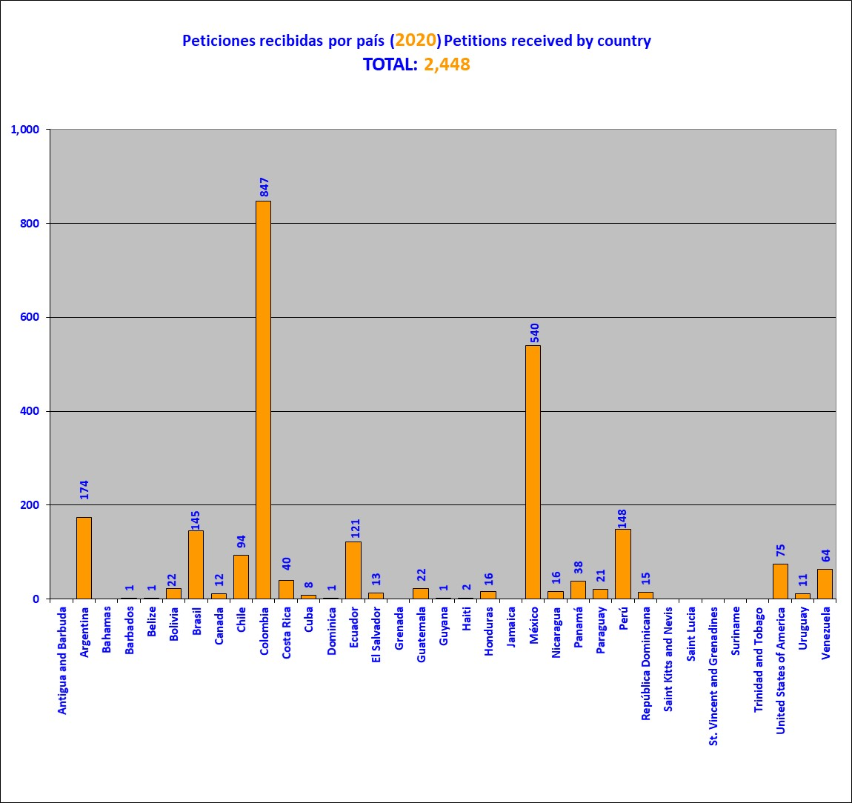

This graph is a snapshot the absolute (gross) number of petitions received at December 31, 2019. As they are examined, they may later be joined or disaggregated. To a lesser, but still possible, extent, new records may be created of petitions lodged in previous years when an involuntary omission of a record is detected, following sufficient checking to confirm it. Likewise, some petitions may be cancelled, if duplicate records are detected. For those reasons, once the examination of petitions lodged in a given year is completed, the number of petitions received may differ slightly from the number originally reported

**2. Petitions received per year**

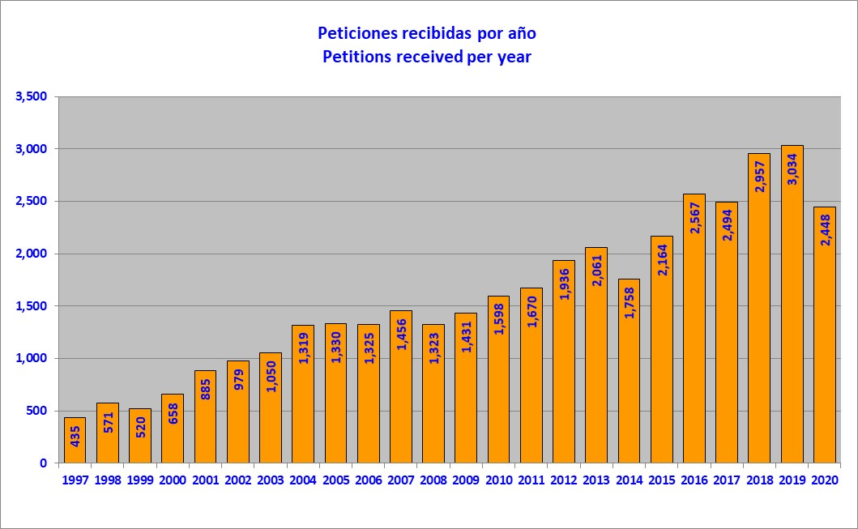

Many of the requests where the requested information is not received are "deactivated" and/or archived. These do not appear in the graphs.

**3. Petitions opened for processing and notified, by country (2020)**

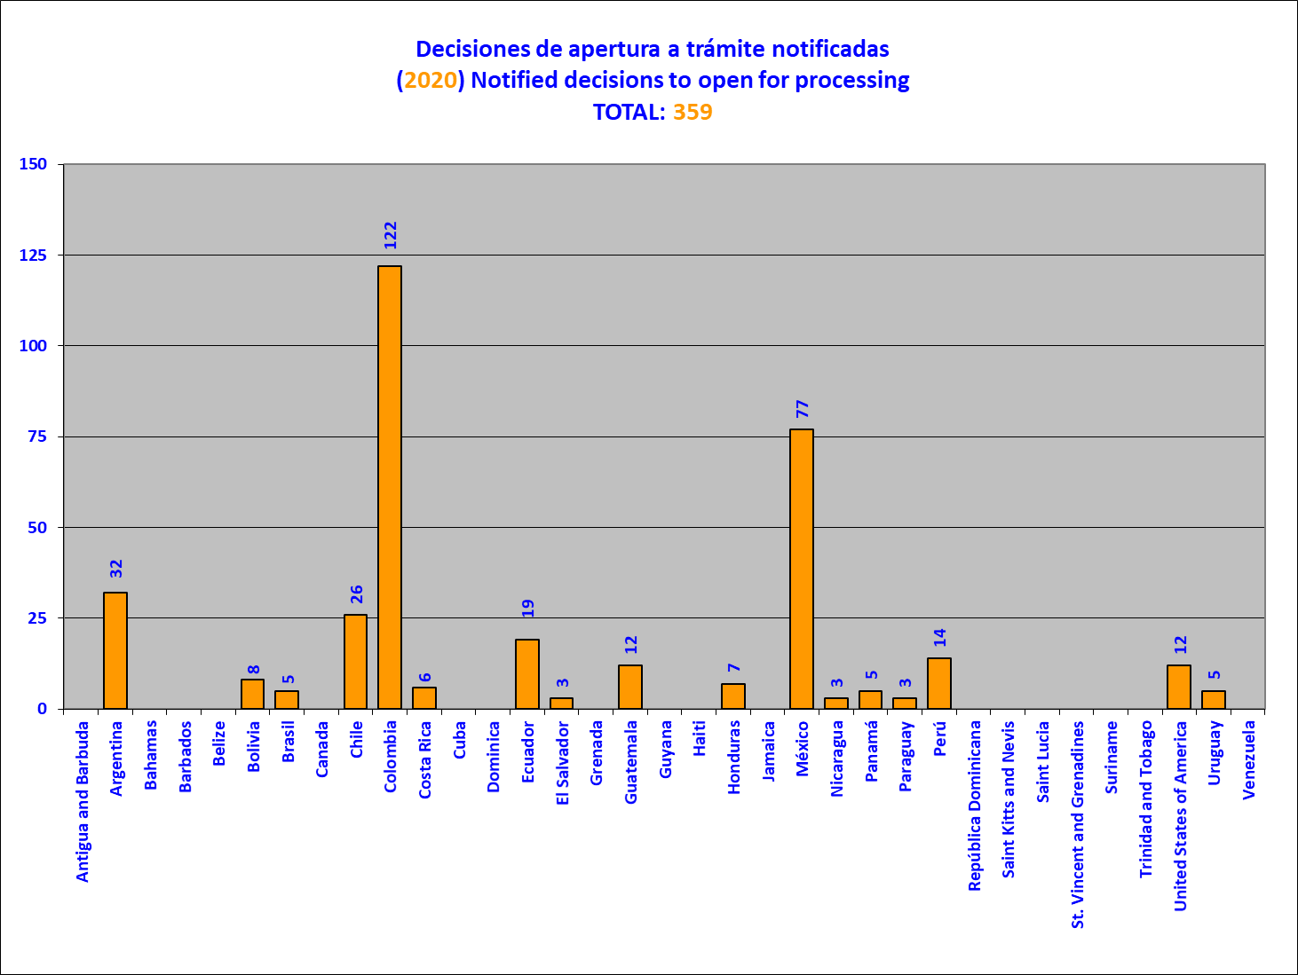

The whole set of petitions reviewed does not correspond only to those received in the year immediately prior to the year covered in the report, because it may include petitions lodged in earlier years and, to a lesser extent, in 2020. Unlike decisions not to open for processing, decisions to open, or begin opening, petitions for processing may not be notified for several years.

**4. Petitions opened for processing, by country (2020)**

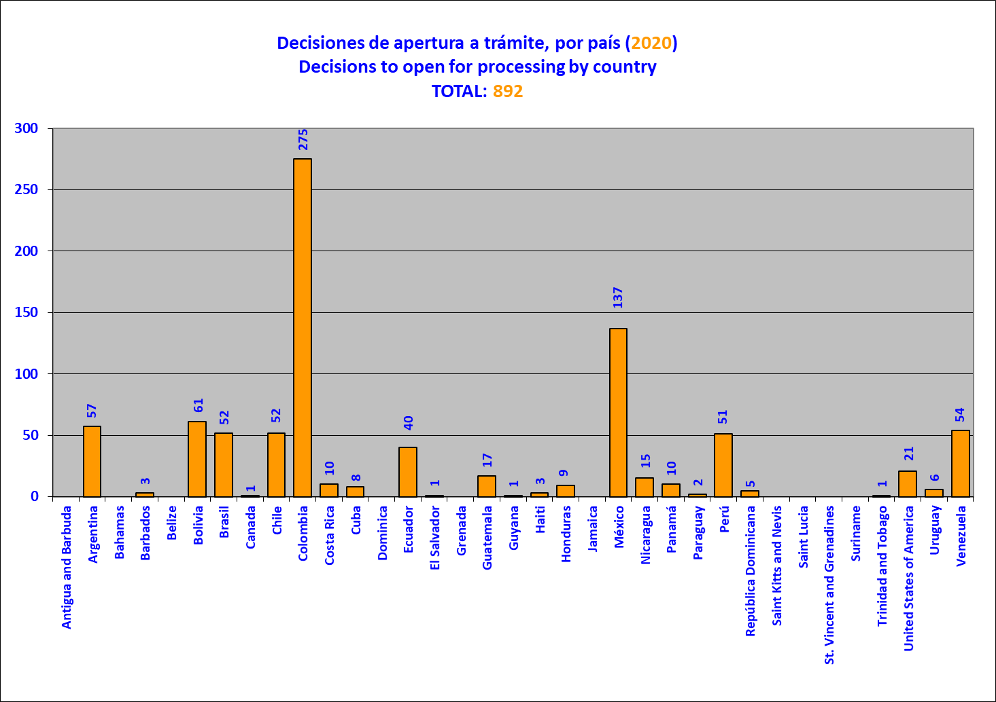

**5. Petitions not opened for processing, by country (2020)**

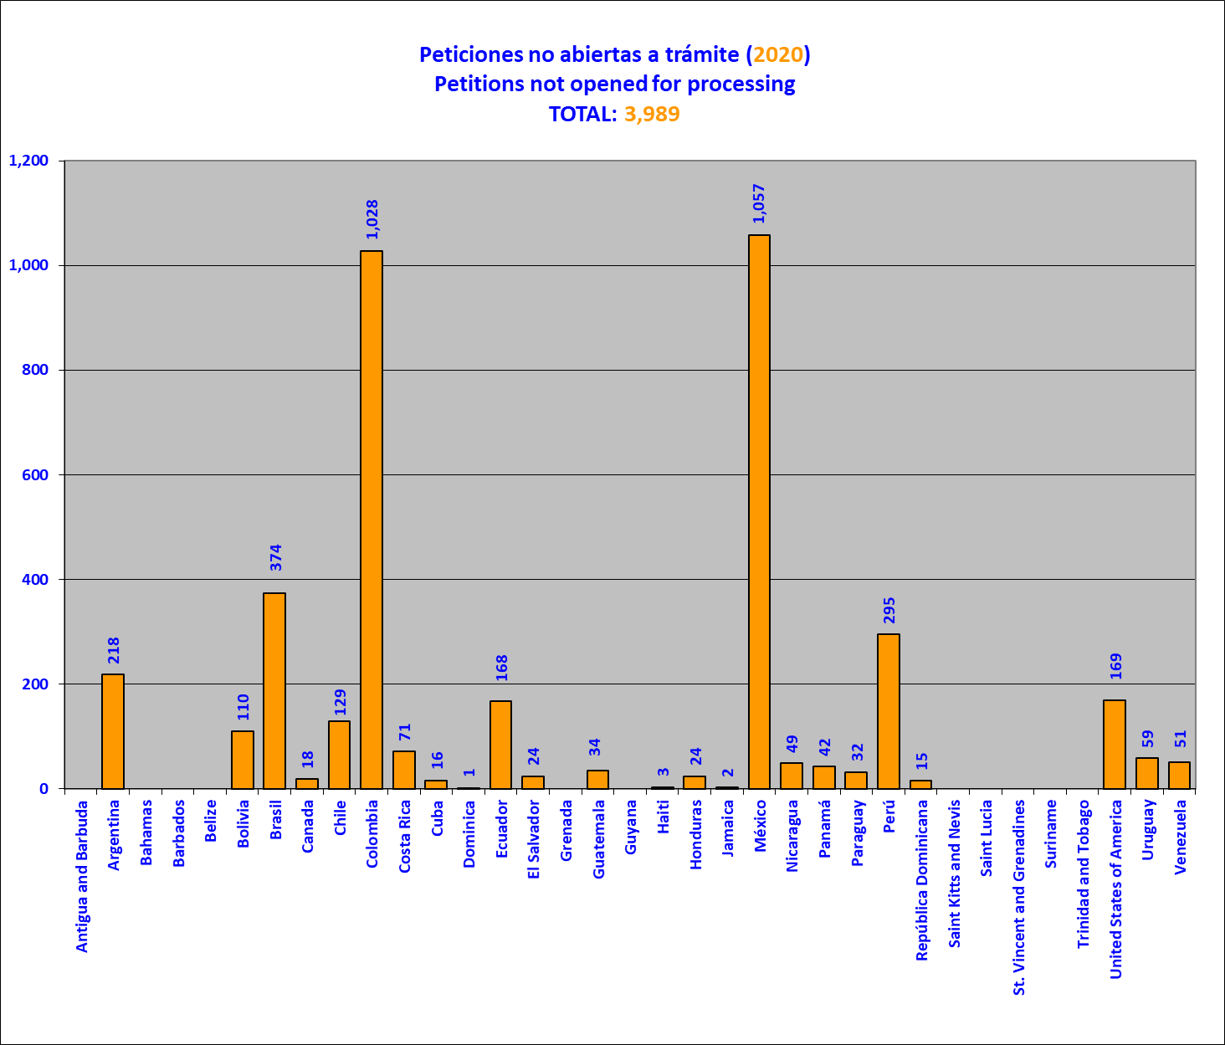

The whole set of petitions reviewed does not correspond only to those received in the year immediately prior to the year covered in the report, because it may include petitions lodged in earlier years.

**6. Decisions taken regarding petitions in the initial review stage (2020)**

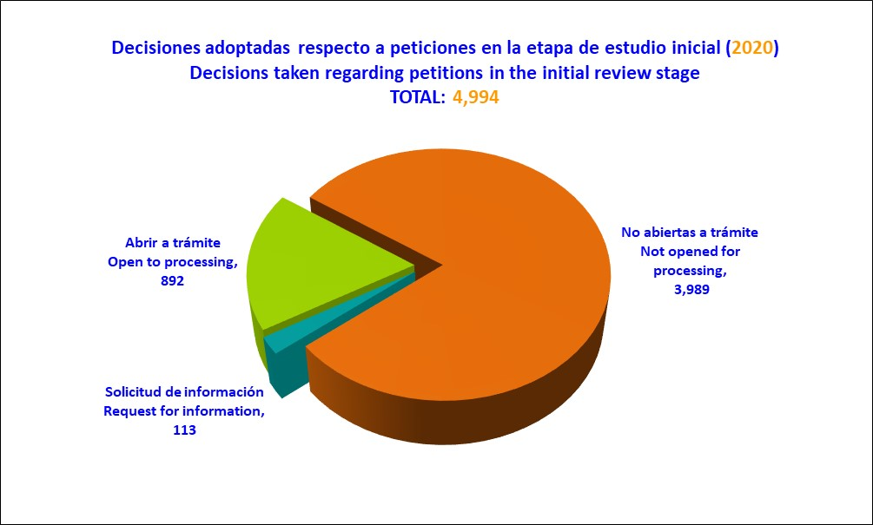

**7. Petitions in admissibility at end of year (2020), by country**

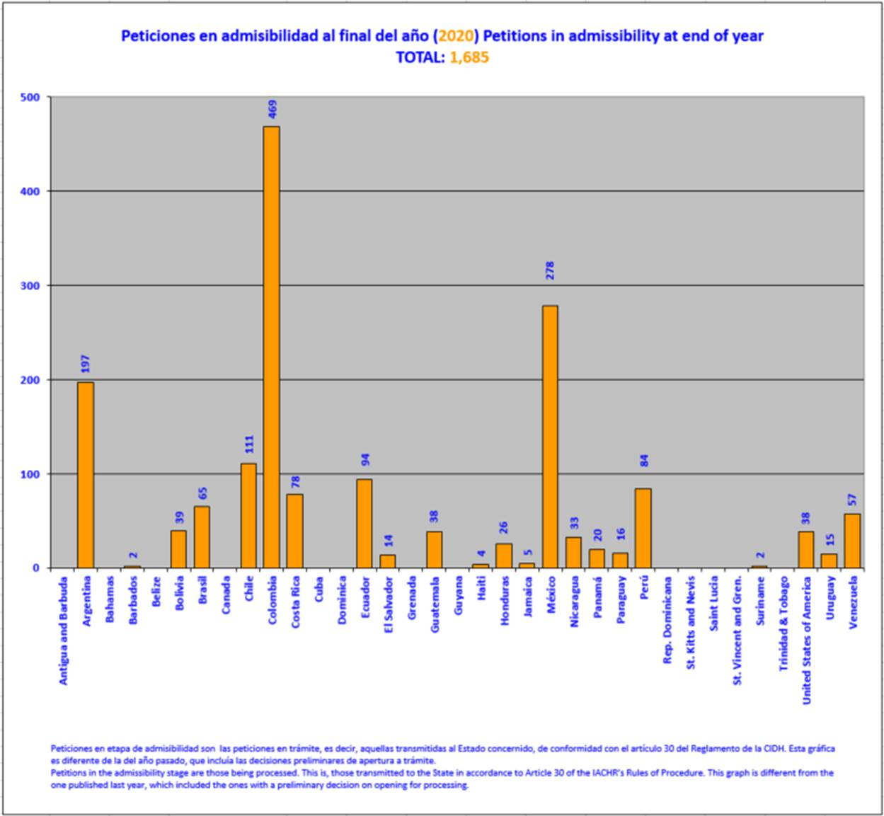

This graph is a snapshot of the current state of the portfolio referred to on December 31, 2020. For the purposes of this report, the expression “petitions in the admissibility stage” refers both to pending petitions --that is, those transmitted to the State concerned in accordance with Artile 30 of the IACHR Rules of Procedure-- and petitions where a decision to open for processing has been made but notification to the parties is pending. Admissibility is the stage in which the IACHR determines whether a petition satisfies the requirements established in Articles 46 and 47 of the American Convention and / or 34 of the IACHR Rules of Procedure, according to the procedure established in Article 48 of the American Convention and / or Articles 30 and 36 of the IACHR Rules of Procedure.

**8. Petitions at the merits stage at end-2020, by country**

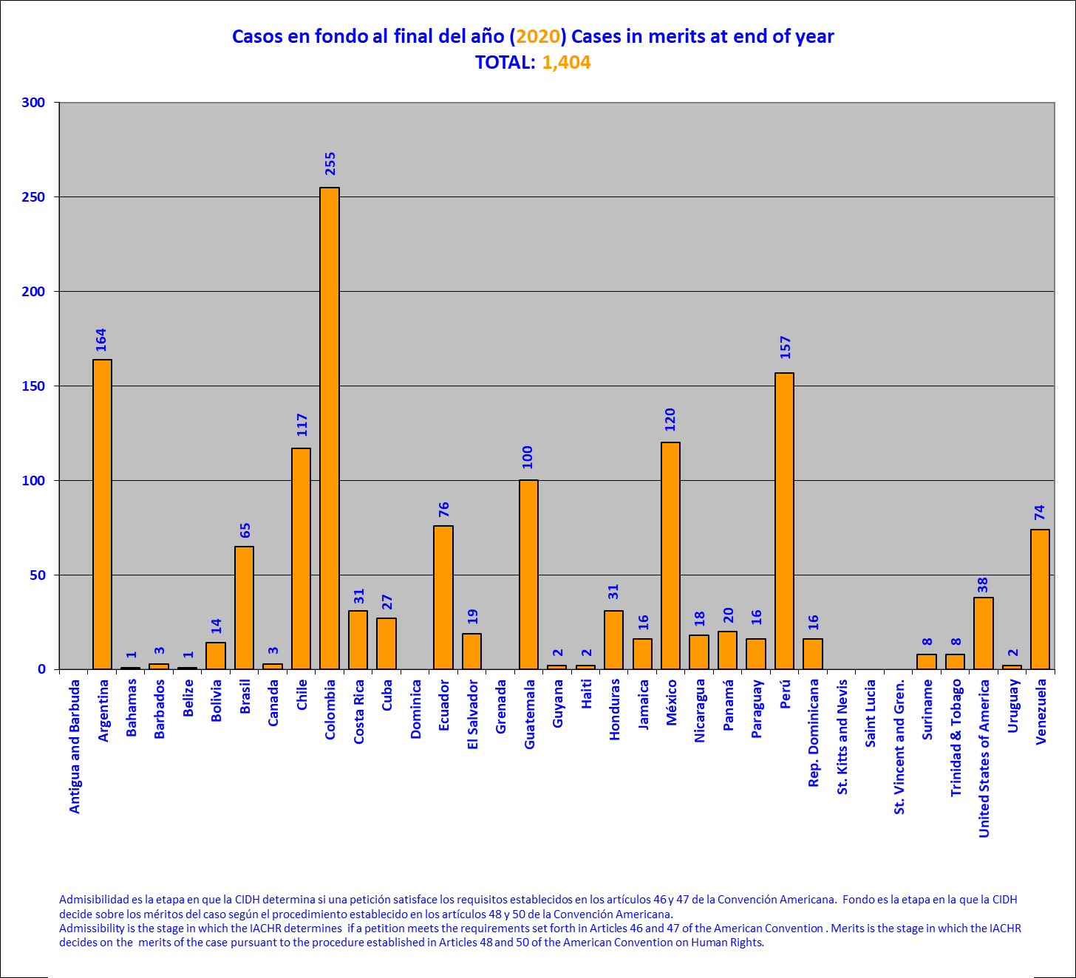

This graph is a snapshot of the state of the above-mentioned portfolio at December 31, 2019. The merits stage is that at which the IACHR decides on the merits of the case pursuant to the procedure established in Articles 48 and 50 of the American Convention and/or Articles 37 to 39, 43, and 44 of the IACHR Rules of Procedure.

**9. Petitions and cases in admissibility and merits (2020)**

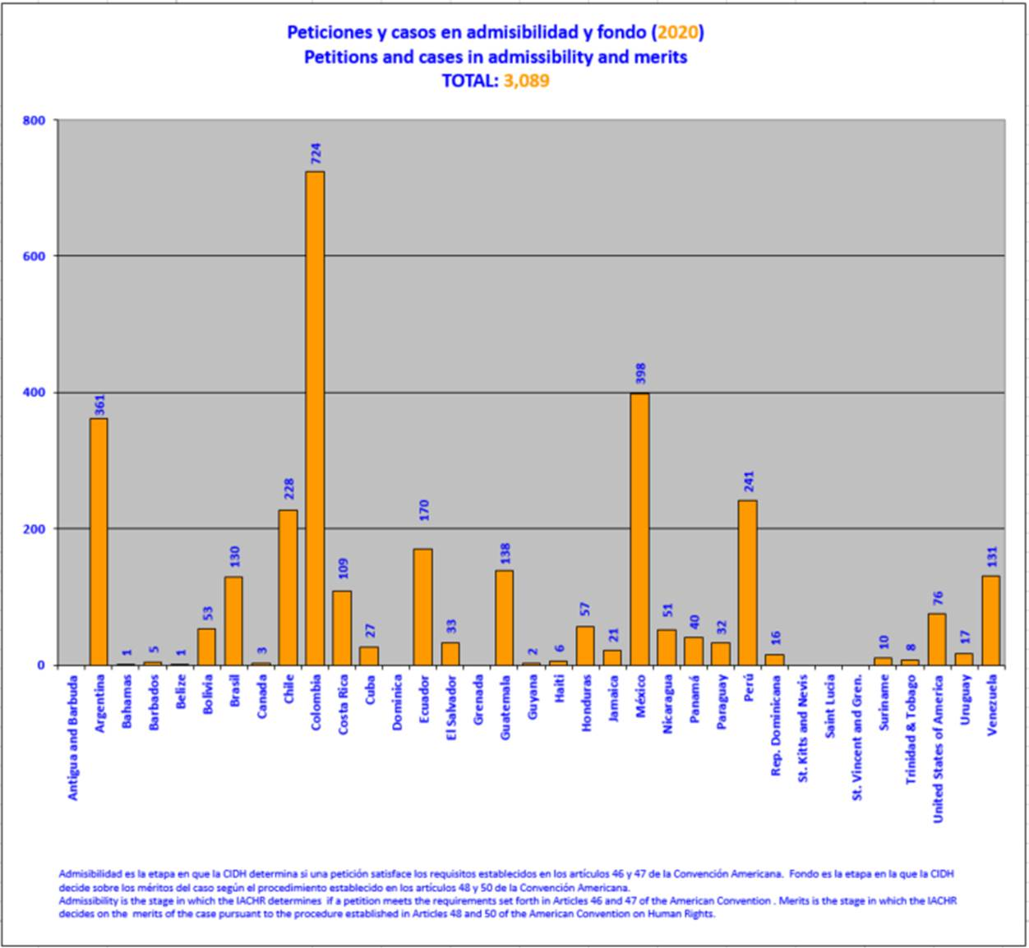

**10. Petitions and cases in friendly settlement procedure a the end of the year**

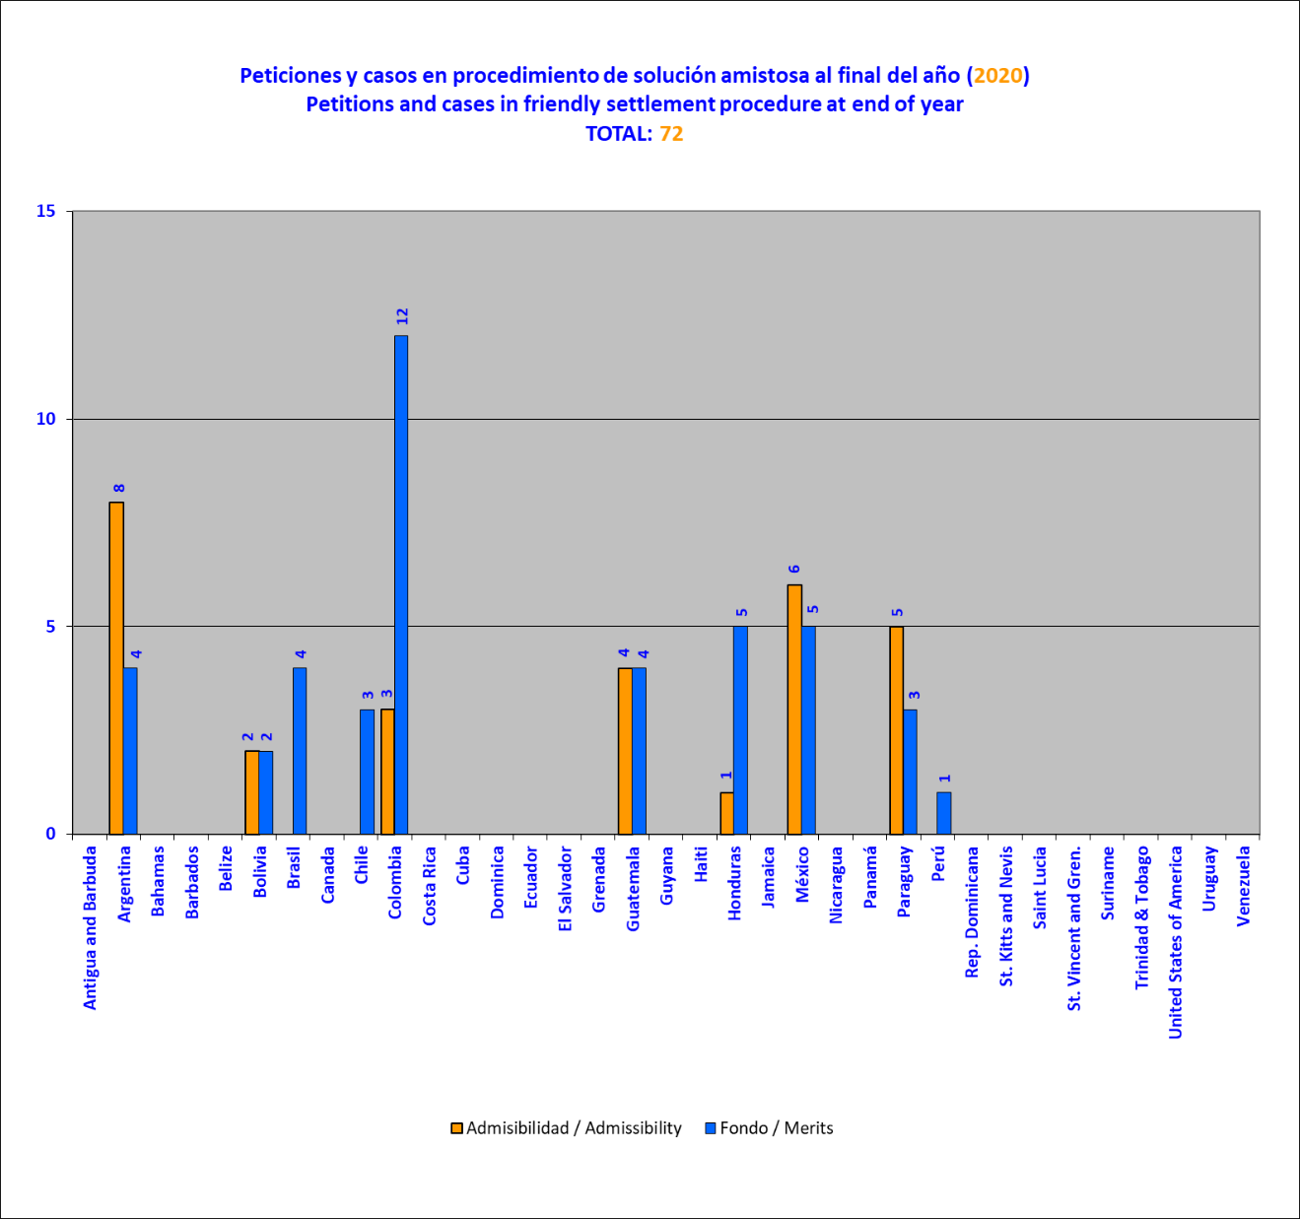

**11. Case docket (admissibility and merits) at the end of each year**

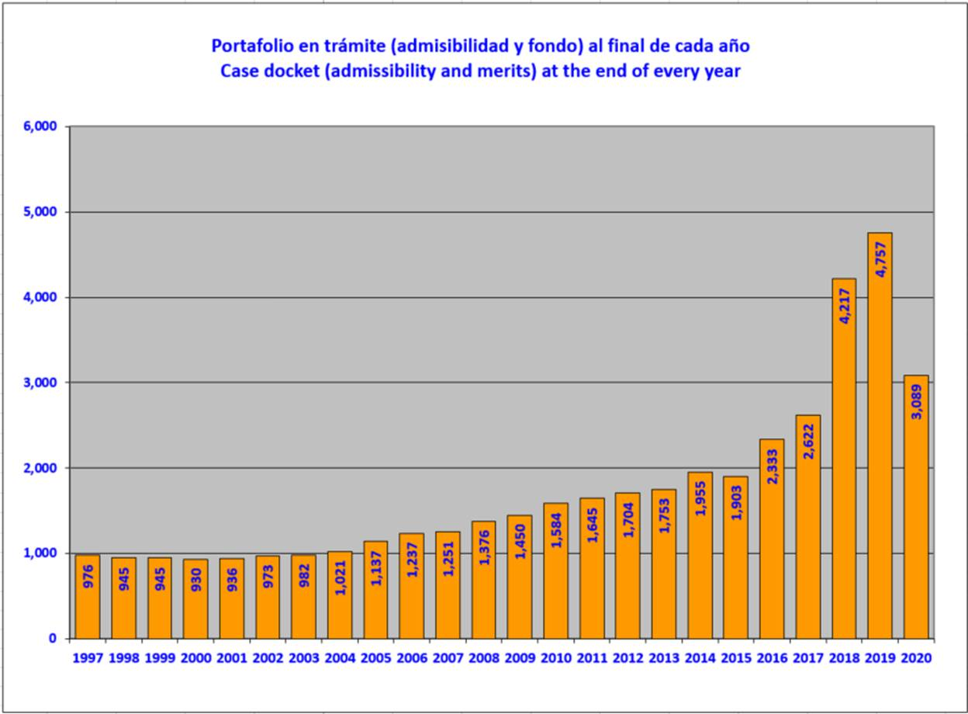

**12. Cases archived (closed), per year**

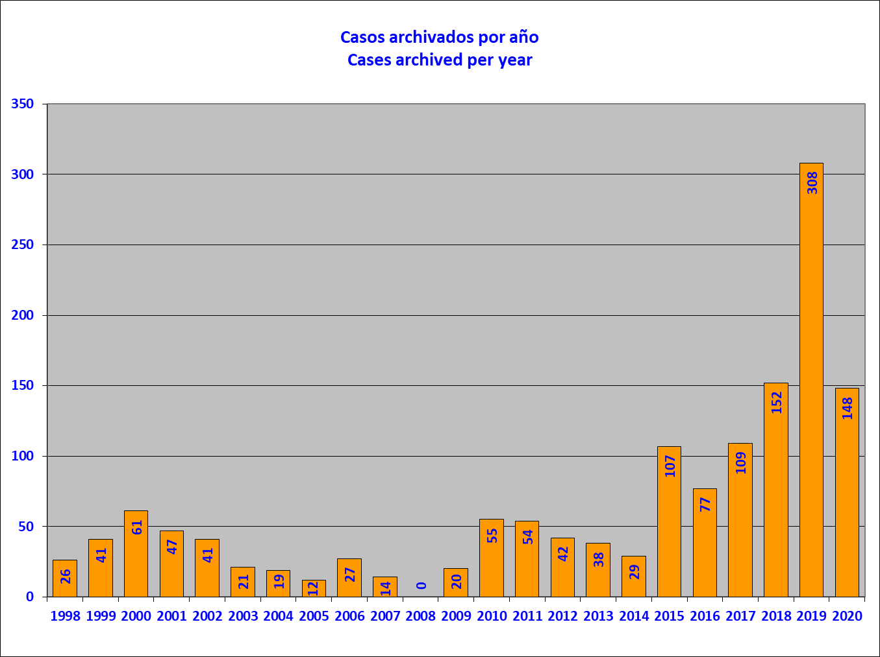

**13. Cases archived (closed) (2020), per country**

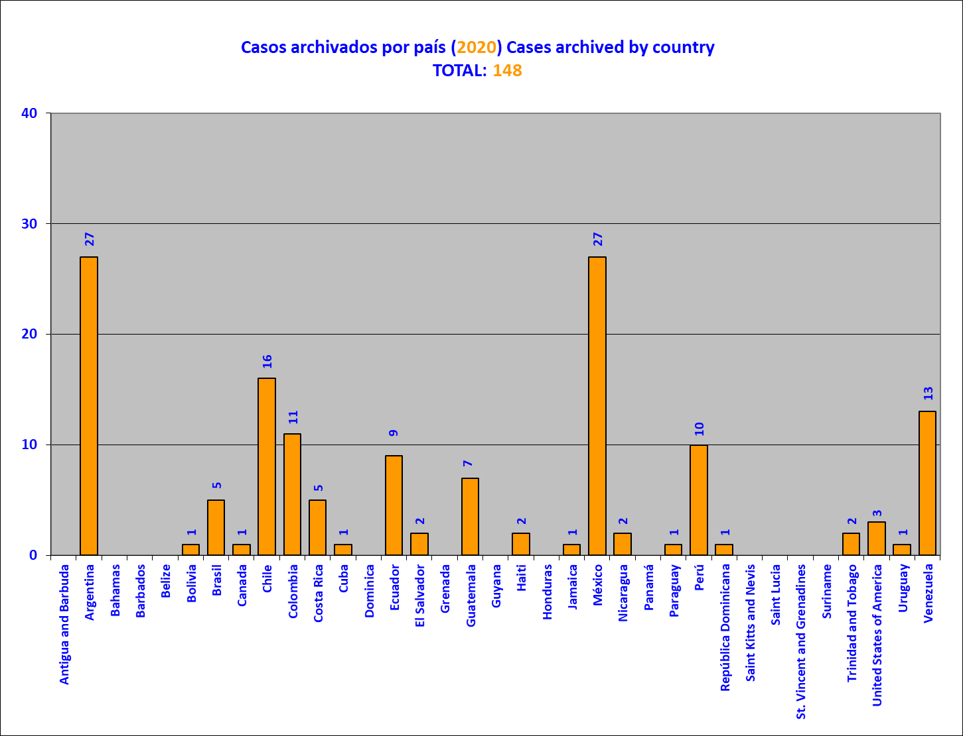

This graph shows the petitions and cases archived in 2020, pursuant to Article 48.b of the American Convention on Human Rights and/or Article 42 of the Rules of Procedure of the IACHR.. Before the Commission takes a decision to archive a petition, the Executive Secretariat warns the petitioner of the possibility of the petition being archived for lack of procedural activity, using to that end the most recent contact information provided. At the same time, statements by petitioners that they wish to desist from their petition are identified, as provided for in Article 41 of the IACHR Rules of Procedure.

**14. Reports on admissibility adopted per year**

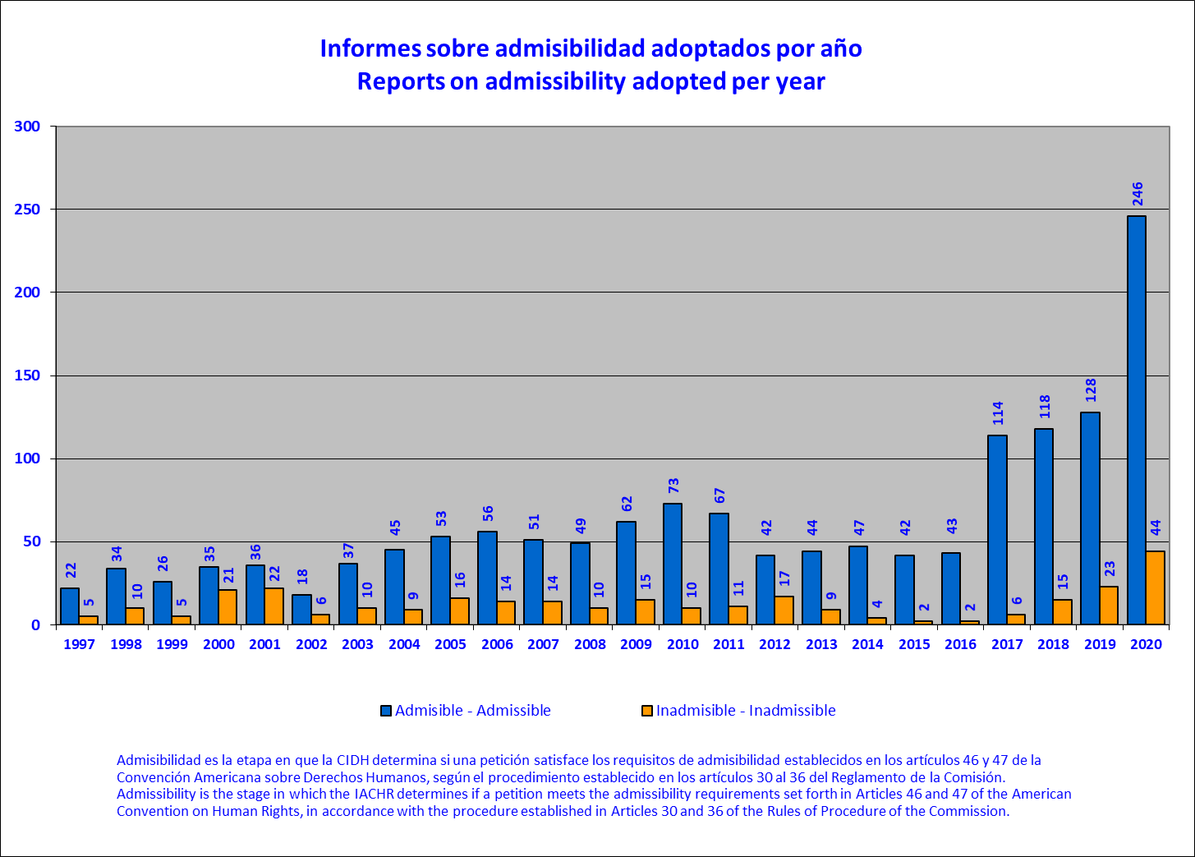

**15. Admissibility reports adopted, by country (2020)**

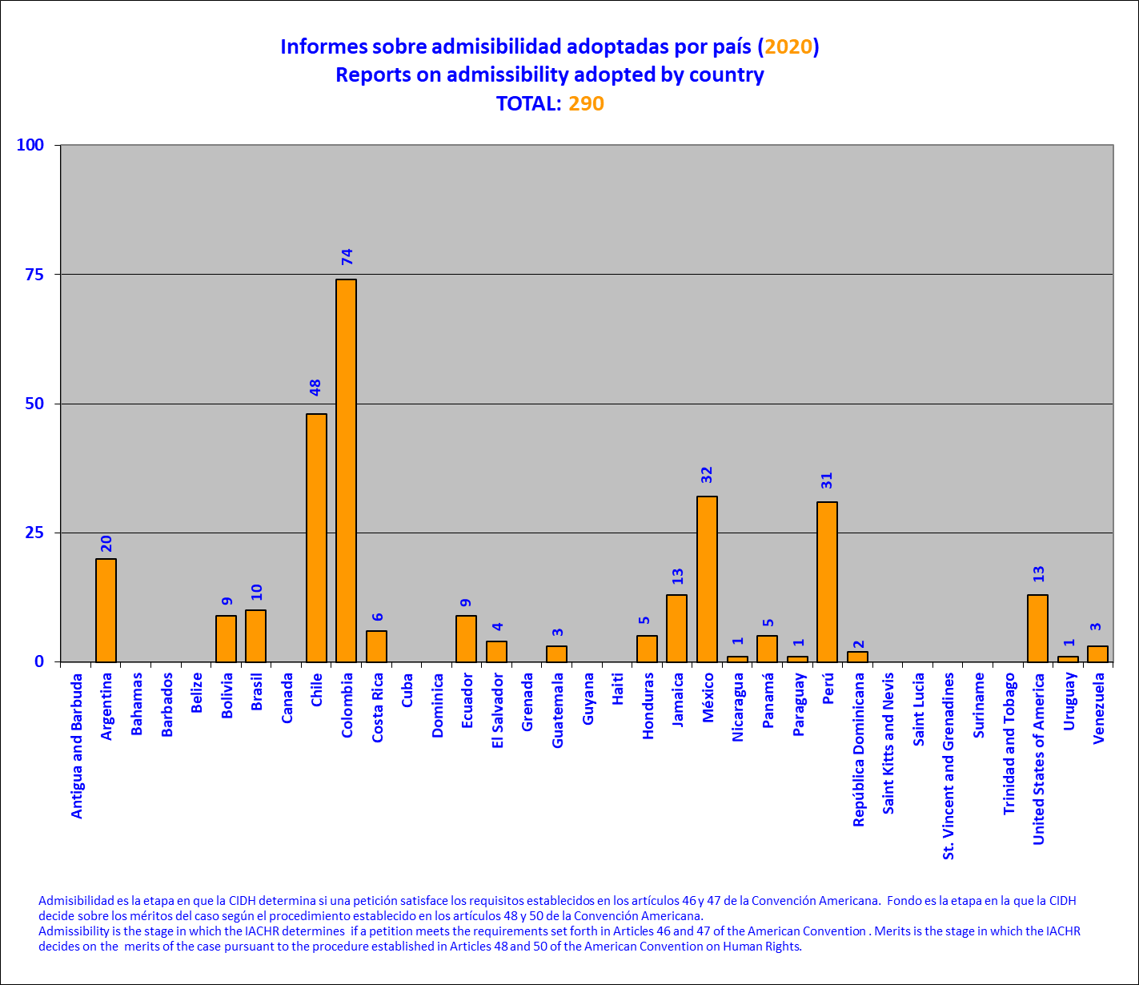

**16. Reports on friendly settlement published per year**

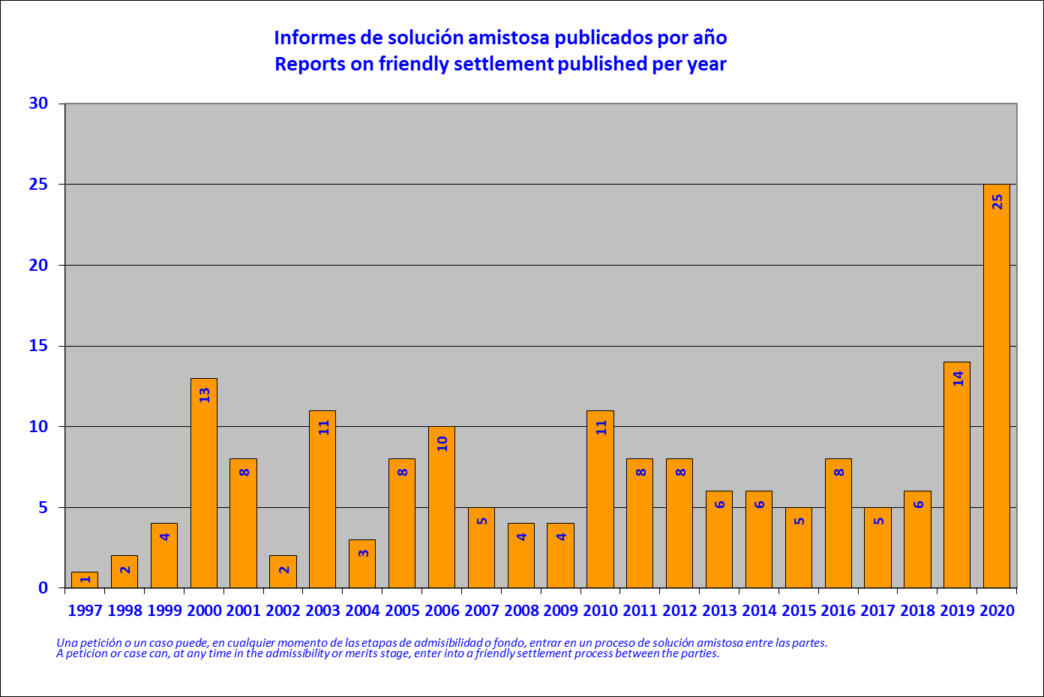

**17. Reports on friendly settlement published by country (2020)**

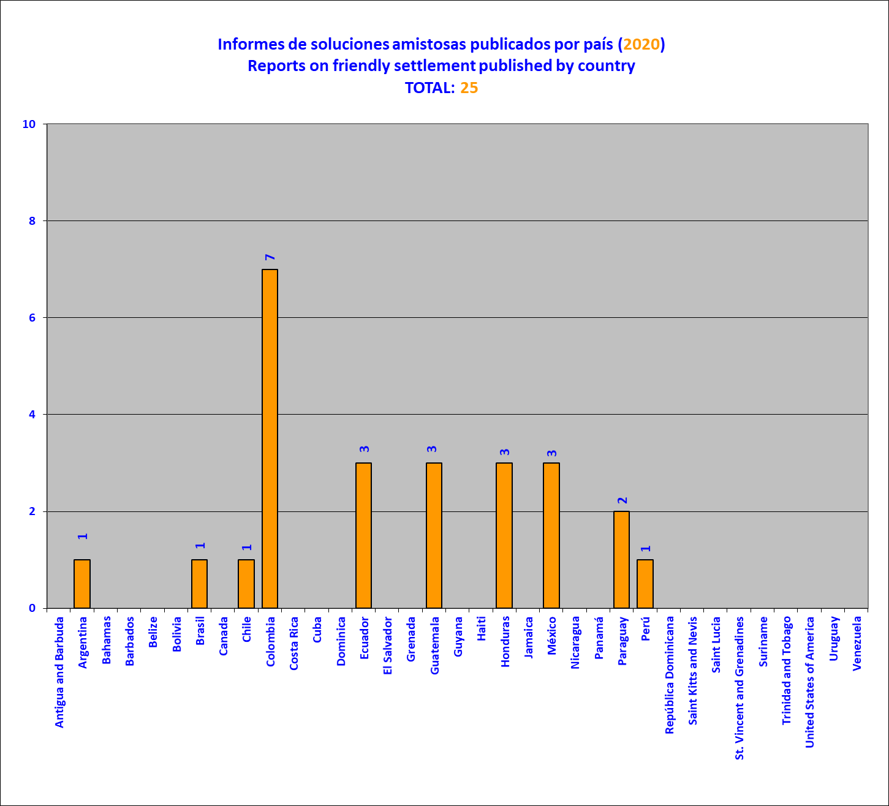

**18. Friendly settlement agreements signed by country (2020)**

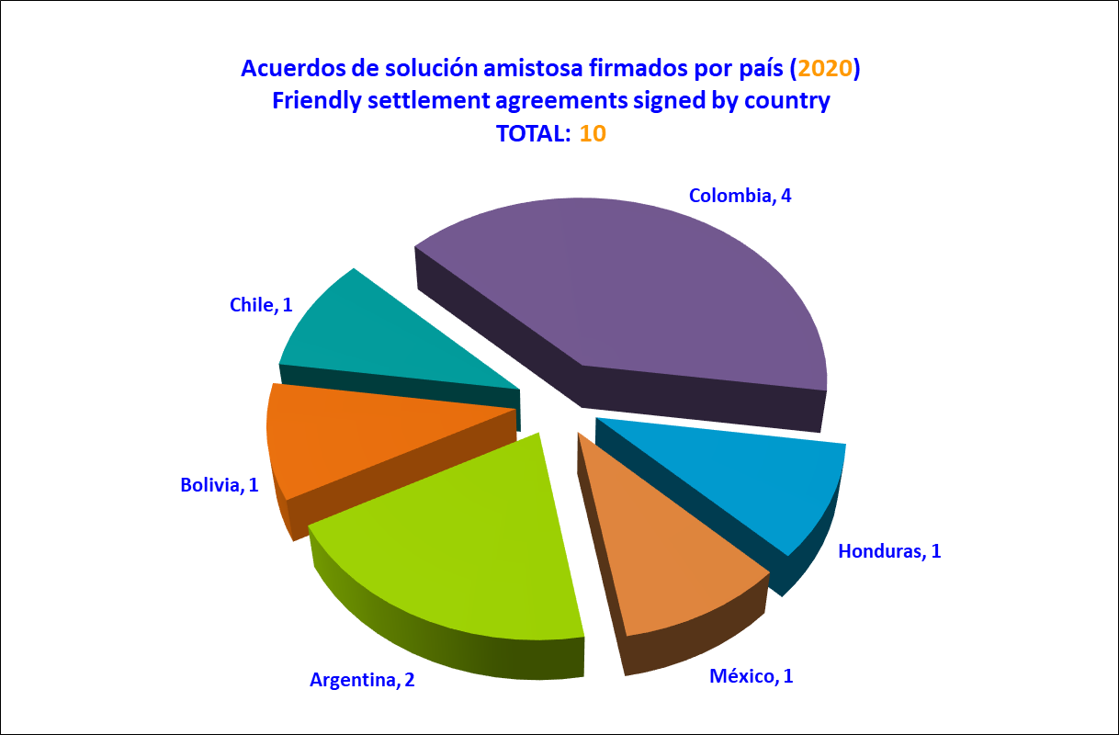

**19. Reports on merits approved per year**

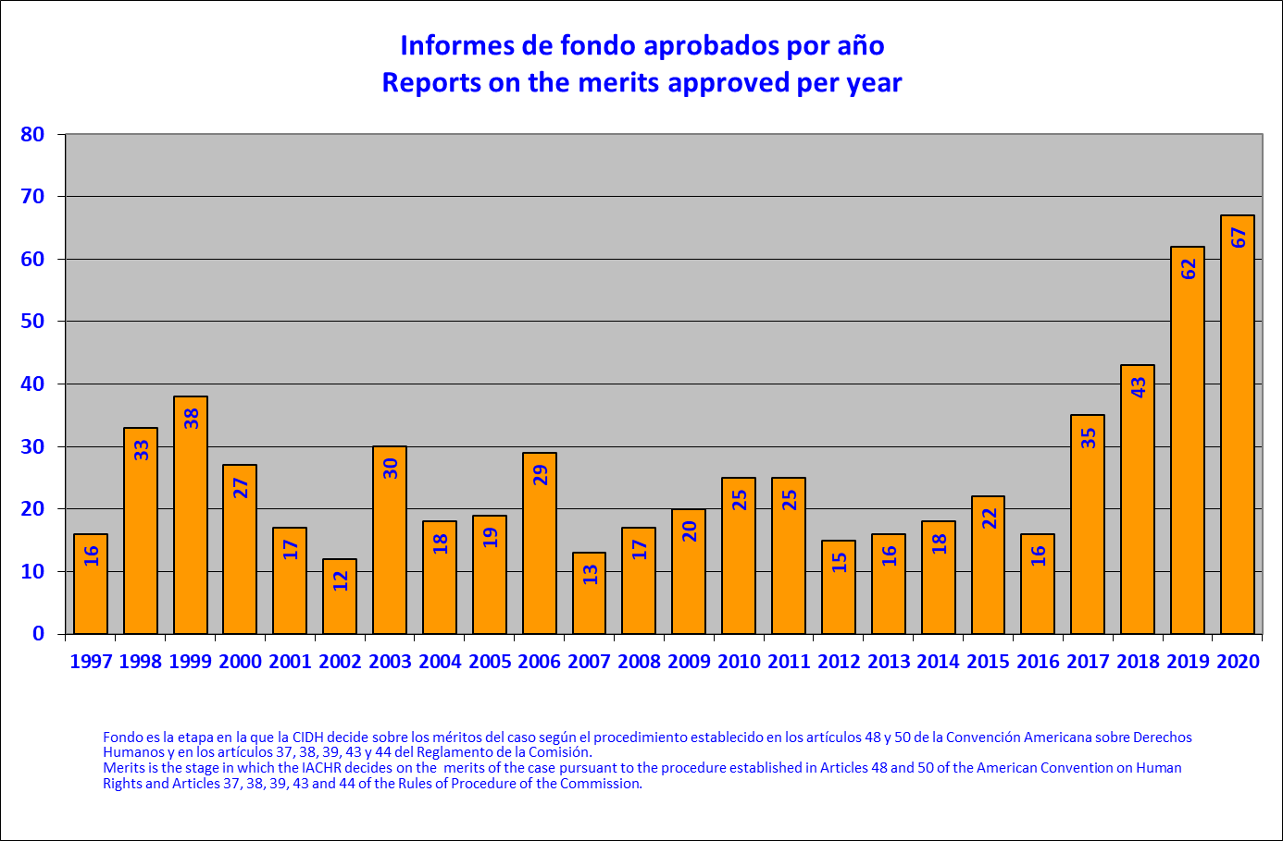

**20. Reports on merits adopted by country (2020)**

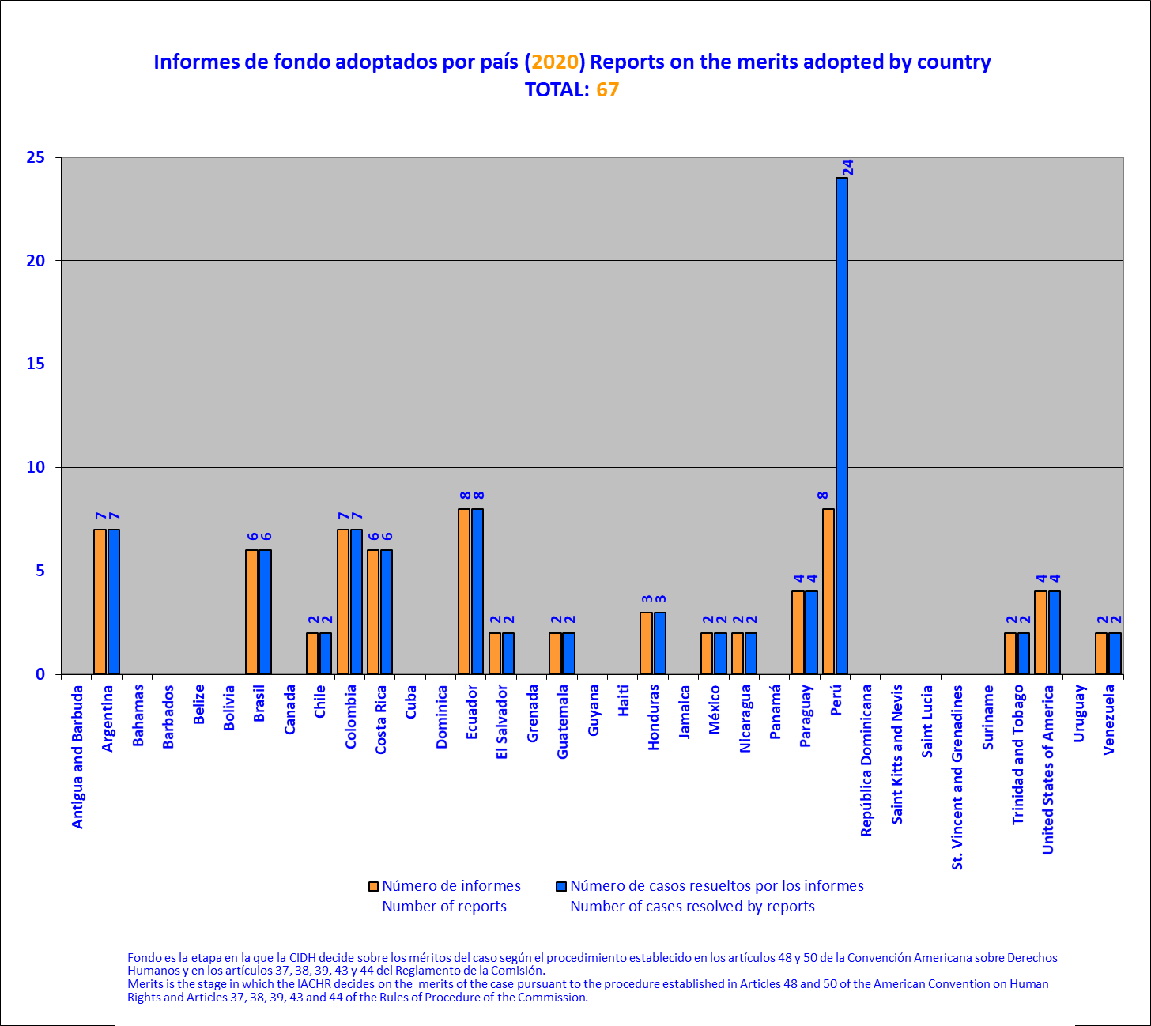

**21. Reports on the merits published by country (2020)**

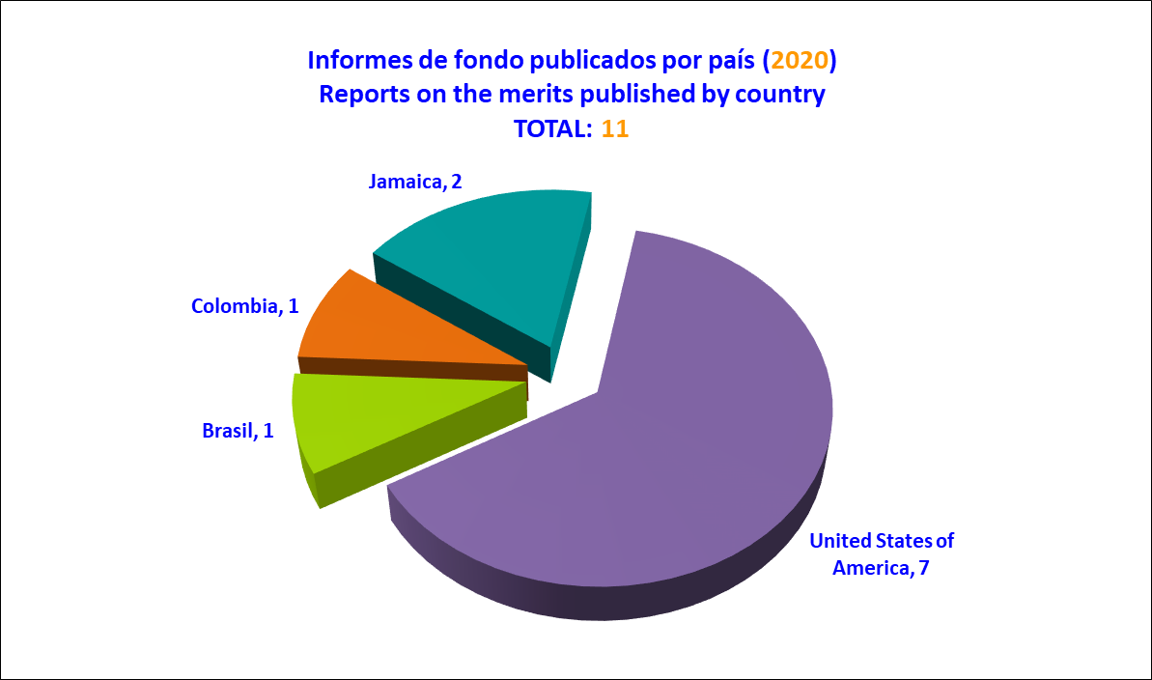

**22. Hearings before the Inter-American Court of Human Rights by country (2020)**

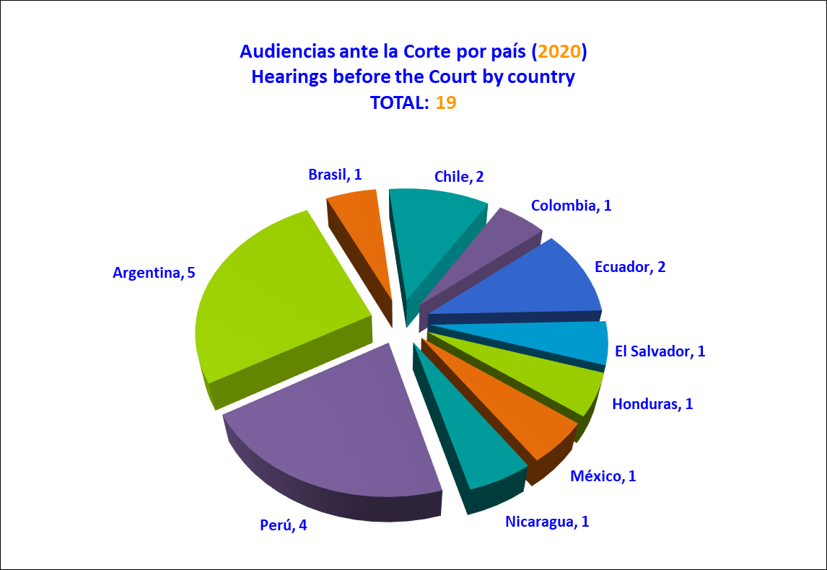

**23. Cases submitted to the Inter-American Court of Human Rights per year**

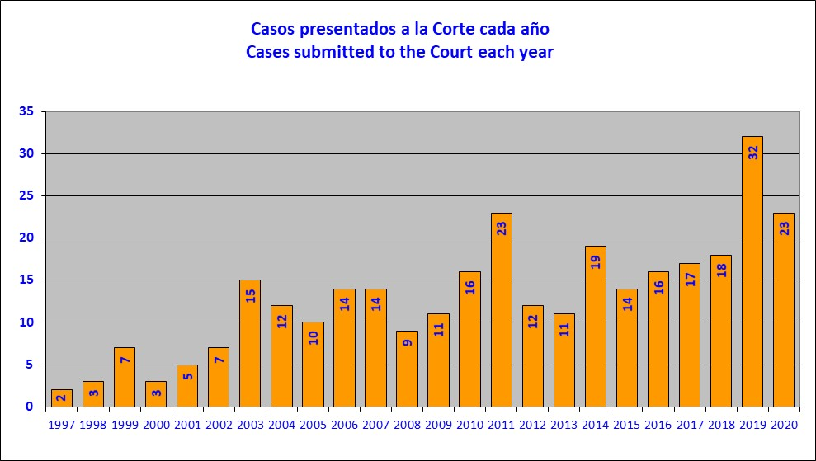

**24. Cases submitted to the Inter-American Court of Human Rights by country (2020)**

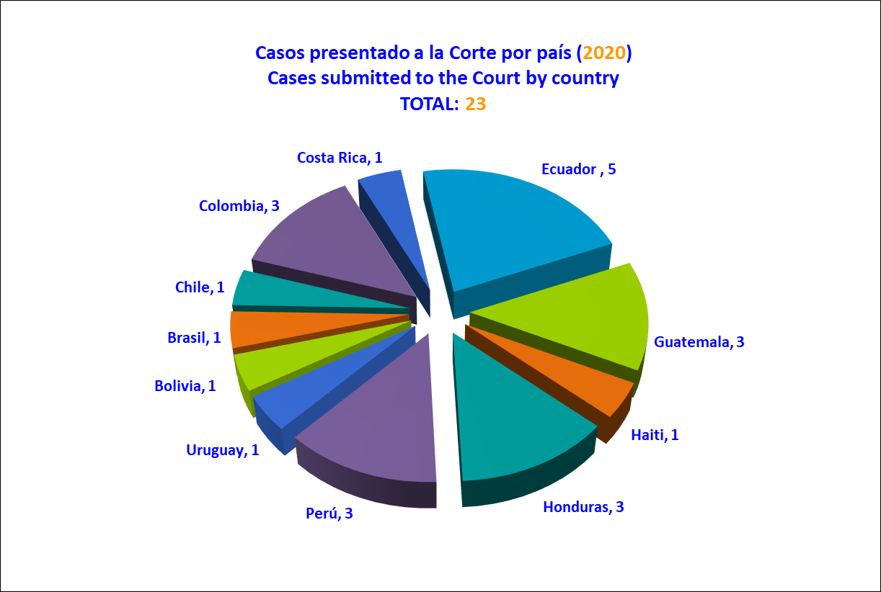

**25. Requests for precautionary measures received per year**

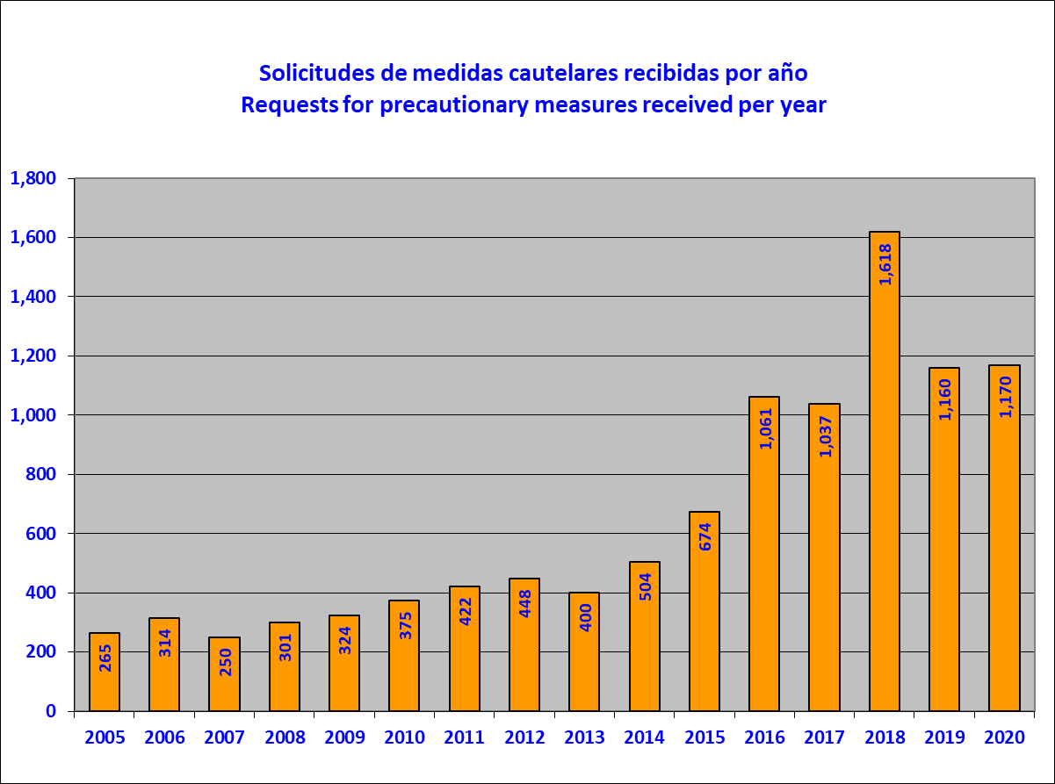

**26. Requests for precautionary measures received by country (2020)**

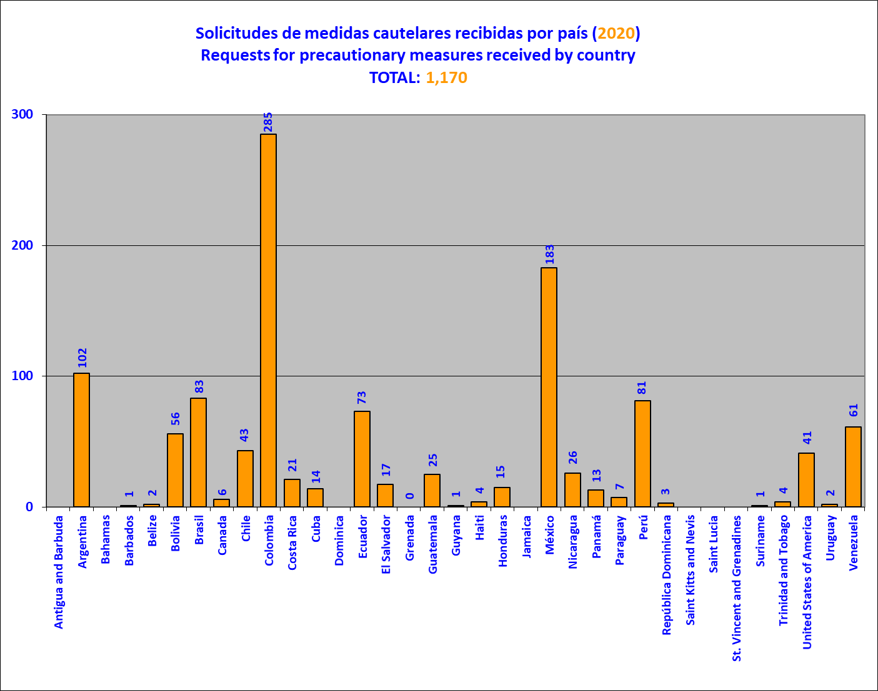

**27. Precautionary measures granted or extended per year**

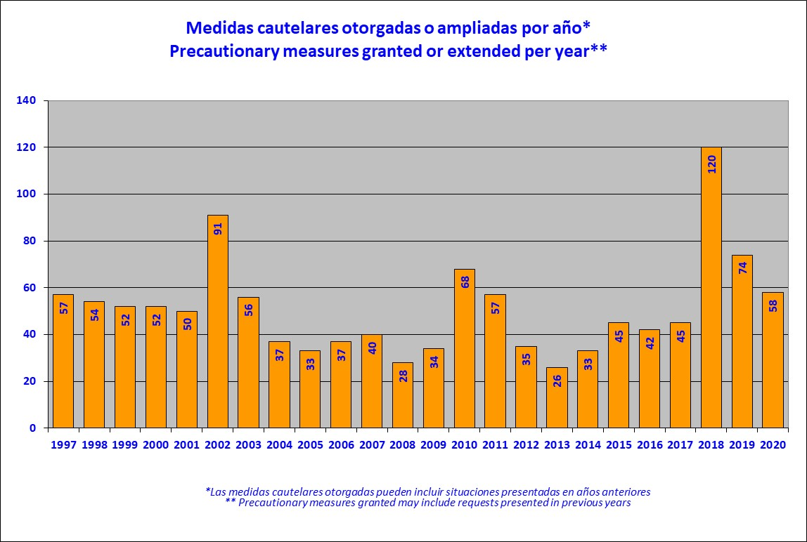

**28. Precautionary measures granted or extended by country (2020)**

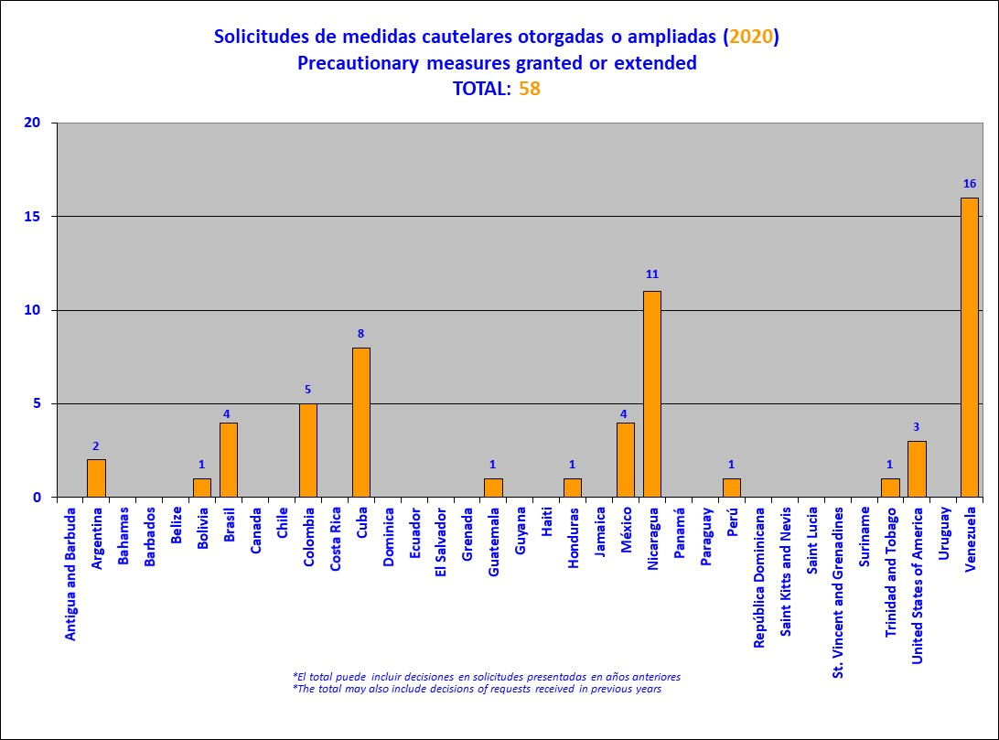

**29. Granting or extension time**

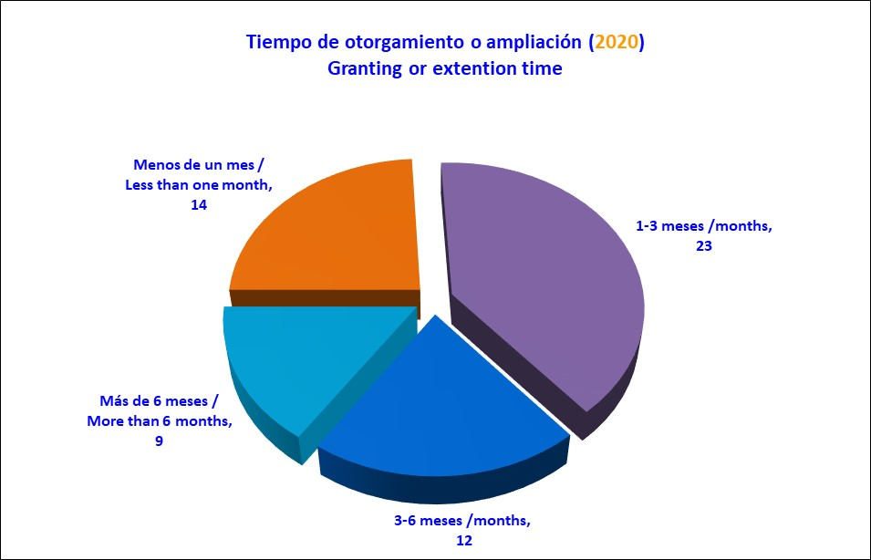

**30. Precautionary measures lifted by country (2020)**

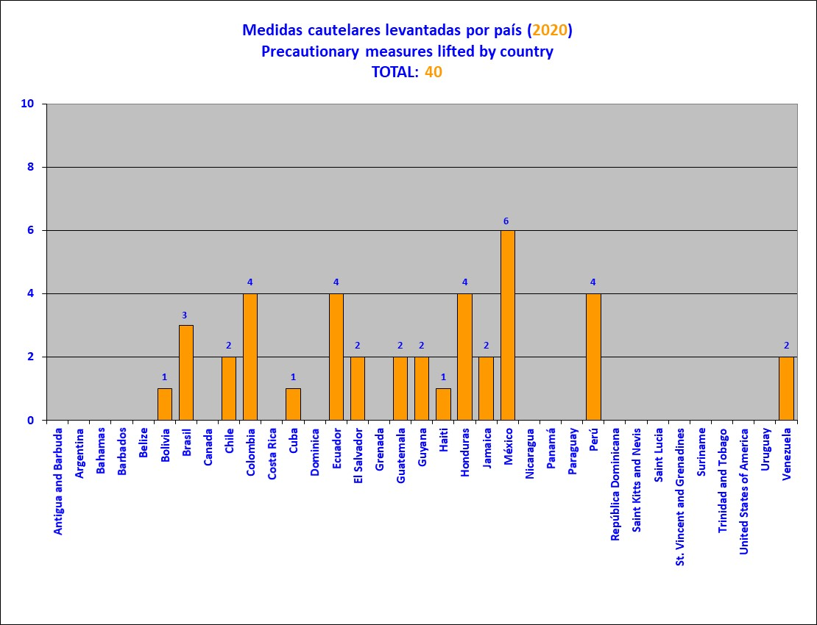

**31. Requests for precautionary measures received on COVID-19 by country (2020)**

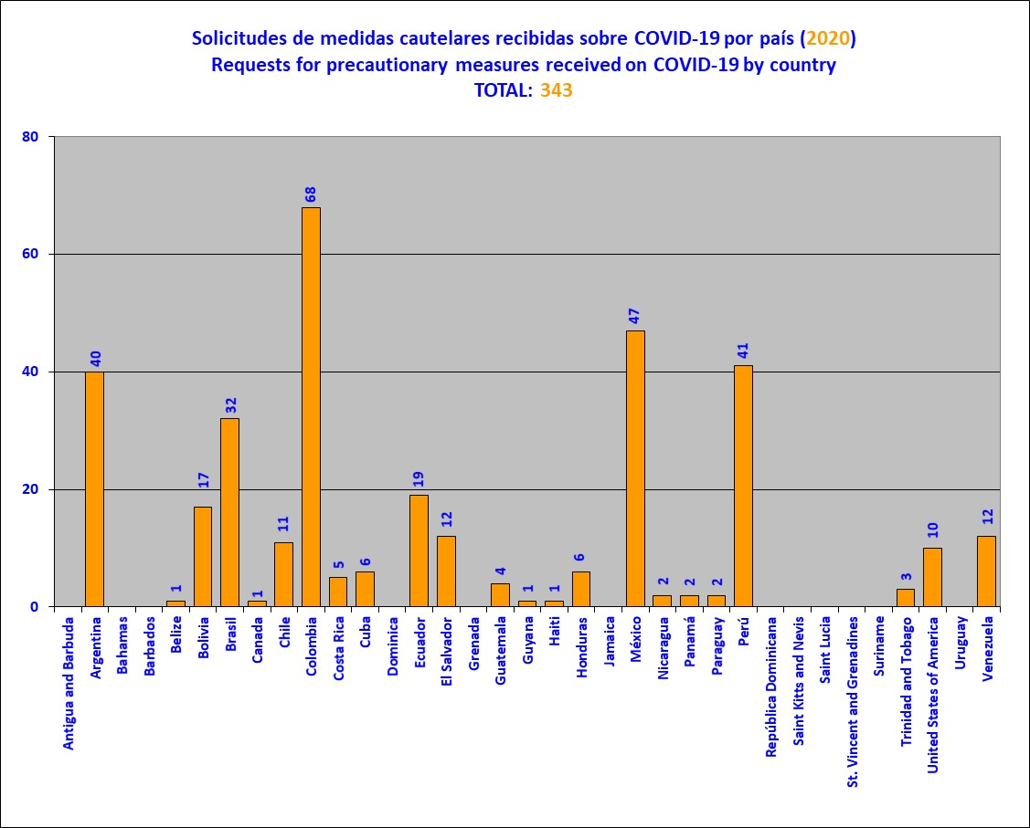

**32. Thematic reports approved per year**

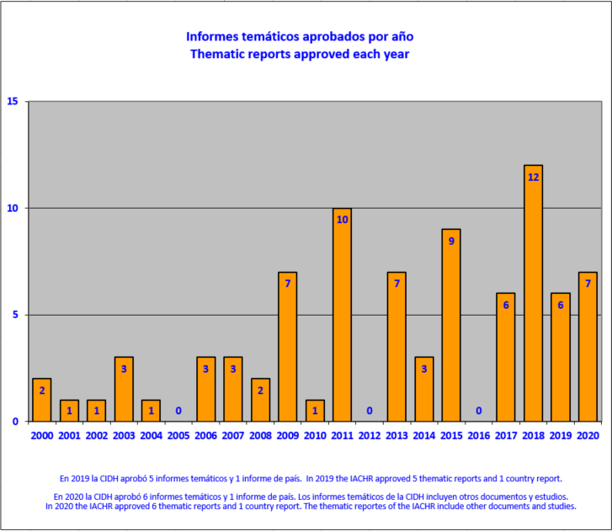

**33. Application of Resolution 1/16, by year**

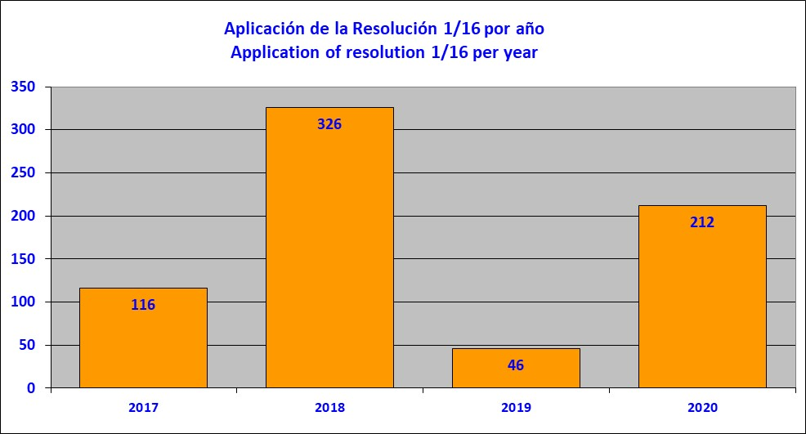

This chart shows the number of petitions at the admissibility stage in which both parties were notified of the application of Article 36.3 of the Rules of Procedure, as envisaged in Resolution 1/16 (adopted on October 18, 2016), by country, during 2020. Application of Resolution 1/16 to a petition at the admissibility stage occurs when one of the exceptional circumstances envisaged in the Resolution is identified and, as a result, treatment of admissibility is deferred until the debate and decision on the merits.

**34. Application of Resolution 1/16, by country (2020)**

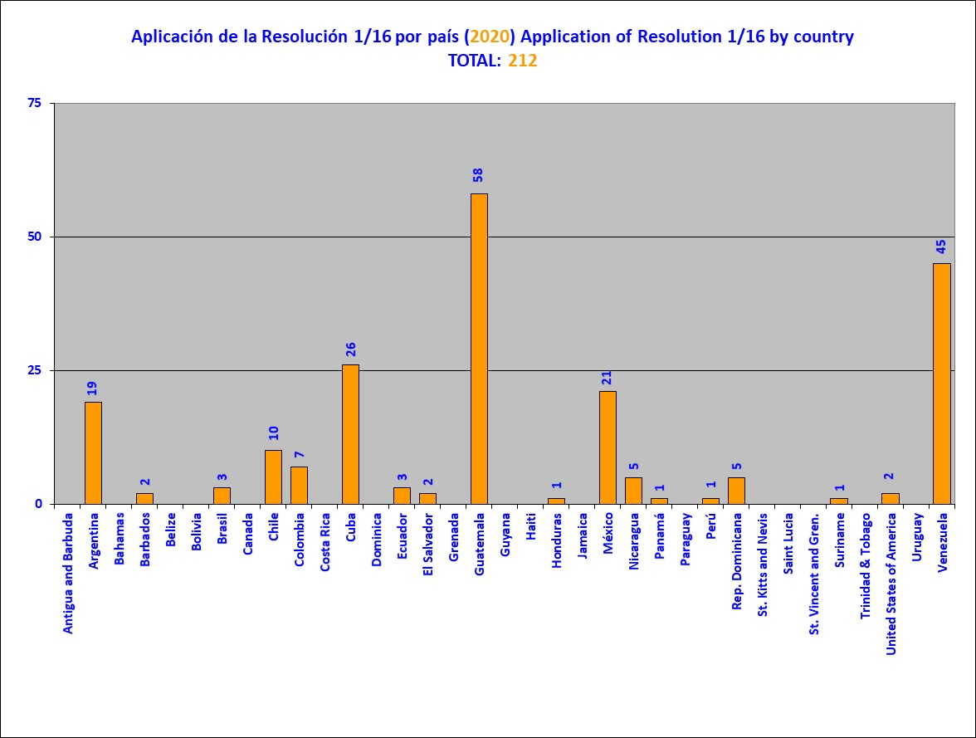

**35. Application of Resolution 1/16, by category**

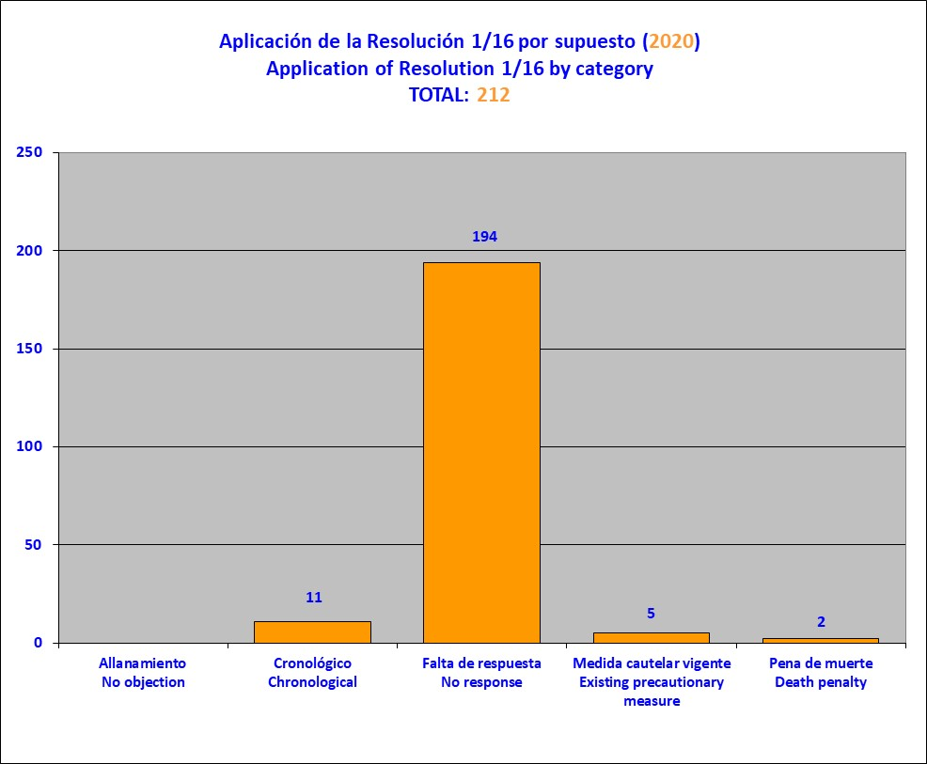

This chart shows the number of petitions at the admissibility stage in which both parties were notified of the application of Article 36.3 of the Rules of Procedure, as envisaged in Resolution 1/16 (adopted on October 18, 2016), by circumstance, during 2020. Application of Resolution 1/16 to a petition at the admissibility stage occurs when one of the exceptional circumstances envisaged in the Resolution is identified and, as a result, treatment of admissibility is deferred until the debate and decision on the merits.

1. In keeping with Article 17(2)(a) of the Commission’s Rules of Procedure, Commissioner Esmeralda Arosemena de Troitiño, a Panamanian national, did not participate in the conclusions of the reports or precautionary measures referring to that country; nor did Commissioners Joel Hernández García in the matters on Mexico; Antonia Urrejola Noguera in the matters on Chile; Margarette May Macaulay, in the matters on Jamaica; Julissa Mantilla Falcón, in the matters on Peru; Stuardo Ralón Orellana in the matters on Gutemala; or Flávia Piovesan in the matters on Brazil.
2. The examples are merely descriptive; they do not imply any prioritization by the IACHR nor do they have any procedural effect.
3. Case 12,854 Ricardo Javier Kaplun, Argentina; Case 11,182 Florentino Rojas, Argentina; Case 13,017 Relatives of Victims of the Military Dictatorship, Panama; P-1186-09 Adela Villamil, Bolivia.
4. On this, see IACHR, Report No. 334/20, Case 12.972. Friendly Settlement. Marcelo Ramón Aguilera Aguilar. Honduras. November 19, 2020.
5. IACHR Report No. 71/19. Case 12.942. Friendly Settlement. Emilia Morales Campos. Costa Rica. May 15, 2019.
6. As noted in the Commission's analysis above, in 2019, eleven petitions and cases achieved full compliance and 10 cases achieved partial compliance. See IACHR, Annual Report 2019, Chapter II, Section G. Friendly Settlements. Available at: http://www.oas.org/en/iachr/docs/annual/2019/docs/IA2019cap2-en.pdf
7. On this see, Petition 1275-04 A, Report No. 23/20, Juan Luis Rivera Matus (Chile); Case 11.141, Report No. 105/05, Villatina Massacre (Colombia); Petition 279-03, Report No. 39/15. Fredy Rolando Hernández Rodríguez et al. (Guatemala); Report No. 20/20, Case 12.961 F, Miguel Angel Chinchilla Erazo et al. (Honduras); Case 12.972, Report No. 334/20, Marcelo Ramón Aguilera Aguilar (Honduras); Case 12.986, Report No. 106/19, José Antonio Bolaños Juárez (Mexico); Case 11.824, Report 216/20, Sabino Díaz Osorio and Rodrigo Gomez Zamorano, (Mexico); Petition 1516-08, Report No. 130/18, Juan Figueroa Acosta (Peru).
8. On this, see, Case 13.011, Report No. 197/20, Graciela Ramos Rochaand fa,i;y(Argentina); Case 12.674, Report No. 111/20, Marcio Lapoente Da Silveira (Brazil); Case 13.776, Report No. 1/20, German Eduardo Giraldo and family (Colombia); Case 13.728, Report No. 21/20, Amira Guzmán Alonso (Colombia); Case 12.909, Report No. 22/20, Gerardo Bedoya Borrero (Colombia); Case 13.370, Report No. 80/20, Luis Horacio Patiño and family (Colombia); Case 13.421,Report No. 333/20, Geminiano Gil Martinez and family (Colombia); Case 12.957, Report No. 167/18, Luis Bolívar Hernández Peñaherrera (Ecuador); Case 11.626 A, Report No. 81/20, Fredy Oreste Cañola Valencia (Ecuador); Case 11.626 B, Report No. 82/20, Luis Enrique Cañola Valencia (Ecuador); Case 11.626 C, Report No. 83/20, Santo Enrique Cañola González (Ecuador); Case 12.732, Report No. 86/20, Richard Conrad Solórzano Contreras (Guatemala); Case 10.441 A, Report No. 214/20, Silvia María Azurdia Utrera et al. (Guatemala); Case 10.441 B, Report No. 215/20, Carlos Humberto Cabrera Rivera (Guatemala); Case 12.891, Report No. 212/20, Adán Guillermo López Lone et al. (Honduras); Case 12.915, Report No. 2/20, Ángel Díaz Cruz et al. (Mexico); Petition 735-07, Report No. 110/20, Ismael Mondragón Molina (Mexico); Case 13.017 C, Report No. 91/19, Family members of victims of the military dictatorship, October 1968 to December 1989 (Panama); Case 13.017 A, Report No. 102/19, Family members of victims of the military dictatorship, October 1968 to December 1989 (Panama); Caso 12.374, Report No. 85/20, Jorge Enrique Patiño Palacios (Paraguay); Petition 747-05, Report No. 256/20, Y´akâ Marangatú Indigenous Community of the Mbya People (Paraguay); Case 12.095, Report No. 3/20, Mariela Barreto (Peru).
9. See IACHR, Annual Report 2019, Chapter II, Section G. Friendly Settlements. Available at: http://www.oas.org/en/iachr/docs/annual/2019/docs/IA2019cap2-en.pdf
10. In 2019, the Commission observed that Colombia managed to make headway with the execution of 23 clauses, 11 of which posted full compliance; 5 achieved partial substantial compliance with the measure; and 7 achieved partial compliance. In addition, the Commission also observed major progress with compliance by the Chilean State, which made headway with 13 reparation measures, for 9 of which full compliance was achieved, In 3, partial substantial compliance was achieved and in 1 compliance was partial. See IACHR, Annual Report 2019, Chapter II, Section G. Friendly Settlements. Available at: http://www.oas.org/en/iachr/docs/annual/2019/docs/IA2019cap2-en.pdf
11. The Commission observed that. in 2019. Argentina complied fully with 4 measures, achieved partial substantial compliance with 3, and partial compliance with 4. All in all, progress was made in 11 reparation clauses of its friendly settlement agreements. See IACHR, Annual Report 2019, Chapter II, Section G. Friendly Settlements. Available at: http://www.oas.org/en/iachr/docs/annual/2019/docs/IA2019cap2-en.pdf
12. Report No. 81/20, Case 11.626 A, Fredy Oreste Cañola Valencia (Ecuador); Report No. 82/20, Case 11.626 B, Luis Enrique Cañola Valencia (Ecuador); Report No. 83/20, Case 11.626 C, Santo Enrique Cañola Gonzáles (Ecuador).
13. Regarding opportunities for dialogue facilitated by the Commission, in 2012 there were 22 working meetings; 20 in 2913; 48 in 2014; 53 in 2015; 47 in 2016; and 57 in 2017. In all cases, those meetings included both friendly settlement process meetings and follow-ups on recommendations. Since areas within the IACHR Executive Secretariat began specializing in those two topics, as of 2018 the Friendly Settlements and Monitoring Section (SSAS) focused exclusively on actually encouraging friendly settlement processes, as a result of which, in 2018, 40 working meetings were held, plus 20 technical meetings on friendly settlements at various stages in the negotiation and implementation of agreements. In 2019, the number of such opportunities was 162. Thus, there has been a gradual expansion of the friendly settlement mechanism, bringing the Commission's good offices within the reach of more users, in more cases, and more frequently.
14. On this see, IACHR Press Releases on Friendly Settlements in 2020:

    IACHR Welcomes Signing of Friendly Settlement Agreement on Petition 1275-04 Regarding Juan Luis Rivera Matus in Chile, February 11, 2020;

    IACHR Publishes Report No. 1/20 on Case 13,776, Germán Eduardo Giraldo and Family, Colombia, February 18, 2020;

    IACHR Announces Publication of Report No. 3/20 on Case 12.095, Mariela Barreto Riofano, Concerning Peru.   
    March 12, 2020;

    IACHR Publishes Report No. 2/20 on Case 12,915—Ángel Díaz Cruz and Others, Mexico, March 12, 2020;

    IACHR Congratulates the State of Mexico on Its Full Compliance with the Friendly Settlement Agreement Signed Regarding Case 12.642, José Iván Correa Arévalo, April 20, 2020;

    IACHR Adopts Resolution to Strengthen and Expand Friendly Settlement Procedure, April 21, 2020;

    IACHR Congratulates the State of Mexico on Its Full Compliance with the Friendly Settlement Agreement Signed Regarding Case 12.813, Blanca Olivia Contreras Vital and One Other, April 22, 2020;

    Progress toward Implementing Friendly Settlement Agreements in 2019, April 22, 2020;

    IACHR Publishes Report No. 21/20 on Case 13,728—Amira Guzmán and Family, Colombia, May 4, 2020;

    IIACHR Congratulates State of Peru for Attaining Full Compliance with Friendly Settlement Agreement Signed in Case 12,078—Ricardo Semoza Di Carlo, May 5, 2020;

    IACHR Publishes Report No. 20/20, on Case 12,961 F—Miguel Ángel Chinchilla Erazo and Others, Honduras,   
    May 8, 2020;

    IACHR Publishes Report No. 23/20 on Petition 1275-04 A—Juan Luis Rivera Matus, Chile, May 18, 2020;

    IACHR Announces Publication of Report No. 85/20 on Case 12.374, Jorge Enrique Patiño Palacios, Concerning Paraguay   
    June 10, 2020;

    IACHR Announces Publication of Report No. 84/20 on Petition 595-09, Jorge Alberto Montes Gallego and Family, Concerning Colombia, June 12, 2020;

    IACHR Publishes Report No. 86/20 on Case 12,732—Richard Conrad Solórzano Contreras, Guatemala, June 16, 2020;

    IACHR Announces the publication of Friendly Settlement Reports Nos. 81/20, 82/20, and 83/20 on cases 11.626 A, B, and C, Fredy Oreste Cañola Valencia, Luis Enrique Cañola Valencia, and Santo Enrique Cañola Gonzales, Concerning Ecuador, June 17, 2020;

    IACHR Announces the Publication of Report No. 80/20 on Case 13.370, Luis Horacio Patiño and Family, Concerning Colombia,   
    June 19, 2020;

    IACHR Announces Publication of Report No. 111/20 on Case 12,674, Marcio Lapoente, June 25, 2020;

    95/20 - IACHR Announces Publication of Report No. 111/20 Concerning Petition 735-07, Ismael Mondragón, June 26, 2020;

    IACHR welcomes passing of the land expropriation bill in first instance in the Senate in connection with the friendly settlement agreement of the Y’akâ Marangatú, indigenous community, July 29, 2020;

    IACHR Welcomes Signing of Friendly Settlement Agreement in Case 13,642–Edgar José Sánchez Duarte, Colombia, August 3, 2020;

    IACHR Publishes Report No. 197/20 on Case 13,011—Graciela Ramos Rocha and Family, Argentina, August 6, 2020;

    IACHR Welcomes Signing of Friendly Settlement Agreement in Case 12,908–Jorge Adolfo Freytter, Colombia, August 28, 2020;

    IACHR Announces the publication of Friendly Settlement Reports Nos. 214/20 and 215/20 on the Cases of Silvia Maria Azurdia Utrera and Carlos Humberto Cabrera Rivera, concerning Guatemala, September 23, 2020;

    IACHR Announces the Publication of Report No. 212/20 on Case 12.981, Adán Guillermo López Lone and Others, Concerning Honduras, September 24, 2020;

    IACHR Publishes Report No. 213/20 on Case 13,319—William Fernández Becerra and Family, Colombia, September 28, 2020;

    IACHR Publishes Report 216/20 on Case 11,824—Sabino Díaz Osorio and Rodrigo Gómez Zamorano, Mexico, September 29, 2020;

    IACHR Publishes Report 256/20 on Petition 747-05, Y’akâ Marangatú indigenous community of the Mbya People of Paraguay, October 26, 2020;

    IACHR Publishes Report 334/20 on Case 12.972, Marcelo Ramón Aguilera Aguilar, Honduras, November 19, 2020;

    IACHR Publishes Report 333/20 on Case 13.421, Geminiano Gil Martínez and Family, Colombia, November 19, 2020.
15. On this see, IACHR, Press release CP/181/20 - IACHR welcomes passing of the land expropriation bill in first instance in the Senate in connection with the friendly settlement agreement of the Y’akâ Marangatú, indigenous community in Paraguay. Washington, D.C., July 29, 2020.
16. Matters 12.854 Ricardo Javier Kaplun, Argentina; 11.182 Florentino Rojas, Argentina; 13.017 A Relatives of families of the victims of the military dictatorship, Panamá; P-1186-09 Adela Villamil, Bolivia.
17. See, Website CIDH Channel. Available at: <https://www.canalcidh.org/>
18. The Commission decided mantain the compliance status categories of its friendly settlement agreement clauses:

    * **Total compliance:** a recommendation/ or FSA clause in which the State has begun and satisfactorily completed the measure for compliance.
    * **Partial Substantial compliance:** a recommendation/ or FSA clause in which the State has adopted relevant measures for compliance and has provided evidence thereof, but the Commission finds that the measures for compliance thereof have still not been completed.
    * **Partial compliance:** a recommendation/ or FSA clause in which the State has adopted some measures for compliance but it still must adopt additional measures.
    * **Compliance pending:** a recommendation/ or FSA clause in which the State has not adopted any measure to comply with the recommendation; or the steps taken have still not produced concrete results; or the measure(s) adopted is/are not relevant to the situation under examination.
    * **Non-compliance:** a recommendation/ or FSA clause in which, due to the State’s conduct, it is not possible for the State to comply or the State has expressly advised that it will not comply with the measure.

   
19. The Commission decided to maintain the traditionally used categories of comprehensive examination of petitions and cases, which are:

    * **Total compliance:** those cases in which the State has fully complied with all of the recommendations / or FSA clauses published by the IACHR. The Commission considers as total compliance, any recommendation or FSA clause in which the State has begun and satisfactorily completed the measures for compliance.
      + - * **Partial compliance:** those cases in which the State has partially complied with the recommendations / or FSA clauses published by the IACHR, either by having complied with only one or some of the recommendations or FSA clauses, or through incomplete compliance with all of the recommendations or FSA clauses; those cases in which the State has fully complied with all of the recommendations or FSA clauses published by the IACHR except for one of them, with which it has been unable to comply.
          * **Compliance pending:** those cases in which the IACHR considers that there has been no compliance with the recommendations/ or FSA clauses published by it, because no steps were taken to that end; or the steps taken have still not produced concrete results; because the State has expressly indicated that it will not comply with the recommendations or FSA clauses published by the IACHR; or the State has not reported to the IACHR and the Commission has no information from other sources to suggest otherwise.

   
20. The percentage of compliance was calculated taking into consideration the total number of measures established in each agreement as a 100%, and the number of clauses that have been totally complied with.
21. See IACHR, *Annual Report 2008*, Chapter III, Section D: Status of Compliance with IACHR Recommendations, paras. 38-40.
22. See IACHR, *Annual Report 2015*, Chapter III, Section D: Status of Compliance with IACHR Recommendations, para. 114.
23. See IACHR, *Annual Report 2011*, Chapter III, Section D: Status of Compliance with IACHR Recommendations, paras. 159-164.
24. See IACHR, Annual Report 2013, Chapter III, Section D: Status of Compliance with IACHR Recommendations, paras. 165 – 175.
25. See IACHR, *Annual Report 2016*, Chapter II, Section D: Status of Compliance with Recommendations and Friendly Settlements in individual cases, paras. 194-205.
26. See, IACHR, *Annual Report 2014*, Chapter II, Section D: States of Compliance with the Recommendations of the IACHR, paras. 173-181.
27. See IACHR, *Annual Report 2012*, Chapter III, Section D: Status of Compliance with IACHR Recommendations, paras. 180-183.
28. See IACHR, *Annual Report 2013*, Chapter II, Section D: Status of Compliance with IACHR Recommendations, paras. 225-252.
29. See IACHR, *Annual Report 2018*, Chapter II, Section G. “Status of Compliance with the Recommendations Issued by the IACHR in Merits Reports and Friendly Settlement Agreements Approved by the IACHR.”
30. See IACHR, *Annual Report 2018*, Chapter II, Section G. “Status of Compliance with the Recommendations Issued by the IACHR in Merits Reports and Friendly Settlement Agreements Approved by the IACHR.”
31. See IACHR, *Annual Report 2009*, Chapter III, Section D: Status of Compliance with IACHR Recommendations, paras. 109-114.
32. See IACHR, *Annual Report 2009*, Chapter III, Section D: Status of Compliance with IACHR Recommendations, paras. 115-119.
33. See IACHR, *Annual Report 2009*, Chapter III, Section D: Status of Compliance with IACHR Recommendations, paras. 120-124.
34. See IACHR, Friendly Settlement Report No. 103-14, Case 12.350, (M.Z.Bolivia), dated November 7, 2014.See IACHR, Annual Report 2015, Chapter II, Section D: Status of Compliance with IACHR Recommendations, paras. 290.
35. See IACHR, *Annual Report 2008*, Chapter III, Section D: Status of Compliance with IACHR Recommendations, paras. 162-175.
36. See IACHR, *Annual Report 2007*, Chapter III, Section D: Status of Compliance with IACHR Recommendations, paras. 187-190.
37. . See IACHR, *Annual Report 2007*, Chapter III, Section D: Status of Compliance with IACHR Recommendations, paras. 191-194.
38. See IACHR, *Annual Report 2010*, Chapter III, Section D: Status of Compliance with IACHR Recommendations, paras. 298-302.
39. See IACHR, Annual Report 2010, Chapter II, Section D: Status of Compliance with IACHR Recommendations, paras. 303-306.
40. See IACHR, Annual Report 2011, Chapter II, Section D: Status of Compliance with IACHR Recommendations, paras. 337-345.
41. See IACHR, Annual Report 2011, Chapter II, Section D: Status of Compliance with IACHR Recommendations, paras. 346-354.
42. See IACHR, Annual Report 2012, Chap II, Section D: Status of Compliance with IACHR Recommendations, paras. 408-412.
43. See IACHR*, IACHR, Report No. 37/19, Case 12.190. Friendly Settlement. José Luis Tapia and Other Members of the Carabineros. Chile. April 16, 2019.*
44. See IACHR, *Annual Report 2010*, Chapter III, Section D: Status of Compliance with IACHR Recommendations, paras. 329-333.
45. See IACHR, *Annual Report 2010*, Chapter III, Section D: Status of Compliance with IACHR Recommendations, paras. 339-344.
46. See IACHR,IACHR*, Report No. 71/19, Case 12.942 Friendly Settlement. Emilia Morales Campos. Costa Rica May 15, 2019.*
47. See IACHR, Annual Report 2020, Chapter II, Section G. Friendly Settlements. Pursuant to Articles 42 and 48 of its Rules of Procedure, the Commission decided, at the request of the petitioning party, to end monitoring of compliance with the friendly settlement agreement and close the matter. The IACHR considers that the State failed to comply with the justice measure embodied in the friendly settlement agreement.
48. See IACHR, Annual Report 2020, Chapter II, Section G. Friendly Settlements. Pursuant to Articles 42 and 48 of its Rules of Procedure, the Commission decided, at the request of the petitioning party, to end monitoring of compliance with the friendly settlement agreement and close the matter. The IACHR considers that the State failed to comply with the justice measure embodied in the friendly settlement agreement.
49. See IACHR, *Annual Report 2008*, Chapter III, Section D: Status of Compliance with IACHR Recommendations, paras. 283-286.
50. See IACHR, Annual Report 2020, Chapter II, Section G. Friendly Settlements. Pursuant to Articles 42 and 48 of its Rules of Procedure, the Commission decided, at the request of the petitioning party, to end monitoring of compliance with the friendly settlement agreement and close the matter. The IACHR considers that the State failed to comply with the justice measure embodied in the friendly settlement agreement.
51. See IACHR, Annual Report 2020, Chapter II, Section G. Friendly Settlements. Pursuant to Articles 42 and 48 of its Rules of Procedure, the Commission decided, at the request of the petitioning party, to end monitoring of compliance with the friendly settlement agreement and close the matter. The IACHR considers that the State failed to comply with the justice measure embodied in the friendly settlement agreement.
52. See IACHR, *2019 Annual Report*, Chapter II, Section G. Status of Compliance with the Recommendations Issued by the IACHR in Merits Reports and Friendly Settlement Agreements Approved by the IACHR. Pursuant to Articles 42 and 48 of its Rules of Procedure, the Commission decided, at the request of the petitioning party, to end monitoring of compliance with the friendly settlement agreement and close the matter. The IACHR considers that the State failed to comply with the justice measure embodied in the friendly settlement agreement.
53. See IACHR, Annual Report 2020, Chapter II, Section G. Friendly Settlements. Pursuant to Articles 42 and 48 of its Rules of Procedure, the Commission decided, at the request of the petitioning party, to end monitoring of compliance with the friendly settlement agreement and close the matter. The IACHR considers that the State failed to comply with the justice measure embodied in the friendly settlement agreement.
54. See IACHR, *Annual Report 2018*, Chapter II, Section G. “Status of Compliance with the Recommendations Issued by the IACHR in Merits Reports and Friendly Settlement Agreements Approved by the IACHR.” At the request of the petitioner, the Commission decided, in accordance with Articles 42 and 48 of its Rules of Procedure, to conclude its monitoring of compliance with the friendly settlement agreement and to close the matter. The IACHR considers that the State did not comply with the justice measure set forth in the friendly settlement agreement.
55. See IACHR, Annual Report 2020, Chapter II, Section G. Friendly Settlements. Pursuant to Articles 42 and 48 of its Rules of Procedure, the Commission decided, at the request of the petitioning party, to end monitoring of compliance with the friendly settlement agreement and close the matter. The IACHR considers that the State failed to comply with the justice measure embodied in the friendly settlement agreement.
56. See IACHR, *Annual Report 2018*, Chapter II, Section G. “Status of Compliance with the Recommendations Issued by the IACHR in Merits Reports and Friendly Settlement Agreements Approved by the IACHR.” At the request of the petitioner, the Commission decided, in accordance with Articles 42 and 48 of its Rules of Procedure, to conclude its monitoring of compliance with the friendly settlement agreement and to close the matter. The IACHR considers that the State did not comply with the justice measure set forth in the friendly settlement agreement.
57. See IACHR, *2019 Annual Report*, Chapter II, Section G. Status of Compliance with the Recommendations Issued by the IACHR in Merits Reports and Friendly Settlement Agreements Approved by the IACHR. Pursuant to Articles 42 and 48 of its Rules of Procedure, the Commission decided, at the request of the petitioning party, to end monitoring of compliance with the friendly settlement agreement and close the matter. The IACHR considers that the State failed to comply with the justice measure embodied in the friendly settlement agreement.
58. See IACHR, Annual Report 2020, Chapter II, Section G. Friendly Settlements. Pursuant to Articles 42 and 48 of its Rules of Procedure, the Commission decided, at the request of the petitioning party, to end monitoring of compliance with the friendly settlement agreement and close the matter. The IACHR considers that the State failed to comply with the justice measure embodied in the friendly settlement agreement.
59. See IACHR, Annual Report 2020, Chapter II, Section G. Friendly Settlements. Pursuant to Articles 42 and 48 of its Rules of Procedure, the Commission decided, at the request of the petitioning party, to end monitoring of compliance with the friendly settlement agreement and close the matter. The IACHR considers that the State failed to comply with the justice measure embodied in the friendly settlement agreement.
60. See IACHR, Annual Report 2020, Chapter II, Section G. Friendly Settlements. Pursuant to Articles 42 and 48 of its Rules of Procedure, the Commission decided, at the request of the petitioning party, to end monitoring of compliance with the friendly settlement agreement and close the matter. The IACHR considers that the State failed to comply with the justice measure embodied in the friendly settlement agreement.
61. See IACHR, Annual Report 2020, Chapter II, Section G. Friendly Settlements. Pursuant to Articles 42 and 48 of its Rules of Procedure, the Commission decided, at the request of the petitioning party, to end monitoring of compliance with the friendly settlement agreement and close the matter. The IACHR considers that the State failed to comply with the justice measure embodied in the friendly settlement agreement.
62. See IACHR, Annual Report 2020, Chapter II, Section G. Friendly Settlements. Pursuant to Articles 42 and 48 of its Rules of Procedure, the Commission decided, at the request of the petitioning party, to end monitoring of compliance with the friendly settlement agreement and close the matter. The IACHR considers that the State failed to comply with the justice measure embodied in the friendly settlement agreement.
63. See IACHR, *Annual Report 2018*, Chapter II, Section G. “Status of Compliance with the Recommendations Issued by the IACHR in Merits Reports and Friendly Settlement Agreements Approved by the IACHR.” At the request of the petitioner, the Commission decided, in accordance with Articles 42 and 48 of its Rules of Procedure, to conclude its monitoring of compliance with the friendly settlement agreement and to close the matter. The IACHR considers that the State did not comply with the justice measure set forth in the friendly settlement agreement.
64. See IACHR, *Annual Report 2018*, Chapter II, Section G. “Status of Compliance with the Recommendations Issued by the IACHR in Merits Reports and Friendly Settlement Agreements Approved by the IACHR.” At the request of the petitioner, the Commission decided, in accordance with Articles 42 and 48 of its Rules of Procedure, to conclude its monitoring of compliance with the friendly settlement agreement and to close the matter. The IACHR considers that the State did not comply with the justice measure set forth in the friendly settlement agreement.
65. See IACHR, *Annual Report 2018*, Chapter II, Section G. “Status of Compliance with the Recommendations Issued by the IACHR in Merits Reports and Friendly Settlement Agreements Approved by the IACHR.” At the request of the petitioner, the Commission decided, in accordance with Articles 42 and 48 of its Rules of Procedure, to conclude its monitoring of compliance with the friendly settlement agreement and to close the matter. The IACHR considers that the State did not comply with the justice measure set forth in the friendly settlement agreement.
66. See IACHR, Annual Report 2020, Chapter II, Section G. Friendly Settlements. Pursuant to Articles 42 and 48 of its Rules of Procedure, the Commission decided, at the request of the petitioning party, to end monitoring of compliance with the friendly settlement agreement and close the matter. The IACHR considers that the State failed to comply with the justice measure embodied in the friendly settlement agreement.
67. See IACHR, Annual Report 2020, Chapter II, Section G. Friendly Settlements. Pursuant to Articles 42 and 48 of its Rules of Procedure, the Commission decided, at the request of the petitioning party, to end monitoring of compliance with the friendly settlement agreement and close the matter. The IACHR considers that the State failed to comply with the justice measure embodied in the friendly settlement agreement.
68. See IACHR, Annual Report 2020, Chapter II, Section G. Friendly Settlements. Pursuant to Articles 42 and 48 of its Rules of Procedure, the Commission decided, at the request of the petitioning party, to end monitoring of compliance with the friendly settlement /agreement and close the matter. The IACHR considers that the State failed to comply with the justice measure embodied in the friendly settlement agreement.
69. See IACHR, Annual Report 2020, Chapter II, Section G. Friendly Settlements. Pursuant to Articles 42 and 48 of its Rules of Procedure, the Commission decided, at the request of the petitioning party, to end monitoring of compliance with the friendly settlement agreement and close the matter. The IACHR considers that the State failed to comply with the justice measure embodied in the friendly settlement agreement.
70. See IACHR, Annual Report 2020, Chapter II, Section G. Friendly Settlements. Pursuant to Articles 42 and 48 of its Rules of Procedure, the Commission decided, at the request of the petitioning party, to end monitoring of compliance with the friendly settlement agreement and close the matter. The IACHR considers that the State failed to comply with the justice measure embodied in the friendly settlement agreement.
71. See IACHR, *Annual Report 2013*, Chapter II, Section D: Status of Compliance with IACHR Recommendations, paras. 879-885.
72. See IACHR, Friendly Settlement Report No. 124/12, Case 11.805 (Carlos Enrique Jaco), dated November 12, 2012.
73. See IACHR, Annual Report 2014, Chapter II, Section D: Status of Compliance with IACHR Recommendations, paras. 956-960.
74. See IACHR, *Report No.101/19, Case 12.961 C. Friendly Settlement. Marcial Coello Medina and Others., Honduras. July 13, 2019.*
75. See IACHR, *Report No.104/19, Case 12.961 D. Friendly Settlement. Jorge Enrique Valladares Argueñal and Others, Honduras.July 13, 2019.*
76. See IACHR, *Report No. 105/19, Case 12.961 A. Friendly Settlement. Bolívar Salgad Welban and Others. Honduras. July 28, 2019.*
77. See IACHR, *Annual Report 2007*, Chapter III, Section D: Status of Compliance with IACHR Recommendations, paras. 552-560.
78. See IACHR, *Annual Report 2007*, Chapter III, Section D: Status of Compliance with IACHR Recommendations, paras. 561-562.
79. See IACHR, *Annual Report 2012*, Chapter III, Section D: Status of Compliance with IACHR Recommendations, paras. 833-844.
80. See IACHR, *Annual Report 2012*, Chapter III, Section D: Status of Compliance with IACHR Recommendations, paras. 876-881.
81. See IACHR, *Annual Report 2011*, Chapter III, Section D: Status of Compliance with IACHR Recommendations, paras. 982-987.
82. See IACHR, Friendly Settlement Report No. 68/12, Petition 318-05, (Gerónimo Gómez López vs. Mexico), dated July 17, 2012.
83. See IACHR, *Annual Report 2018*, Chapter II, Section G. “Status of Compliance with the Recommendations Issued by the IACHR in Merits Reports and Friendly Settlement Agreements Approved by the IACHR.”
84. See IACHR, *Report No. 106/19, Case 12.986. Friendly Settlement. José Antonio Bolaños Juárez. Mexico. July 28, 2019.*
85. See IACHR, Report No. 42/16, Case 12,848. Friendly Settlement. Mrs. N. Panama. September 25, 2016.
86. See IACHR, Annual Report 2014, Chapter II, Section D: Status of Compliance with IACHR Recommendations, paras. 1101-1105.
87. See IACHR, *Annual Report 2005*, Chapter III, Section D: Status of Compliance with IACHR Recommendations, paras. 332-335.
88. See IACHR, *Annual Report 2005*, Chapter III, Section D: Status of Compliance with IACHR Recommendations, paras. 336 and 337.
89. See IACHR, Annual Report 2013, Chapter III, Section D: Status of Compliance with IACHR Recommendations, paras. 1094 and 1107.
90. See IACHR, *Annual Report 2007*, Chapter III, Section D: Status of Compliance with IACHR Recommendations, paras. 613-616.
91. See IACHR, Friendly Settlement Report No. 69/14, Case 12.041 (M.M. vs. Peru), dated July 25, 2014.
92. See IACHR, *Annual Report 2018*, Chapter II, Section G. “Status of Compliance with the Recommendations Issued by the IACHR in Merits Reports and Friendly Settlement Agreements Approved by the IACHR.”
93. See IACHR, *Annual Report 2018*, Chapter II, Section G. “Status of Compliance with the Recommendations Issued by the IACHR in Merits Reports and Friendly Settlement Agreements Approved by the IACHR.”
94. See IACHR, *Annual Report 2018*, Chapter II, Section G. “Status of Compliance with the Recommendations Issued by the IACHR in Merits Reports and Friendly Settlement Agreements Approved by the IACHR.”
95. See IACHR, Friendly Settlement Report No. 31/12, Case 12,174 (Israel Gerardo Paredes Acosta vs. Dominican Republic), dated March 20, 2012.
96. See IACHR, *Annual Report 2012*, Chapter III, Section D: Status of Compliance with IACHR Recommendations, paras. 1033-1039.
97. See IACHR, *Report No. 103/19, Petition 1224 07. Friendly Settlement. David Rabinovich. Uruguay. July 16, 2019.*
98. See IACHR, *Annual Report 2018*, Chapter II, Section G. “Status of Compliance with the Recommendations Issued by the IACHR in Merits Reports and Friendly Settlement Agreements Approved by the IACHR.” The Commission notes the lack of progress in compliance with the friendly settlement agreement since its approval. Therefore, on January 8, 2019, the IACHR decided, in accordance with Articles 42 and 48 of its Rules of Procedure, to conclude its monitoring of compliance with the friendly settlement agreement and to close the matter. The IACHR considers that the State did not comply with any of the measures set forth in the friendly settlement agreement and therefore compliance with it is pending.
99. Case 11.421, Report No. 93/00, Edison Patricio Quispe; Case 11.439, Report No. 94/00, Byron Roberto Cañaveral; Case 11.466, Report No. 96/00, Manuel Inocencio Lavay Guamán; Case 11.584, Report No. 97/00, Carlos Juela Molina; Case 11.991, Report No. 100/00, Kelvin Vicente Torres Cueva; Case 11.605, Report No. 21/01, René Gonzalo Cruz Pazmiño; Case 11.443, Report No. 105/01, Washington Ayora Rodriguez; Case 11.450, Report No. 106/01, Marco Vinicio Almeida Calispa; Case 11.542, Report No. 107/01, Ángel Reiniero Vega Jiménez; Case 11.574, Report No. 108/01, Wilberto Samuel Manzano; Case 11.632, Report No. 109/01, Vidal Segura Hurtado; Case 12.558, Report No. 47/06, Fausto Mendoza Giler and Diógenes Mendoza Bravo; Petition 533-05, Report No. 122/12, Julio Rubén Robles Eras, (Ecuador). See also: Case 11.626 A, Report No. 81/20, Fredy Oreste Cañola Valencia (Ecuador); Case 11.626 B, Report No. 82/20, Luis Enrique Cañola Valencia (Ecuador); Case 11.626 C, Report No. 83/20, Santo Enrique Cañola González (Ecuador).
100. Cases 11.141, Masacre de Villatina, Colombia; 11.868, Carlos Santiago y Pedro Andrés Restrepo Arismendy, Ecuador; 12.394, Joaquín Hernández Alvarado, Marlon Loor Argote y Hugo Lara Pinos, Ecuador; 12.238, Myriam Larrea Pintado, Ecuador; 12.546, Juan Jacobo Arbenz Guzmán
101. Vienna Convention on the Law of Treaties, U.N. Doc. A/CONF.39/27 (1969), Article 26: "Pacta sunt servanda". Every treaty in force is binding upon the parties to it and must be performed by them in good faith.
102. In its 2018 Annual Report, the IACHR Reportd the OAS General Assembly that on April 10, 2019, the IACHR notified the parties of its decision, based on Article 48 of its Rules of Procedure, to stop monitoring compliance with the merits report and to close the case. IACHR, Annual Report 2018, Chapter IV, [Follow-up Factsheet of Report No. 83/09. Case of Horacio Aníbal Schillizzi](https://www.google.com/url?sa=t&rct=j&q=&esrc=s&source=web&cd=1&cad=rja&uact=8&ved=2ahUKEwiCze7mvcTmAhUFjVkKHXVgCsAQFjAAegQIBBAC&url=http%3A%2F%2Fwww.oas.org%2Fen%2Fiachr%2Fdocs%2Fannual%2F2018%2Fdocs%2FIA2018cap.2.g.ar11.732-en.doc&usg=AOvVaw3_fBFEUJYRh2KcaU37zKAZ), para. 7.
103. See IACHR, Annual Report 2008, [Chapter III, Section D: Status of compliance with the recommendations of the IACHR](http://www.cidh.org/annualrep/2008eng/Chap3.f.eng.htm),   
     paras. 216-224.
104. See IACHR, Annual Report 2016, [Chapter II, Section D: Status of compliance with the recommendations and friendly settlements of the IACHR](http://www.oas.org/en/iachr/docs/annual/2016/docs/InformeAnual2016cap2Dseguimiento-en.pdf), paras. 602-614.
105. See IACHR, Annual Report 2009, [Chapter III, Section D: Status of compliance with the recommendations of the IACHR](http://www.cidh.org/annualrep/2009eng/Chap.III.f.eng.htm),   
     paras. 274-280.
106. See IACHR, [Case 12.393, Report No. 44/17, James Judge (Ecuador)](http://www.oas.org/es/cidh/decisiones/2017/EC12393ES.pdf), paras. 115-116 (only available in Spanish).
107. See IACHR, Annual Report 2016, [Chapter II, Section D: Status of compliance with the recommendations and friendly settlements of the IACHR](http://www.oas.org/en/iachr/docs/annual/2016/docs/InformeAnual2016cap2Dseguimiento-en.pdf), paras. 1685-1708.
108. See IACHR Annual Report 2012, [Chapter III, Section D: Status of compliance with the recommendations of the IACHR](http://www.oas.org/en/iachr/docs/annual/2012/Chap.3.D.doc),   
     paras. 904-908.
109. See IACHR Annual Report 2005, [Chapter III, Section D: Status of compliance with the recommendations of the IACHR](http://www.cidh.org/annualrep/2005eng/chap.3d.htm#compliance),   
     paras. 928-935.
110. See IACHR Annual Report 2005, [Chapter III, Section D: Status of compliance with the recommendations of the IACHR](http://www.cidh.org/annualrep/2005eng/chap.3d.htm#compliance),   
     paras. 185-186.
111. See IACHR, Annual Report 2010, [Chapter III, Section D: Status of compliance with the recommendations of the IACHR](http://www.cidh.org/annualrep/2010eng/Chap.III.D.doc),   
     paras. 1020-1127.
112. During 2019, the IACHR held working meetings at its 175th, 176th, 177th, and 178th Periods of Sessions in relation to the following cases: Case 12.254, Report No. 24/17, Víctor Hugo Saldaño (United States); Case 9.961, Report No. 62/90, José María García Portillo (Guatemala); Case 9.961, Resolution No. 25/86, Jorge Hiram García (Guatemala); Case 11.517, Case P-1193-CA, 159 Cases Covered by Paragraphs C and D of the Joint Press Release (Peru); Case 11.565, Report No. 53/01, González Pérez Sisters (Mexico); Case 12.053, Report No. 40/04, Mayan Indigenous Communities of Toledo District (Belize); Case 12.632, Report No. 43/15, Adriana Beatriz Gallo, Ana María Careafa, and Silvia Maluf de Christian (Argentina); Case 12.051, Report No. 54/01, Maria da Penha Maia Fernandes (Brazil); Case 12.001, Report No. 66/06, Simone André Diniz (Brazil); Case 12.308, Report No. 37/10, Manoel Leal de Oliveira (Brazil); Case 12.213, Report No. 7/16, Aristeu Guida da Silva and family (Brazil); Case 11.481, Report No. 37/00, Msgr. Óscar Arnulfo Romero (El Salvador); Case 12.469, Report No. 56/10, Margarita Barbería Miranda (Chile); Case 10.916, Report No. 79/11, James Zapata Valencia and José Heriberto (Colombia); Case 10.455, Report No. 45/17, Valentín Basto Calderón (Colombia); Case 12.551, Report No. 51/13, Paloma Angélica Escobar (Mexico); Case 11.031, Report No. 111/00, Pedro Pablo González and others (Peru); Case 10.247, Report No. 101/01, Luis Miguel Pasachand others (Peru); Case 13.356, Report No. 200/20, Nelson Iván Serrano (United States).
113. IACHR, Press Release No. 95/20 – [IACHR Hails Progress Made During 2019 by States in the Americas to Implement the Recommendations Held in Published Merits Reports](http://www.oas.org/en/iachr/media_center/PReleases/2020/095.asp), Washington, D.C., April 30, 2020; Press Release No. 132/20 – [IACHR Launches Inter-American SIMORE to Monitor Its Recommendations](http://www.oas.org/en/iachr/media_center/PReleases/2020/132.asp), Washington, D.C., June 10, 2020.
114. Case 11.565, Report No. 53/01, González Pérez Sisters (Mexico).
115. Case 12.310, Report No. 25/09, Sebastião Camargo Filho (Brazil), Recommendation 2; Case 12.183, Report No. 127/01, Joseph Thomas (Jamaica), Recommendation 3; Case 12.417, Report No. 41/04, Whitley Myrie (Jamaica), Recommendation 2; Case 11.656, Report No. 122/08, Marta Lucía Álvarez Giraldo (Colombia), Compliance Agreement Clause C.4.
116. Cases 11.826, 11.843, 11.846, and 11.847, Report No. 49/01, Leroy Lamey, Kevin Mykoo, Milton Montique, and Dalton Daley (Jamaica), Recommendation 5; Case 12.275, Report No. 58/02, Denton Aitken (Jamaica), Recommendation 5; Case 12.417, Report No. 41/04, Whitley Myrie (Jamaica), Recommendations 1 and 3; Case 12.418, Report No. 92/05, Michael Gayle (Jamaica), Recommendation 3; Case 12.347, Report No. 76/02, Dave Sewell (Jamaica), Recommendation 4; Case 12.504, Report No. 81/07, Daniel and Kornel Vaux (Guyana), Recommendation 1.
117. Case 12.001, Report No. 66/06, Simone André Diniz (Brazil), Recommendations 10 and 11; Case 11.331, Report No. 99/03, César Fierro (United States), Recommendation 1; Case 11.725, Report No. 139/99, Carmelo Soria Espinoza (Chile), Recommendation 2; Case 11.565, Report No. 53/01, González Pérez Sisters (Mexico), Recommendation 2; Paloma Angélica Escobar Ledezma and others (Mexico) Recommendations Compliance Agreement 9.a.
118. The initial evaluation determines the substance of the application and its level of urgency, thereby enabling the Commission to place a higher priority on situations of greater risk. This procedure differs from the legal assessment of the matter, which involves a technical analysis of whether an application meets the requirements established in the Rules of Procedure for a precautionary measure to be granted.
119. The Commission notes that a request may be reactivated at the applicant’s request.
120. IACHR, Press Release 201/20 – IACHR Reports Implementation of Resolution 2/2020 on Strengthening of the Monitoring of Precautionary Measures in Force, August 17, 2020. Available at: https://www.oas.org/en/iachr/media_center/PReleases/2020/201.asp.
121. The periods indicated include the time spent on the initial evaluation of the request, on conveying information between the parties, on preparing the draft resolution, and on consultations with the IACHR Commissioners. When applications involve emergency situations, they are processed and decided on in a matter of days and, in some cases, within 24 hours.
122. IACHR, IACHR Announces Work System during COVID-19 Pandemic, March 19, 2020. Available at: http://www.oas.org/en/iachr/media_center/PReleases/2020/059.asp.
123. IACHR, IACHR Extends Suspension of Deadlines for Petition, Case, and Friendly Settlement System by One Month in Response to the COVID-19 Health Emergency, April 21, 2020. Available at: http://www.oas.org/en/iachr/media_center/PReleases/2020/083.asp.
124. Hearing available at: https://www.corteidh.or.cr/galeria-multimedia.cfm.